Lab Exercises
Assumptions:
Operating system: Windows 7

Location of the required installations:
JAVA_INSTALL_PATH=C:\Users\nasiruddin.shaikh\Downloads\jdk-7u71-windows-x64.exe
LABS_SOURCE_DIR = C:\Users\nasiruddin.shaikh\git\TechnicalDocs\training\core_java\lab

Java Setup

Lab 1: Installing the Java Software and setting up the envrionment
Task 1: Create a ‘softwares’, “Samples” directory under “D” drive on your system. i.e. (D:\softwares and D:\Samples).
Task 2: Copy the java installation exe from the <JAVA_INSTALL_PATH> to your directory created as per the task 1 i.e D:\softwares.
Task 3: Double click on the exe file located in D:\softwares.
Task 4: select all defaults to install the java software.
Task 5: Open a command prompt by navigating to “Start > Run “, type cmd and hit enter.
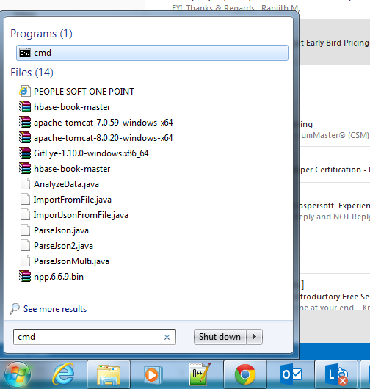
Task 6: Type “java –version” in the command prompt and you should be able to see the output something similar to the following.
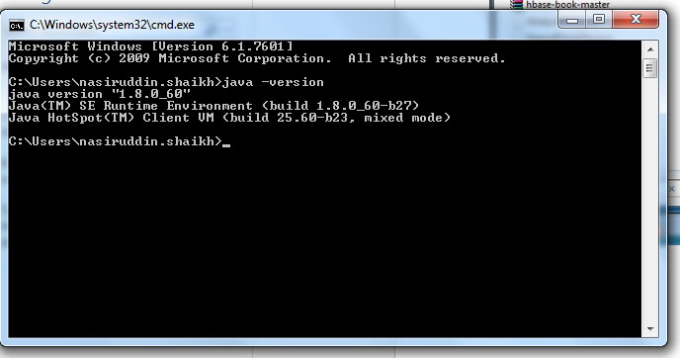

Lab 2: Setting up the Java environment.
For Window 7 users:
- From the desktop, right click the Computer icon.
- Choose Properties from the context menu.
- Click the Advanced system settings link.
- Click Environment Variables. In the section System Variables, find the PATH environment variable and select it. Click Edit. If the PATH environment variable does not exist, click New.
- Create a new variable with the name “JAVA_HOME” with value as the java installation folder. Eg: C:\Program Files\Java\jdk1.8.0_05
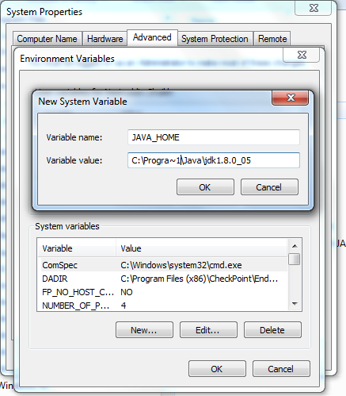
- Add JAVA_HOME variable to the “Path” variable as specified below.
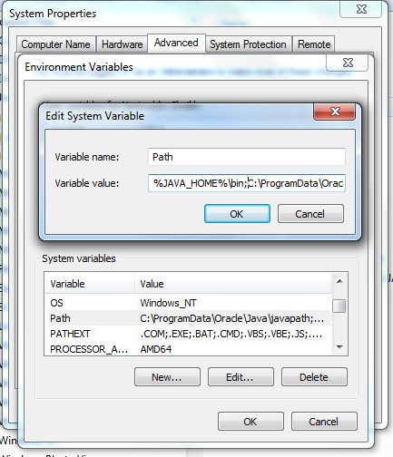
- Now open a command prompt and type “javac”, you should get the output similar to the following
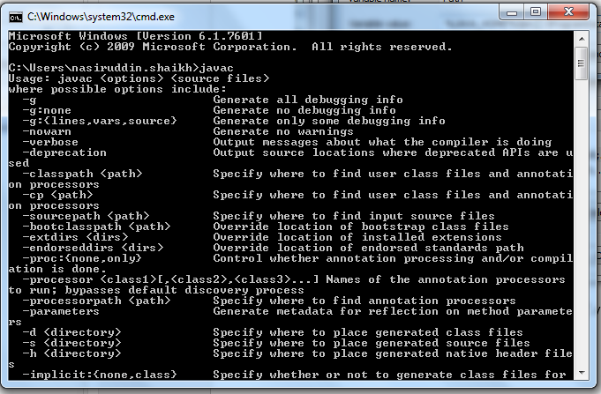

Lab 3: Writing and executing java Hello World Programme
Task 1: Open a notepad (Type “notepad” in Start > Run prompt)
Task 2: Copy the file from “<LABS_SOURCE_DIR>\lab\lab3\HelloWorld.java” to local directory D:\Samples.
Task 3: Open a command prompt.
Task 4: Compile the java programme with following command
Javac HelloWorld.java
Task 5: Execute the programme
Java HelloWorld
Task 6: You will see following output
“Welcome to Java”

Variables and Data Types

Lab 4: Demonstration of defining variables
Task 1: Open a notepad (Type “notepad” in Start > Run prompt)
Task 2: Copy the file from “<LABS_SOURCE_DIR>\lab\lab4\ Car.java” to local directory D:\Samples.
Task 3: Open a command prompt
Task 4: Compile the java programme with following command
Javac Car.java
Task 5: Execute the programme
Java Car
Task 6: Go through the java programme “Car.java” to understand how the arrays are created and how the array elements are accessed.

Arrays

Lab 5: Working with Arrays
Task 1: Open a notepad (Type “notepad” in Start > Run prompt)
Task 2: Copy the file from “<LABS_SOURCE_DIR>\lab\lab4\ ArrayDemo.java” to local directory D:\Samples.
Task 3: Open a command prompt
Task 4: Compile the java programme with following command
Javac ArrayDemo.java
Task 5: Execute the programme
Java ArrayDemo
Task 6: Go through the java programme “ArrayDemo.java” to understand how the arrays are created and how the array elements are accessed.

Operators

Lab 6.1: Arithmetic operator demo
Task 1: Copy, Understand and execute the programme located at “<LABS_SOURCE_DIR>\lab\lab6\ ArithmeticDemo.java”

Lab 6.2: Unary operator demo
Task 1: Copy, Understand and execute the programme located at “<LABS_SOURCE_DIR>\lab\lab6\ UnaryDemo.java”

Lab 6.3: Relational operator demo
Task 1: Copy, Understand and execute the programme located at “<LABS_SOURCE_DIR>\lab\lab6\ ComparisonDemo.java”

Lab 6.4: Conditional operator demo
Task 1: Copy, Understand and execute the programme located at “<LABS_SOURCE_DIR>\lab\lab6\ ConditionalDemo1.java
Task 2: Copy, Understand and execute the programme located at “<LABS_SOURCE_DIR>\lab\lab6\ ConditionalDemo2.java

Control Flow

Lab7.1: Demonstration of If Else control flow statements.
Task 1: Analyze the programme located at “<LABS_SOURCE_DIR>\lab\lab7\IfElseDemo.java”.
Task 2: Copy the programme locally and execute.

Lab7.2: Demonstration of Switch control flow statements.
Task 1: Analyze the programme located at “<LABS_SOURCE_DIR>\lab\lab7\SwitchDemo.java”.
Task 2: Copy the programme locally and execute.

Lab7.3: Demonstration of Switch control flow statements without break statement.
Task 1: Analyze the programme located at “<LABS_SOURCE_DIR>\lab\lab7\ SwitchDemoFallThrough.java”.
Task 2: Copy the programme locally and execute

Lab7.4: Demonstration of Switch control flow statements with String object in switch control statement.
Task 1: Analyze the programme located at “<LABS_SOURCE_DIR>\lab\lab7\ StringSwitchDemo.java”.
Task 2: Copy the programme locally and execute

Lab7.5: Demonstration of using while loop.
Task 1: Analyze the programme located at “<LABS_SOURCE_DIR>\lab\lab7\ WhileDemo.java”.
Task 2: Copy the programme locally and execute

Lab7.6: Demonstration of using do-while loop.
Task 1: Analyze the programme located at “<LABS_SOURCE_DIR>\lab\lab7\ WhileDemo.java”.
Task 2: Copy the programme locally and execute

Lab7.7: Demonstration of using for loop.
Task 1: Analyze the programme located at “<LABS_SOURCE_DIR>\lab\lab7\ ForDemo.java”.
Task 2: Copy the programme locally and execute

Lab7.8: Demonstration of using enhanced for loop.
Task 1: Analyze the programme located at “<LABS_SOURCE_DIR>\lab\lab7\ EnhancedForDemo.java”.
Task 2: Copy the programme locally and execute

Lab7.9: Demonstration of using labelled break statement.
Task 1: Analyze the programme located at “<LABS_SOURCE_DIR>\lab\lab7\ EnhancedForDemo.java”.
Task 2: Copy the programme locally and execute

Lab7.10: Demonstration of using un-labelled continue statement.
Task 1: Analyze the programme located at “<LABS_SOURCE_DIR>\lab\lab7\ ContinueDemo.java”.
Task 2: Copy the programme locally and execute

Lab7.11: Demonstration of using labelled continue statement.
Task 1: Analyze the programme located at “<LABS_SOURCE_DIR>\lab\lab7\ ContinueWithLabelDemo.java”.
Task 2: Copy the programme locally and execute

Classes and Objects

Lab8.1: Demonstration of using Access modifiers.
Task 1: Analyze the programme located at “<LABS_SOURCE_DIR>\lab\lab8\ CarClient.java” and ““<LABS_SOURCE_DIR>\lab\lab7\ Car.java”.
Task 2: Copy the programme locally and execute“java CarClient”
Task3: You will see that there are no compilation issues.
Task4: Now change the access modified for the “make” variable to private and re-run “java CarClient”.
Task5: You will get the compilations issues saying “ make has private access in car”.

Lab9.1: Passing primitive data type and reference data type arguments to contstuctors and methods.
Task 1: Analyze the programme located at “<LABS_SOURCE_DIR>\lab\lab9\ Swap.java”.
Task 2: Copy the programme locally and execute.

Lab9.2: Creating and using Objects.
Task 1: Analyze the programme located at “<LABS_SOURCE_DIR>\lab\lab9\ CreateObjectDemo.java”.
Task 2: Copy the programme locally and execute.

Lab10.1: Demonstration of using the packages.
Task 1: Analyze the programme located at
“<LABS_SOURCE_DIR>\ lab\lab10\com\myapp\draw”.
“<LABS_SOURCE_DIR>\ lab\lab10\com\myapp\geo”.
“<LABS_SOURCE_DIR>\ lab\lab10\com\myapp\test”.
Task 2: Copy all the source code locally and compile the source using command similar to following
Javac com/myapp/draw/Point.java
Task 3: Execute the following java programme and see the results.
Java com.myapp.test. CreateObjectDemo

Lab10.2: Demonstration of using the packages, access modified, class variable, class methods.
Task 1: Analyze the programme located at “<LABS_SOURCE_DIR>\ lab\lab10\com\myapp\test\Bicycle.java”.
Task 2: copy, compile and execute the java programme and see the results.

Lab11.1: Demonstration of using inner classes: ShadowTest
Task 1: Analyze the programme located at “<LABS_SOURCE_DIR>\ lab\lab11\ ShadowTest.java”.
Task 2: copy, compile and execute the java programme and see the results.

Lab11.2: Demonstration of using inner classes: DataStructure
Task 1: Analyze the programme located at “<LABS_SOURCE_DIR>\ lab\lab11\ DataStructure.java”.
Task 2: copy, compile and execute the java programme and see the results.

Lab11.3: Demonstration of using Local classes:
Task 1: Analyze the programme located at “<LABS_SOURCE_DIR>\ lab\lab11\ LocalClassExample.java”.
Task 2: copy, compile and execute the java programme and see the results.

Lab11.4: Demonstration of using Anonymous classes:
Task 1: Analyze the programme located at “<LABS_SOURCE_DIR>\ lab\lab11\ HelloWorldAnonymousClasses.java”.
Task 2: copy, compile and execute the java programme and see the results.

Lab11.5: Demonstration of using Enum types:
Task 1: Analyze the programme located at
“<LABS_SOURCE_DIR>\ lab\lab11\ enum.java”.
“<LABS_SOURCE_DIR>\ lab\lab11\ EnumTest.java”.
Task 2: copy, compile and execute the java programme “EnumTest” and see the results.

Lab11.6: Demonstration of using Enum types with calculations:
Task 1: Analyze the programme located at
“<LABS_SOURCE_DIR>\ lab\lab11\ Planet.java”.
Task 2: copy, compile and execute the java programme “Planet.java” and see the results.

Interfaces

Lab12.1: Demonstration of using Interfaces:
Task 1: Analyze all the programmes located at
“<LABS_SOURCE_DIR>\ lab\lab12”.
Task 2: copy, compile and execute the java programme “com.tutorial.design.ShapeTest” and see the results.

Lab12.2: Demonstration of interface using the example of Relatable:
Task 1: Analyze all the programmes located at
“<LABS_SOURCE_DIR>\ lab\lab12\ com\tutorial\design\Relatable.java”.
“<LABS_SOURCE_DIR>\ lab\lab12\ com\tutorial\shapes\RectanglePlus.java”.
“<LABS_SOURCE_DIR>\ lab\lab12\ com\tutorial\shapes\ RelatableTest.java”.
Task 2: copy, compile and execute the java programme “com.tutorial.design.RelatableTest” and see the results.

Lab12.3: Demonstration of interface using default method:
Task 1: Analyze all the programmes located at
“<LABS_SOURCE_DIR>\ lab\lab12\ com\tutorial\defaultintf\*.java”.
Task 2: copy, compile and execute the java programme “com.tutorial.defaultintf. TestSimpleTimeClient” and see the results.

Lab12.4: Demonstration of interface using enum constants using Card game
Task 1: Analyze all the programmes located at
“<LABS_SOURCE_DIR>\ lab\lab12\ com\tutorial\card\*.java”.
Task 2: copy, compile and execute the java programme “com.tutorial.card. StandardDeck” and see the results.

Inheritance

Lab13.1: Demonstration of Inheritance using super class and sub-class:
Task 1: Analyze all the programmes located at
“<LABS_SOURCE_DIR>\ lab\lab13\com\tutorial\inheritance\*.java”.
Task 2: copy, compile and execute the java programme “com.tutorial.inheritance. BicycleTest” and see the results.

Lab13.2: Demonstration of static method overriding:
Task 1: Analyze all the programmes located at
“<LABS_SOURCE_DIR>\ lab\lab13\com\tutorial\inheritance\staticoverride\*.java”.
Task 2: copy, compile and execute the java programme “com.tutorial.inheritance. staticoverride.Cat” and see the results.

Lab13.3: Demonstration of interface method overriding:
Task 1: Analyze all the programmes located at
“<LABS_SOURCE_DIR>\ lab\lab13\com\tutorial\inheritance\intfmethodoverride\*.java”.
Task 2: copy, compile and execute the java programme “com.tutorial.inheritance. intfmethodoverride. Pegasus” and see the results

Lab13.4: Demonstration of using super in sub classes:
Task 1: Analyze all the programmes located at
“<LABS_SOURCE_DIR>\ lab\lab13\com\tutorial\inheritance\Superclass.java”.
“<LABS_SOURCE_DIR>\ lab\lab13\com\tutorial\inheritance\Subclass.java”.
Task 2: copy, compile and execute the java programme “com.tutorial.inheritance. Subclass” and see the results

Exception Handling

Lab14.1: Demonstration of using Exception handling:
Task 1: Analyze all the programmes located at
“<LABS_SOURCE_DIR>\ lab\ lab14\com\tutorial\exception\ ListOfNumbers.java”.
Task 2: copy and compile the java programme “com.tutorial.exception.ListOfNumbers” and see the results
Task3: You will get the compiler error message saying “unreported exception”. To fix this error uncomment the try/catch block commented in the java source code and recompile and execute.

Lab14.2: Demonstration of using single exception handler for catching more than one exception:
Task 1: Analyze all the programmes located at
“<LABS_SOURCE_DIR>\ lab\ lab14\com\tutorial\exception\ AdvancedListOfNumbers.java”.
Task 2: copy and compile the java programme “com.tutorial.exception. AdvancedListOfNumbers” and see the results

Lab14.3: Demonstration of using try with resource
Task 1: Analyze all the programmes located at
“<LABS_SOURCE_DIR>\ lab\ lab14\com\tutorial\exception\ TryWithResourceDemo.java”.
Task 2: copy and compile the java programme “com.tutorial.exception. TryWithResourceDemo” and see the results

Collections

Lab15.1: Demonstration of traversing through sets:
Task 1: Analyze all the programmes located at
“<LABS_SOURCE_DIR>\ lab15\com\tutorial\setdemo\FindDups.java”.
Task 2: copy and compile the java programme “com.tutorial. setdemo. FindDups” and see the results

Lab15.2: Demonstration of traversing through sets using iterator:
Task 1: Analyze all the programmes located at
“<LABS_SOURCE_DIR>\ lab15\com\tutorial\setdemo\FindDupsUsingIterator.java”.
Task 2: copy and compile the java programme “com.tutorial. setdemo. FindDupsUsingIterator” and see the results

Lab15.3: Demonstration of traversing through sets:
Task 1: Analyze all the programmes located at
“<LABS_SOURCE_DIR>\ lab15\com\tutorial\setdemo\FindDups2.java”.
Task 2: copy and compile the java programme “com.tutorial. setdemo. FindDup2” and see the results

Lab15.4: Demonstration of traversing through list:
Task 1: Analyze all the programmes located at
“<LABS_SOURCE_DIR>\ lab15\com\tutorial\listdemo\ Shuffle.java”.
Task 2: copy and compile the java programme “com.tutorial. listdemo. Shuffle” and see the results

Lab15.5: Demonstration of working with List using card game:
Task 1: Analyze all the programmes located at
“<LABS_SOURCE_DIR>\ lab15\com\tutorial\listdemo\ Deal.java”.
Task 2: copy and compile the java programme “com.tutorial. listdemo. Deal” and see the results

Lab15.6: Demonstration of working with Queue with countdown example:
Task 1: Analyze all the programmes located at
“<LABS_SOURCE_DIR>\ lab15\com\tutorial\queuedemo\ Countdown.java”.
Task 2: copy and compile the java programme “com.tutorial. queuedemo. Countdown” and see the results

Lab15.6: Demonstration of working with Queue with countdown example:
Task 1: Analyze all the programmes located at
“<LABS_SOURCE_DIR>\ lab15\com\tutorial\queuedemo\ Countdown.java”.
Task 2: copy and compile the java programme “com.tutorial. queuedemo. Countdown” and see the results

Lab15.7: Demonstration of working with Maps:
Task 1: Analyze all the programmes located at
“<LABS_SOURCE_DIR>\ lab15\com\tutorial\mapdemo\ Freq.java”.
Task 2: copy and compile the java programme “com.tutorial. mapdemo. Freq” and see the results

Lab15.8: Demonstration of working with Maps with Anagram example:
Task 1: Analyze all the programmes located at
“<LABS_SOURCE_DIR>\ lab15\com\tutorial\mapdemo\ Anagram.java”.
Task 2: copy and compile the java programme “com.tutorial. mapdemo. Anagram” and see the results

Lab15.9: Demonstration of Comparing objects using Comparable interface:
Task 1: Analyze all the programmes located at
“<LABS_SOURCE_DIR>\ lab15\com\tutorial\mapdemo\ Name.java”.
“<LABS_SOURCE_DIR>\ lab15\com\tutorial\mapdemo\ NameSort.java”.

Task 2: copy and compile the java programme “com.tutorial. mapdemo. NameSort” and see the results

Lab15.10: Demonstration of Comparing objects using Comparator:
Task 1: Analyze all the programmes located at
“<LABS_SOURCE_DIR>\ lab15\com\tutorial\mapdemo\ Student.java”.
“<LABS_SOURCE_DIR>\ lab15\com\tutorial\mapdemo\ NameComparator.java”.
“<LABS_SOURCE_DIR>\ lab15\com\tutorial\mapdemo\ GradeComparator.java”.
“<LABS_SOURCE_DIR>\ lab15\com\tutorial\mapdemo\ MainComparatorExample.java”.

Task 2: copy and compile the java programme “com.tutorial. mapdemo. MainComparatorExample” and see the results

Generics

Lab16.1: Demonstration of using Generics:
Task 1: Analyze all the programmes located at
“<LABS_SOURCE_DIR>\ lab16\com\tutorial\generics\ Pair.java”.
“<LABS_SOURCE_DIR>\ lab16\com\tutorial\generics\ OrderedPair.java”.
“<LABS_SOURCE_DIR>\ lab16\com\tutorial\generics\ GenericsTest.java”.
Task 2: copy and compile the java programme “com.tutorial. generics. GenericsTest” and see the results

Lab16.2: Demonstration of Bounded type Generics:
Task 1: Analyze all the programmes located at
“<LABS_SOURCE_DIR>\ lab16\com\tutorial\generics\ Box.java”.
Task 2: copy and compile the java programme “com.tutorial. generics. Box” and see the results

Numbers and Strings

Lab17.1: Demonstration of using Number formatter:
Task 1: Analyze all the programmes located at
“<LABS_SOURCE_DIR>\ lab17\com\tutorial\formatting\ TestFormat.java”.
Task 2: copy and compile the java programme “com.tutorial. formatting. TestFormat” and see the results

Lab17.2: Demonstration of using Decimal formatter:
Task 1: Analyze all the programmes located at
“<LABS_SOURCE_DIR>\ lab17\com\tutorial\formatting\ DecimalFormatDemo.java”.
Task 2: copy and compile the java programme “com.tutorial. formatting. DecimalFormatDemo” and see the results

Lab17.3: Demonstration of using Math functions:
Task 1: Analyze all the programmes located at
“<LABS_SOURCE_DIR>\ lab17\com\tutorial\maths\ BasicMathDemo”.
Task 2: copy and compile the java programme “com.tutorial. maths. BasicMathDemo” and see the results

Lab17.4: Demonstration of using Math exponential functions:
Task 1: Analyze all the programmes located at
“<LABS_SOURCE_DIR>\ lab17\com\tutorial\maths\ ExponentialDemo.java”.
Task 2: copy and compile the java programme “com.tutorial. maths. ExponentialDemo” and see the results

Lab17.5: Demonstration of using Math trigonometric functions:
Task 1: Analyze all the programmes located at
“<LABS_SOURCE_DIR>\ lab17\com\tutorial\maths\ TrigonometricDemo.java”.
Task 2: copy and compile the java programme “com.tutorial. maths. TrigonometricDemo” and see the results

Lab17.6: Demonstration of adding numbers passed as arguments:
Task 1: Analyze all the programmes located at
“<LABS_SOURCE_DIR>\ lab17\com\tutorial\maths\ Adder.java”.
Task 2: copy and compile the java programme “com.tutorial. maths. Adder” and see the results

Lab17.7: Demonstration of String functions:
Task 1: Analyze all the programmes located at
“<LABS_SOURCE_DIR>\ lab17\examples\”.
Task 2: copy and compile the java each java programme and see the results

Lab17.8: Demonstration of String functions with palindrome example:
Task 1: Analyze the programmes located at
“<LABS_SOURCE_DIR>\ lab17\ com\tutorial\strings\ Palandrome.java”.
“<LABS_SOURCE_DIR>\ lab17\ com\tutorial\strings\ StringBuilderDemo.java”.

Task 2: copy and execute the java programme and see the results

Lab17.9: Demonstration of converting string to numbers:
Task 1: Analyze the programmes located at
“<LABS_SOURCE_DIR>\ lab17\ com\tutorial\strings\ ValueOfDemo.java”.
Task 2: copy and execute the java programme and see the results

Lab17.10: Demonstration of string search functions:
Task 1: Analyze the programmes located at
“<LABS_SOURCE_DIR>\ lab17\ com\tutorial\strings\ Filename.java”.
Task 2: copy and execute the java programme and see the results

Lab17.11: Demonstration of Unboxing:
Task 1: Analyze the programmes located at
“<LABS_SOURCE_DIR>\ lab17\ com\tutorial\boxing\ Unboxing.java”.
Task 2: copy and execute the java programme and see the results

Lab17.12: Demonstration of using String functions to find anagram:
Task 1: Analyze the programmes located at
“<LABS_SOURCE_DIR>\ lab17\ com\tutorial\strings\ Anagram.java”.
Task 2: copy and execute the java programme and see the results

Concurrency

Lab18.1: Creating threads using Runnable:
Task 1: Analyze the programmes located at
“<LABS_SOURCE_DIR>\ lab18\ com\tutorial\threads\ HelloRunnable.java”.
Task 2: copy and execute the java programme and see the results

Lab18.2: Creating threads using Thread class:
Task 1: Analyze the programmes located at
“<LABS_SOURCE_DIR>\ lab18\ com\tutorial\threads\ HelloThread.java”.
Task 2: copy and execute the java program and see the results

Lab18.3: Pausing thread execution by invoking sleep.:
Task 1: Analyze the programmes located at
“<LABS_SOURCE_DIR>\ lab18\ com\tutorial\threads\ SleepMessages.java”.
Task 2: copy and execute the java program and see the results

Lab18.4: Interrupting threads.:
Task 1: Analyze the programmes located at
“<LABS_SOURCE_DIR>\ lab18\ com\tutorial\threads\ TestInterruptingThread1.java”.
Task 2: copy and execute the java program and see the results

Lab18.5: Joining threads.:
Task 1: Analyze the programmes located at
“<LABS_SOURCE_DIR>\ lab18\ com\tutorial\threads\ TestJoinMethod1.java”.
Task 2: copy and execute the java program and see the results

Lab18.6: Interrupting threads – Example 2:
Task 1: Analyze the programmes located at
“<LABS_SOURCE_DIR>\ lab18\ com\tutorial\threads\SimpleThreads.java”.
Task 2: copy and execute the java program and see the results

Lab18.6: Demonstration of thread interference:
Task 1: Analyze the programmes located at
“<LABS_SOURCE_DIR>\ lab18\ com\tutorial\threads\Counter.java”.
“<LABS_SOURCE_DIR>\ lab18\ com\tutorial\threads\IncrementCounterThread.java”.
“<LABS_SOURCE_DIR>\ lab18\ com\tutorial\threads\DecrementCounterThread.java”.
“<LABS_SOURCE_DIR>\ lab18\ com\tutorial\threads\CounterThreadTest.java”.

Task 2: copy, compile and execute the java program “java com.tutorial.threads. CounterThreadTest” and see the results

Lab18.7: Demonstration of avoiding thread interference using synchronization:
Task 1: Analyze the programmes located at
“<LABS_SOURCE_DIR>\ lab18\ com\tutorial\threads\Counter.java”.
“<LABS_SOURCE_DIR>\ lab18\ com\tutorial\threads\IncrementCounterThread.java”.
“<LABS_SOURCE_DIR>\ lab18\ com\tutorial\threads\DecrementCounterThread.java”.
“<LABS_SOURCE_DIR>\ lab18\ com\tutorial\threads\CounterThreadTest.java”.
Task 2: Modify all the methods in Counter.java to “synchronized”.
Task 3: copy, compile and execute the java program “java com.tutorial.threads. CounterThreadTest” and see the results

Lab18.8: Demonstration of avoiding thread interference using synchronized blocks:
Task 1: Analyze the programmes located at
“<LABS_SOURCE_DIR>\ lab18\ com\tutorial\threads\SBCounter.java”.
“<LABS_SOURCE_DIR>\ lab18\ com\tutorial\threads\SBIncrementCounterThread.java”.
“<LABS_SOURCE_DIR>\ lab18\ com\tutorial\threads\SBDecrementCounterThread.java”.
“<LABS_SOURCE_DIR>\ lab18\ com\tutorial\threads\SBCounterThreadTest.java”.
Task 2: Modify all the methods in Counter.java to “synchronized”.
Task 3: copy, compile and execute the java program “java com.tutorial.threads. SBCounterThreadTest” and see the results

Lab18.9: Demonstration of threads dead lock:
Task 1: Analyze the programmes located at
“<LABS_SOURCE_DIR>\ lab18\ com\tutorial\threads\Deadlock.java”.
Task 2: copy, compile and execute the java program “java com.tutorial.threads. Deadlock” and see the results

Lab18.10: Demonstration of solving threads dead lock:
Task 1: Analyze the programmes located at
“<LABS_SOURCE_DIR>\ lab18\ com\tutorial\threads\DeadlockSolved.java”.
Task 2: copy, compile and execute the java program “java com.tutorial.threads. DeadlockSolved” and see the results

Lab18.11: Demonstration of Guarded blocks:
Task 1: Analyze the programmes located at
“<LABS_SOURCE_DIR>\ lab18\ com\tutorial\threads\Drop.java”.
“<LABS_SOURCE_DIR>\ lab18\ com\tutorial\threads\Producer.java”.
“<LABS_SOURCE_DIR>\ lab18\ com\tutorial\threads\Consumer.java”.
“<LABS_SOURCE_DIR>\ lab18\ com\tutorial\threads\ProducerConsumerExample.java”.

Task 2: copy, compile and execute the java program “java com.tutorial.threads. ProducerConsumerExample” and see the results

Lab18.12: Demonstration of Using Locks:
Task 1: Analyze the programmes located at
“<LABS_SOURCE_DIR>\ lab18\ com\tutorial\threads\Safelock.java”.

Task 2: copy, compile and execute the java program “java com.tutorial.threads. Safelock” and see the results

Lab18.13: Demonstration of Using Fork/Join:
Task 1: Analyze the programmes located at
“<LABS_SOURCE_DIR>\ lab18\ com\tutorial\threads\ ForkBlur.java”.

Task 2: copy, compile and execute the java program “java com.tutorial.threads. ForkBlur” and see the results

Lab18.14: Demonstration of Using Atomic variables to avoid synchronization:
“<LABS_SOURCE_DIR>\ lab18\ com\tutorial\threads\AtomicCounter.java”.
“<LABS_SOURCE_DIR>\ lab18\ com\tutorial\threads\AtomicIncrementCounterThread.java”.
“<LABS_SOURCE_DIR>\ lab18\ com\tutorial\threads\AtomicDecrementCounterThread.java”.
“<LABS_SOURCE_DIR>\ lab18\ com\tutorial\threads\AtomicCounterThreadTest.java”.
Task 2: copy, compile and execute the java program “java com.tutorial.threads. AtomicCounterThreadTest” and see the results

