Lab Exercises

Assumptions:

Operating system: Windows 7

Location of the required installations:

JAVA_INSTALL_PATH=C:\Users\nasiruddin.shaikh\Downloads\jdk-7u71-windows-x64.exe

LABS_SOURCE_DIR = C:\Users\nasiruddin.shaikh\git\TechnicalDocs\training\core_java\lab

## Lab 1: Installing the Java Software and setting up the envrionment

Task 1: Create a ‘softwares’, “Samples” directory under “D” drive on your system. i.e. (D:\softwares and D:\Samples).

Task 2: Copy the java installation exe from the <JAVA_INSTALL_PATH> to your directory created as per the task 1 i.e D:\softwares.

Task 3: Double click on the exe file located in D:\softwares.

Task 4: select all defaults to install the java software.

Task 5: Open a command prompt by navigating to “Start > Run “, type cmd and hit enter.

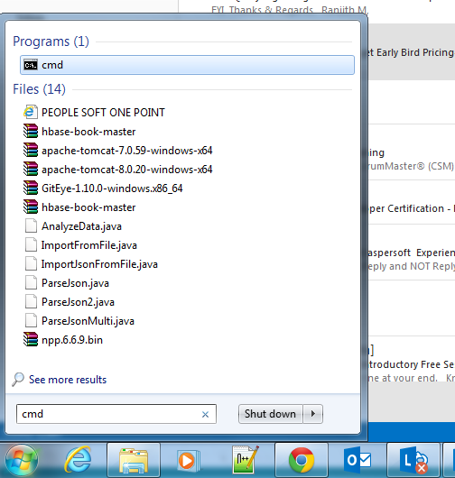

Task 6: Type “java –version” in the command prompt and you should be able to see the output something similar to the following.

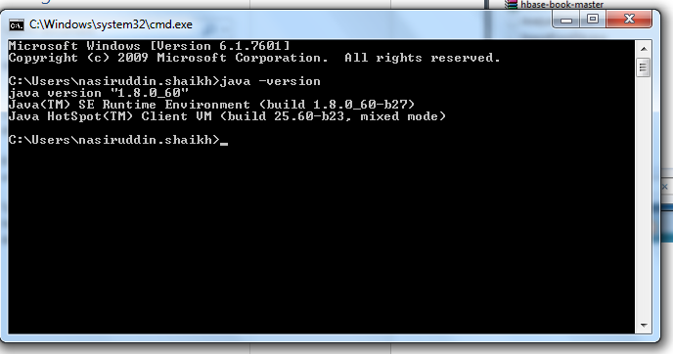

## Lab 2: Setting up the Java environment.

For Window 7 users:

1. From the desktop, right click the **Computer** icon.
2. Choose **Properties** from the context menu.
3. Click the **Advanced system settings** link.
4. Click **Environment Variables**. In the section **System Variables**, find the PATH environment variable and select it. Click **Edit**. If the PATH environment variable does not exist, click New.
5. Create a new variable with the name “JAVA_HOME” with value as the java installation folder. Eg: C:\Program Files\Java\jdk1.8.0_05

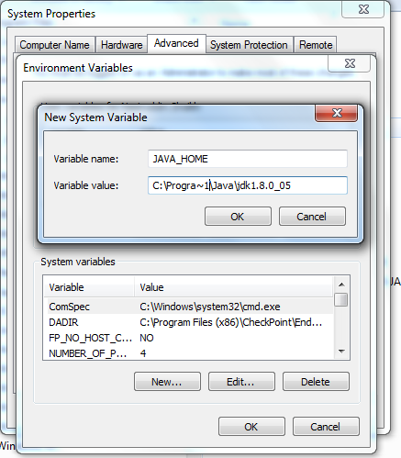

1. Add JAVA_HOME variable to the “Path” variable as specified below.

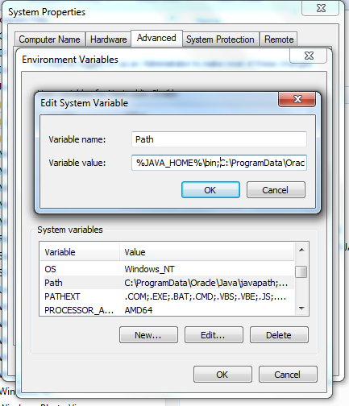

1. Now open a command prompt and type “javac”, you should get the output similar to the following

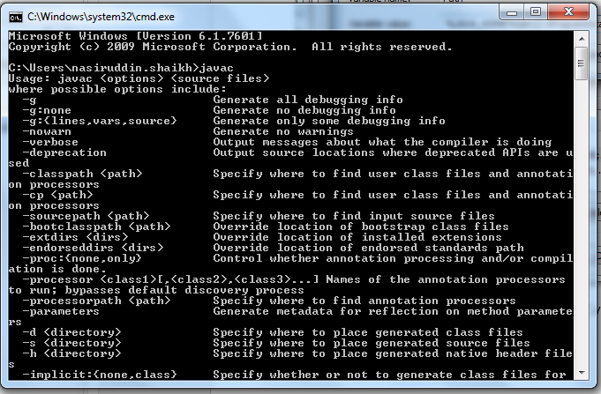

## Lab 3: Writing and executing java Hello World Programme

Task 1: Open a notepad (Type “notepad” in Start > Run prompt)

Task 2: Copy the file from “<LABS_SOURCE_DIR>\lab\lab3\HelloWorld.java” to local directory D:\Samples.

Task 3: Open a command prompt.

Task 4: Compile the java programme with following command

Javac HelloWorld.java

Task 5: Execute the programme

Java HelloWorld

Task 6: You will see following output

“Welcome to Java”