**Code Structure and Dataset:**

Here is the file structure of our submission:  
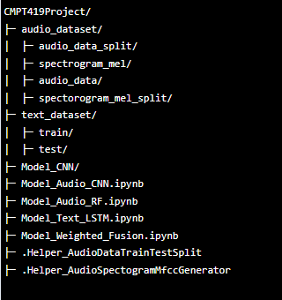

The folders labels are self explanatory and the Collab notebook files (.ipynb) as well. We have two helper notebook prefixed with “Helper”. Apart from that, each trained model is saved under its own folder.

---------------

**Project Link:**

<https://drive.google.com/drive/folders/1Z6GSxD0UN0dpCcTdErbVggLeXXew7wBC?usp=sharing>

---------------

**Self evaluation of the project:**

We believe our group was able to achieve almost everything we outlined in our project proposal. In fact, even though we only decided to implement CNN to classify audio data (using mel-spectrograms), we ended up implementing a second model - a Random Forest Classifier, to compare with our CNN. Also, we spent quite a while trying to implement a decent performing SVM but due to time constraints, we decided not to pursue it further. However, we ended up making some changes to our initial plans. We switched our fusion technique from early fusion to late fusion, hence we would like to explore early fusion in our future work. Also, we planned to implement real-time classification if time permitted, which it did not. Early fusion and real-time classification are still on our list of items to finish in the future.