**Case Study 3: Follow up questions**

1. From the population structure analysis, what population does the A. cervicornis samples from San Andres belong to? What other countries/regions form a genetic cluster with San Andres? And, what side of the Caribbean break (East or West) does it fall out with?
2. In the space below, draw on the Panama-Colombia Gyre and Caribbean Current to sample map. **Explain** how these ocean currents contribute to the gene flow and population structure observed in the A. cervicornis samples in the space under the map.

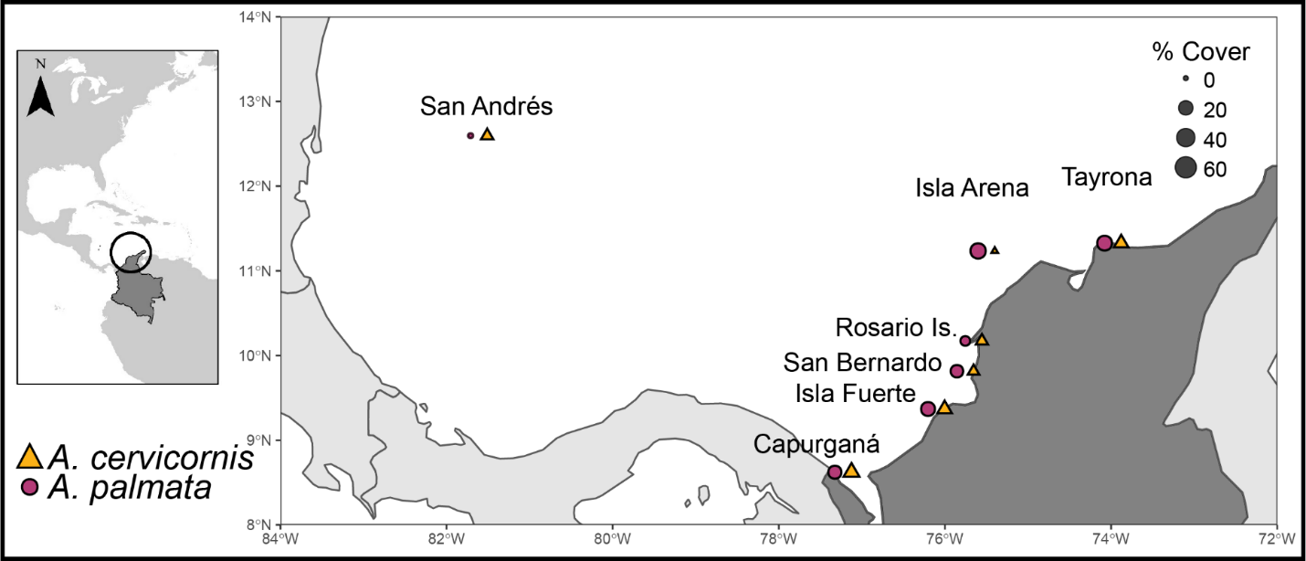

Note: Capurgana = Urba Gulf

1. García-Urueña & Garzón-Machado 2020 reported an overall decrease in A. cervicornis coverage at all Colombia sites with limited to no evidence of recruitment (i.e., babies). When encountered, A. cervicornis reefs were often isolated patches of relict colonies. Given our population structure results, what sort of restoration strategy might you suggest to ***enhance A. cervicornis coral coverage***?
2. What strategy would you suggest to ***enhance A. cervicornis genetic diversity***? (hint- this strategy is probably different than above).
3. From the AMOVA test, how much allelic variation is found among populations? Was this result significant?