

Model Driven Software Engineering

(COEN 6312)

Project Deliverable 3

Submitted to

Dr. Abdelwahab Hamou-Lhadj

Submitted by

Nareshkumar M. Sisodiya 27650817

Arjun Lokhande 27411111

Binu Basil John 27421753

Anant Mathur 27323670

Khushboo Handa 27323794

February 29, 2016

Contents

List of Figures 3

1. Introduction 4

2. Class Diagram Description 5

2.1 Person 5

2.1.1 User 6

2.1.2 Administrator 6

2.2 Online Air Reservation System 6

2.3 Ticket 7

2.4 Catalog 7

2.5 Flight 8

2.6 Payment 8

3. OCL Constraints 9

# List of Figures

# 1. Introduction

# FlyAir (2).png2. Class Diagram Description

## 2.1 Person

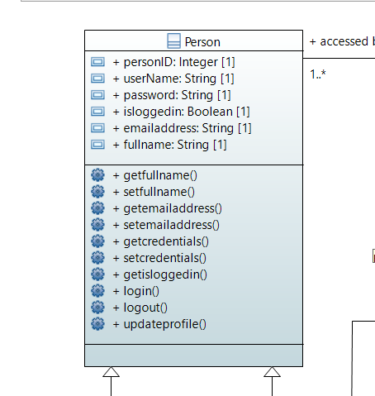

### 2.1.1 User

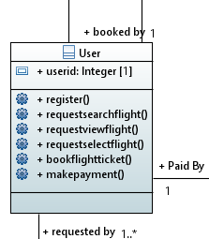

### 2.1.2 Administrator

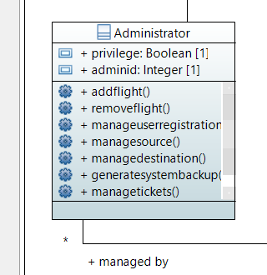

Admin class will define the role of an administrator in the system. This class will inherit the Person class. The primary task of Admin class is perform administrative functions in flight reservation system. Administrator will manage flight details, user registrations and routinely take system back-up. Admin class can manage overall system.

## 2.2 Online Air Reservation System

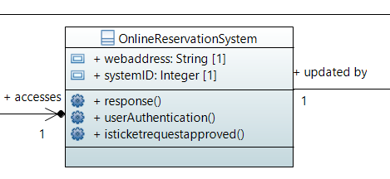

OnlineReservationSystem class plays a vital role in responding to the request initiated by the person. Also User authentication as well as approval of ticket request will be handled by this class.

## 2.3 Ticket

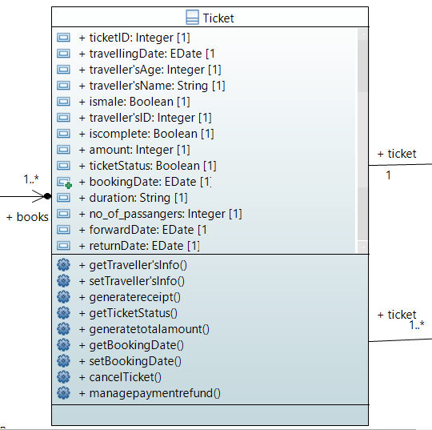

## 2.4 Catalog

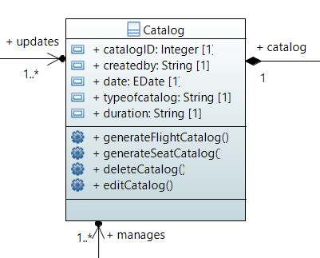

Catalog class holds all required data for flights and tickets. Upon receiving different combinations of requests, it can serve list of flight or list of available seats.

## 2.5 Flight

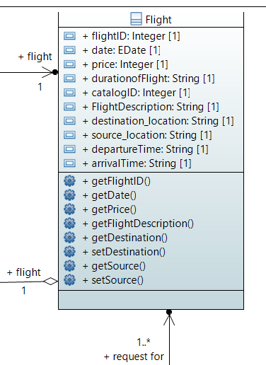

## 2.6 Payment

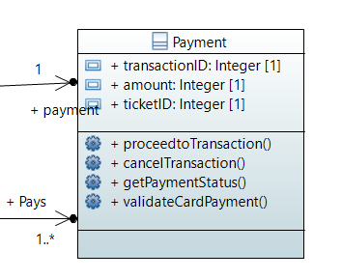

# 3. OCL Constraints

* Each person who logs in to the system to book a ticket must have an unique ID :

Context : Person

inv : self.allinstances()->forall(P1,P2:Person | P1 <> P2 implies P1.userID <> P2.userID);

* Each Ticket booked by the user for scheduled travel should have an unique ID :

Context : Ticket

inv : self.allinstances()->forall(T1,T2:Tickets | T1<>T2 implies T1.ticketID <> T2.ticketID);

* A logged in user planning a travel can book at most 10 tickets of the flight :

Context : User

inv : self.book->no_of_passengers <= 10;

* Source and Destination location of the flight cannot be the same :

Context : Flight

inv : self.destination_location <> self.source_location;

* User must provide Traveller's information while booking ticket :

Context : Ticket

int : self.travellersName->notEmpty() AND self.travellersAge->notEmpty() AND self.travellersID->notEmpty();

* The return journey date must be after the forward journey date :

Context : Ticket

inv : self.forwardDate < self.returnDate;