

Model Driven Software Engineering

(COEN 6312)

Project Deliverable 2

Submitted to

Dr. Abdelwahab Hamou-Lhadj

Submitted by

Nareshkumar M. Sisodiya 27650817

Arjun Lokhande 27411111

Binu Basil John 27421753

Anant Mathur 27323670

Khushboo Handa 27323794

February 8, 2016

Contents

List of Figures ii

List of Tables iii

INTRODUCTION 1

USE CASE Diagrams 1

USE CASE Descriptions 2

User 2

Administrator 10

NON FUNCTIONAL REQUIREMENTS 12

# List of Figures

Figure 1: User Use Case Diagram 1

Figure 2: Administrator Use Case 2

# List of Tables

Table 1: Register Use Case 2

# INTRODUCTION

Fly Air offers an online reservation for its flights between various destinations at an affordable cost. This online reservation system enables the user to search, view and select flights as per requirements.

# USE CASE Diagrams

User Use Case Diagram

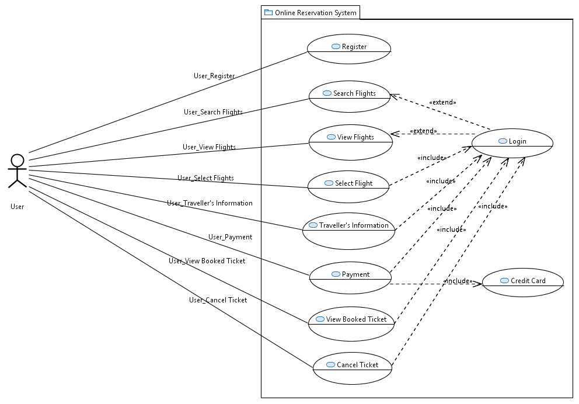

Figure : User Use Case

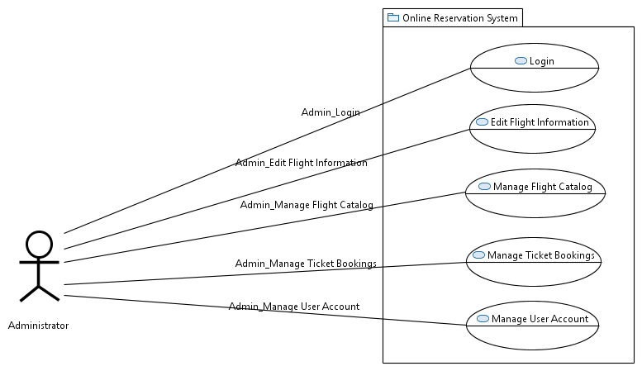

Figure : Administrator Use Case

# USE CASE Descriptions

## User

Register

Table : Register Use Case

|  |  |
| --- | --- |
| **Use Case Name** | Register |
| **Use Case ID** | UC-1 |
| **Description** | Registration of a new user to generate a new account in the system database |
| **Actor** | User, Administrator and System |
| **Pre-Conditions** | User doesn’t have an account. |
| **Post-Conditions** | Success End condition:  1.New account created for the user.  2.The database has been updated.  3.A success message is displayed to the user.  Failure End condition:  1. The account not created.  2. An error message is displayed to the user. |
| **Normal Flow:** | 1.  The user clicks on the link for registration on the webpage  2.  The system displays the registration page.  3.  The user inputs all of his necessary personal information.  4.  The system verifies the entered information.  5.  The system updates the database.  6.  The confirmation message for the new account is displayed to the user. |
| **Alternative Flow** | N/A |
| **Exceptions** | In step4: The user registration form is missing mandatory information or has incorrect characters or duplicate email ID.  4.1. The system highlights the sections having error.  4.2. The system notifies with an error message that alerts the user about the error.  4.3. The system prompt the user to fix the wrong information or to add the missing information.  In step 5 : The system detects a problem with the database connection  5.1. The system informs the user of the problem with connection  5.2. The user registration fails. |
| **Includes** | Get Authentication use case. |
| **Priority** | High |

Login

|  |  |
| --- | --- |
| **Use Case Name** | Login |
| **Use Case ID** | **UC-2** |
| **Description** | The user logins to the system using the username and password. |
| **Actor** | User, Administrator and System |
| **Pre-Conditions** | Active account in the system |
| **Post-Conditions** | **Success End condition:**  1. The User is logged in.  2. The system display the User home page.  **Failure End condition:**  1. The User is not logged in.  2. An error message is displayed to the User. |
| **Normal Flow** | 1. The system display the login page.  2. The User enters the user information (username and password)  3. The system verify the User information  4. The system display the User homepage. |
| **Alternative Flow** | N/A |
| **Exceptions** | Step 1: The User enters a wrong login information.  1.1. The system shows an error message displaying invalid username and/or password.  1.2. The system prompts the User to re-enter the login information. |
| **Includes** | N/A |
| **Priority** | High |

Search Flights

|  |  |
| --- | --- |
| **Use Case Name** | Search Flights |
| **Use Case ID** | **UC-3** |
| **Description** | Searches the available flights as entered by the User |
| **Actor** | User and Administrator |
| **Pre-Conditions** | User has logged into the system |
| **Post-Conditions** | **Success end condition:**  1. The requested Flight list information has been retrieved.  **Failure end condition:**  1.The requested flight list information could not be retrieved.  2. An error message is displayed to the User |
| **Normal Flow** | 1.  The user navigates to the Search Flights section.  2.  The User enters the Travel information.  3.  The system retrieves all the relevant flight information from the database. |
| **Alternative Flow** | The User can search the flights without Login |
| **Exceptions** | In step 2:  1. The user enters invalid Travel Information  2.  The systems displays the error message to the user.  In step 3: There is no flight available at the requested time. |
| **Includes** | N/A |
| **Priority** | Medium |

View Flights

|  |  |
| --- | --- |
| **Use Case ID** | **UC-4** |
| **Use Case Name** | View Flights |
| **Description** | This use case describes that the user will view list of available flights |
| **Actor** | User and Administrator |
| **Pre-Conditions** | 1.  User searches a Flight  2.  Flight exists in the system |
| **Post-Conditions** | **Success End condition:**  1. The flight information has been retrieved and shown to the user.  **Failure End condition:**  1. The flight information could not be retrieved.  2. An error message is displayed to the user. |
| **Normal Flow** | 1. The system displays the list of flights page.  2. The user navigates through the list of flights.  3. The user selects the desired flight. |
| **Alternative Flow** | The user can view of the list of Flights page without login. |
| **Exceptions** | In step 3: The system detects a problem with retrieving the desired flight information from the database.  3.1 The User must login to select the flight  3.2 The system requests the user to login to proceed with selection of flight. |
| **Includes** | N/A |
| **Priority** | Medium |

Select Flights

|  |  |
| --- | --- |
| **Use Case ID** | **UC-05** |
| **Use Case Name** | Select Flight |
| **Description** | The User can select a Flight |
| **Primary Actor** | User and Administrator |
| **Pre-Conditions** | 1. User has logged into the system  2. User has viewed the list of flights |
| **Normal Flow** | 1.  The User navigates through the flight selection section  2.  The system retrieves the flight information from the database and checks for any conflicts.  3.  The system updates the database.  4.  The system displays the confirmed selection. |
| **Alternative Flow** | N/A |
| **Exceptions** | 1. The user is unable to select the desired flight due to technical issues. 2. The Database is inaccessible. |
| **Includes** | The User must Login |
| **Priority** | High |

Traveller's Information

|  |  |
| --- | --- |
| **Use Case ID** | **UC-06** |
| **Use Case Name** | Enter Traveller’s Information |
| **Description** | The User must enter the traveller’s information |
| **Primary Actor** | User and Administrator |
| **Pre-Conditions** | 1. User has logged into the system  2. User has viewed and selected the flight |
| **Normal Flow** | 1.  The User has selected the flight and entered traveller’s information  2. The system updates the database.  4.  The system displays the information and prompts to  confirm to proceed further . |
| **Alternative Flow** | N/A |
| **Exceptions** | 1. The Database is inaccessible. 2. The user has not filled all the mandatory fields.. 3. 2.  An error message is displayed to the user. |
| **Includes** | The User must Login |
| **Priority** | High |

Payment

|  |  |
| --- | --- |
| **Use Case ID** | **UC-07** |
| **Use Case Name** | Payment |
| **Description** | The user makes payment for the selected tickets |
| **Primary Actor** | User and Administrator |
| **Pre-Conditions** | 1. User has logged into the system  2. User has viewed the list of flights  3. User has selected the flight and entered the travelers’ information.  4. The payment method has been selected by user. |
| **Normal Flow** | 1.  The user makes flight selection and enter travellers’ information.  2. The user selects the payment method and enter the valid information for the payment  3.  The system validates the user credentials for the payment.  4.  The system informs the user of the successful payment. |
| **Alternative Flow** | N/A |
| **Exceptions** | 1. Unsuccessful payment due to insufficient balance. 2. Payment unsuccessful due to wrong payment or card information. 3. Communication failure between system and bank server. 4. User is informed about the unsuccessful transaction and prompted for another payment. |
| **Includes** | The User must Login |
| **Priority** | High |

View Booked Ticket

|  |  |
| --- | --- |
| **Use Case ID** | **UC-08** |
| **Use Case Name** | View Booked Ticket |
| **Description** | The User can view the tickets |
| **Primary Actor** | User |
| **Pre-Conditions** | 1. User has logged into the system  2. User has booked a ticket. |
| **Normal Flow** | 1.  The User views the ticket he/she has booked  2.  The system displays the information and prompts to  confirm to proceed further . |
| **Alternative Flow** | N/A |
| **Exceptions** | 1. The booked ticket has been deleted from the history. 2. The Database is inaccessible. |
| **Includes** | The User must Login |
| **Priority** | High |

Cancel Ticket

|  |  |
| --- | --- |
| **Use Case ID** | **UC-09** |
| **Use Case Name** | Cancel Ticket |
| **Description** | The User can cancel ticket and get refund |
| **Primary Actor** | User |
| **Pre-Conditions** | 1. User has logged into the system  2. User has booked a ticket. |
| **Normal Flow** | 1. The User selects booked the ticket he/she wants to cancel  2. The system displays the information and prompts to confirm to proceed further. |
| **Alternative Flow** | N/A |
| **Exceptions** | 1. The Database is inaccessible.  2. The user could not cancel ticket  2.  An error message is displayed to the user. |
| **Includes** | The User must Login |
| **Priority** | High |

## Administrator

Edit Flight Information

|  |  |
| --- | --- |
| **Use Case ID** | **UC-10** |
| **Use Case Name** | Edit Flight Information |
| **Description** | The Admin can edit the flight information if some changes are made by the airlines management. |
| **Primary Actor** | Administrator |
| **Pre-Conditions** | The Admin is logged into the system |
| **Post-Conditions** | The Admin has successfully edited the flight information |
| **Normal Flow** | 1.  The Administrator logs into the system.  2. The Administrator can edit the existing flight information. |
| **Alternative Flow** | N/A |
| **Exceptions:** | The Administrator forgets the password of editing the information. |
| **Includes** | N/A |
| **Priority** | High |

Manage Flight Catalog

|  |  |
| --- | --- |
| **Use Case ID** | **UC-11** |
| **Use Case Name** | Manage Flight Schedule |
| **Description** | The Admin manages the flight catalog and edits the flight schedule if necessary |
| **Primary Actor** | Administrator |
| **Pre-Conditions** | The Admin is logged into the system |
| **Post-Conditions** | The Admin has updated the flight catalog. |
| **Normal Flow** | 1.  The Administrator logs into the system.  2. The Administrator manages the flight catalog. |
| **Alternative Flow** | N/A |
| **Exceptions** | The Administrator forgets the secondary password for editing the catalog. |
| **Includes** | N/A |
| **Priority** | High |

# NON FUNCTIONAL REQUIREMENTS

* **Performance:** Overall response time of the system should be as small as possible. System will be required to provide list of flights in response of flight search request. The system should respond in acceptable time frame. Accepting payment, validating transaction from the bank and confirming the ticket booking should be done very quickly. Also the process to cancel tickets and get refunds should be instantaneous and convenient.
* **Availability:** The system should be available 24 x 7. The supporting systems and software should be stable and operational all the time.
* **Reliability:** The system should not crash frequently. System should save data at frequent intervals so that in case of failure, system can restore the user data and ongoing sessions.
* **Maintainability:** The online system must be kept up to date in terms of flight status and flight availability.
* **Serviceability:** The reservation system must be able to service the demands of all the users. Number of people who can access the system at a time should be utmost.
* **Security:** System must handle unauthorized access and notify user immediately. Password must have special characters and complex combinations.User should be notified if he/she selects weak password. User should be automatically logged off in case of more than 10 minutes of inactivity.The payment process must happen over a secured session.
* **Privacy:** The user/traveller information must be protected from unwanted usage.
* **Usability:** Users must be able to search and view flights without logging / registering.