

Model Driven Software Engineering

(COEN 6312)

Project Deliverable 4

Submitted to

Dr. AbdelwahabHamou-Lhadj

Submitted by

Nareshkumar M. Sisodiya 27650817

Arjun Lokhande 27411111

Binu Basil John 27421753

Anant Mathur 27323670

Khushboo Handa 27323794

March 23, 2016

Contents

List of Figures ii

1. Introduction 1

2. User 1

2.1 State Machine Diagram 1

2.2 Operations 1

3. Ticket 2

3.1 State Machine Diagram 2

3.2 Operations 2

4. Payment 3

4.1 State Machine Diagram 3

4.2 Operations 3

# List of Figures

Figure 1: State Machine Diagram - User Class 1

Figure 2: State Machine Diagram - Ticket Class 2

Figure 3: State Machine Diagram - Payment Class 3

# 1. Introduction

State Diagram

A state diagram defines the dynamic behaviour of the objects of any class. As the name suggests a state diagram indicates the various states of an object. At a time the object of a class remains in only one state until it receives a signal such as a method, operation, external or internal signals which triggers it into another state. An action is an instruction or a statement described using an action specification language.

# 2. User

## 2.1 State Machine Diagram

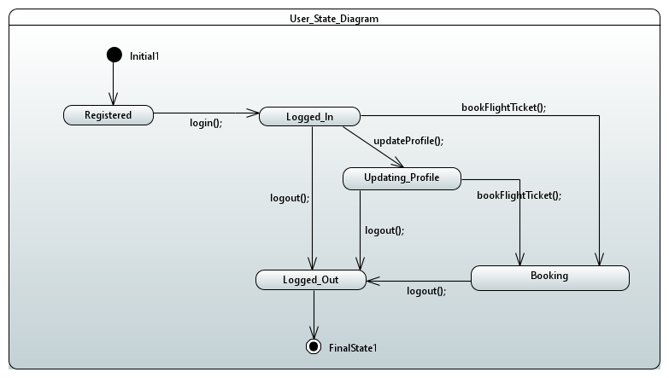

Figure : State Machine Diagram - User Class

## 2.2 Operations

* login(User usr)
  1. The user logs into the reservation system
* updateProfile(User usr)
  1. User can update his/her profile
  2. Subsequently the system is updated
* bookFlightTicket(Ticket tkt, User usr, Flight flt)
  1. The user can book the ticket
* logout(User usr)
  1. The user logs out on completion of task

# 3. Ticket

## 3.1 State Machine Diagram

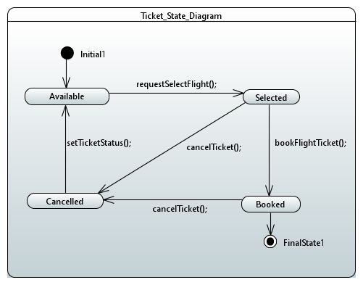

Figure : State Machine Diagram - Ticket Class

## 3.2 Operations

* requestSelectFlight(Ticket tkt, User usr, Flight flt)
  1. Desired flight can be requested by the user
* bookFlightTicket(Ticket tkt, User usr, Flight flt)
  1. The user can book the ticket
* cancelTicket(Ticket tkt, User usr)
  1. Ticket can be cancelled by the user
* setTicketStatus()
  1. Ticket status gets updated to available if ticket is cancelled

# 4. Payment

## 4.1 State Machine Diagram

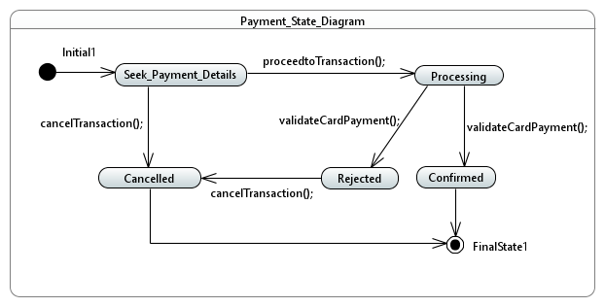

Figure : State Machine Diagram - Payment Class

## 4.2 Operations

* cancelTransaction(Payment pmt, User usr )
  1. Transaction can be cancelled by the user.
* validateCardPayment(Payment pmt, User usr)
  1. Card Payment is validated
  2. Status is updated - Confirmed or Rejected
* proceedtoTransaction(Payment pmt, User usr)
  1. User enters card details to book flight ticket and proceeds to transaction