To install docker:

sudo yum install docker
sudo systemctl start docker
sudo systemctl status docker
sudo systemctl enable docker
sudo systemctl status docker
sudo docker run hello-world

sudo docker run hello-world ( To check if docker installed and running)

echo $USER (centos)
sudo groupadd docker
sudo usermod -aG docker $USER
sudo systemctl restart docker
(Open duplicate session)
docker run hello-world
(to see list of images )
docker images

sudo docker build -t mamta12/sampleapp .
sudo docker run -p 8081:3000 -d mamta12/sampleapp
sudo docker ps
docker ps -a
docker exec -it 73f1291c2fe5 bash
sudo docker ps
docker stop <docker id> (to stop the docker container)

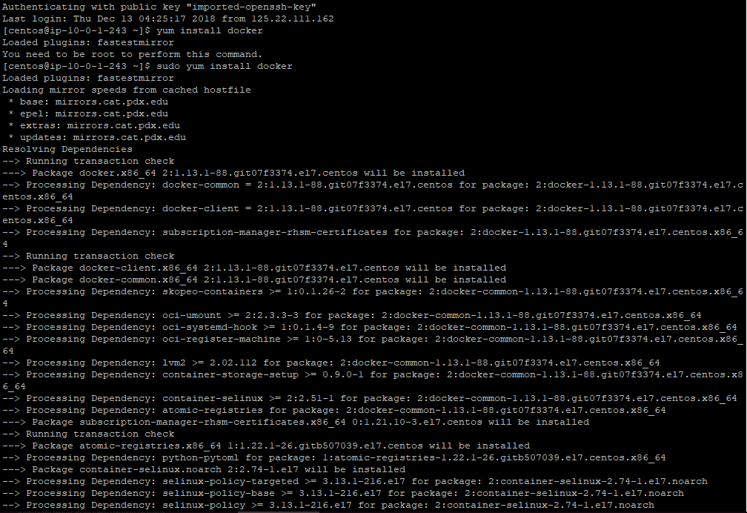

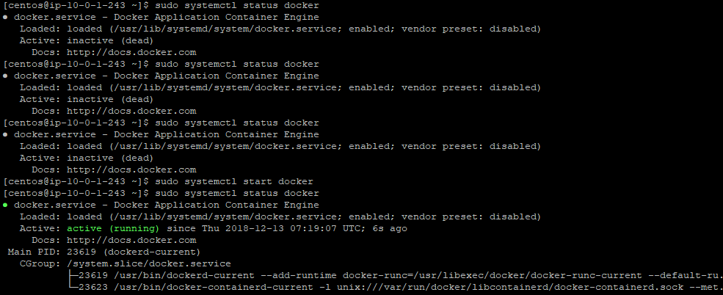

sudo docker run hello-world ( To check if docker installed and running)
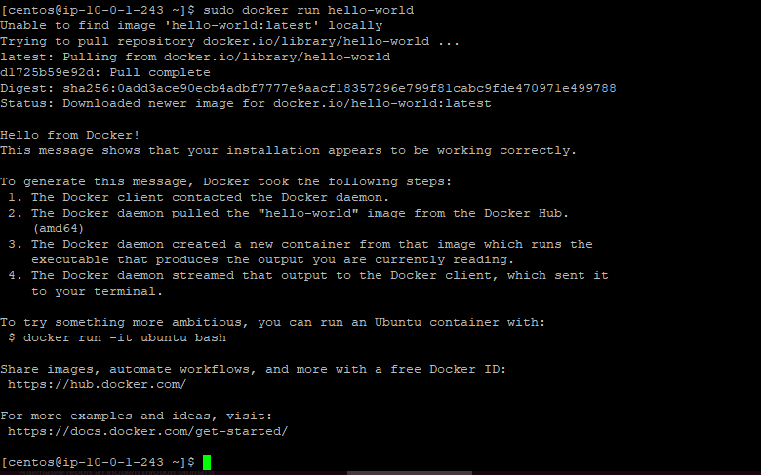

Go to git hub in project and Create a dockerfile

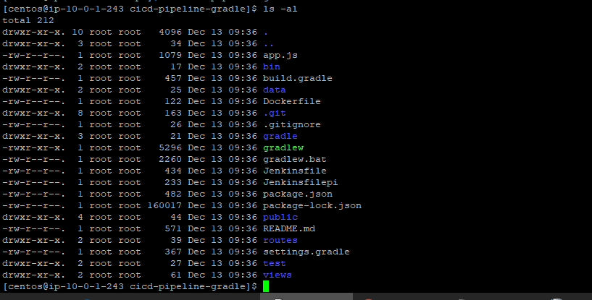
We can see the dockerfile over here
Create your docker hub: https://hub.docker.com/

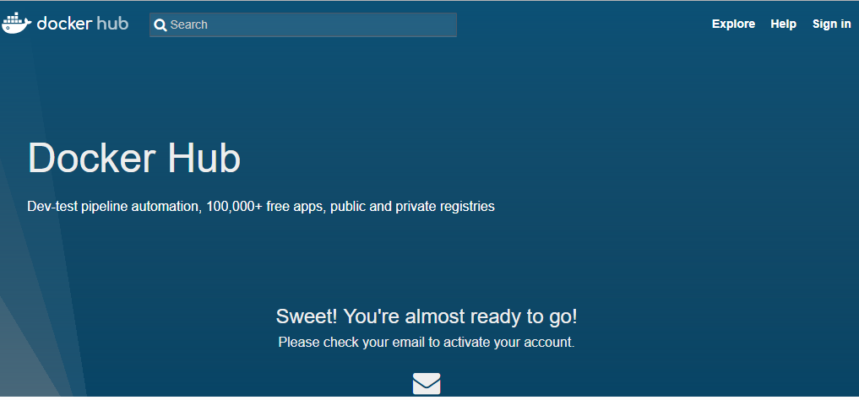

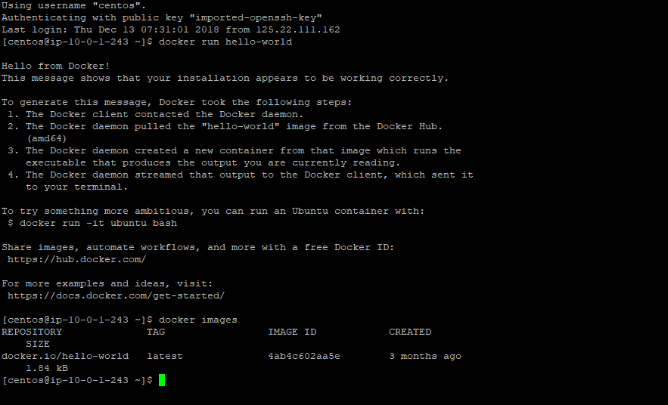
Latest means which tag is latest and it will be pulled.(for that Docker image)

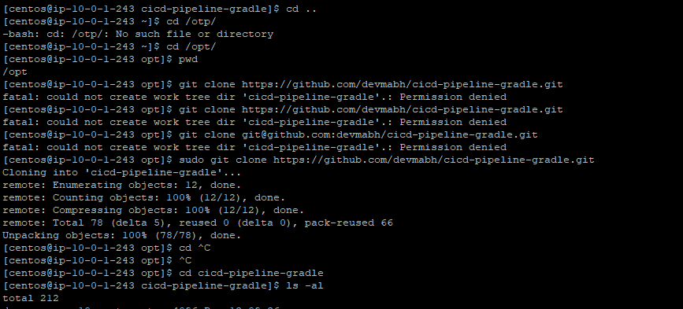

sudo docker build -t mamta12/sampleapp .

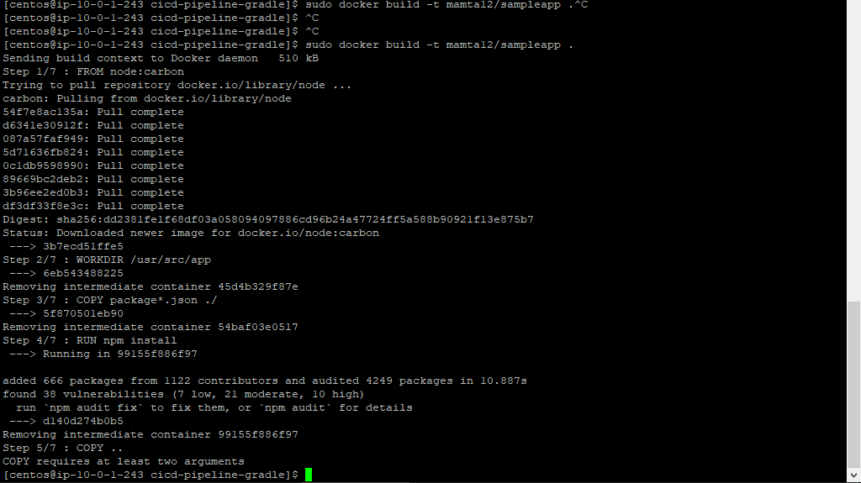
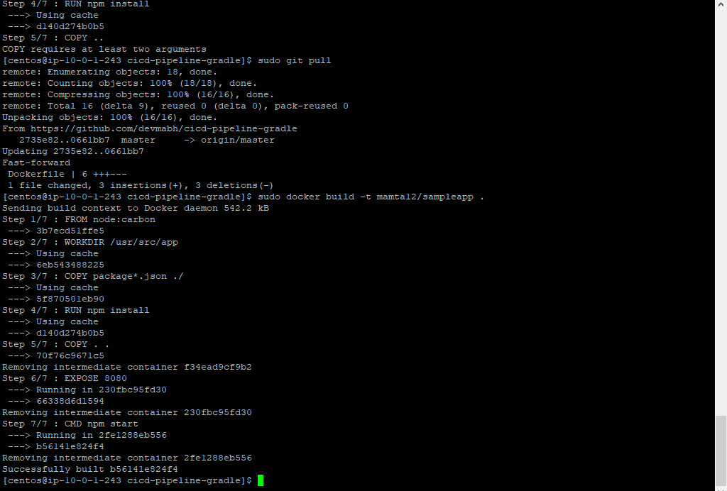

sudo docker run -p 8081:3000 -d mamta12/sampleapp

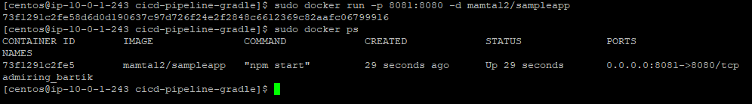
sudo docker ps
docker ps -a
docker exec -it 73f1291c2fe5 bash
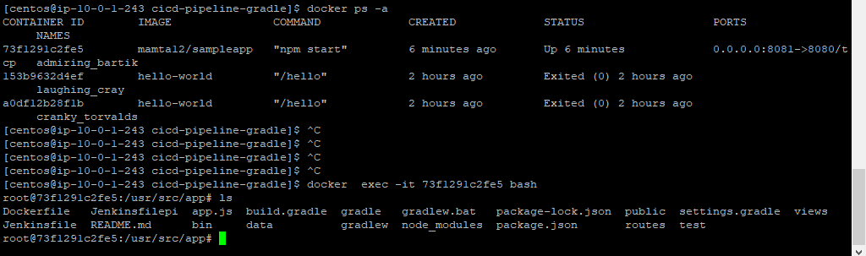
sudo docker ps
docker stop <docker id>
sudo docker run -p 8081:3000 -d mamta12/sampleapp

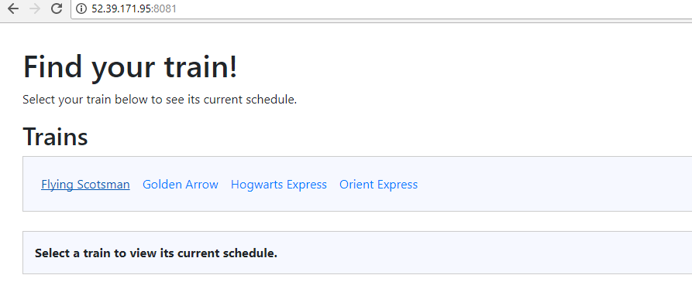
sudo dockers -f losg <container id>

