Configure System: Go to Jenkins and follow the below steps:

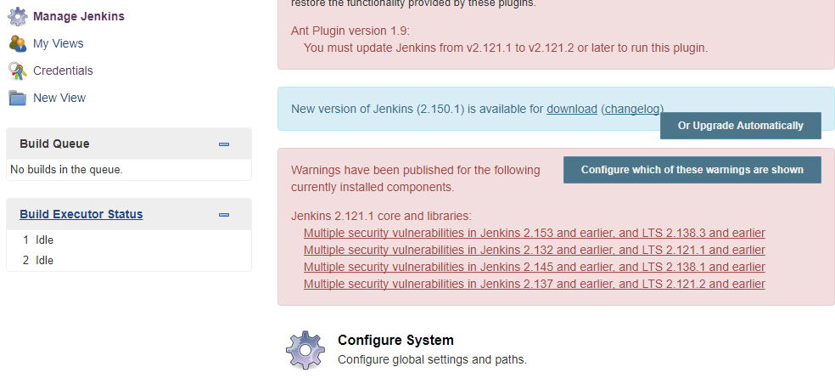

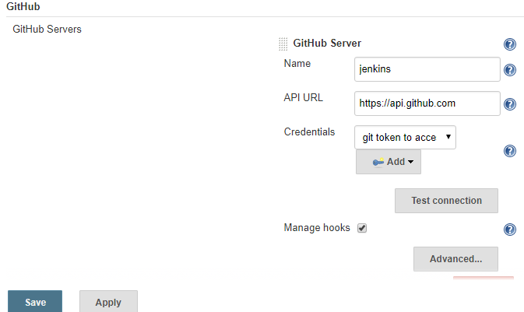

Add
Credential - > Jenkins secret
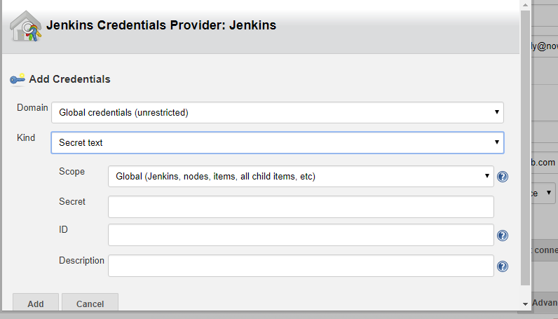
take access token from git hub add it secret in above screen shot

Go to GIT

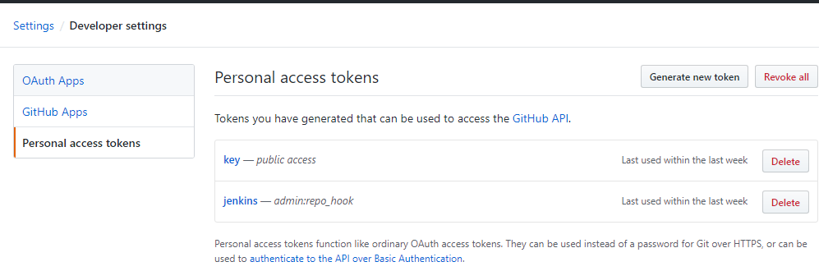

Generate new token and add it to jenkins credential provider(as in last screen)

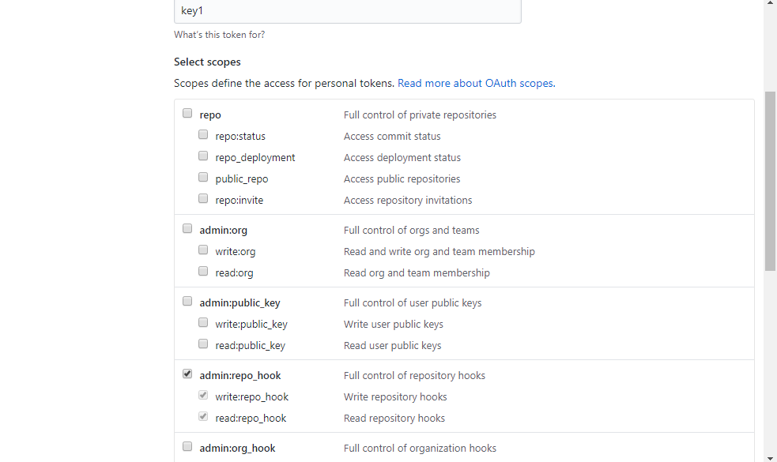
Generate the token

03ca4d9adc00d0b7344204ec7db4dbe5d63a07e1

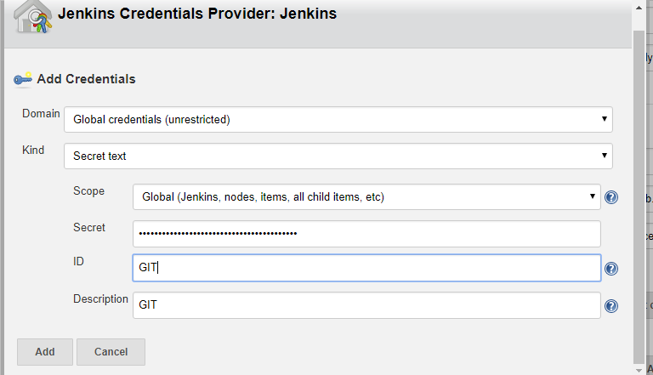

Manage Jenkins - > Global tool configuration :

sudo yum -y install unzip java-1.8.0-openjdk
sudo yum -y install maven

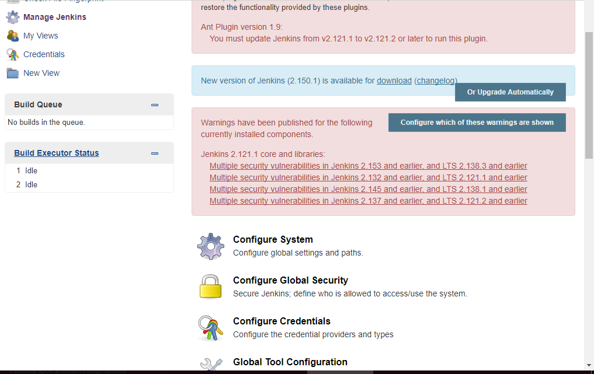

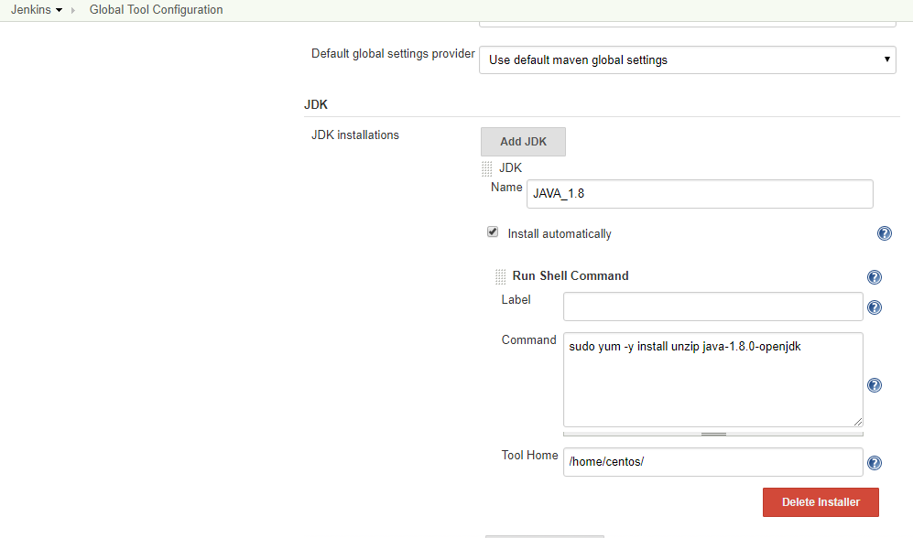

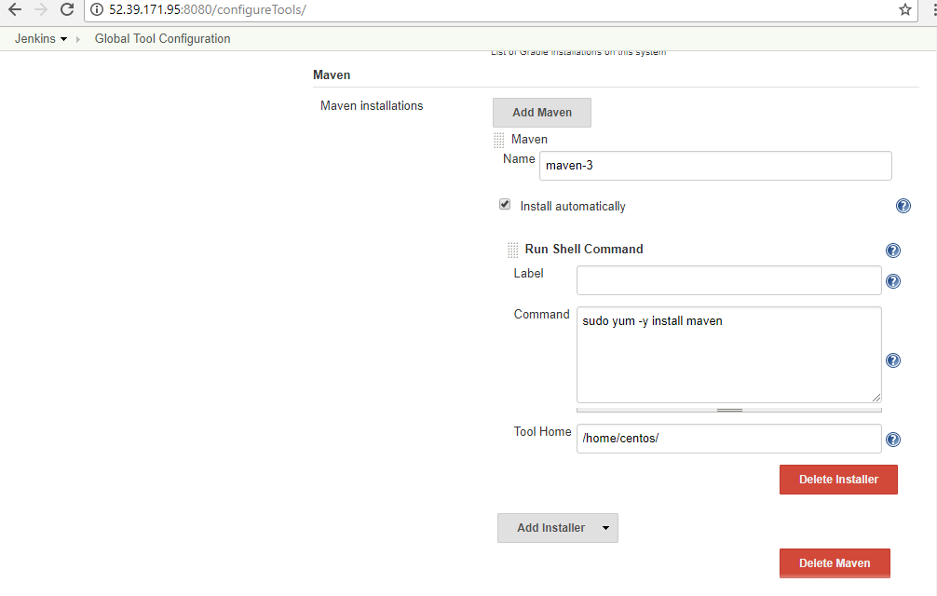

Go to GITHUB, in your project create Jenkinsfile .
and write the code in Jenkins file to install maven and java

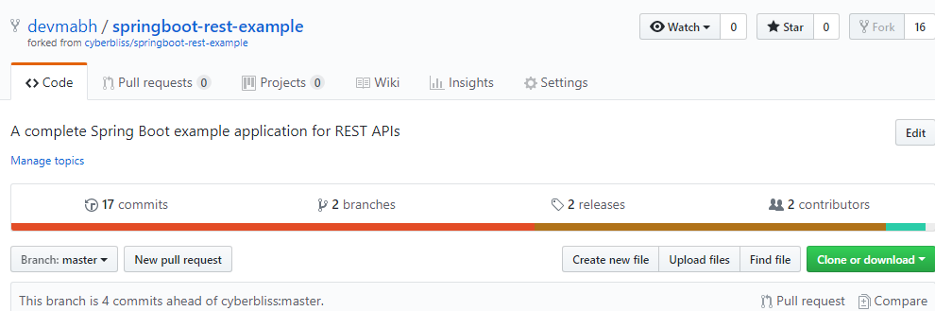

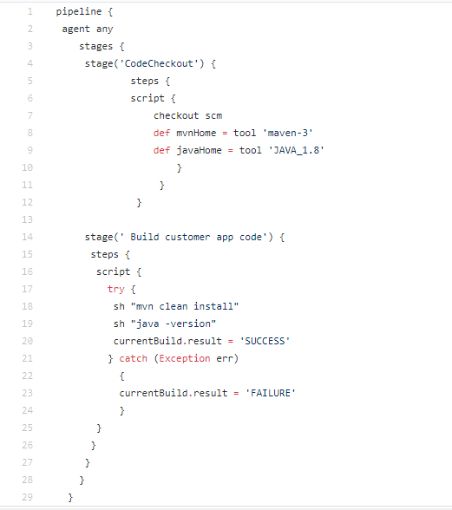

pipeline {
agent any
stages {
stage('CodeCheckout') {
steps {
script {
checkout scm
def mvnHome = tool 'maven-3'
def javaHome = tool 'JAVA_1.8'
}
}
}
stage(' Build customer app code') {
steps {
script {
try {
sh "mvn clean install"
sh "java -version"
currentBuild.result = 'SUCCESS'
} catch (Exception err)
{
currentBuild.result = 'FAILURE'
}
}
}
}
}
}

Now to build the project - >

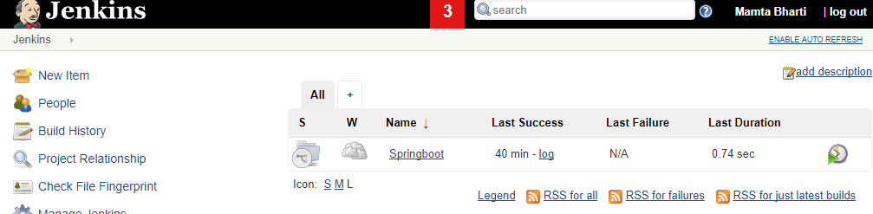
Click on Springboot ->

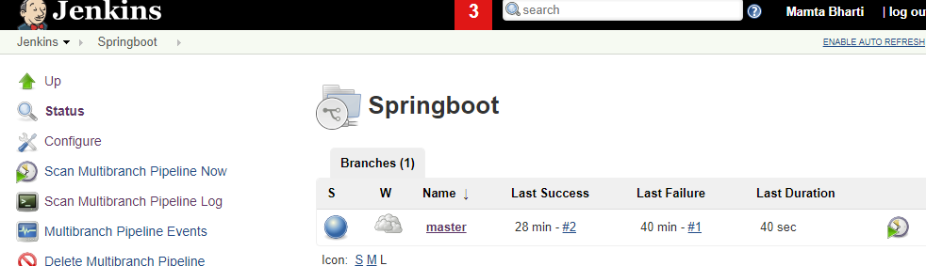

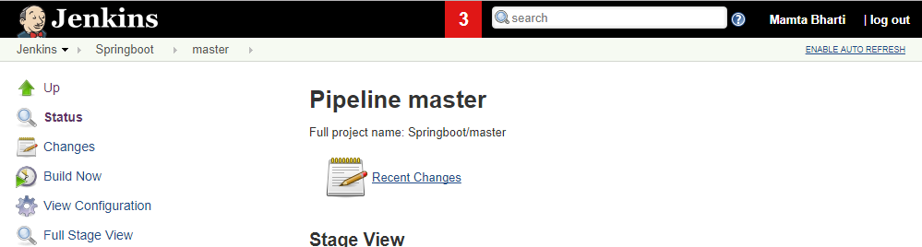
Here click on "Build Now" to build the project

You can see build is in progress

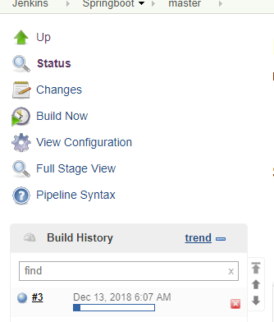

You can check the console to check the log:

