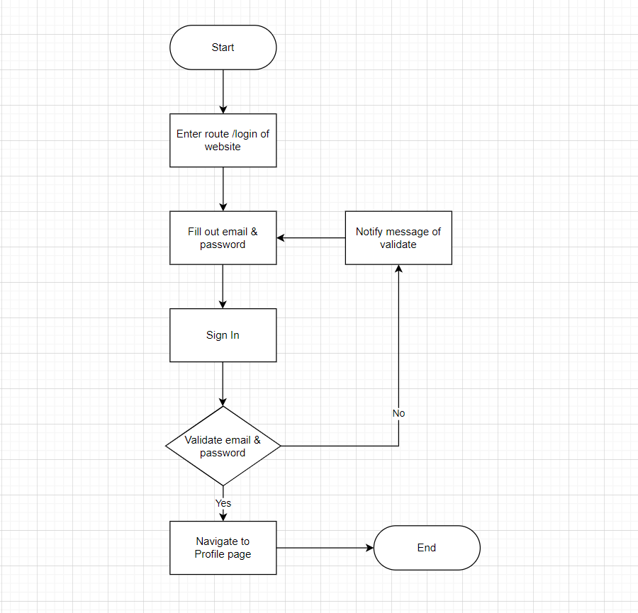

First, user will enter route “/login” of website to access the page. After that, user will fill out email & password field and press Sign In. Website will validate the data, in client will validate email format and password length, if all true website will send data to server to check email & password exist or not and send back the result to client, if result is true website will navigate to Profile page and end the flow, if false it requests user fill out email & password again.