Matlab 打开 BFOA文件

1. 在E盘创建一个名为DNA_design的文件夹；
2. 初始化里面的参数可以自己设，都有注释；
3. 程序得出来的Sim和H-measure值需要手动分别除以DNA总数-1和总数：

然后才能带入公式加以计算（论文中有写）

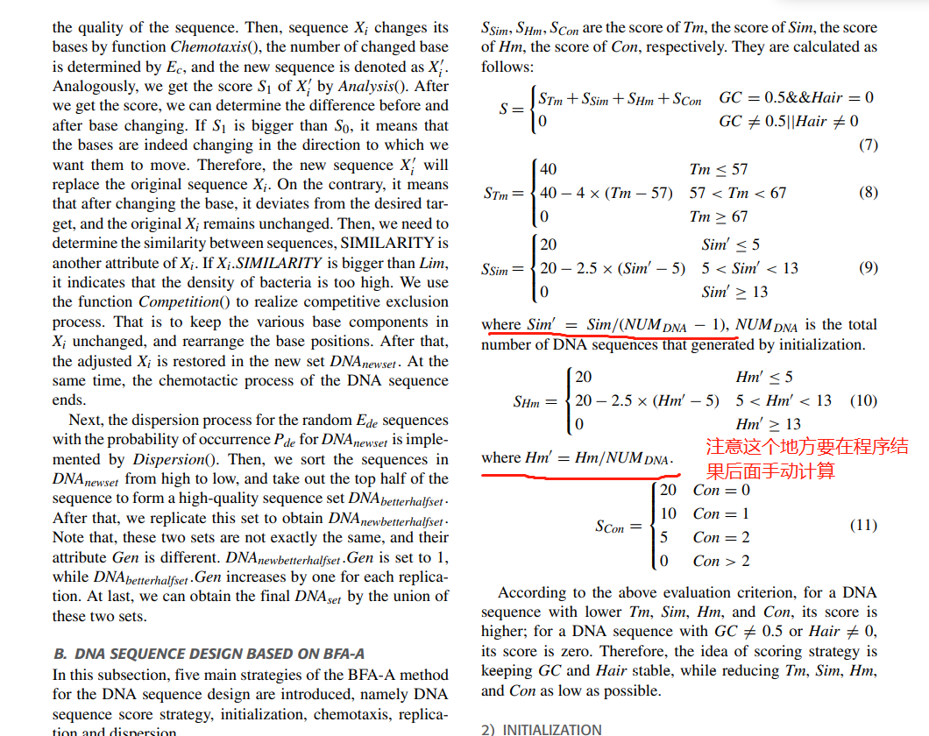

注意，这个程序是我在硕士论文中列出的那篇ACM会议论文的程序，IEEE中的程序暂时找不到了。

>tr|A0A384BLU0|A0A384BLU0_URSMA Apoptosis-associated speck-like protein containing a CARD OS=Ursus maritimus OX=29073 GN=LOC103657888 PE=4 SV=1

MGCTRDAILDALENLTADEFKKFKLKLLSVPLREGYGRIPRGTLMSMDAMDLTDKLVSFYLEKYSAELTAFVLREIGMQETAEKLQEITCKGPAPGPAGIQDHQTAAKPGPHFVDQHRAALIARVTDVDGVLDALYGNVLSEEQYGAVRAEPTNPMKMRKLLSFAPAWNKTCKDLLLQALRNTHPYLVADLEKS

UCACACAUGUUUUUGGUUUU

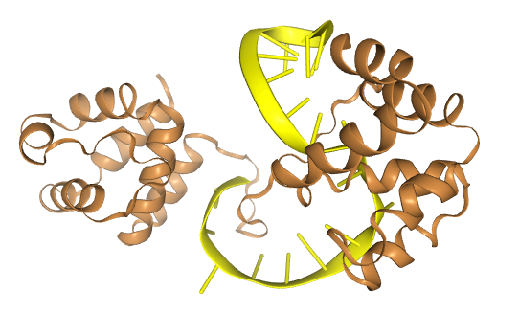

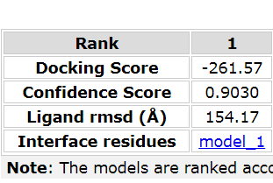

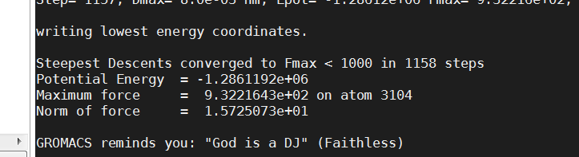

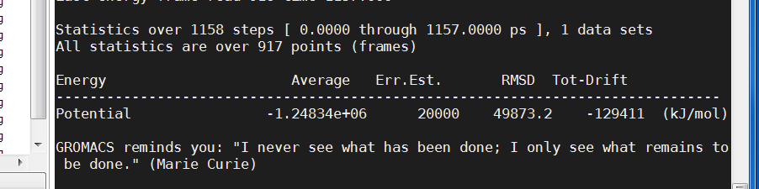

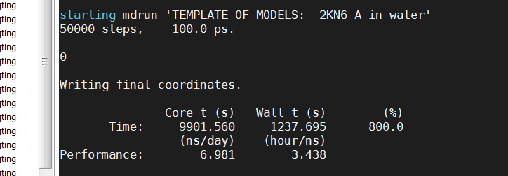

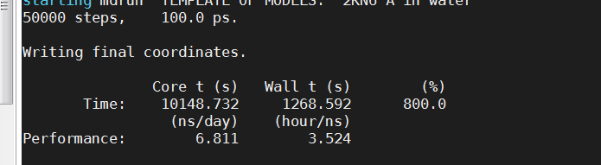

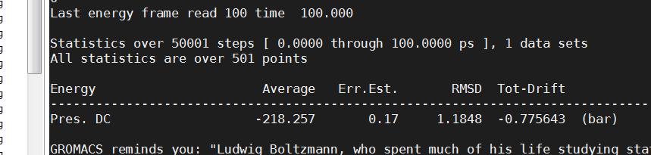

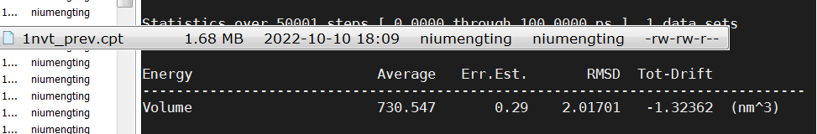

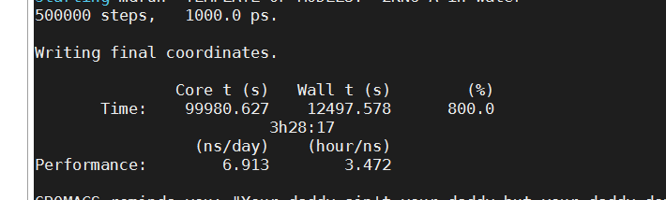

>tr|U6CUV5|U6CUV5_NEOVI Apoptosis-associated speck-like protein containing a CARD OS=Neovison vison OX=452646 GN=ASC PE=2 SV=1

MGRTRDAILDALENLTADEFKKFKLKLLSVPLREGYGRIPRGTLMSMDAIDLTDKLVSSYLEEYSAELTGIVLREMGMQETAEHLQLRCTGPAPGPAGIQAHQTGTSPAPHFVDRHRAALIARVTDVDGVLDALYGKALSAGQYEAVRAEPTNTMKMRKLLSFAPAWDTACKDLLLQALRNTHPYLVADLEKSAC

AUUGGCACCAAGAAAACU

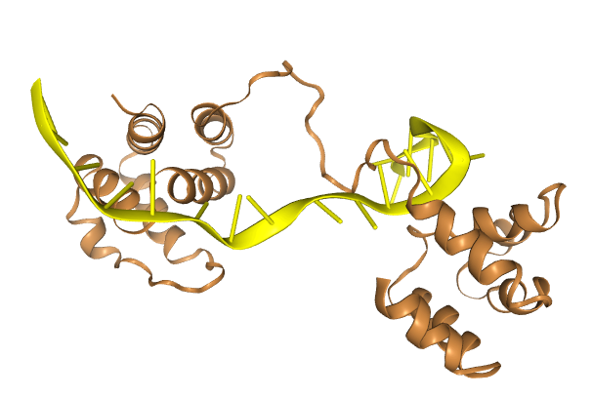

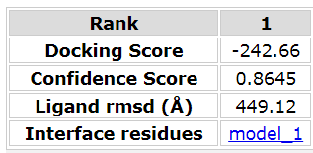

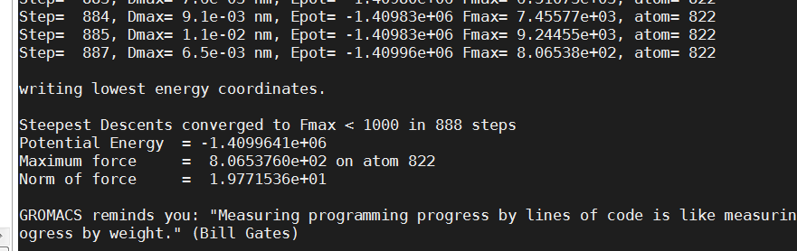

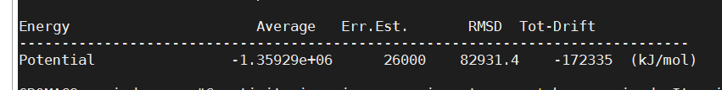 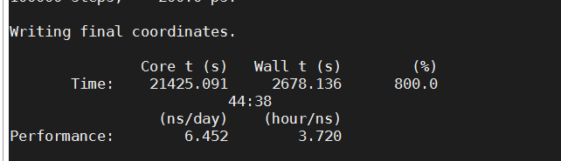 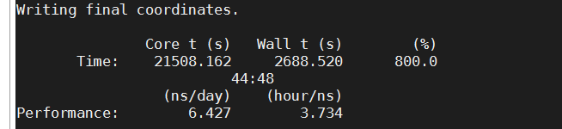

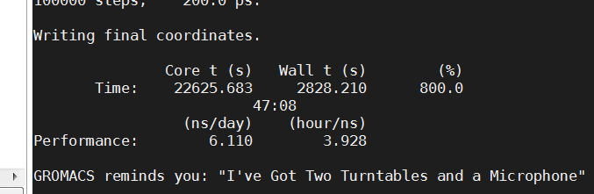

>tr|D2HQM1|D2HQM1_AILME Apoptosis-associated speck-like protein containing a CARD (Fragment) OS=Ailuropoda melanoleuca OX=9646 GN=PYCARD PE=4 SV=1

MGCTRDAILDALENLTADEFKKFKLKLLSVPLREGYGRIPRGTLMSMDAMDLTDKLVSFYLEKYSAELTAVVLREIGMQETAEKLQEITCKGPAPGPAGIQDHQTAAKPGLHFVDQHRAALVARVTDVDGVLDALYGNVLSEEQYGAVRAEPTNPMKMRKLLGFAPAWNTTCKDLLLQALRNTHPYLVADLEKS

UAACGGAACGAGUAUCCAUU

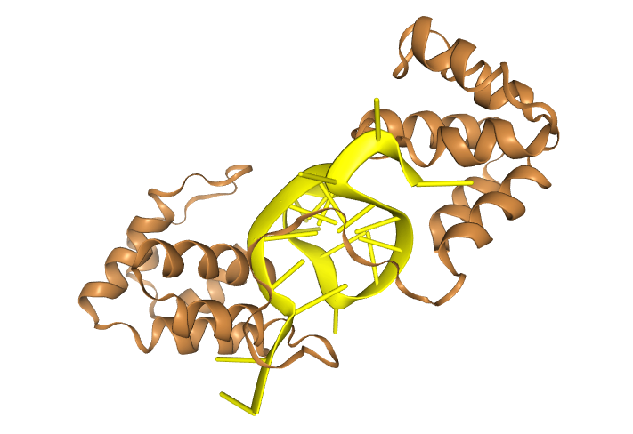

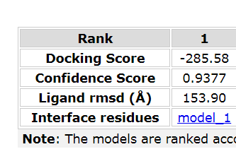 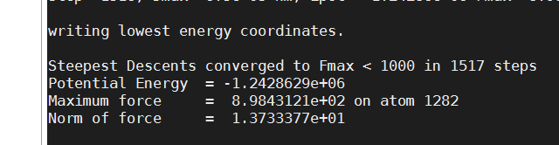 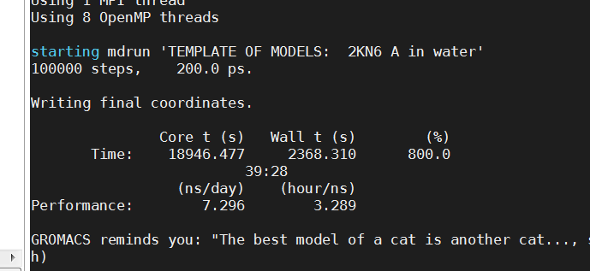 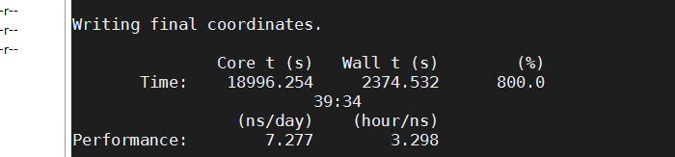 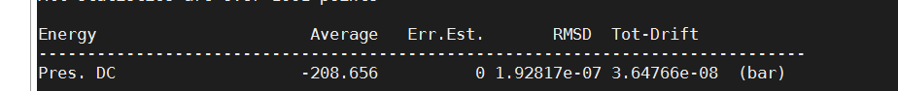 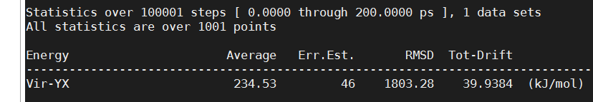 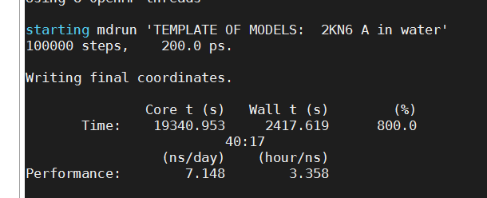

>tr|F1MQF6|F1MQF6_BOVIN Apoptosis-associated speck-like protein-containing a CARD OS=Bos taurus OX=9913 GN=PYCARD PE=4 SV=1

MGCTRDAILDALENLTADEFKKFKMKLLSVPLREGYGRIPRGTLLPLDAVDLTDKLVSYYLEAYGAELTALVLRDMGMQEVAEQLQETMSKGPRNVLAEVRDPLQKTAKPGLHFVDQHRAALIARVTVVDGVLDALYGKVLTEEQYQAVRAERTSSDKMRKLFSFSPAWNMTCKDLLLQALRDTQPYLVDDLEQS

AAGGCUCAUGAUAGAUGGUG

