Nguyễn Minh Trường_1250080218
Lớp: CNTT4
Câu 1:
SELECT *
FROM NHANVIEN
WHERE TenNV = 'Huynh';
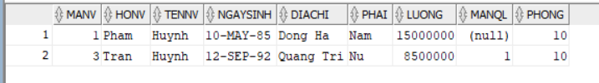
Câu 2:
SELECT nv.MaNV,
nv.HoNV || ' ' || nv.TenNV AS HoTen,
nv.DiaChi
FROM NHANVIEN nv
JOIN PHONGBAN pb ON nv.Phong = pb.MaPhong
WHERE pb.TenPhong = 'Hanh Chinh';
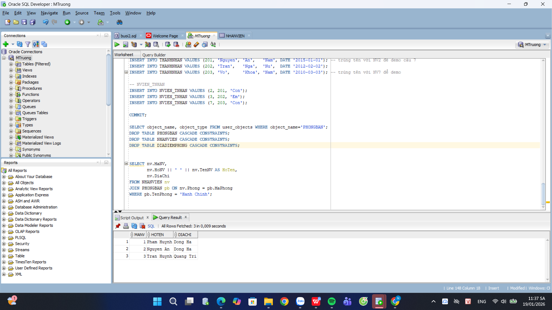
Câu 3:
SELECT nv.MaNV,
nv.HoNV || ' ' || nv.TenNV AS HoTen,
nv.DiaChi
FROM NHANVIEN nv
JOIN PHONGBAN pb ON nv.Phong = pb.MaPhong
WHERE pb.TenPhong IN ('Hanh Chinh', 'Tai Vu');
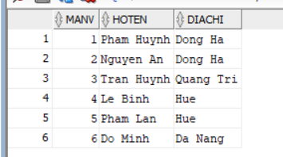
Câu 5:
SELECT da.MaDA,
da.TenDA,
pb.TenPhong,
pb.TruongPhong AS MaTruongPhong,
tp.HoNV || ' ' || tp.TenNV AS TenTruongPhong
FROM DEAN da
JOIN PHONGBAN pb ON da.Phong = pb.MaPhong
LEFT JOIN NHANVIEN tp ON tp.MaNV = pb.TruongPhong;
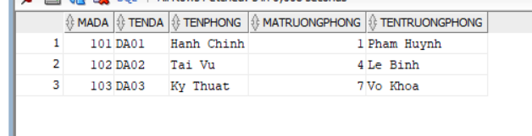
Câu 7:
SELECT DISTINCT nv.MaNV,
nv.HoNV || ' ' || nv.TenNV AS HoTen
FROM NHANVIEN nv
JOIN NVIEN_TNHAN nt ON nt.MaNV = nv.MaNV
JOIN THANHNHAN tn ON tn.MaTN = nt.MaTN
WHERE nv.TenNV = tn.TenTN;
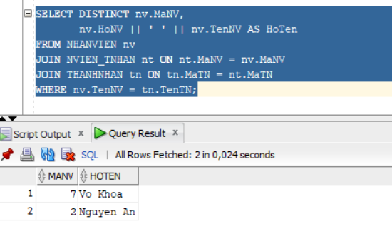
Câu 8:
SELECT nv.MaNV,
nv.HoNV || ' ' || nv.TenNV AS HoTen
FROM NHANVIEN nv
JOIN PHONGBAN pb ON nv.Phong = pb.MaPhong
JOIN NHANVIEN tp ON tp.MaNV = pb.TruongPhong
WHERE tp.HoNV = 'Pham'
AND tp.TenNV = 'Huynh';
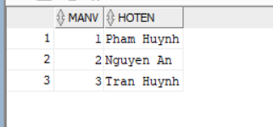
Câu 9:
SELECT nv.MaNV,
nv.HoNV || ' ' || nv.TenNV AS HoTen
FROM NHANVIEN nv
JOIN NHANVIEN ql ON ql.MaNV = nv.MaNQL
WHERE ql.HoNV = 'Pham'
AND ql.TenNV = 'Huynh';
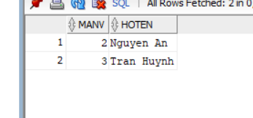
Câu 12:
SELECT AVG(Luong) AS LuongTrungBinh
FROM NHANVIEN;

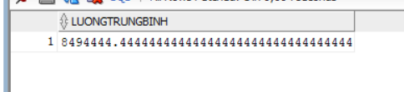

Câu 13:
SELECT AVG(Luong) AS LuongTrungBinh_Nam
FROM NHANVIEN
WHERE Phai = 'Nam';
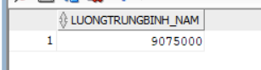
Câu 14:
SELECT COUNT(*) AS TongSoDeAn
FROM DEAN;
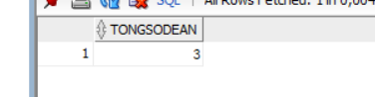
Câu 18:
DELETE FROM NHANVIEN
WHERE Luong < 500000;


