John Abbott College Robotics soldering tutorial

Required Tools

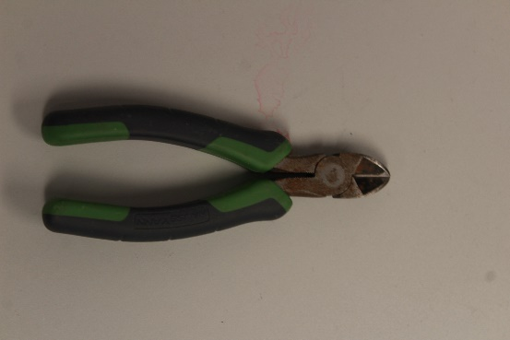

Wire Cutters

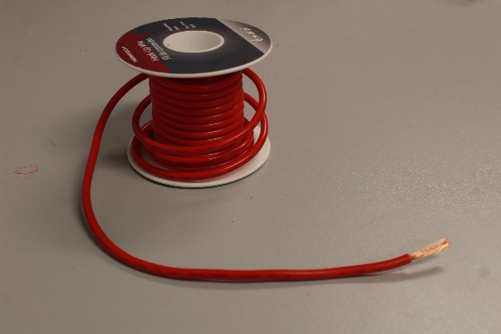

Role of stranded wire

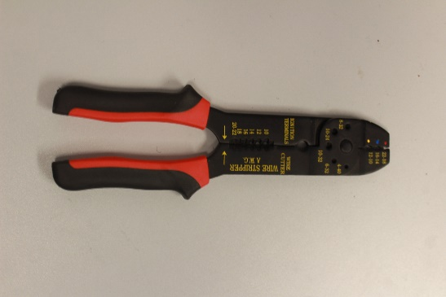

Wire Strippers

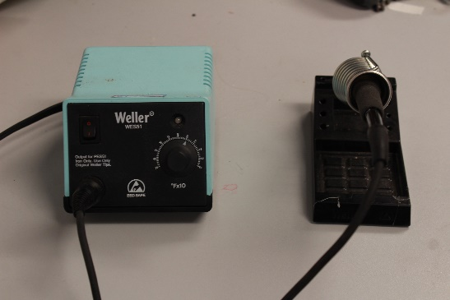

Soldering Iron & stand

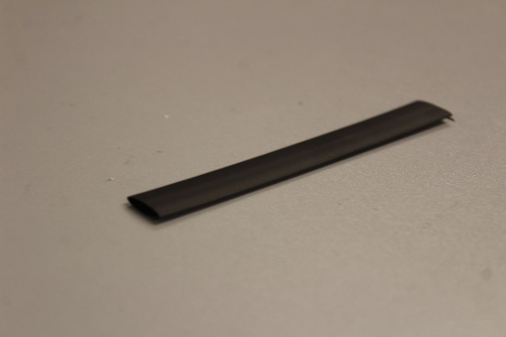

Heat Shrink

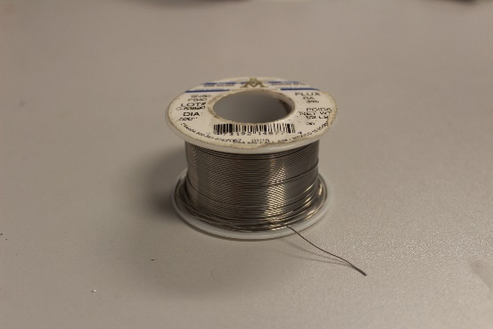

Solder

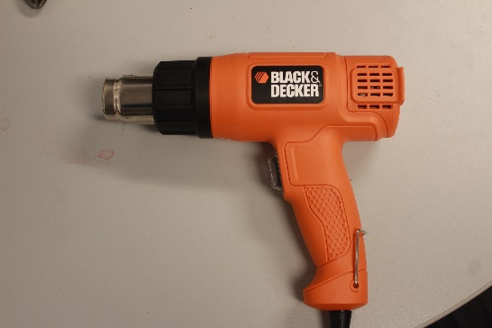

Heat gun

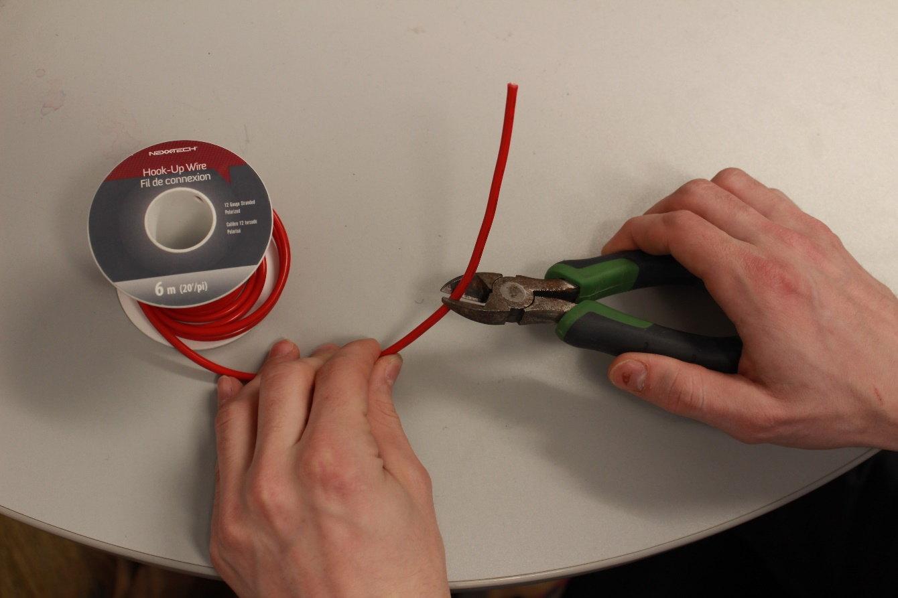

1. Cut a piece of wire to the desired length

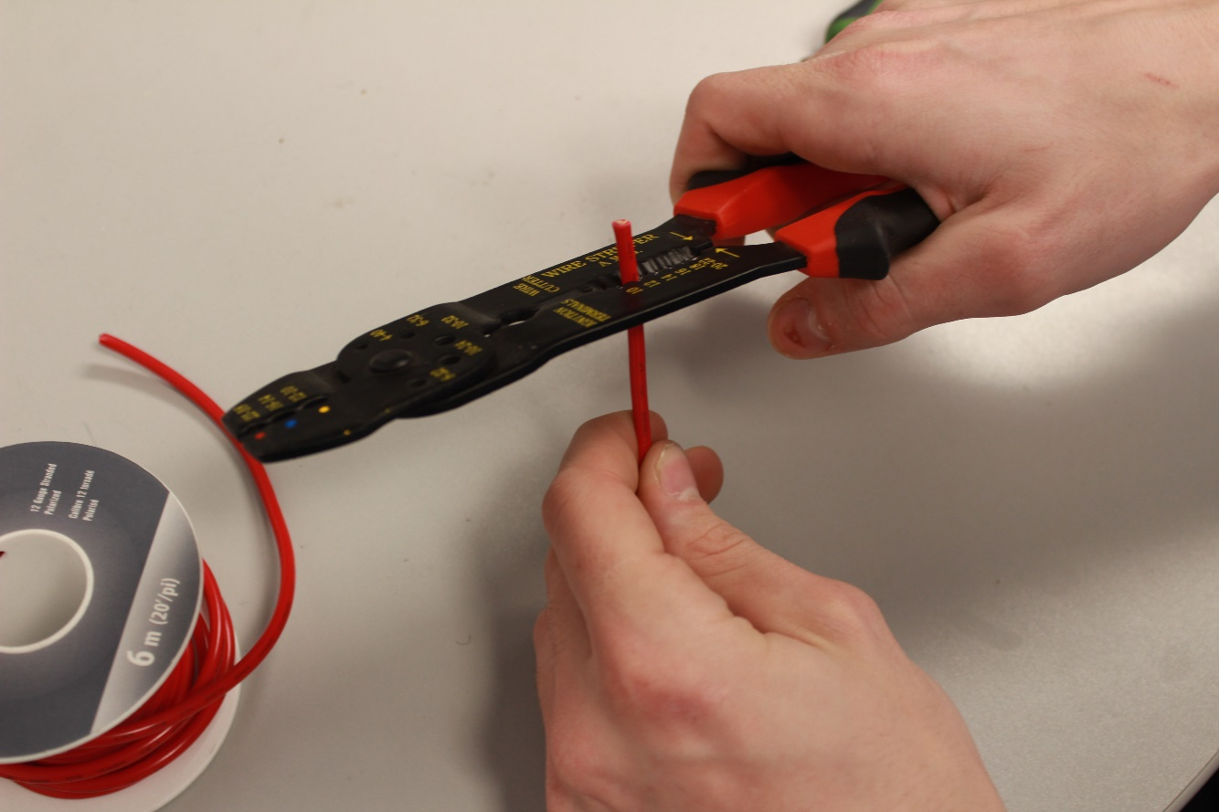

1. Strip the wire about 2cm

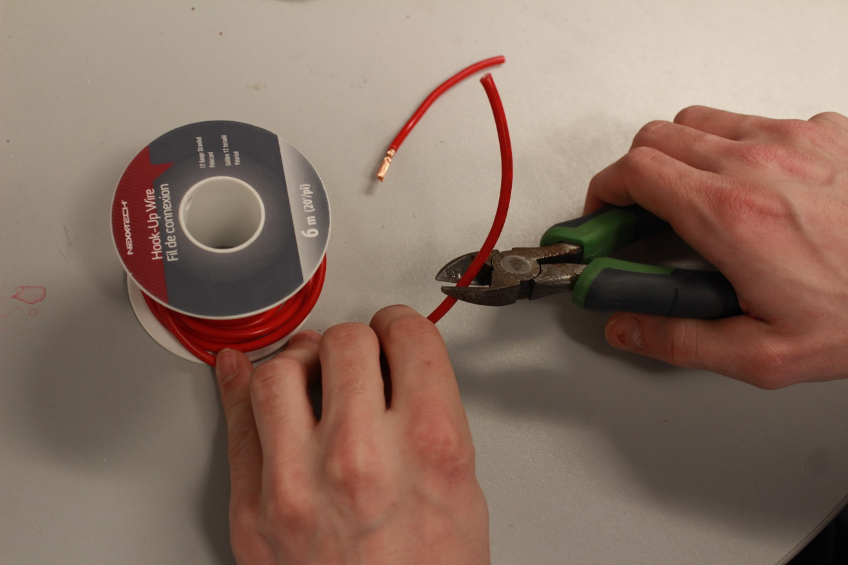

1. Cut a second piece of wire to about the same length as the first

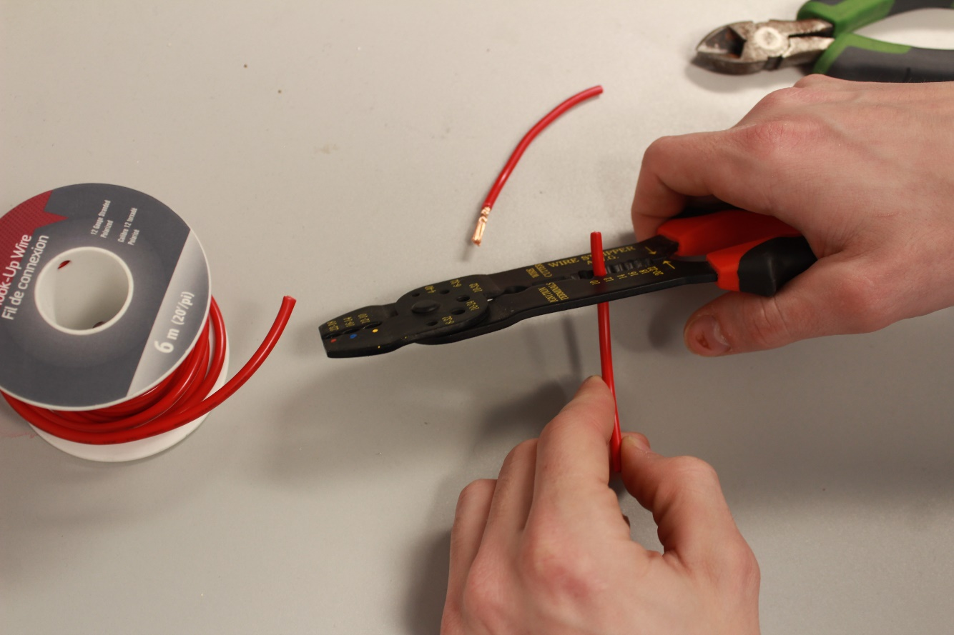

1. Strip the second wire about 2cm

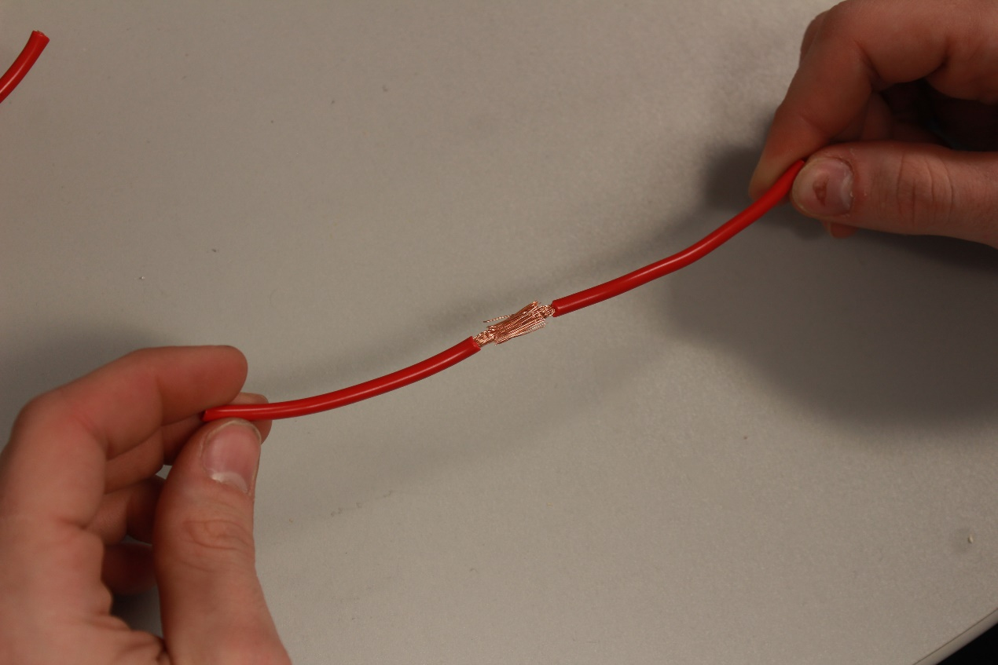

1. Push the two stripped ends of the wires together and turn on the soldering iron

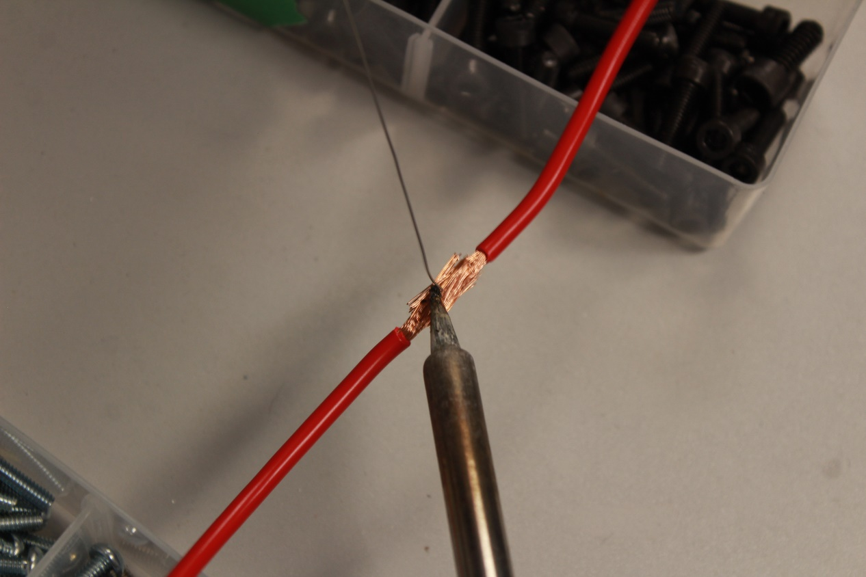

1. Have some objects hold the wires suspended and place the soldering iron on the wire segment to be soldered, with the solder in the other hand touch the hot tip and watch as the solder flows onto the wire segment applying it evenly.

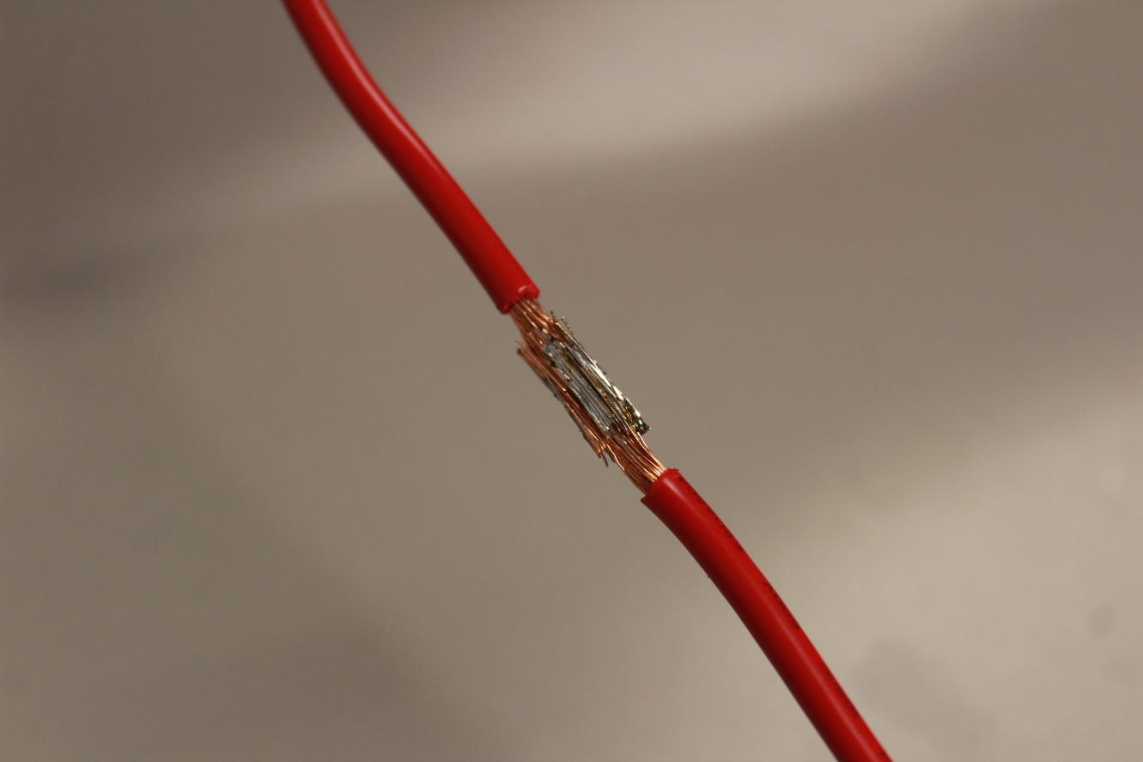

1. This is what the solder joint should resemble

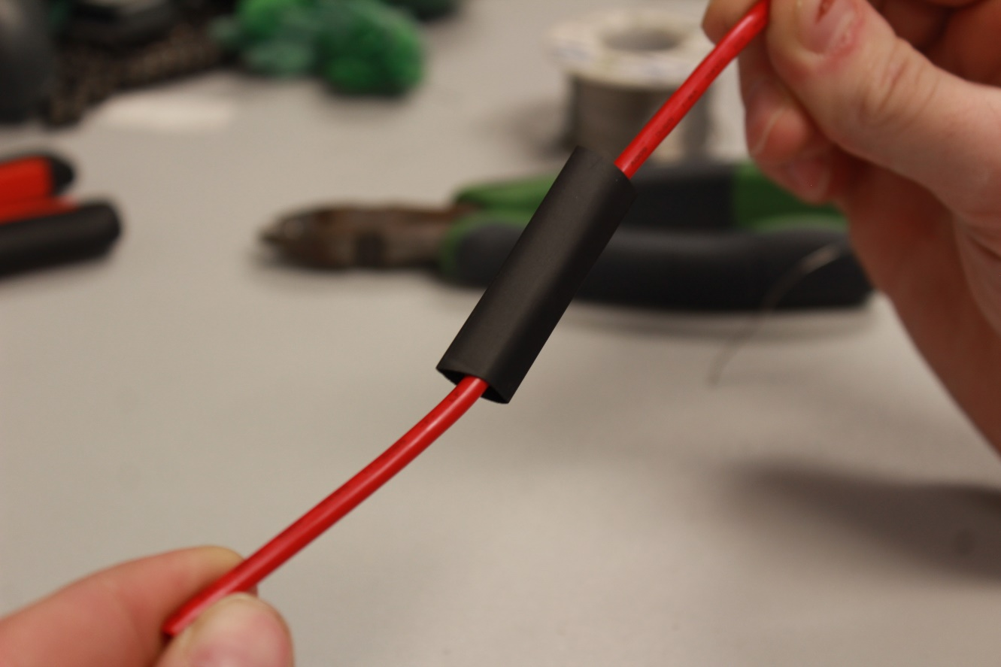

1. Slip over the heat shrink onto the solder joint

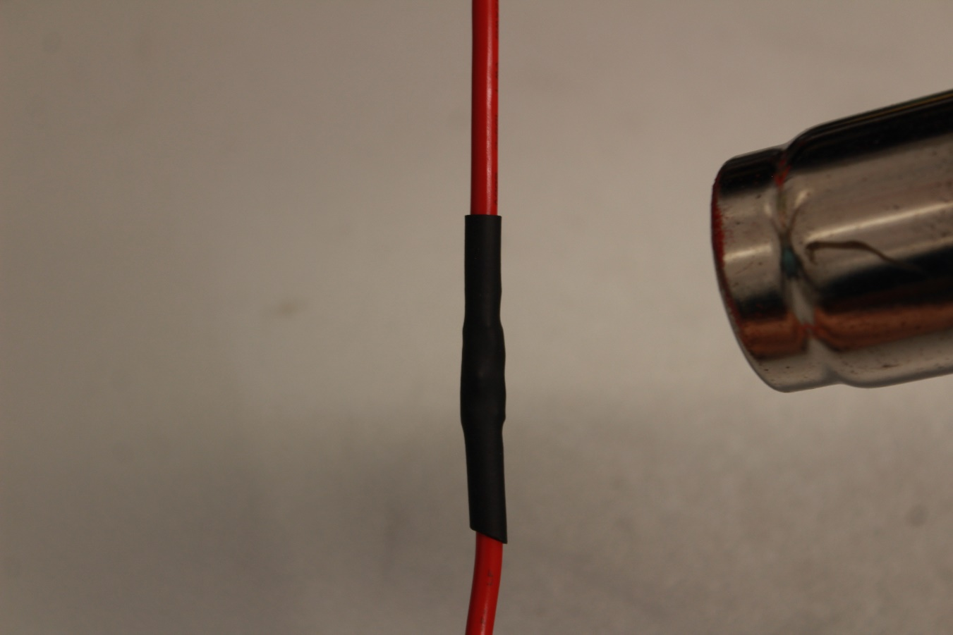

1. Using the heat gun, heat the heat shrink until it’s completely wrapped around

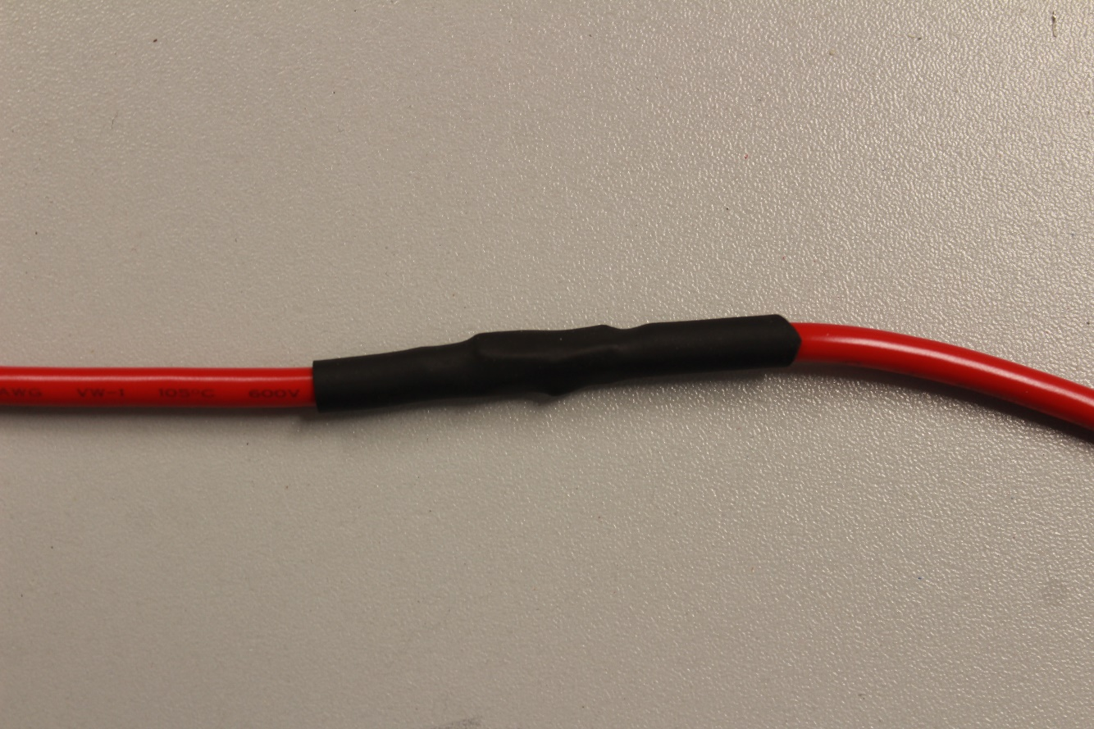

1. Once the heat shrink has cooled down the wire should be ready to be put into a circuit