**OpenText Assignments: Test Results**

The test cases spreadsheet contains 6 test cases (4 web-related and 2 installer-related). Out of the 6, I have automated the below 3 test cases (2 web-related and 1 installer related) as a part of the task provided. The respective results/challenges are attached with the same.

1. **WEB-TC001:** **Accept Cookies on website Launch** -- Pass

2. **WEB-TC002:** **Signup for the “Claim Free Trail” of Carbonite Installer** – Partially Failed  
As a part of the automation, I have filled the form like email, confirm email, password, confirm password and click on “Claim Free Trial” button. The test failed as I was unable to automate captcha as a part of the sign-up process. However, I have handled the exception that come as a part of error when the captcha is not checked.

The complete test is handled in a POM + Pytest Framework

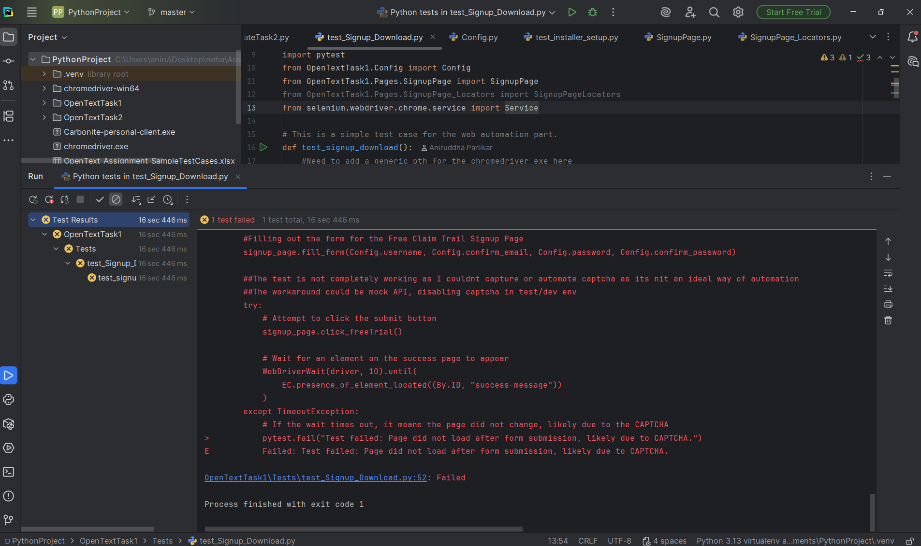

3. **DESKTOP-TC001:** **Check the Installation Process of the carbonite Installer** -- Pass

The above test is automated using Pywinauto Library of Python where the script is able to start and connect to the installer. Click on the “Terms and Condition” checkbox and click on Next button.