

Online Ordering System
User Guide

For software support please contact our customer service team on
020 8751 1111

Contents

- Accessing the on-line ordering system
- Checking and ordering stock
- Track and Trace

Accessing the online ordering system

- Type http://www.sprintexpress.co.uk/accenture into your web browser

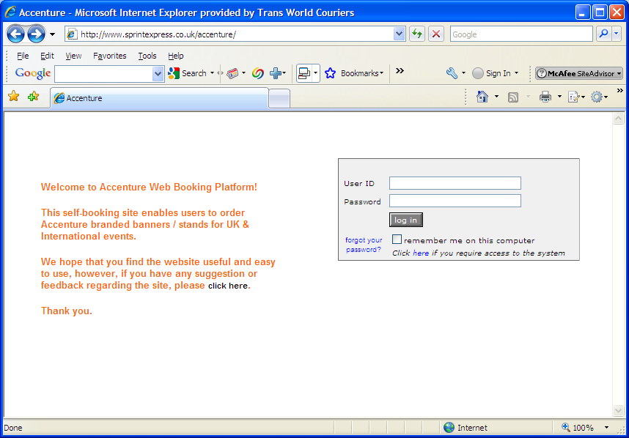

- Enter your User ID and Password into the appropriate field and click on ‘Log in’.

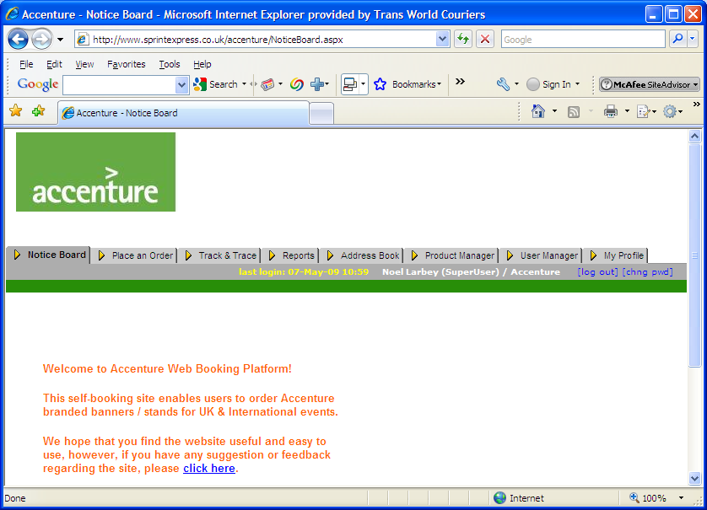

Checking and ordering stock

1. Select the “Place an order” tab at the top of the page
2. Either select a category, search for a product or download a list.

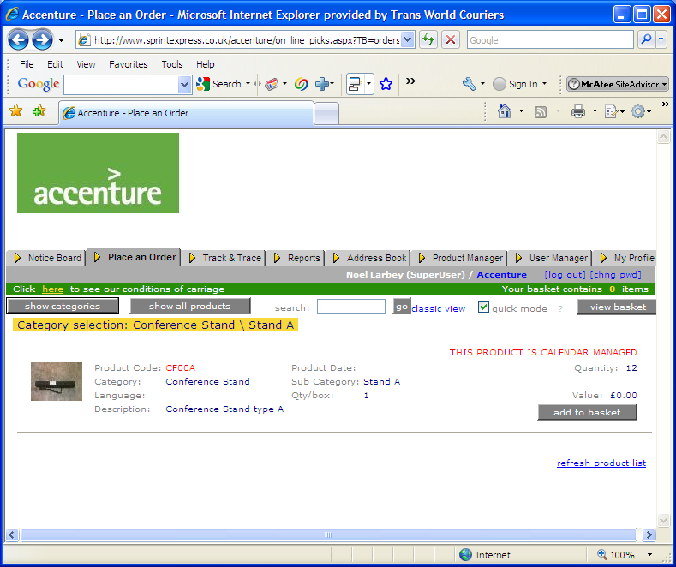

- Select from the options to view all items within this search criteria. To sort these, click on the relevant blue underlined heading.

- To view JPEG information on a specific item, select the product icon to the left of each product line. To close this window click on ‘Back to product list’

- To place an order for the product, select the button ‘Add to basket’. You can select as many as you wish within the list provided.

- As you place orders for additional products the product number in “Your Basket” will change to reflect this figure.

- Once you have selected the products required for the order simply hit the button” View basket” as shown above.

- This takes you to the next screen which is your current and live shopping basket. The products you have selected will be displayed along with any associated products at the bottom of the page. To add an associated product to your order, simply add to your basket. Once your list of products is complete select the quantity required for each product. To speed the process the system will default to “1”, once complete, select the checkout button.

- The system will now present you with a list of distribution options.
  - You can key in a post code of the destination you require and search the latest UK national postcode database.
  - You can simply select an address from your address book.

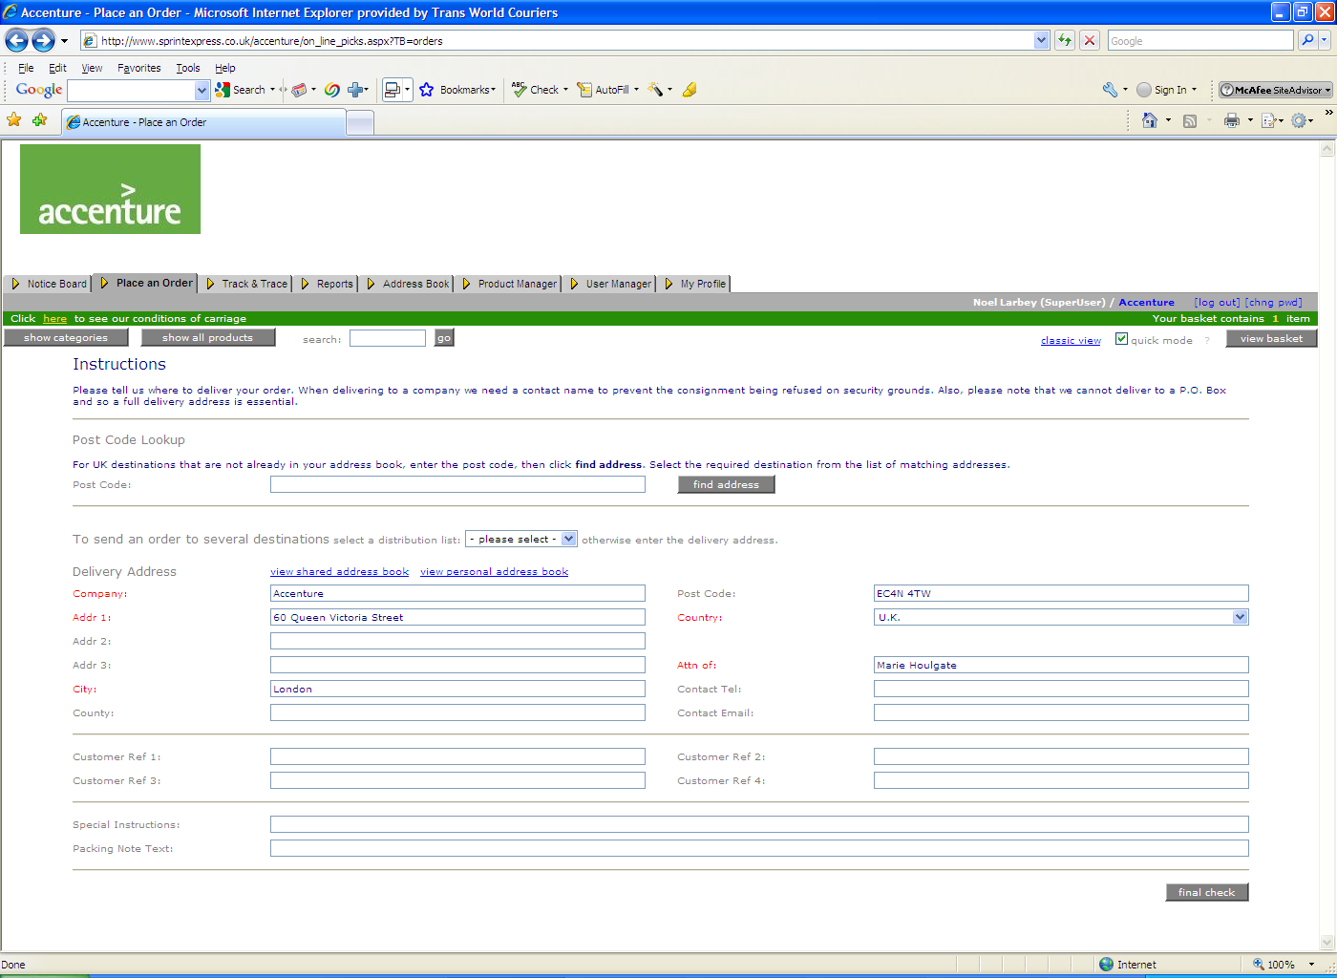

- Additional fields can also be populated at the bottom of the screen to capture additional marketing information for future MI reporting. If you need to communicate any additional special information to Sprint about the order please complete the free text box at the bottom of the page. An additional note can also be sent as a “compliment slip” and will be printed and sent with your consignment.

- The final page prior to placing the order simply presents your order for checking. It displays the products and addresses you have selected and asks for a final confirmation.

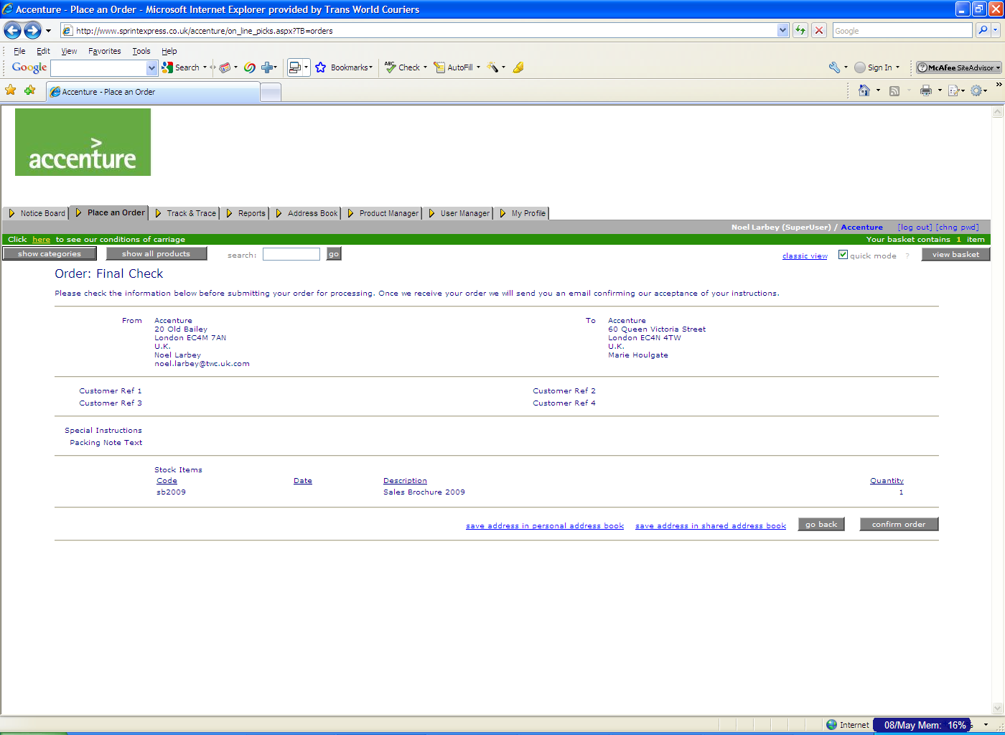

Once you have placed the order, the screen will present you with a list of tracking numbers for your consignments.

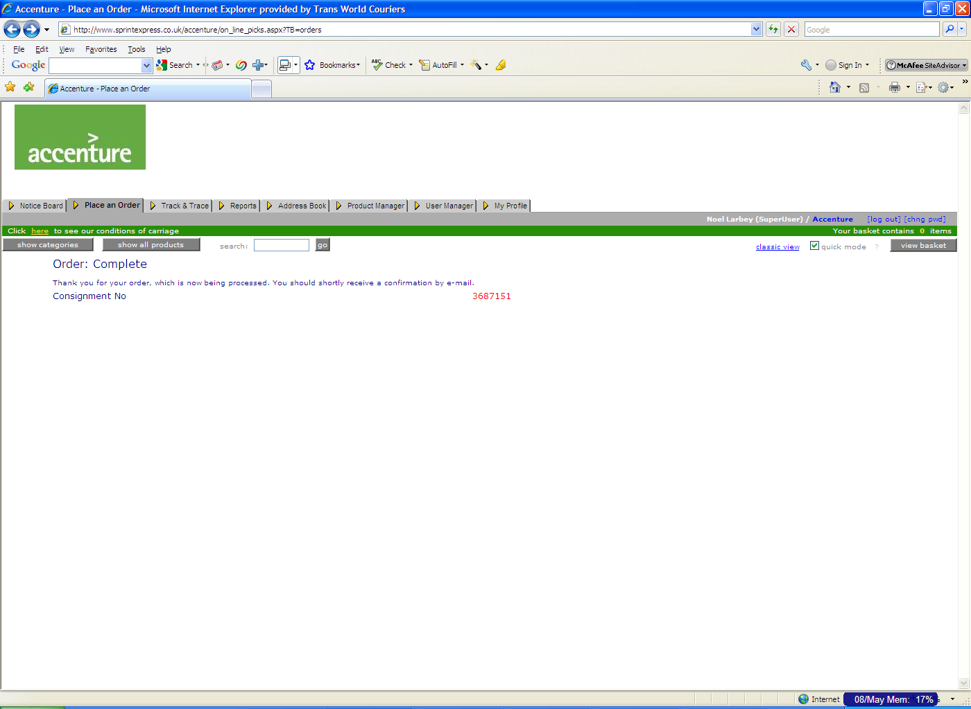

Your order has now been completed and will be despatched within the next 24 hours unless otherwise instructed. You will also receive a notification of your order via email. A hyperlink to the tracking for your consignment will also be available direct from the email allowing tracking without logging into the system.

Additional information on your bookings can be tracked under the tab marked “Track and Trace”.

Calendar Managed Products

As with the above order process, some products, such as conference stands can be ordered utilising a calendar manager. This allows users to identify easily the availability of a stand, which events have already been booked and the contact details of who has already reserved a stand and dates booked.

This is shown on the below screen shot.

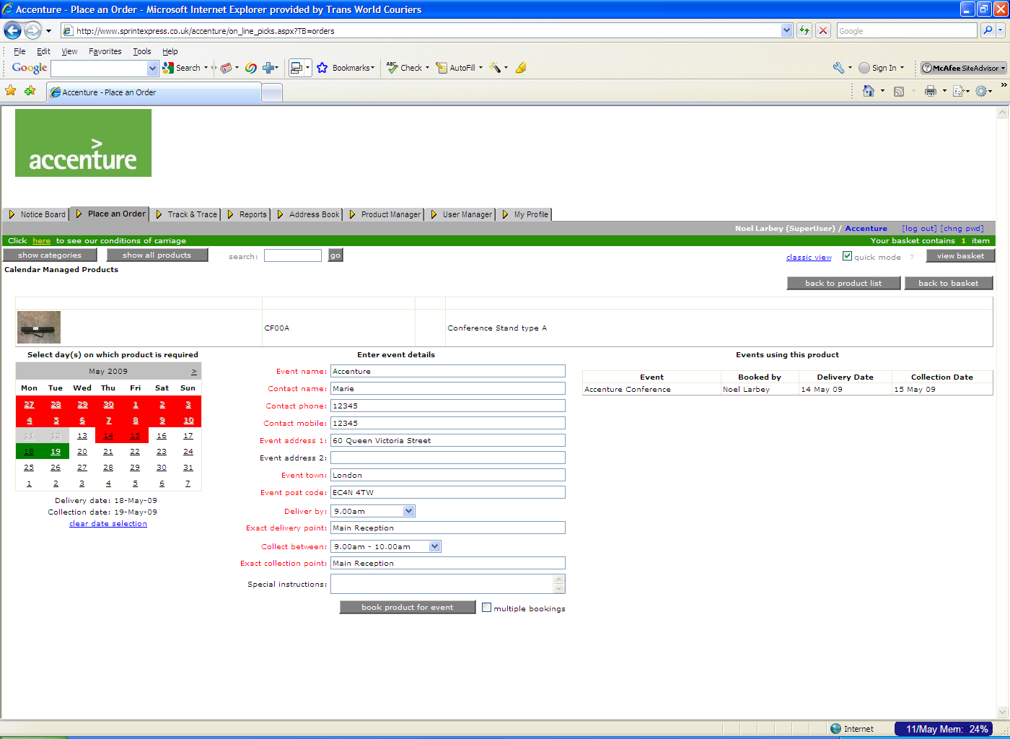

Track and Trace

- Select the ‘Track & Trace’ tab at the top of the page for a list of all items ordered under this user ID. View ‘status’ for order progress

