

**DEPARTMENT OF COMPUTER SCIENCE**

“OBJECT-ORIENTED PROGRAMMING (OOP)”

**DEVELOPERS:**

* VELASCO KAREN
* VIVAS NATHALY
* ZAMBRANO CHARLES

**Registration System and IT solutions for technical problems according to the level of support required for SMEs.**

MSc Edison Lascano

**Devs Java KND**

**Workshop:** RegistrationSystem and IT solutions for technical problems according to the level of support required for SMEs.

# Problem

A system is needed to improve the organization and efficiency of SMEs dedicated to the provision of IT services. So, they can have an orderly record of all the problems reported by their clients and in this way create a structure that allows them to meet their needs in a strategic way and provide them with a positive experience.

To understand what the program should do, it is first necessary to know that it depends on the size of a company, a technical support team can be made up of a single person or even more people. To serve customers or users.

However, we will keep things simple and only deal in registering customers or users issues through IT support levels.

# Overview

Society in this era of pandemic is increasingly involved in the technological field since the last decade; but they start from it with great ignorance. That is why when a problem occurs they turn to a person with the necessary knowledge and experience to provide them with a solution. By trusting them they expect efficient results.

Therefore, collaboration through problem registers aided in creating a structure for efficient customer service.

# Background

Currently, there are small and medium-sized companies that are dedicated to providing IT-related services, such as: internet providers, consulting centers and technical support, among others. Which receive more than one request daily. So they need a register, that is a control that facilitates the organization of the problems that have been notified and structure them in a hierarchical way.

*Example 1: A small business that provides internet receives daily calls about network failures in different points of the town, what the manager does is take "notes" on the name of the client, the sector where they live and the problem they have. This exercise is done every time he receives a phone call, an email, or a message on their social network. However, customers call back to file a complaint that their problem has not been fixed.*

*Example 2. In a consulting and technical support center, people arrive with PCs with a deconfigured operating system, as do people with problems of overheating of the machine due to overload of junk files or only screen freezing that can be solved, by deleting the cache files or restarting the PC.*

Both are problems that need to be resolved, of course, one requires more time than the other.

That's why an order of priority or levels of IT support is needed.

When we talk about IT support levels, we try to solve requirements such as: Solve simple problems quickly, establish a deadline and resolution protocol for the most complex problems, increase customer satisfaction.

Incident or Requirement?

* If it is an incident, an immediate solution will be given.
* If it is a requirement, a time will be determined for the resolution of the problem.

**Classification of IT support levels:**

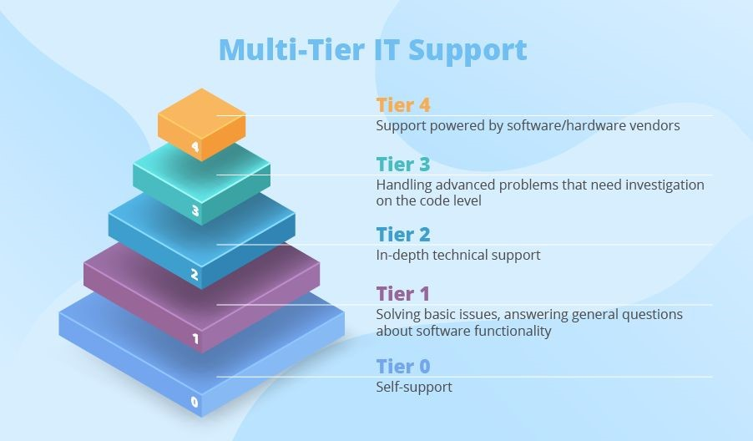

**Level 0** ​ *A technician is not present at this level*​

In the support structure, Level 0 is designed to help users find answers to questions about software functionality and resolve minor issues independently without contacting support agents.

**Level 1** ​ *Basic troubleshooting*​

At this level of IT support, also known as the help desk, agents answer general questions about using the software and approach simple issues, such as resolving login problems, reinstalling basic applications, checking for proper software and hardware configurations.

**Level 2** ​ *In-depth technical support*​

Level 2 is more in-depth technical support that works with issues that Level 1 personnel cannot solve. To resolve these issues, agents often must research the registers and understand the software that a supported solution integrates with. If the Level 2 Support Specialists are unable to fix the problem, proceed to the next level of support for a more detailed investigation of the code level.

**Level 3** ​ *Handling advanced problems that need investigation at the code level*​

Level 3 support includes researching and preparing solutions for problems that require code fixes, as well as making minor enhancements to supported software.

**Level 4** ​ *Support driven by software / hardware vendors*​

It is a level that includes escalating a problem to software or hardware vendors beyond the organization.

# Bibliography

Chrissy Kidd, J. H. (25 de Abril de 2019). *bmc blogs*​ ​. Obtenido de Service Management Blog: https://www.bmc.com/blogs/support-levels-level-1-level-2-level-3/

GyT Flotas. (24 de Junio de 2020). *GyT Flotas GPS y telemetria para su*​  *empresa*​. Obtenido de GyT Blog:

https://www.gytflotas.com/iot-industrial-6-caracteristicas-a-buscar-en-u n-socio-de-tecnologia/

Maldonado, D. (23 de Octubre de 2019). *icorp*​ ​. Obtenido de icorp blog:

http://www.icorp.com.mx/blog/incidente-solicitud-de-servicio-ticket/

Maldonado, D. (1 de Octubre de 2019). ​*icorp* ​. Obtenido de icorp blog: http://www.icorp.com.mx/blog/niveles-de-soporte-de-ti/

Nielsen, S. (12 de Octubre de 2017). ​*orange matter*​. Obtenido de https://orangematter.solarwinds.com/2017/10/12/whats-the-differencebetween-incidents-service-requests-and-tickets/

Shiklo, B. (5 de Agosto de 2019). ​*Science Soft Profesional Software*

*Development*​. Obtenido de https://www.scnsoft.com/blog/help-desk