Specification of software requirements

Proyect: ​Registration System and IT solutions for technical problems according to
the level of support required for SMEs
Review [ ]

December 2020


Revision history

Date | Review | Author | Verified by d. D0CC
12/12/2020 |  | Velasco Karen  Vivas Nathaly  Zambrano Charles

Document validated by the parties on date:

For the client | By the University
SMEs dedicated to providing IT service to different communities | Universidad de las Fuerzas Armadas ESPE

Content
Revision history 2
Content 3
1 Introduction 5
1.1 Purpose 5
1.2 Scope 5
1.3 Involved personnel 5
1.4 Definitions, acronyms and abbreviations 5
1.5 References 6
1.6 Summary 6
2 General description 6
2.1 Product perspective 6
2.2 Product functionality 7
2.3 User characteristics 7
2.4 Restrictions 8
2.5 Assumptions and dependencies 8
2.6 Predictable evolution of the system 8
3 Specific requirements 8
3.1 Common interface requirements 12
3.1.1 User interfaces 12
3.1.2 Hardware interfaces 12
3.1.3 Software interfaces 12
3.1.4 Communication interfaces 12
3.2 Functional requirements 13
3.2.1 Functional requirement 1 13
3.2.2 Functional requirement 2 13
3.2.3 Functional requirement 3 13
3.2.4 Functional requirement n 14
3.3 Non-functional requirements 15
3.3.1 Performance requirements 15
3.3.2 Security 15
3.3.3 Reliability 15
3.3.4 Availability 15
3.3.5 Maintainability 15
3.3.6 Portability 16
3.4 Other requirements ¡Error! Marcador no definido.
4 Appendices 16

Introduction
A system is needed to improve the organization and efficiency of SMEs (Small and Medium Enterprises) dedicated to the provision of IT (Information Technologies) services. So, they can have an orderly record of all the problems reported by their clients and in this way create a structure that allows them to meet their needs in a strategic way and provide them with a positive experience.

Purpose
The document present have on purpose define the functional specifications and not functional for the develop of a system registration that can allow us manage different reports of the IT problems that are present on the community. This program it’s going to be use by an admin-user.

Scope
This specification of requirements it’s directed to the user of system, to manage the different services of IT solutions with better planning and to deepen their automation, which aims at the organized recording of incidents and requirements.

Involved personnel
Name | Karen Velasco
Role | Analyst, Designer, Developer
Professional category | Eng. Tics
Responsibilities | Analyze of information, design and develop of RSIT
Contact information | kavelasco@espe.edu.ec

Name | Nathaly Vivas
Role | Analyst, Designer, Developer, team lider
Professional category | Eng. Tics
Responsibilities | Analyze of information, design and develop of RSIT
Contact information | nmvivas@espe.edu.ec

Name | Charles Zambrano
Role | Analyst, Designer, Developer
Professional category | Eng. Tics
Responsibilities | Analyze of information, design and develop of RSIT
Contact information | cdzambrano3@espe.edu.ec

Definitions, acronyms and abbreviations
Name | Description
Admin-user | Person that it’s going to use the system to manage the reports.
SMEs | Small and Medium Enterprises
IT | Information Technologies
RSIT | Registration System of Information Technologies
SRS | Specification Requirements Software
FR | Functional Requirements
NFR | No Functional Requirements
NetBeans | Development Framework

References
Title | Reference
Standard IEEE830-1998 | lnstitute of Electrical and Electronics Engineers

Summary
This document has 3 sections. In the first section, we made an introduction of itself that give us a general vision of the specification resources system.

In the second section, we made a general description of the system, in order to know the principal functions that it’s going to make, the associated dates and dependencies that affect the develop, with out entering in deep details.

Finally, in the third section it’s were we define with details the requirements that needs to satisfy the system.

General description

Product perspective
The RS IT system will be a program specifically designed to improve the efficiency of SMEs, dedicated to providing services related to IT solutions, in this way the demand of companies will increase and the client will be satisfied with the quality and response time of every incident or requirement.

Product functionality

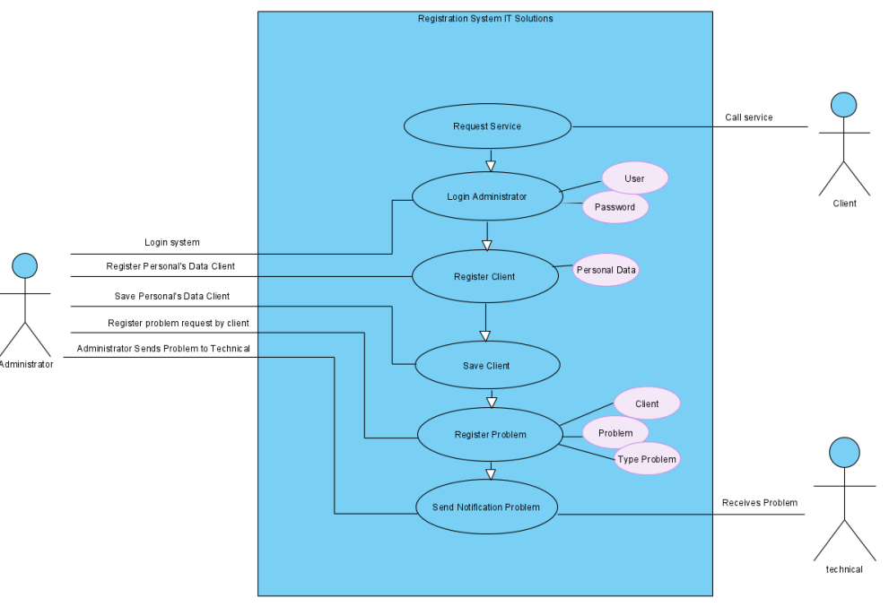

User characteristics
Type of user | Administrator
Training | Eng. Tics
Skills | Ease of recognition of the IT problem  Speed  Serenity
Activities | Attention to client

Restrictions

Interface to be used without internet.

Languages and technologies in JAVA.

The system must have a database.

The system should have a simple design and implementation, regardless of the platform or programming language.

Assumptions and dependencies

The requirements described here are assumed to be stable

The computers on which the program will be executed must comply with the requirements indicated above to guarantee a correct execution of the program. Predictable evolution of the system
.

Predictable evolution of the system

It is expected to be able to add new functions that optimize the solution time for each client. Also, allow the customer to see the status of the problem they requested to solve.

To optimize the solution time, we are going to add Tier Problems.

Also, client it’s going to be able to check the status of problem.

The program it’s going to use a base data online with a server.

Specific requirements

Functional Requirements
Requirement number | RF01
Requirement name | Administrator Authentication
Type | X Requirement | Restriction
Characteristics | An administrator username and password must be validated
Description Requirements | The system may only be used by a designated administrator respectively
Requirement priority | x High / Essential | Average / Desired | Low / Optional

Requirement number | RF02
Requirement name | Administrator registration
Type | X Requirement | Restriction
Characteristics | An administrator must be registered to use the system
Description Requirements | A person is registered as an administrator, with their personal data and also a username and password.
Requirement priority | x High / Essential | Average / Desired | Low / Optional

Requirement number | RF03
Requirement name | Record of the Problem
Type | X Requirement | Restriction
Characteristics | The problem that the client requests to solve is recorded
Description Requirements | A brief description of the problem, its type and the name of the client who has notified it is entered.
Requirement priority | x High / Essential | Average / Desired | Low / Optional

Requirement number | RF04
Requirement name | Customer registration
Type | X Requirement | Restriction
Characteristics | The customer who requested the service must be registered in the system.
Description Requirements | The client's record contains as primary data, a name, an address and a cell phone number
Requirement priority | x High / Essential | Average / Desired | Low / Optional

Requirement number | RF05
Requirement name | A problem
Type | X Requirement | Restriction
Characteristics | The administrator will need to enter a problem to register
Description Requirements | Here, the administrator must enter a brief description of the problem and its solution status.
Requirement priority | x High / Essential | Average / Desired | Low / Optional

Requirement number | RF06
Requirement name | Type of problem
Type | X Requirement | Restriction
Characteristics | The problems entered will be of the request or request type.
Description Requirements | The problem reported by the client is assigned a type of check with a corresponding code. This will be done by the administrator.
Requirement priority | x High / Essential | Average / Desired | Low / Optional

Requirement number | RF07
Requirement name | Service technician registration
Type | X Requirement | Restriction
Characteristics | There are specialized technicians to solve the reported problems.
Description Requirements | The administrator is responsible for registering a technician with their respective primary data. In addition, you will be asked for your specialization as an IT professional.
Requirement priority | x High / Essential | Average / Desired | Low / Optional

No Functional Requirements
Requirement number | RF01
Requirement name | Help in Use System
Type | X Requirement | Restriction
Characteristics | The system its’ going to have a help service, that is, handbook.
Description Requirements | The user interface must present a help system that can facilitate the user's work, in this case the administrator.
Requirement priority | High /Essential | XAverage / Desired | Low / Optional

Requirement number | RF02
Requirement name | Maintenance
Type | X Requirement | Restriction
Characteristics | The system must have an installation manual and a user manual to facilitate the maintenance that will be carried out by the administrator.
Description Requirements | The system will provide easily updateable documentation that allows maintenance operations to be carried out with the least possible effort.
Requirement priority | x High / Essential | Average / Desired | Low / Optional

Requirement number | RF03
Requirement name | System interface
Type | X Requirement | Restriction
Characteristics | The interface will be easy to use, intuitive and simple.
Description Requirements | The system must have a user-friendly interface.
Requirement priority | x High / Essential | Average / Desired | Low / Optional

Requirement number | RF04
Requirement name | Performance
Type | X Requirement | Restriction
Characteristics | The system will guarantee users a performance regarding the stored data, offering reliability to it.
Description Requirements | Guarantee the performance of the computer system to the different users. In this sense, the information stored or records made may be consulted and permanently updated.
Requirement priority | x High / Essential | Average / Desired | Low / Optional

Requirement number | RF05
Requirement name | Information security
Type | X Requirement | Restriction
Characteristics | The system will guarantee the users a security regarding the information that is preceded in the system.
Description Requirements | Guarantee the security of the system with respect to the information and data that are handled such as the personal data of the managers and / or clients.
Requirement priority | x High / Essential | Average / Desired | Low / Optional

Common interface requirements

User interfaces

The user interface will consist of a set of options within a menu, lists and text fields. This must be built specifically for the proposed system and will be viewed from the NetBeans console

Hardware interface

It will be necessary to have computer equipment in perfect condition with the following characteristics:

1.66GHz processor or better

256Mb minimum memory

A spreadsheet (Excel)

Mouse

Keyboard

Software interfaces

Operating system: Windows 10

JAVA

JDK

Netbeans 8.0

Communication interfaces
The administrator and the program with all its classes and methods will communicate with each other using default standards from the source code in netbeans.

Functional requirements

Functional requirement 1

Administrator Authentication. - An administrator username and password must be validated.

The system may only be used by a designated administrator respectively

Authentication it’s going to be performed using one the following methods that its’s Knowledge authentication: Based on information that only the user knows.

Functional requirement 2

Administrator registration. - An administrator must be registered to use the system

A person is registered as an administrator, with their personal data and also a username and password.

Id

Names

Last names

Email

Nickname

Password

The nickname and password it’s to going used for login in the system

This is the process by which the network records each and every access to the resources made by the user, authorized or not.

Functional requirement 3

Record of the problem

The problem that the client requests to solve is recorded.

A brief description of the problem, its type and the name of the client who has notified it is entered.

There are two types of problems pre-established in the system with code as identifier. When registering the problem, the code of the type of problem to which it refers must also be entered.

Functional requirement 4

Customer Registration

The customer who requested the service must be registered in the system.

The client's record contains as primary data, a name, an address and a cell phone number

The customer, who calls to request the service and has not been registered in our database, will be asked to provide us with the information required to add it and proceed with the registration of the problem.

Functional requirement 5

A problem

The administrator will need to enter a problem to register

Here, the administrator must enter a brief description of the problem and its solution status. This requirement takes the necessary data to be assigned a type, that is, the description of the problem must be clear and concise.

Functional requirement 6

Type of problem

The problems entered will be of the request or request type.

The problem reported by the client is assigned a type of check with a corresponding code. This will be done by the administrator.

The system will incorporate two types of problems: incident or request. Its difference lies in the solution time that will be assigned to it.

Incident: It has priority; therefore, it will be resolved as soon as possible.

Petition: Refers to a problem that will take a longer time to solve and therefore, you will be registered to solve it within a certain time.

Functional requirement 7

Service technician registration

There are specialized technicians to solve the reported problems.

The administrator is responsible for registering a technician with their respective primary data. In addition, you will be asked for your specialization as an IT professional.

Once the administrator has registered different technicians, he can assign them one problem at a time according to their specialty, the respective type of problem will be identified.

Non-functional requirements

Performance requirements

Security

Guarantee the reliability, security and performance of the computer system to the different users. In this sense, the information stored or the records made can be consulted and permanently updated.

Guarantee the security of the system with respect to the information and data that are handled, such as the personal data of the client and the administrator's passwords.

Facilities and controls to allow access to information to authorized personnel, with the intention of consulting and adding pertinent information to the records.

Reliability

The system must have an intuitive and simple user interface.

The interface shown by the console must adjust to the vision, so that it provides correct handling and future errors are avoided.

Availability

The system has to be function twenty-four hours per day and seven days per week because we can’t control when a customer had a problem.

Also the availability on the administrator, he has to decide when operate it and serve the customers.

Maintainability

The system must have easily updateable documentation that allows maintenance operations to be carried out with the least possible effort.

The interface must be complemented with a good help system (the administration may fall on personnel with little experience in the use of computer applications)

Portability

The system will be developed under the Windows platform and with the Netbeans software as ID.

