**ASSIGNMENT -1**

1. **Install Power BI Desktop and share the final screenshot of the report view page which appears when power desktop starts.**

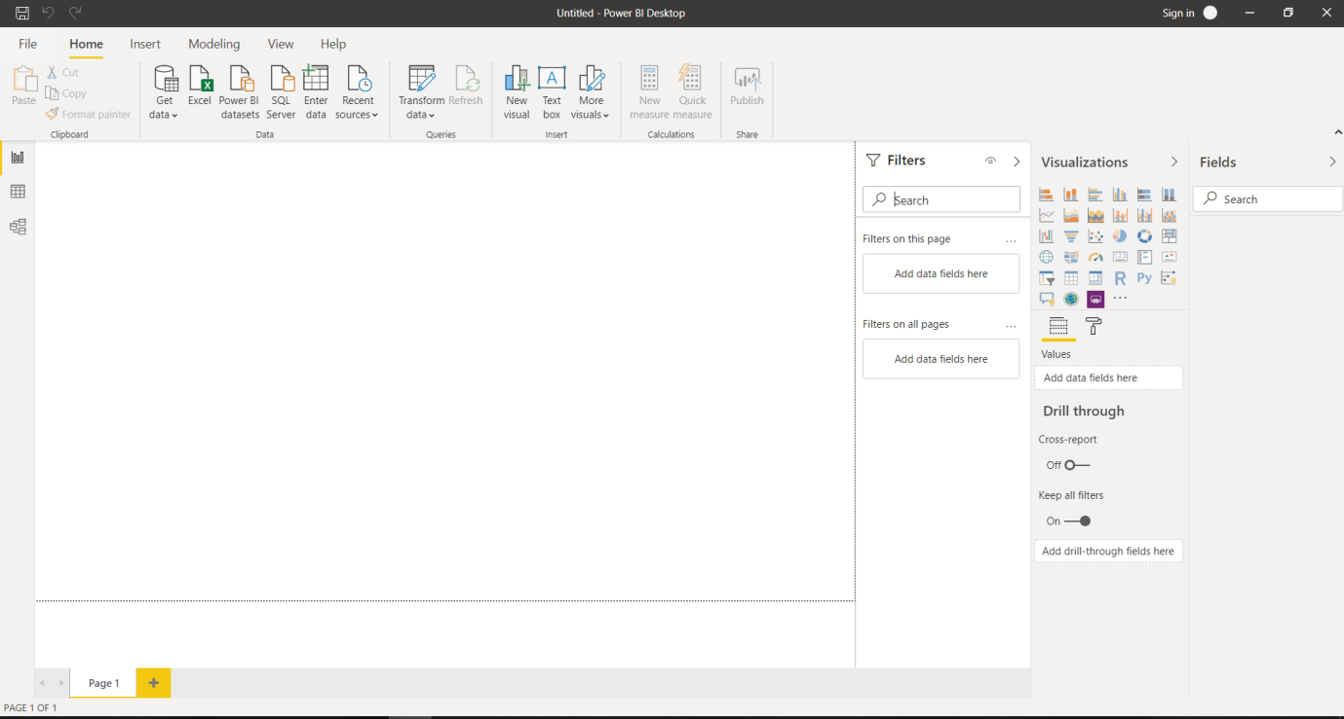

1. **Prepare a document and with the following screenshot**

Report View

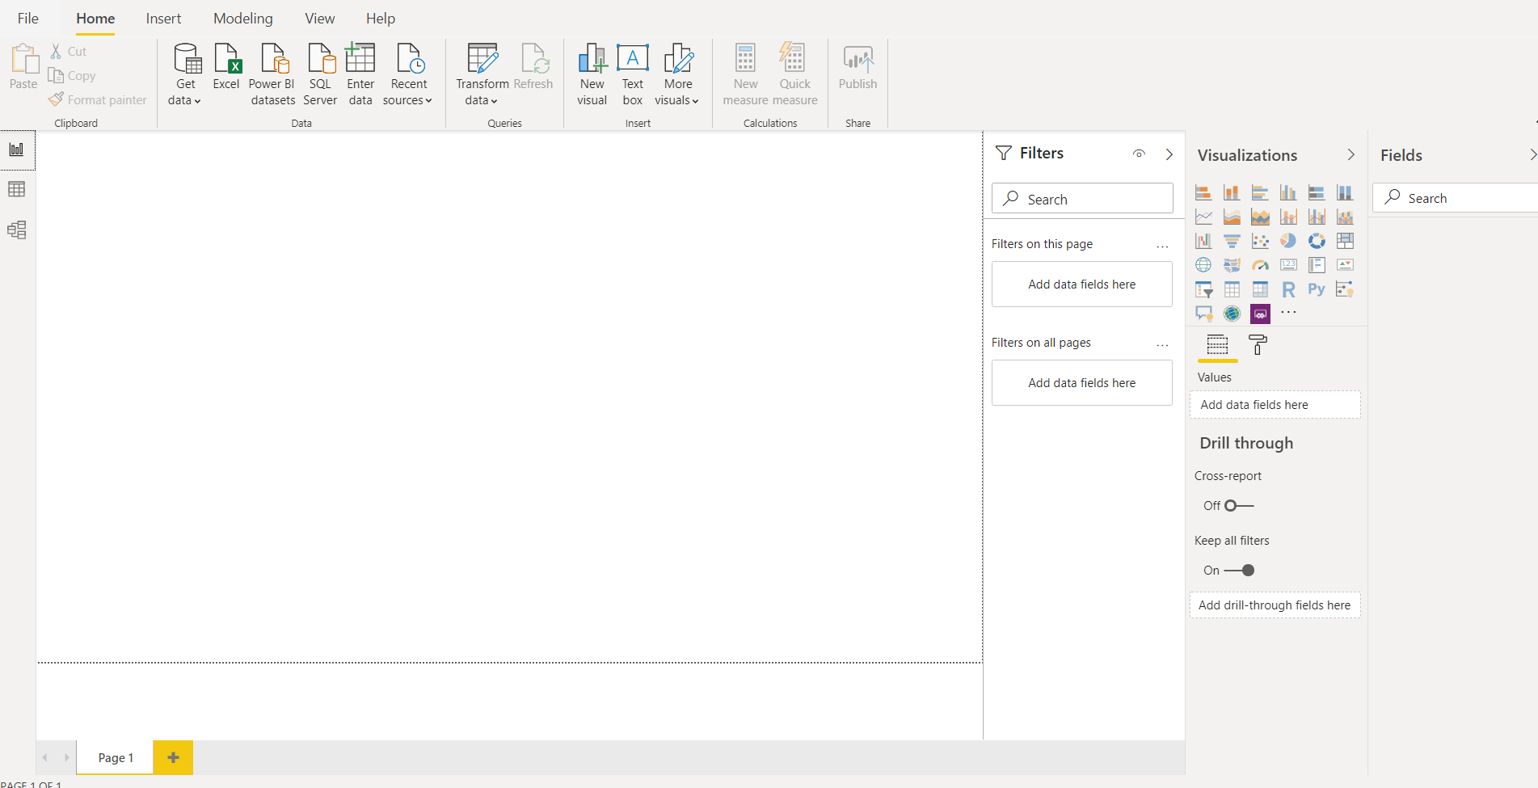

Data View

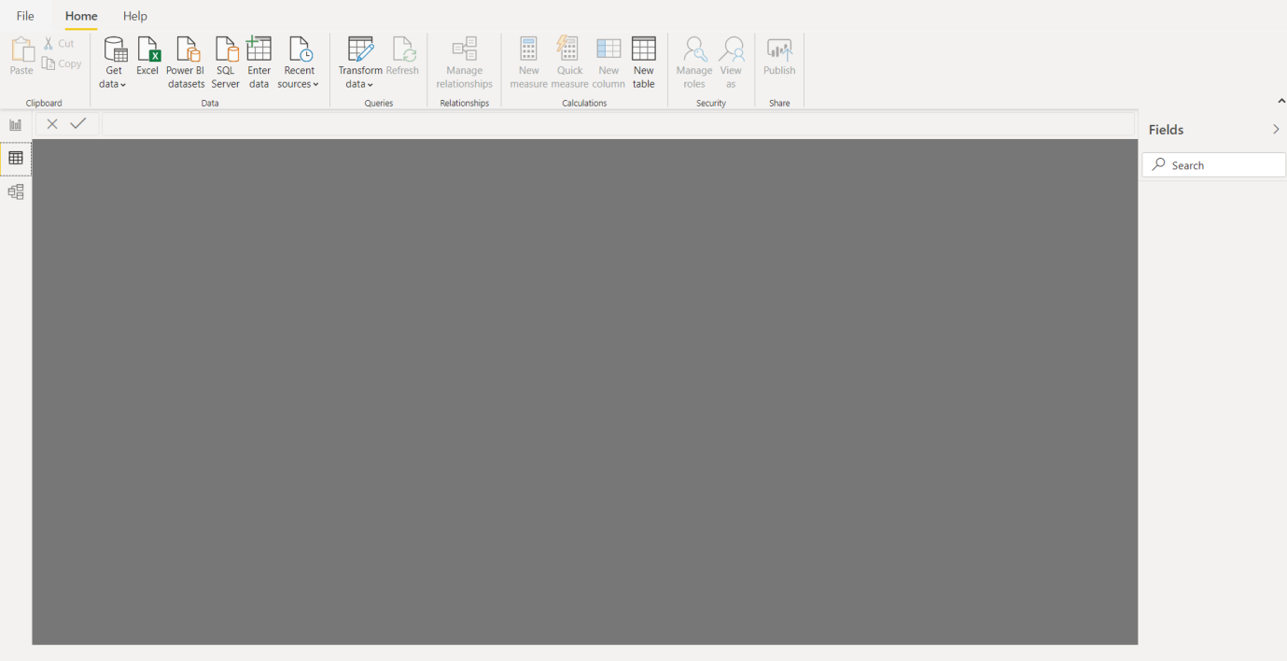

Model View

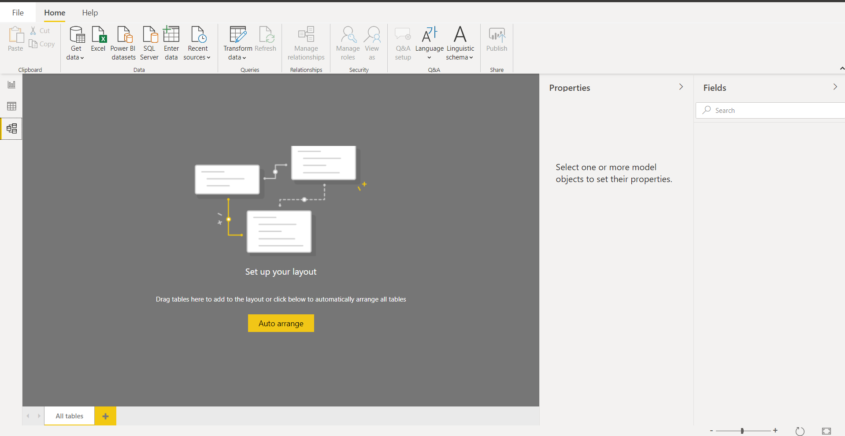

Power Query Editor

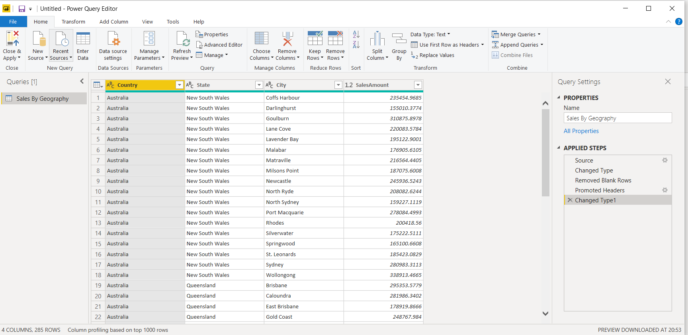

Advance Editor

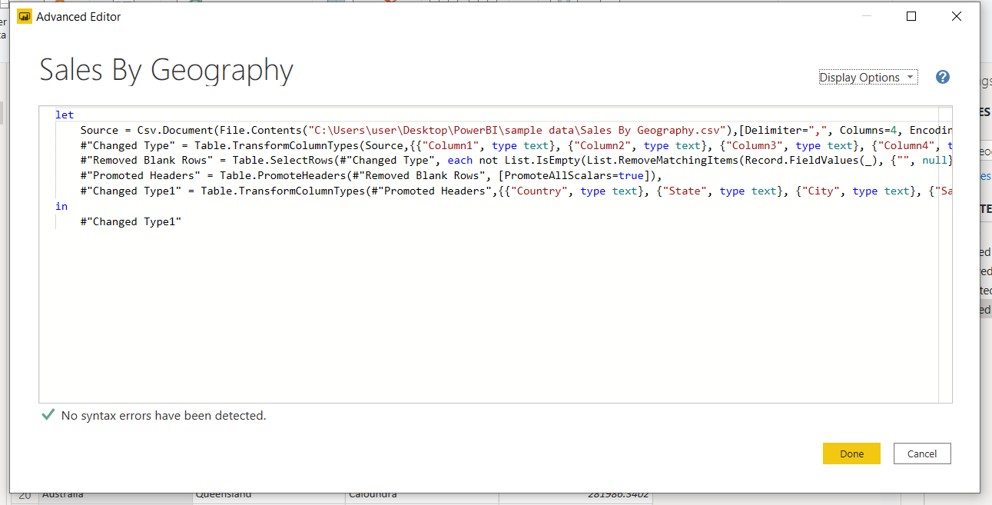

1. **Prepare a document with details of the following along with their price**

**Power BI Desktop**

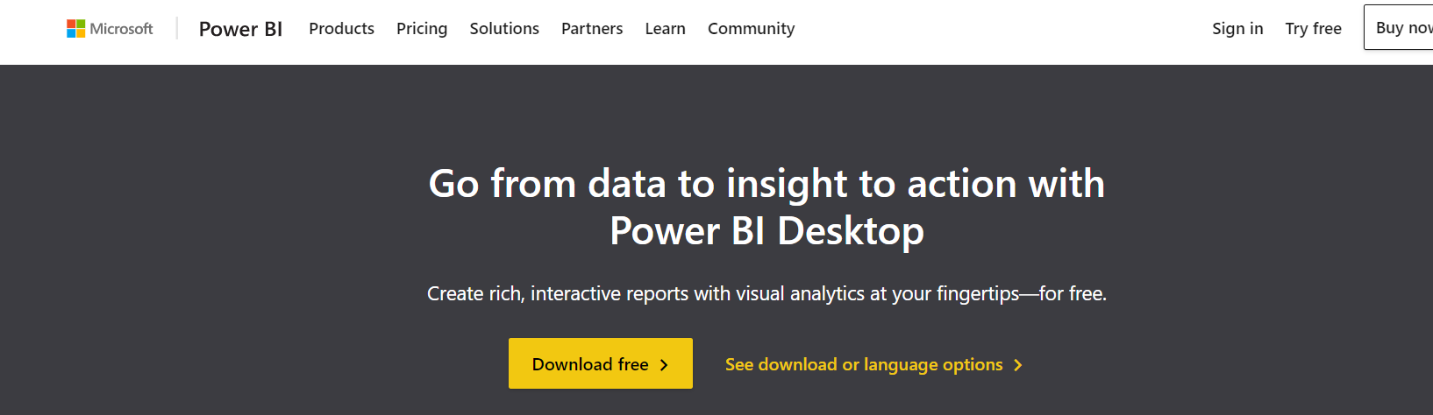

**Power BI Pro Power BI Premium**

