**ASSIGNMENT-2**

1. **Connect to the Store Sales Data and do the following: -**

− Remove all the blank rows.

− Update the column header if they are not updated

* 1. − Create a text table and show the sales in terms of
  2. o Customers
  3. o Product Category
  4. o Regions

**Connected Store Sales Data**

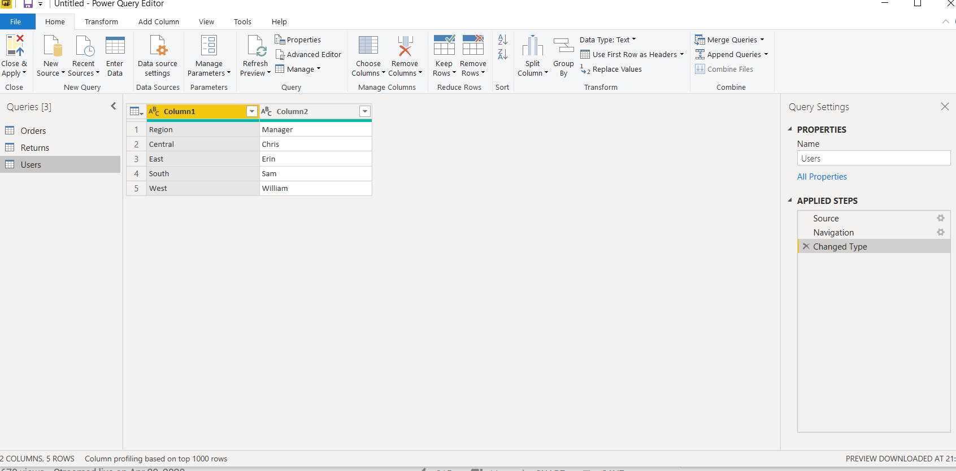

**Remove all the blank rows**

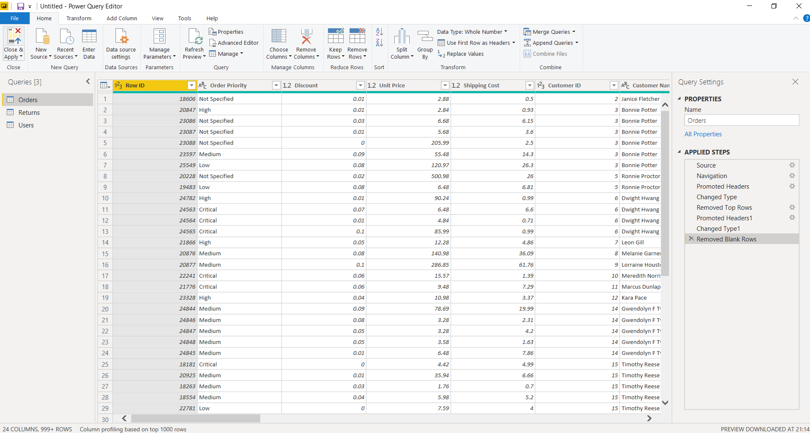

**Update the column header if they are not updated**

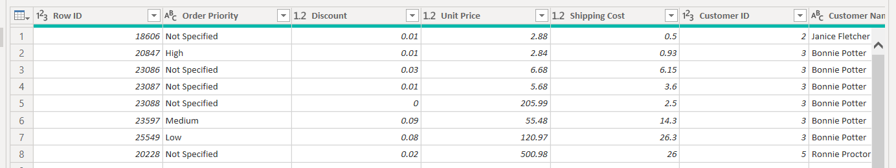

**Create a text table and show the sales in terms of**

* 1. o Customers
  2. o Product Category

o Regions

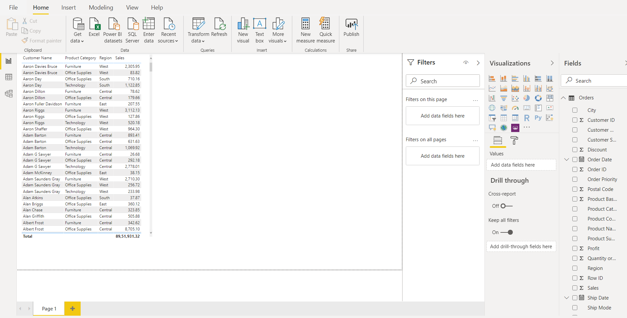

1. **Create a line and Clustered Column Chart showing the Sales and Discount as per the State or Province**

− Format the bars and line with different colors

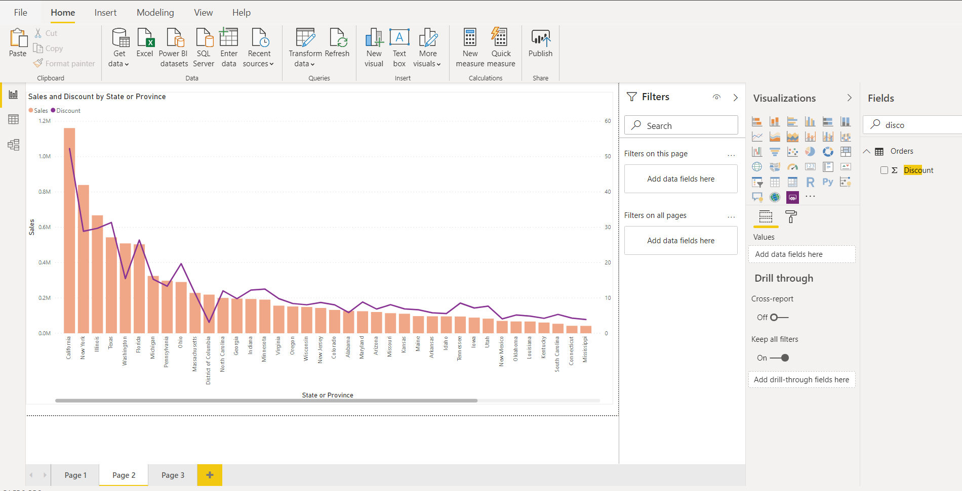

− Which state has the highest sales in terms Technology

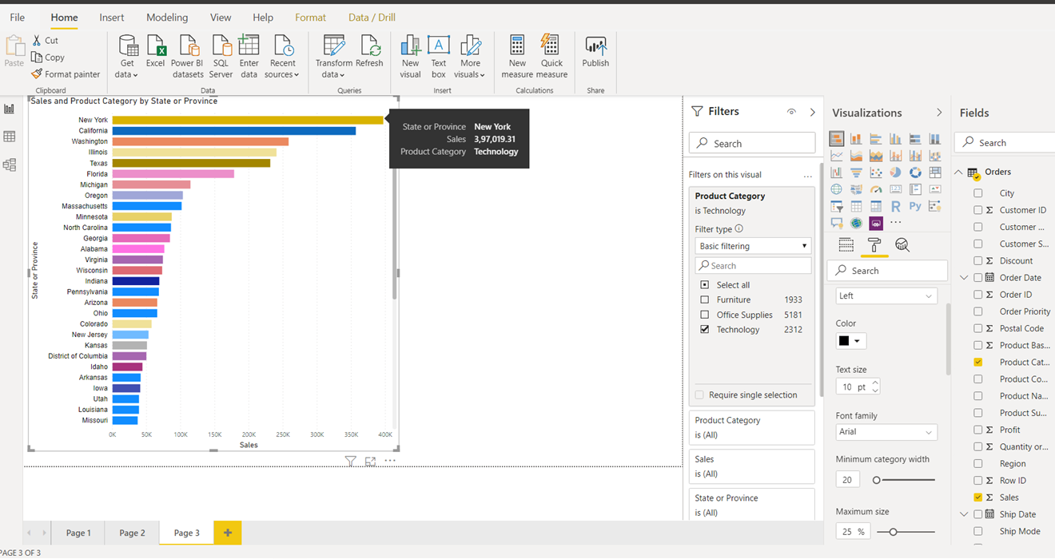

1. **Create a** *Donut Chart* **showing sales in terms of Product category**

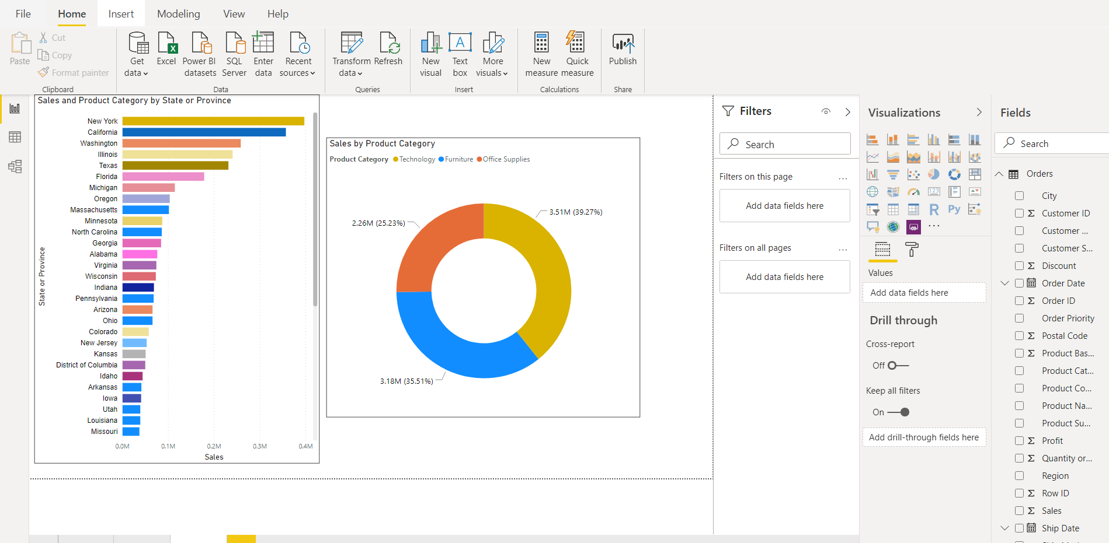

1. **Create a** *Slicer* **and show the regions in dropdown. See how all the visuals mentioned above behaving when a particular region is selected.**

