**Deliverables**

**Code Base :** [**https://github.com/nmvvskb/ATMServices.git**](https://github.com/nmvvskb/ATMServices.git)

[**git@github.com:nmvvskb/ATMServices.git**](mailto:git@github.com:nmvvskb/ATMServices.git)

**NOTE :** From above Git Repository , please clone the assigned task from **master** Brach.

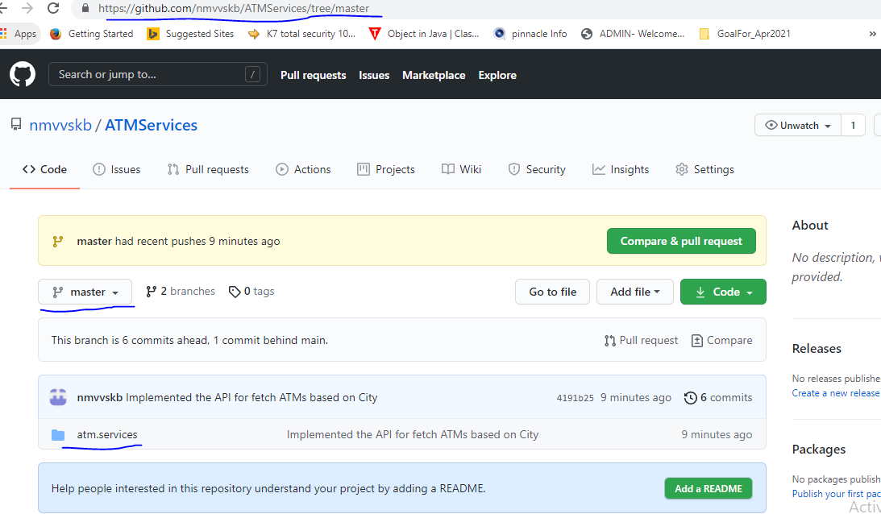

**PROCESS for running application.**

**Required Environmetns :** Java 1.8

**IDE :** eclipse

**Build tool :** Maven

Procedure :

1. **Need to import the project in eclipse IDE.**
2. **Need to update the project** 
   1. **Right click on project -> maven -> update project -> select project -> force update -> ok**
3. **Run the Spring boot application**
   1. **First do the mvn build by give clean compile install**
   2. **Click on run as Java application (if you get any pop window, there select** AtmServicesApplication**).**
4. **Or else directlry go into** AtmServicesApplication then do right click then click on run as Java Application.

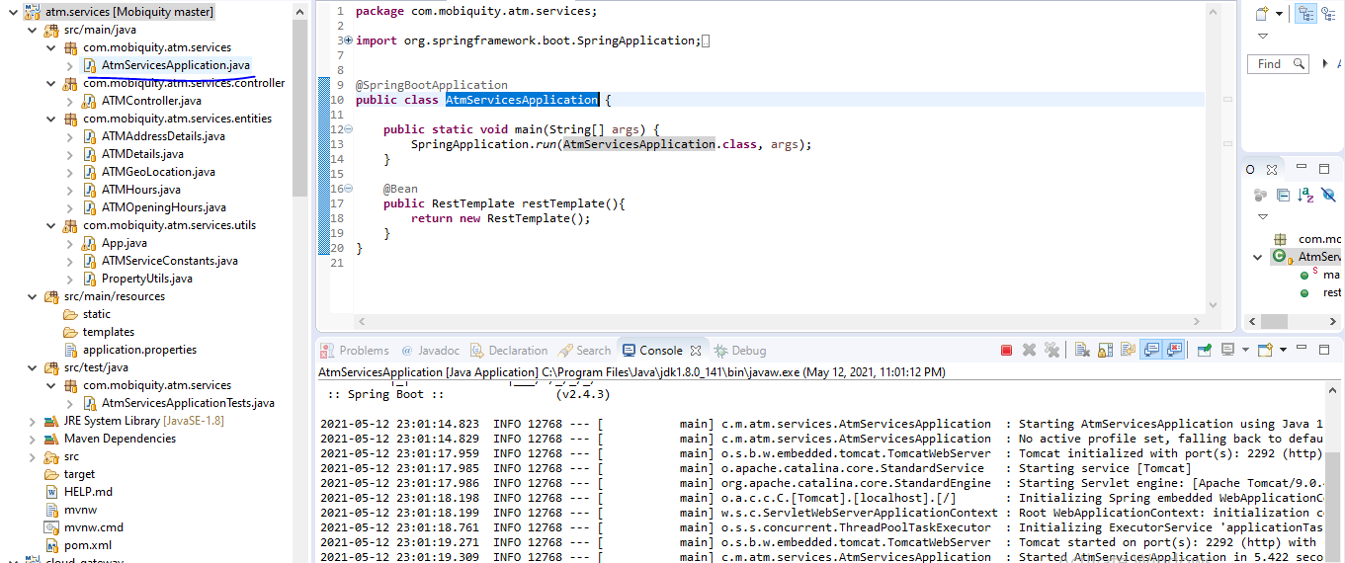

**POST MAN OUTPUTS**

**NOTE** : as per the given requirement, have implemented the two APIs

1. An API to get a list of all the atms
2. An API to filter the atms by city

**To fetch All the ATMS implemented the below REST API.**

* <http://localhost:2292/atm/getATMsList>
  + For this REST API will get the All ATM details information in JSON format.

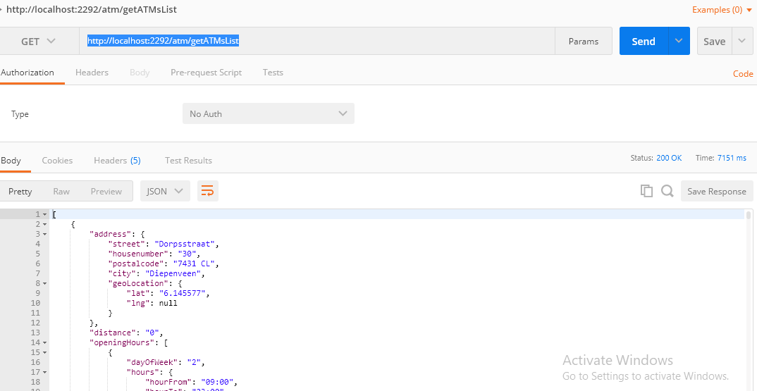

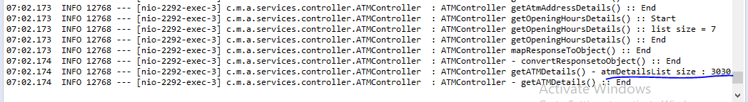

**TO fetch ATM details based on City implemented the below REST API.**

* http://localhost:2292/atm/{cityName}

**ex :** http://localhost:2292/atm/Klundert

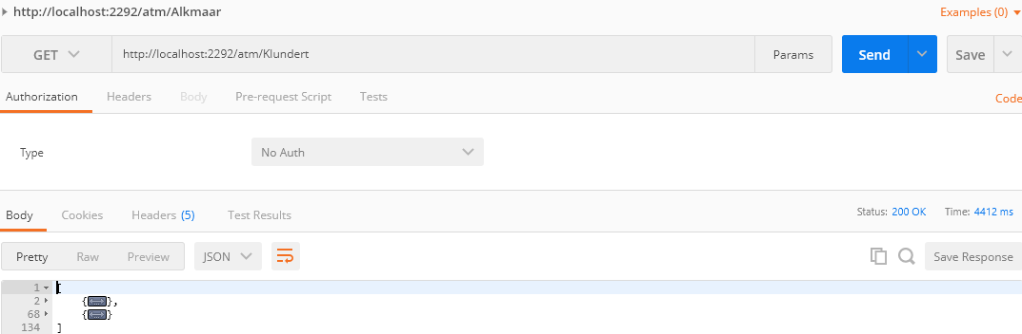

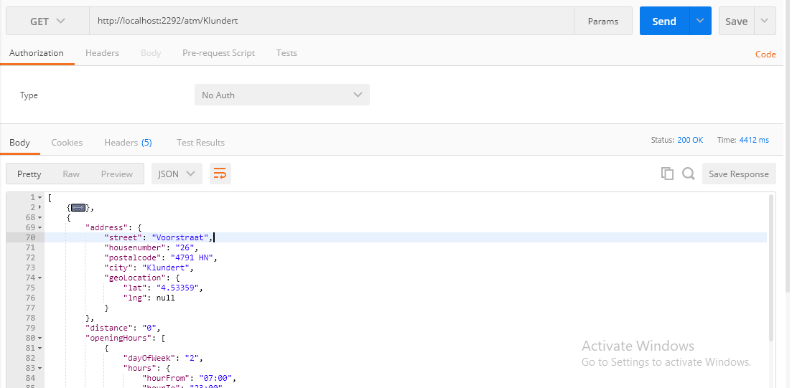

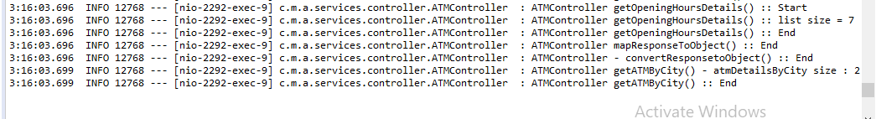

**ex :** http://localhost:2292/atm/Diepenveen

