# **SIGNALS AND NETWORKS LAB EE29001**

# **EXPERIMENT O4 - ACTIVE LOW PASS FILTER**

*AIM :* To familiarise with second order Sallen key active low pass filters and to measure their frequency responses on LTSpice simulation platform. To analyse the frequency response plots obtained from LTSpice and compare the inferences with the theoretical results.

*PART O1 :*

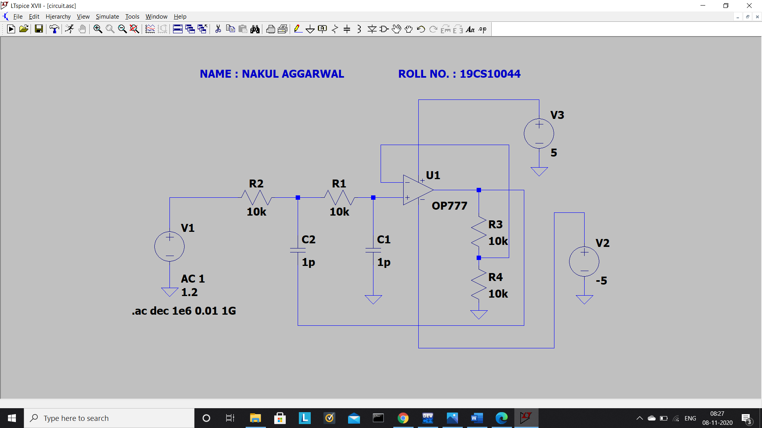

*Here $R_{3}$ is the feedback resistance $R_{f}.$*

*PART O2 :*

$$R_{1}=R_{2}=10 kΩ$$

$$C_{1}=C_{2}=1 nF$$

$$Q=1$$

$$Q= \frac{1}{3-K}\underset{→}{yields} K=3-\frac{1}{Q} =2$$

$$K=1+ \frac{R_{3}}{R_{4}} \underset{→}{yields} \frac{R_{3}}{R_{4}}=1$$

$$Choose R_{4}=R_{1}=10 kΩ$$

$$Therefore R_{3}=10 kΩ$$

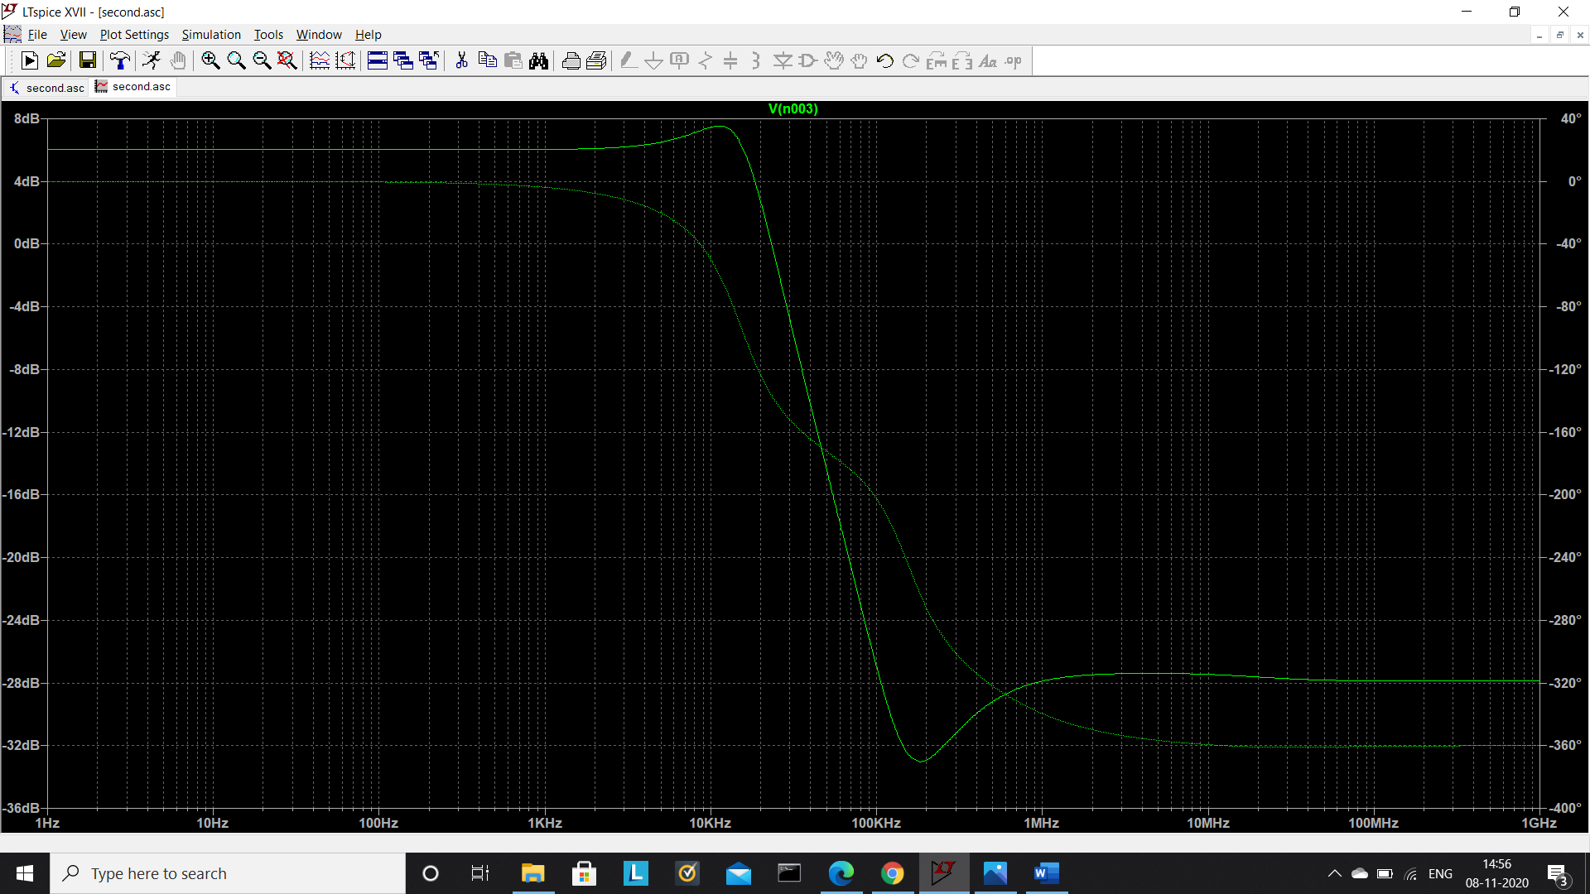

$$f_{o-theoretical}=\frac{1}{2πR_{1}C_{1}}=\frac{1}{2*3.141*{10}^{4}*{10}^{-9}}=15.92 kHz$$

$$f_{o-practical}=11.20 kHz ( from the plot )$$

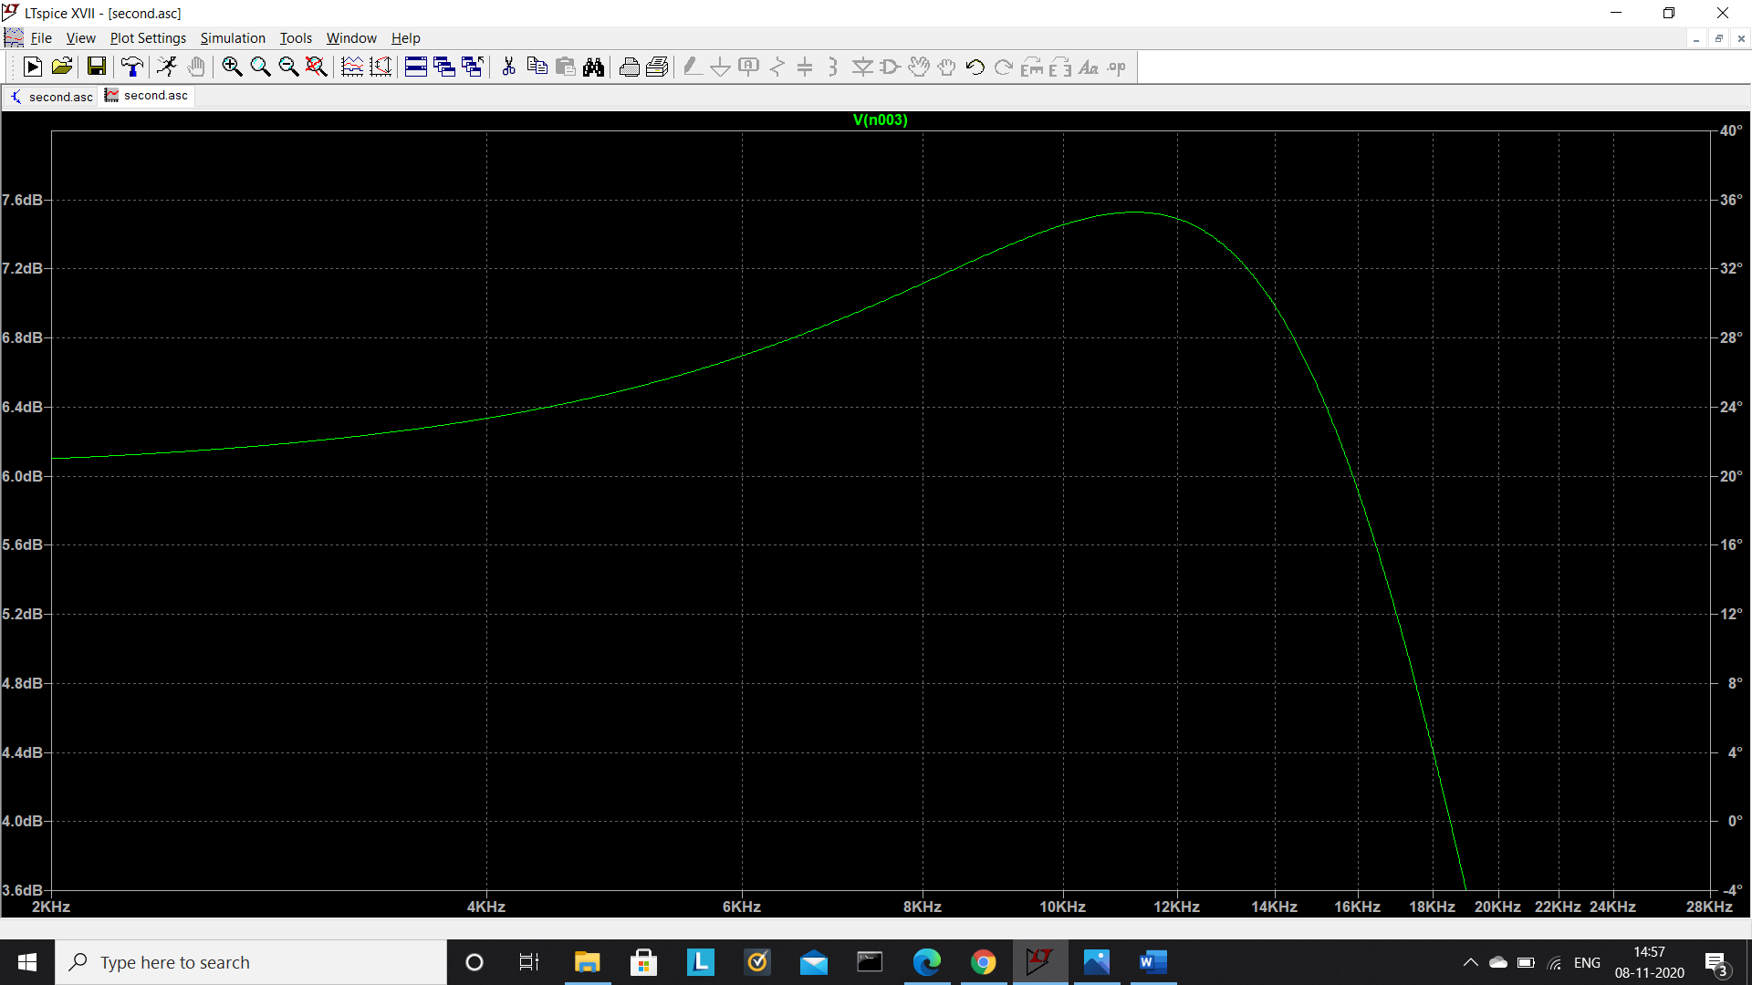

*COMMENTS :*  The theoretical and practical values of the undamped natural frequencies though of the same order, differ by almost 30%. The gain vs frequency plot suggests the behaviour of a low pass filter, in accordance with the theory. In the zoomed-in version of this plot, a local maximum can be spotted which is the characteristic of the active low pass filter. Due to low quality factor, the peak almost appears to be flat with very less sharpness.

*PART O3 :*

$$R_{1}=R_{2}=10 kΩ$$

$$C_{1}=C_{2}=1 nF$$

$$Q=1.5$$

$$Q= \frac{1}{3-K}\underset{→}{yields} K=3-\frac{1}{Q} =2.333$$

$$K=1+ \frac{R_{3}}{R_{4}} \underset{→}{yields} \frac{R_{3}}{R_{4}}=1.333$$

$$Choose R_{4}=R_{1}=10 kΩ$$

$$Therefore R_{3}=13.33 kΩ$$

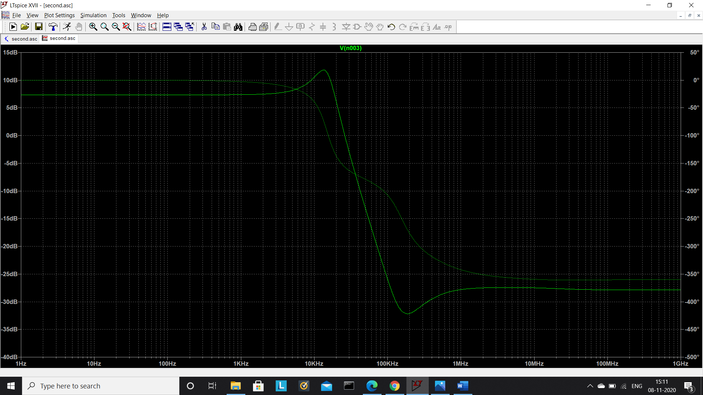

$$f_{o-theoretical}=\frac{1}{2πR_{1}C_{1}}=\frac{1}{2*3.141*{10}^{4}*{10}^{-9}}=15.92 kHz$$

$$f_{o-practical}=13.41 kHz ( from the plot )$$

*COMMENTS :*  The theoretical and practical values of the undamped natural frequencies are of the same order and differ by 15.77%. The gain vs frequency plot suggests the behaviour of a low pass filter, in accordance with the theory. In the plot, a local maximum can be easily spotted which is the characteristic of the active low pass filter. Due to increase in quality factor, the peak becomes sharper and more prominent. Quality factor is inversely proportional to the bandwidth of the local maximum. Since here, the undamped natural frequency remains same as the previous part, an increase in quality factor will cause a decrease in this bandwidth and hence, the peak becomes sharper.

$$R_{1}=R_{2}=10 kΩ$$

$$C_{1}=C_{2}=1 nF$$

$$Q=2.5$$

$$Q= \frac{1}{3-K}\underset{→}{yields} K=3-\frac{1}{Q} =2.6$$

$$K=1+ \frac{R_{3}}{R_{4}} \underset{→}{yields} \frac{R_{3}}{R_{4}}=1.6$$

$$Choose R_{4}=R_{1}=10 kΩ$$

$$Therefore R_{3}=16 kΩ$$

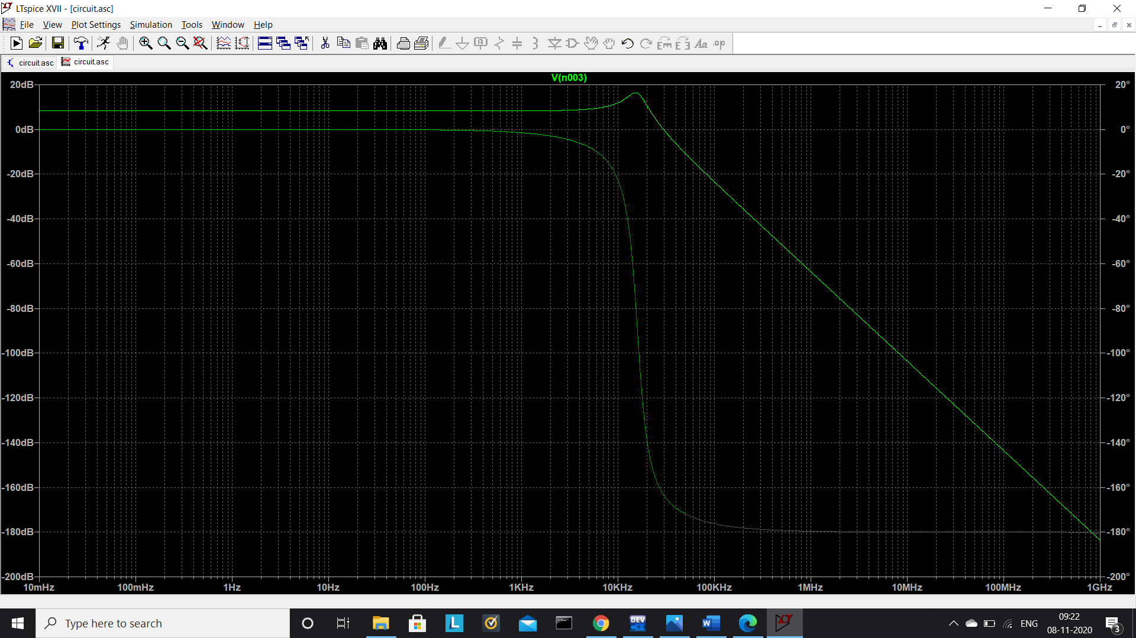

$$f_{o-theoretical}=\frac{1}{2πR_{1}C_{1}}=\frac{1}{2*3.141*{10}^{4}*{10}^{-9}}=15.92 kHz$$

$$f_{o-practical}=14.26 kHz ( from the plot )$$

*COMMENTS :*  The theoretical and practical values of the undamped natural frequencies are of the same order and differ by just 10.43%. The gain vs frequency plot suggests the behaviour of a low pass filter, in accordance with the theory. In the plot, a local maximum can be easily spotted which is the characteristic of the active low pass filter. The peak in this part is the sharpest among all the three quality factors. This is because of the inverse proportional relation between the bandwidth of the local maximum and the quality factor. The value of the undamped natural frequency is independent of the quality factor and depends only on the values of $R_{1}$ and $C_{1}$ ( provided $R_{1}=R_{2}$ and $C_{1}=C_{2}$). Because the values of $R_{1}$ and $C_{1}$ in the above three cases were kept intact ( and also $R_{1}=R_{2}$ and $C_{1}=C_{2}$), the increase in quality factor will decrease the width of the peak appearing in the frequency response plot and as the result of this, the peak becomes sharper. The practical results obey these theoretical predictions perfectly.

*PART O4 :*

$$R_{1}=R_{2}=10 kΩ$$

$$C_{1}=C_{2}=1 pF$$

$$Q=2.5$$

$$Q= \frac{1}{3-K}\underset{→}{yields} K=3-\frac{1}{Q} =2.6$$

$$K=1+ \frac{R_{3}}{R_{4}} \underset{→}{yields} \frac{R_{3}}{R_{4}}=1.6$$

$$Choose R_{4}=R_{1}=10 kΩ$$

$$Therefore R_{3}=16 kΩ$$

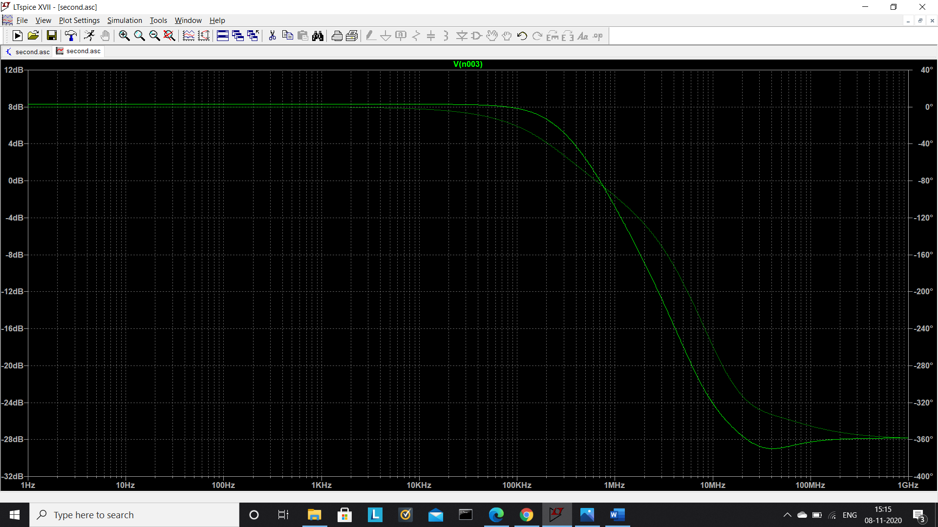

$$f_{o-theoretical}=\frac{1}{2πR_{1}C_{1}}=\frac{1}{2*3.141*{10}^{4}*{10}^{-12}}=15.92 MHz$$

*COMMENTS :*  Though the plot of gain vs frequency suggests the behaviour of a low pass filter, yet no local maximum is observed. Besides, the theoretical value of the undamped natural frequency for this circuit is 15.92 MHz and the corner frequency of the above plot is around 295 kHz. The reason for this huge difference is the very small values of the capacitances, that are in picofarads. Even the values of parasitic capacitances are larger than 1pF and when in the circuit itself the values of external capacitances are this small, the effect of parasitic capacitances cannot be neglected as is done in the theory for simplification. Secondly, an opamp consists of around 20-30 transistors all of which might have some winding capacitance and junction capacitances that are of very small values (a few picofarads). If the capacitances used in the circuit are of the same order as these capacitances present inside the opamp, the latter cannot be ignored and hence the practical results will deviate from the theoretical calculations. Thirdly, the gain bandwidth product (GBP) of the opamp used in this simulation (OP777) as modelled in LTSpice is 0.7MHz. In this plot, the maximum gain comes out to be more than 2.5 and the bandwidth is around 0.295 MHz. The product of maximum gain and bandwidth therefore comes out to be more than 0.7 MHz, the GBP of the opamp OP777. In the previous parts, the GBP was less than this value and therefore these large deviations were not observed.