Lần 1:
📊 Tổng quan Dữ liệu (Dataset: ISCX)
Hệ thống đã tìm thấy 8 file CSV với tổng cộng 2,830,743 dòng.
Tên File | Số dòng
Monday-WorkingHours.pcap_ISCX.csv | 529,918
Tuesday-WorkingHours.pcap_ISCX.csv | 445,909
Wednesday-workingHours.pcap_ISCX.csv | 692,703
Thursday-WorkingHours-Morning-WebAttacks.pcap_ISCX.csv | 170,366
Thursday-WorkingHours-Afternoon-Infilteration.pcap_ISCX.csv | 288,602
Friday-WorkingHours-Morning.pcap_ISCX.csv | 191,033
Friday-WorkingHours-Afternoon-PortScan.pcap_ISCX.csv | 286,467
Friday-WorkingHours-Afternoon-DDos.pcap_ISCX.csv | 225,745
Thống kê Nhãn (Label)
Dữ liệu bị mất cân bằng lớn giữa lưu lượng bình thường (BENIGN) và các loại tấn công:
- BENIGN: 2,273,097
- DoS Hulk: 231,073
- PortScan: 158,930
- DDoS: 128,027
- Các cuộc tấn công nhỏ khác: DoS GoldenEye, FTP-Patator, SSH-Patator, Bot, Web Attacks, Infiltration, Heartbleed...

⚙️ Cấu hình Đặc trưng & Mô hình
Hệ thống đã chọn lọc 10 đặc trưng (features) quan trọng:
- Flow Duration
- Total Fwd Packets
- Total Backward Packets
- Flow Bytes/s
- Flow Packets/s
- Fwd IAT Mean
- Packet Length Mean
- SYN Flag Count
- ACK Flag Count
- Init_Win_bytes_forward
Thông số mô hình:
- Thiết bị: CUDA (GPU)
- Kiến trúc: feature_size=10, nhead=2
- Số lượng tham số: 8,866 params
- Kích thước cửa sổ (Windows): (10, 10)

📉 Quá trình Huấn luyện (Training Log)
Dữ liệu được chia thành các bộ: Train (1,817,056), Val (454,264), và Test (556,556).
Epoch | Train Loss | Val Loss | Best Val Loss
1/80 | 0.05458 | 0.03836 | 0.03836
10/80 | 0.03829 | 0.03835 | 0.03835
50/80 | 0.03829 | 0.03834 | 0.03834
80/80 | 0.03829 | 0.03834 | 0.03834

✅ Trạng thái: Đã hoàn tất huấn luyện!
🚀 Tiếp theo: Đang tiến hành tính toán ngưỡng (Threshold) để phân loại tấn công.
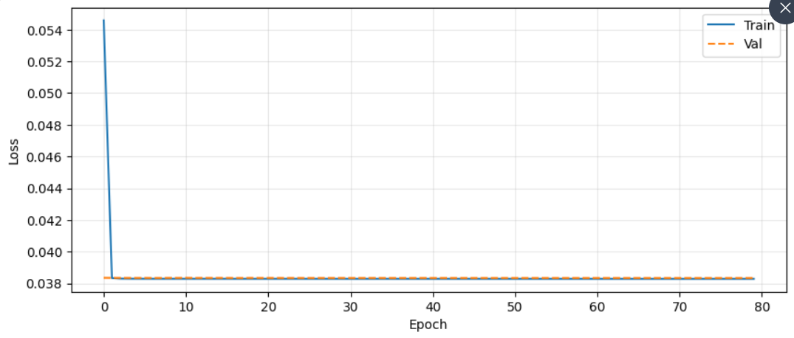
Lần 2:
🖥️ Cấu hình Hệ thống & Dữ liệu
- Thiết bị: cuda (GPU)
- Số lượng đặc trưng: 10
- Kích thước tập Validation: torch.Size([454255, 10, 10])
- Kích thước tập Test: torch.Size([556547, 10, 10])
- Trạng thái mô hình: Đã tải thành công ✅

🔍 Quá trình Tính toán Ngưỡng (Thresholding)
Hệ thống thực hiện tính toán ngưỡng dựa trên sai số tái tạo (Reconstruction Error) của tập dữ liệu bình thường (BENIGN):
- Tiến độ: Hoàn thành 454,255/454,255 mẫu.
- Kết quả ngưỡng tối ưu:
  - $\text{threshold\_re}$: 0.077243
  - $\text{threshold\_u}$: 0.000000

🛡️ Kết quả Đánh giá trên tập Tấn công (Attack Set)
Sau khi áp dụng ngưỡng, mô hình thực hiện phân loại trên 556,547 mẫu tấn công. Kết quả thu được như sau:
Bảng chỉ số chi tiết (Classification Report)
Nhãn (Label) | Precision | Recall | F1-Score | Support
BENIGN | 0.52 | 0.99 | 0.68 | 454,255
Attack | 0.98 | 0.25 | 0.40 | 556,547
Accuracy |  |  | 0.59 | 1,010,802
Macro Avg | 0.75 | 0.62 | 0.54 | 1,010,802
Weighted Avg | 0.78 | 0.59 | 0.53 | 1,010,802

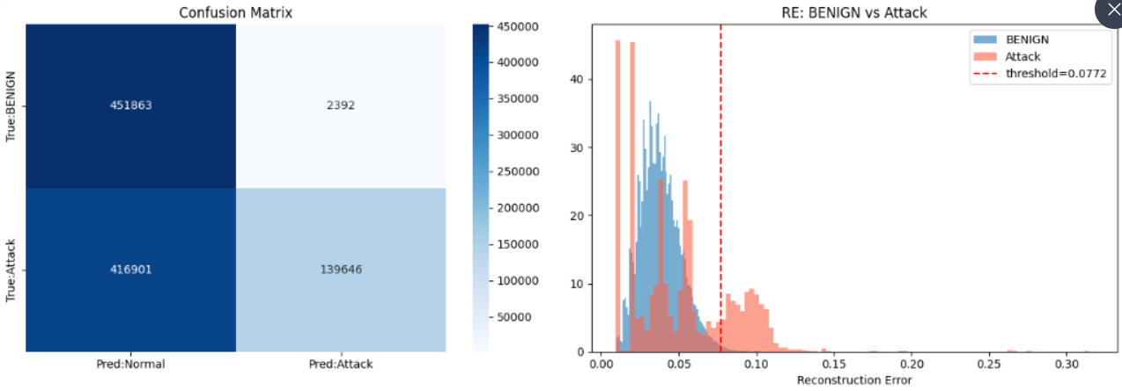
💡 Nhận xét nhanh:
- Recall của BENIGN cực cao (0.9947): Mô hình nhận diện rất tốt các dữ liệu bình thường, hầu như không bỏ sót.
- Recall của Attack thấp (0.2509): Đây là vấn đề chính. Mô hình hiện tại chỉ nhận diện được khoảng 25% các cuộc tấn công. Tuy nhiên, khi đã báo động là Attack thì độ chính xác rất cao (Precision 0.98).
- Hướng cải thiện: Có thể cân nhắc điều chỉnh giảm threshold_re để tăng khả năng phát hiện tấn công (tăng Recall cho Attack), mặc dù điều này có thể làm tăng tỉ lệ báo động giả (False Positive) cho nhãn BENIGN.

Lần 3:
feature_size: 10
latent_dim: 32
threshold_re: 0.094204
threshold_u: 0.00000000

Device: cuda
✅ GPU sẵn sàng!
Tìm thấy 8 file CSV
✓ Friday-WorkingHours-Afternoon-PortScan.pcap_ISCX.csv: 286,467 rows
✓ Thursday-WorkingHours-Morning-WebAttacks.pcap_ISCX.csv: 170,366 rows
✓ Tuesday-WorkingHours.pcap_ISCX.csv: 445,909 rows
✓ Friday-WorkingHours-Afternoon-DDos.pcap_ISCX.csv: 225,745 rows
✓ Monday-WorkingHours.pcap_ISCX.csv: 529,918 rows
✓ Friday-WorkingHours-Morning.pcap_ISCX.csv: 191,033 rows
✓ Thursday-WorkingHours-Afternoon-Infilteration.pcap_ISCX.csv: 288,602 rows
✓ Wednesday-workingHours.pcap_ISCX.csv: 692,703 rows

Tổng: 2,830,743 rows | Features: 10
Label
BENIGN 2273097
DoS Hulk 231073
PortScan 158930
DDoS 128027
DoS GoldenEye 10293
FTP-Patator 7938
SSH-Patator 5897
DoS slowloris 5796
DoS Slowhttptest 5499
Bot 1966
Web Attack � Brute Force 1507
Web Attack � XSS 652
Infiltration 36
Web Attack � Sql Injection 21
Heartbleed 11
Log1p transform: 8 features.
Train:1,817,056 | Val:454,264 | Test(Attack):556,556
✅ Scaler mới đã lưu.
Tạo sliding windows...
Train: (1817047, 10, 10)
Val : (454255, 10, 10)
Test : (556547, 10, 10)
✅ Windows xong!
Model: 19,474 params | β=0.1

>>> Train từ đầu (β=0.1, epoch 1/80)
Training | 3548 batches/epoch

[ 1/80] train=0.09012 (MSE=0.08251 KLD=0.07606) val=0.07503 best=0.07503 lr=3.0e-04
[ 2/80] train=0.07518 (MSE=0.07512 KLD=0.00060) val=0.07502 best=0.07502 lr=3.0e-04
[ 3/80] train=0.07507 (MSE=0.07506 KLD=0.00010) val=0.07502 best=0.07502 lr=3.0e-04
[ 4/80] train=0.07506 (MSE=0.07506 KLD=0.00001) val=0.07502 best=0.07502 lr=3.0e-04
[ 5/80] train=0.07505 (MSE=0.07505 KLD=0.00000) val=0.07502 best=0.07502 lr=3.0e-04
[ 6/80] train=0.07505 (MSE=0.07505 KLD=0.00000) val=0.07502 best=0.07502 lr=3.0e-04
[ 7/80] train=0.07505 (MSE=0.07505 KLD=0.00000) val=0.07503 best=0.07502 lr=2.9e-04
[ 8/80] train=0.07505 (MSE=0.07505 KLD=0.00000) val=0.07502 best=0.07502 lr=2.9e-04
[ 9/80] train=0.07505 (MSE=0.07505 KLD=0.00000) val=0.07502 best=0.07502 lr=2.9e-04
[ 10/80] train=0.07505 (MSE=0.07505 KLD=0.00000) val=0.07502 best=0.07502 lr=2.9e-04
[ 11/80] train=0.07505 (MSE=0.07505 KLD=0.00000) val=0.07502 best=0.07502 lr=2.9e-04
[ 12/80] train=0.07505 (MSE=0.07505 KLD=0.00000) val=0.07502 best=0.07502 lr=2.8e-04
[ 13/80] train=0.07505 (MSE=0.07505 KLD=0.00000) val=0.07502 best=0.07502 lr=2.8e-04
[ 14/80] train=0.07505 (MSE=0.07505 KLD=0.00000) val=0.07502 best=0.07502 lr=2.8e-04
[ 15/80] train=0.07505 (MSE=0.07505 KLD=0.00000) val=0.07502 best=0.07502 lr=2.8e-04
[ 16/80] train=0.07505 (MSE=0.07505 KLD=0.00000) val=0.07502 best=0.07502 lr=2.7e-04
[ 17/80] train=0.07505 (MSE=0.07505 KLD=0.00000) val=0.07502 best=0.07502 lr=2.7e-04
[ 18/80] train=0.07505 (MSE=0.07505 KLD=0.00000) val=0.07502 best=0.07502 lr=2.7e-04
[ 19/80] train=0.07505 (MSE=0.07505 KLD=0.00000) val=0.07502 best=0.07502 lr=2.6e-04
[ 20/80] train=0.07505 (MSE=0.07505 KLD=0.00000) val=0.07502 best=0.07502 lr=2.6e-04
[ 21/80] train=0.07505 (MSE=0.07505 KLD=0.00000) val=0.07502 best=0.07502 lr=2.5e-04
[ 22/80] train=0.07505 (MSE=0.07505 KLD=0.00000) val=0.07502 best=0.07502 lr=2.5e-04
[ 23/80] train=0.07505 (MSE=0.07505 KLD=0.00000) val=0.07502 best=0.07502 lr=2.4e-04
[ 24/80] train=0.07505 (MSE=0.07505 KLD=0.00000) val=0.07502 best=0.07502 lr=2.4e-04
[ 25/80] train=0.07505 (MSE=0.07505 KLD=0.00000) val=0.07502 best=0.07502 lr=2.4e-04
[ 26/80] train=0.07505 (MSE=0.07505 KLD=0.00000) val=0.07502 best=0.07502 lr=2.3e-04
[ 27/80] train=0.07505 (MSE=0.07505 KLD=0.00000) val=0.07502 best=0.07502 lr=2.3e-04
[ 28/80] train=0.07505 (MSE=0.07505 KLD=0.00000) val=0.07502 best=0.07502 lr=2.2e-04
[ 29/80] train=0.07505 (MSE=0.07505 KLD=0.00000) val=0.07502 best=0.07502 lr=2.2e-04
[ 30/80] train=0.07505 (MSE=0.07505 KLD=0.00000) val=0.07502 best=0.07502 lr=2.1e-04
[ 31/80] train=0.07505 (MSE=0.07505 KLD=0.00000) val=0.07502 best=0.07502 lr=2.1e-04
[ 32/80] train=0.07505 (MSE=0.07505 KLD=0.00000) val=0.07502 best=0.07502 lr=2.0e-04
[ 33/80] train=0.07505 (MSE=0.07505 KLD=0.00000) val=0.07502 best=0.07502 lr=1.9e-04
[ 34/80] train=0.07505 (MSE=0.07505 KLD=0.00000) val=0.07502 best=0.07502 lr=1.9e-04
[ 35/80] train=0.07505 (MSE=0.07505 KLD=0.00000) val=0.07502 best=0.07502 lr=1.8e-04
[ 36/80] train=0.07505 (MSE=0.07505 KLD=0.00000) val=0.07502 best=0.07502 lr=1.8e-04
[ 37/80] train=0.07505 (MSE=0.07505 KLD=0.00000) val=0.07502 best=0.07502 lr=1.7e-04
[ 38/80] train=0.07505 (MSE=0.07505 KLD=0.00000) val=0.07502 best=0.07502 lr=1.7e-04
[ 39/80] train=0.07505 (MSE=0.07505 KLD=0.00000) val=0.07502 best=0.07502 lr=1.6e-04
[ 40/80] train=0.07505 (MSE=0.07505 KLD=0.00000) val=0.07502 best=0.07502 lr=1.5e-04
[ 41/80] train=0.07505 (MSE=0.07505 KLD=0.00000) val=0.07501 best=0.07501 lr=1.5e-04
[ 42/80] train=0.07505 (MSE=0.07505 KLD=0.00000) val=0.07502 best=0.07501 lr=1.4e-04
[ 43/80] train=0.07505 (MSE=0.07505 KLD=0.00000) val=0.07502 best=0.07501 lr=1.4e-04
[ 44/80] train=0.07505 (MSE=0.07505 KLD=0.00000) val=0.07502 best=0.07501 lr=1.3e-04
[ 45/80] train=0.07505 (MSE=0.07505 KLD=0.00000) val=0.07502 best=0.07501 lr=1.3e-04
[ 46/80] train=0.07505 (MSE=0.07505 KLD=0.00000) val=0.07502 best=0.07501 lr=1.2e-04
[ 47/80] train=0.07505 (MSE=0.07505 KLD=0.00000) val=0.07502 best=0.07501 lr=1.2e-04
[ 48/80] train=0.07505 (MSE=0.07505 KLD=0.00000) val=0.07502 best=0.07501 lr=1.1e-04
[ 49/80] train=0.07505 (MSE=0.07505 KLD=0.00000) val=0.07502 best=0.07501 lr=1.0e-04
[ 50/80] train=0.07505 (MSE=0.07505 KLD=0.00000) val=0.07501 best=0.07501 lr=1.0e-04
[ 51/80] train=0.07505 (MSE=0.07505 KLD=0.00000) val=0.07501 best=0.07501 lr=9.4e-05
[ 52/80] train=0.07505 (MSE=0.07505 KLD=0.00000) val=0.07501 best=0.07501 lr=8.9e-05
[ 53/80] train=0.07505 (MSE=0.07505 KLD=0.00000) val=0.07502 best=0.07501 lr=8.4e-05
[ 54/80] train=0.07505 (MSE=0.07505 KLD=0.00000) val=0.07501 best=0.07501 lr=7.9e-05
[ 55/80] train=0.07505 (MSE=0.07505 KLD=0.00000) val=0.07501 best=0.07501 lr=7.4e-05
[ 56/80] train=0.07505 (MSE=0.07505 KLD=0.00000) val=0.07502 best=0.07501 lr=7.0e-05
[ 57/80] train=0.07505 (MSE=0.07505 KLD=0.00000) val=0.07502 best=0.07501 lr=6.5e-05
[ 58/80] train=0.07505 (MSE=0.07505 KLD=0.00000) val=0.07501 best=0.07501 lr=6.1e-05
[ 59/80] train=0.07505 (MSE=0.07505 KLD=0.00000) val=0.07502 best=0.07501 lr=5.7e-05
[ 60/80] train=0.07505 (MSE=0.07505 KLD=0.00000) val=0.07501 best=0.07501 lr=5.2e-05
[ 61/80] train=0.07505 (MSE=0.07505 KLD=0.00000) val=0.07502 best=0.07501 lr=4.9e-05
[ 62/80] train=0.07505 (MSE=0.07505 KLD=0.00000) val=0.07501 best=0.07501 lr=4.5e-05
[ 63/80] train=0.07505 (MSE=0.07505 KLD=0.00000) val=0.07501 best=0.07501 lr=4.1e-05
[ 64/80] train=0.07505 (MSE=0.07505 KLD=0.00000) val=0.07501 best=0.07501 lr=3.8e-05
[ 65/80] train=0.07505 (MSE=0.07505 KLD=0.00000) val=0.07501 best=0.07501 lr=3.4e-05
[ 66/80] train=0.07505 (MSE=0.07505 KLD=0.00000) val=0.07502 best=0.07501 lr=3.1e-05
[ 67/80] train=0.07505 (MSE=0.07505 KLD=0.00000) val=0.07501 best=0.07501 lr=2.8e-05
[ 68/80] train=0.07505 (MSE=0.07505 KLD=0.00000) val=0.07501 best=0.07501 lr=2.6e-05
[ 69/80] train=0.07505 (MSE=0.07505 KLD=0.00000) val=0.07501 best=0.07501 lr=2.3e-05
[ 70/80] train=0.07505 (MSE=0.07505 KLD=0.00000) val=0.07501 best=0.07501 lr=2.1e-05
[ 71/80] train=0.07505 (MSE=0.07505 KLD=0.00000) val=0.07501 best=0.07501 lr=1.9e-05
[ 72/80] train=0.07505 (MSE=0.07505 KLD=0.00000) val=0.07501 best=0.07501 lr=1.7e-05
[ 73/80] train=0.07505 (MSE=0.07505 KLD=0.00000) val=0.07501 best=0.07501 lr=1.5e-05
[ 74/80] train=0.07505 (MSE=0.07505 KLD=0.00000) val=0.07501 best=0.07501 lr=1.4e-05
[ 75/80] train=0.07505 (MSE=0.07505 KLD=0.00000) val=0.07501 best=0.07501 lr=1.3e-05
[ 76/80] train=0.07505 (MSE=0.07505 KLD=0.00000) val=0.07501 best=0.07501 lr=1.2e-05
[ 77/80] train=0.07505 (MSE=0.07505 KLD=-0.00000) val=0.07501 best=0.07501 lr=1.1e-05
[ 78/80] train=0.07505 (MSE=0.07505 KLD=-0.00000) val=0.07501 best=0.07501 lr=1.0e-05
[ 79/80] train=0.07505 (MSE=0.07505 KLD=0.00000) val=0.07501 best=0.07501 lr=1.0e-05
[ 80/80] train=0.07505 (MSE=0.07505 KLD=0.00000) val=0.07501 best=0.07501 lr=1.0e-05

✅ Train xong!
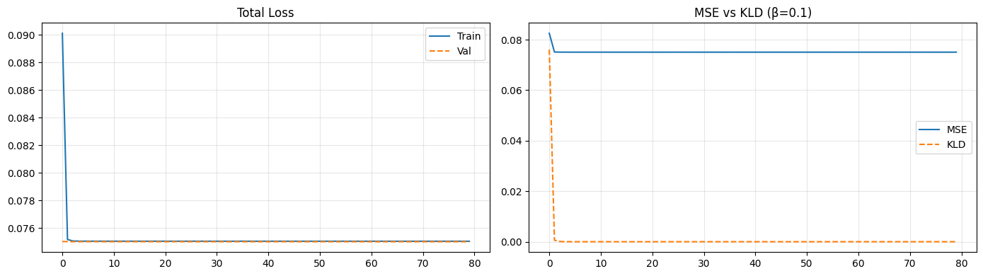
Tính threshold...
0/454255...
40960/454255...
81920/454255...
122880/454255...
163840/454255...
204800/454255...
245760/454255...
286720/454255...
327680/454255...
368640/454255...
409600/454255...
450560/454255...

★ threshold_re = 0.094204
★ threshold_u = 0.0000000005
Đánh giá Attack...
0/556547...
40960/556547...
81920/556547...
122880/556547...
163840/556547...
204800/556547...
245760/556547...
286720/556547...
327680/556547...
368640/556547...
409600/556547...
450560/556547...
491520/556547...
532480/556547...

=================================================================
precision recall f1-score support

BENIGN 0.6020 0.9000 0.7214 454255
Attack 0.8630 0.5143 0.6445 556547

accuracy 0.6876 1010802
macro avg 0.7325 0.7072 0.6830 1010802
weighted avg 0.7457 0.6876 0.6791 1010802

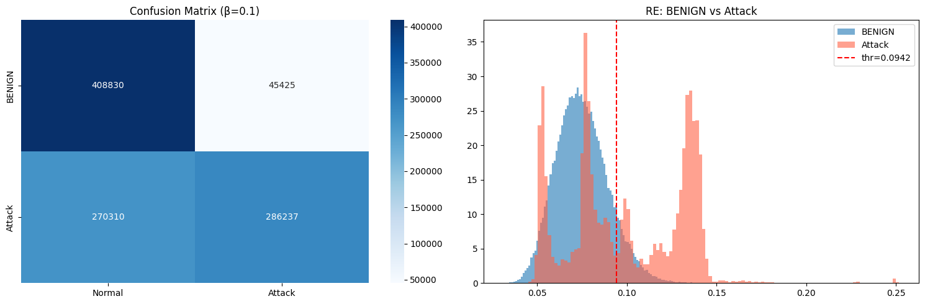

╔══════════════════════════════════════════════════════╗
║ Model đã lưu tại /kaggle/working/ ║
║ Vào Output panel bên phải để tải về ║
╠══════════════════════════════════════════════════════╣
║ Cập nhật config.yaml: ║
║ feature_size: 10 ║
║ latent_dim: 32 ║
║ threshold_re: 0.094204 ║
║ threshold_u: 0.00000000 ║
╚══════════════════════════════════════════════════════╝
Lần 4 :

Đang kết nối Google Drive...
Mounted at /content/drive
✅ Drive kết nối! Thư mục: /content/drive/MyDrive/DDoS_AI_Project
✅ Backup model cũ đã có: /content/drive/MyDrive/DDoS_AI_Project/model_beta001_backup.pth
✅ Zip đã có trong /content/

Device: cuda
✅ GPU sẵn sàng!
✅ Dataset đã giải nén sẵn.
Tìm thấy 8 file CSV
✓ Thursday-WorkingHours-Morning-WebAttacks.pcap_ISCX.csv: 170,366 rows
✓ Friday-WorkingHours-Morning.pcap_ISCX.csv: 191,033 rows
✓ Thursday-WorkingHours-Afternoon-Infilteration.pcap_ISCX.csv: 288,602 rows
✓ Tuesday-WorkingHours.pcap_ISCX.csv: 445,909 rows
✓ Wednesday-workingHours.pcap_ISCX.csv: 692,703 rows
✓ Friday-WorkingHours-Afternoon-DDos.pcap_ISCX.csv: 225,745 rows
✓ Friday-WorkingHours-Afternoon-PortScan.pcap_ISCX.csv: 286,467 rows
✓ Monday-WorkingHours.pcap_ISCX.csv: 529,918 rows

Tổng: 2,830,743 rows | Features: 10
Label
BENIGN 2273097
DoS Hulk 231073
PortScan 158930
DDoS 128027
DoS GoldenEye 10293
FTP-Patator 7938
SSH-Patator 5897
DoS slowloris 5796
DoS Slowhttptest 5499
Bot 1966
Web Attack � Brute Force 1507
Web Attack � XSS 652
Infiltration 36
Web Attack � Sql Injection 21
Heartbleed 11
Log1p transform: 8 features.
Train:1,817,056 | Val:454,264 | Test(Attack):556,556
Fit scaler mới...
✅ Scaler lưu: /content/drive/MyDrive/DDoS_AI_Project/scaler_conv_beta01.pkl
Tạo sliding windows...
Train: (1817047, 10, 10)
Val : (454255, 10, 10)
Test : (556547, 10, 10)
✅ Windows xong!
Model: 19,784 params | β=0.1

>>> Bắt đầu train mới (β=0.1, epoch 1/80)
Training | 3548 batches/epoch

[ 1/80] train=0.09426 (MSE=0.08027 KLD=0.13989) val=0.07492 best=0.07492 lr=3.0e-04
[ 2/80] train=0.07498 (MSE=0.07493 KLD=0.00051) val=0.07491 best=0.07491 lr=3.0e-04
[ 3/80] train=0.07490 (MSE=0.07489 KLD=0.00008) val=0.07491 best=0.07491 lr=3.0e-04
[ 4/80] train=0.07488 (MSE=0.07488 KLD=0.00000) val=0.07490 best=0.07490 lr=3.0e-04
[ 5/80] train=0.07487 (MSE=0.07487 KLD=0.00000) val=0.07491 best=0.07490 lr=3.0e-04
[ 6/80] train=0.07487 (MSE=0.07487 KLD=0.00000) val=0.07490 best=0.07490 lr=3.0e-04
[ 7/80] train=0.07487 (MSE=0.07487 KLD=0.00000) val=0.07491 best=0.07490 lr=2.9e-04
[ 8/80] train=0.07487 (MSE=0.07487 KLD=0.00000) val=0.07490 best=0.07490 lr=2.9e-04
[ 9/80] train=0.07487 (MSE=0.07487 KLD=0.00000) val=0.07491 best=0.07490 lr=2.9e-04
[ 10/80] train=0.07487 (MSE=0.07487 KLD=0.00000) val=0.07490 best=0.07490 lr=2.9e-04
[ 11/80] train=0.07487 (MSE=0.07487 KLD=0.00000) val=0.07490 best=0.07490 lr=2.9e-04
[ 12/80] train=0.07487 (MSE=0.07487 KLD=0.00000) val=0.07491 best=0.07490 lr=2.8e-04
[ 13/80] train=0.07487 (MSE=0.07487 KLD=0.00000) val=0.07490 best=0.07490 lr=2.8e-04
[ 14/80] train=0.07487 (MSE=0.07487 KLD=0.00000) val=0.07490 best=0.07490 lr=2.8e-04
[ 15/80] train=0.07487 (MSE=0.07487 KLD=0.00000) val=0.07490 best=0.07490 lr=2.8e-04
[ 16/80] train=0.07487 (MSE=0.07487 KLD=0.00000) val=0.07490 best=0.07490 lr=2.7e-04
[ 17/80] train=0.07487 (MSE=0.07487 KLD=0.00000) val=0.07490 best=0.07490 lr=2.7e-04
[ 18/80] train=0.07487 (MSE=0.07487 KLD=0.00000) val=0.07490 best=0.07490 lr=2.7e-04
[ 19/80] train=0.07487 (MSE=0.07487 KLD=0.00000) val=0.07490 best=0.07490 lr=2.6e-04
[ 20/80] train=0.07487 (MSE=0.07487 KLD=0.00000) val=0.07490 best=0.07490 lr=2.6e-04
[ 21/80] train=0.07487 (MSE=0.07487 KLD=0.00000) val=0.07490 best=0.07490 lr=2.5e-04
[ 22/80] train=0.07487 (MSE=0.07487 KLD=0.00000) val=0.07490 best=0.07490 lr=2.5e-04
[ 23/80] train=0.07487 (MSE=0.07487 KLD=0.00000) val=0.07490 best=0.07490 lr=2.4e-04
[ 24/80] train=0.07487 (MSE=0.07487 KLD=0.00000) val=0.07490 best=0.07490 lr=2.4e-04
[ 25/80] train=0.07487 (MSE=0.07487 KLD=0.00000) val=0.07490 best=0.07490 lr=2.4e-04
[ 26/80] train=0.07487 (MSE=0.07487 KLD=0.00000) val=0.07490 best=0.07490 lr=2.3e-04
[ 27/80] train=0.07487 (MSE=0.07487 KLD=0.00000) val=0.07490 best=0.07490 lr=2.3e-04
[ 28/80] train=0.07487 (MSE=0.07487 KLD=0.00000) val=0.07490 best=0.07490 lr=2.2e-04
[ 29/80] train=0.07487 (MSE=0.07487 KLD=0.00000) val=0.07490 best=0.07490 lr=2.2e-04
[ 30/80] train=0.07487 (MSE=0.07487 KLD=0.00000) val=0.07490 best=0.07490 lr=2.1e-04
[ 31/80] train=0.07487 (MSE=0.07487 KLD=0.00000) val=0.07490 best=0.07490 lr=2.1e-04
[ 32/80] train=0.07487 (MSE=0.07487 KLD=0.00000) val=0.07490 best=0.07490 lr=2.0e-04
[ 33/80] train=0.07487 (MSE=0.07487 KLD=0.00000) val=0.07490 best=0.07490 lr=1.9e-04
[ 34/80] train=0.07487 (MSE=0.07487 KLD=0.00000) val=0.07490 best=0.07490 lr=1.9e-04
[ 35/80] train=0.07487 (MSE=0.07487 KLD=0.00000) val=0.07490 best=0.07490 lr=1.8e-04
[ 36/80] train=0.07487 (MSE=0.07487 KLD=0.00000) val=0.07490 best=0.07490 lr=1.8e-04
[ 37/80] train=0.07487 (MSE=0.07487 KLD=0.00000) val=0.07490 best=0.07490 lr=1.7e-04
[ 38/80] train=0.07487 (MSE=0.07487 KLD=0.00000) val=0.07490 best=0.07490 lr=1.7e-04
[ 39/80] train=0.07487 (MSE=0.07487 KLD=0.00000) val=0.07490 best=0.07490 lr=1.6e-04
[ 40/80] train=0.07487 (MSE=0.07487 KLD=0.00000) val=0.07490 best=0.07490 lr=1.5e-04
[ 41/80] train=0.07487 (MSE=0.07487 KLD=0.00000) val=0.07490 best=0.07490 lr=1.5e-04
[ 42/80] train=0.07487 (MSE=0.07487 KLD=0.00000) val=0.07490 best=0.07490 lr=1.4e-04
[ 43/80] train=0.07487 (MSE=0.07487 KLD=0.00000) val=0.07490 best=0.07490 lr=1.4e-04
[ 44/80] train=0.07487 (MSE=0.07487 KLD=0.00000) val=0.07490 best=0.07490 lr=1.3e-04
[ 45/80] train=0.07487 (MSE=0.07487 KLD=0.00000) val=0.07490 best=0.07490 lr=1.3e-04
[ 46/80] train=0.07487 (MSE=0.07487 KLD=0.00000) val=0.07490 best=0.07490 lr=1.2e-04
[ 47/80] train=0.07487 (MSE=0.07487 KLD=0.00000) val=0.07490 best=0.07490 lr=1.2e-04
[ 48/80] train=0.07487 (MSE=0.07487 KLD=0.00000) val=0.07490 best=0.07490 lr=1.1e-04
[ 49/80] train=0.07487 (MSE=0.07487 KLD=0.00000) val=0.07490 best=0.07490 lr=1.0e-04
[ 50/80] train=0.07487 (MSE=0.07487 KLD=0.00000) val=0.07490 best=0.07490 lr=1.0e-04
[ 51/80] train=0.07486 (MSE=0.07486 KLD=0.00000) val=0.07490 best=0.07490 lr=9.4e-05
[ 52/80] train=0.07487 (MSE=0.07487 KLD=0.00000) val=0.07490 best=0.07490 lr=8.9e-05
[ 53/80] train=0.07487 (MSE=0.07487 KLD=0.00000) val=0.07490 best=0.07490 lr=8.4e-05
[ 54/80] train=0.07487 (MSE=0.07487 KLD=0.00000) val=0.07490 best=0.07490 lr=7.9e-05
[ 55/80] train=0.07487 (MSE=0.07487 KLD=0.00000) val=0.07490 best=0.07490 lr=7.4e-05
[ 56/80] train=0.07487 (MSE=0.07487 KLD=0.00000) val=0.07490 best=0.07490 lr=7.0e-05
[ 57/80] train=0.07487 (MSE=0.07487 KLD=0.00000) val=0.07490 best=0.07490 lr=6.5e-05
[ 58/80] train=0.07487 (MSE=0.07487 KLD=0.00000) val=0.07490 best=0.07490 lr=6.1e-05
[ 59/80] train=0.07486 (MSE=0.07486 KLD=0.00000) val=0.07490 best=0.07490 lr=5.7e-05
[ 60/80] train=0.07487 (MSE=0.07487 KLD=0.00000) val=0.07490 best=0.07490 lr=5.2e-05
[ 61/80] train=0.07487 (MSE=0.07487 KLD=0.00000) val=0.07490 best=0.07490 lr=4.9e-05
[ 62/80] train=0.07487 (MSE=0.07487 KLD=0.00000) val=0.07490 best=0.07490 lr=4.5e-05
[ 63/80] train=0.07487 (MSE=0.07487 KLD=0.00000) val=0.07490 best=0.07490 lr=4.1e-05
[ 64/80] train=0.07486 (MSE=0.07486 KLD=0.00000) val=0.07490 best=0.07490 lr=3.8e-05
[ 65/80] train=0.07486 (MSE=0.07486 KLD=0.00000) val=0.07490 best=0.07490 lr=3.4e-05
[ 66/80] train=0.07487 (MSE=0.07487 KLD=0.00000) val=0.07490 best=0.07490 lr=3.1e-05
[ 67/80] train=0.07487 (MSE=0.07487 KLD=0.00000) val=0.07490 best=0.07490 lr=2.8e-05
[ 68/80] train=0.07486 (MSE=0.07486 KLD=0.00000) val=0.07490 best=0.07490 lr=2.6e-05
[ 69/80] train=0.07487 (MSE=0.07487 KLD=0.00000) val=0.07490 best=0.07490 lr=2.3e-05
[ 70/80] train=0.07486 (MSE=0.07486 KLD=0.00000) val=0.07490 best=0.07490 lr=2.1e-05
[ 71/80] train=0.07487 (MSE=0.07487 KLD=0.00000) val=0.07490 best=0.07490 lr=1.9e-05
[ 72/80] train=0.07486 (MSE=0.07486 KLD=0.00000) val=0.07490 best=0.07490 lr=1.7e-05
[ 73/80] train=0.07487 (MSE=0.07487 KLD=0.00000) val=0.07490 best=0.07490 lr=1.5e-05
[ 74/80] train=0.07487 (MSE=0.07487 KLD=0.00000) val=0.07490 best=0.07490 lr=1.4e-05
[ 75/80] train=0.07486 (MSE=0.07486 KLD=-0.00000) val=0.07490 best=0.07490 lr=1.3e-05
[ 76/80] train=0.07486 (MSE=0.07486 KLD=0.00000) val=0.07490 best=0.07490 lr=1.2e-05
[ 77/80] train=0.07486 (MSE=0.07486 KLD=-0.00000) val=0.07490 best=0.07490 lr=1.1e-05
[ 78/80] train=0.07486 (MSE=0.07486 KLD=-0.00000) val=0.07490 best=0.07490 lr=1.0e-05
[ 79/80] train=0.07486 (MSE=0.07486 KLD=-0.00000) val=0.07490 best=0.07490 lr=1.0e-05
[ 80/80] train=0.07486 (MSE=0.07486 KLD=0.00000) val=0.07490 best=0.07490 lr=1.0e-05

✅ Train xong! Model lưu: /content/drive/MyDrive/DDoS_AI_Project/model_conv_beta01_best.pth
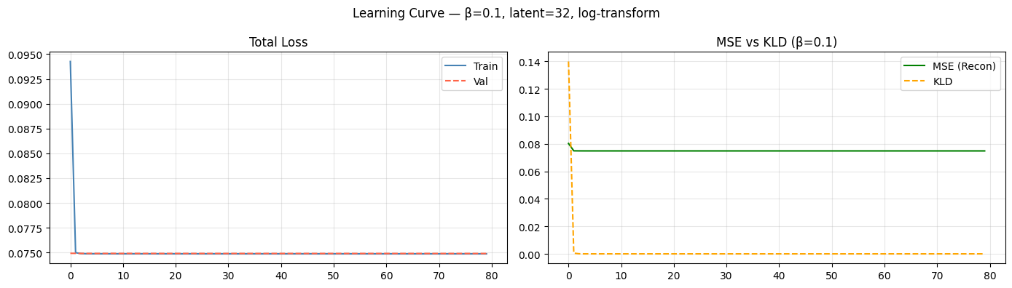
Tính threshold trên Val (BENIGN)...
0/454255...
40960/454255...
81920/454255...
122880/454255...
163840/454255...
204800/454255...
245760/454255...
286720/454255...
327680/454255...
368640/454255...
409600/454255...
450560/454255...

=======================================================
★ threshold_re = 0.094056
★ threshold_u = 0.0000000003
=======================================================
RE val — mean=0.07490, std=0.01448
U val — mean=2.01e-10, std=3.02e-11, max=3.46e-10

Đánh giá trên Test (Attack)...
0/556547...
40960/556547...
81920/556547...
122880/556547...
163840/556547...
204800/556547...
245760/556547...
286720/556547...
327680/556547...
368640/556547...
409600/556547...
450560/556547...
491520/556547...
532480/556547...

=================================================================
KẾT QUẢ — CIC-IDS2017 | β=0.1 | log-transform | latent=32
=================================================================
precision recall f1-score support

BENIGN 0.6012 0.9000 0.7209 454255
Attack 0.8627 0.5128 0.6433 556547

accuracy 0.6868 1010802
macro avg 0.7320 0.7064 0.6821 1010802
weighted avg 0.7452 0.6868 0.6781 1010802

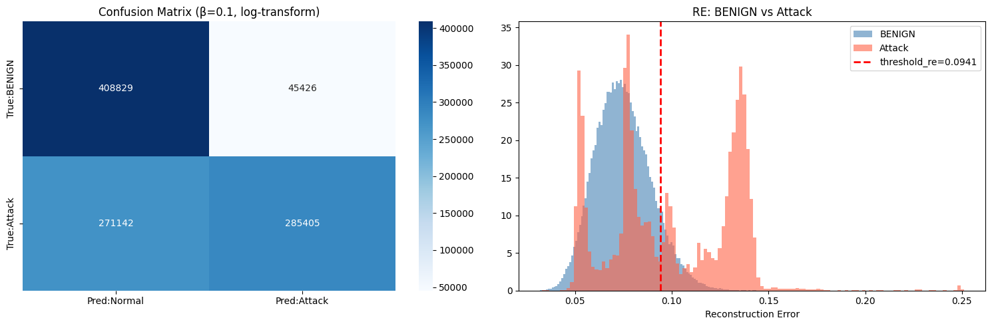

Attack Type N RE_mean Det%
────────────────────────────────────────────────────────────────────────
---------------------------------------------------------------------------
ValueError Traceback (most recent call last)
/tmp/ipykernel_6724/2172205617.py in <cell line: 0>()
501 Xsub = sub[[f for f in FEATS if f in sub.columns]].values.astype(np.float32)
502 Xsub[:, LOG_IDX] = np.log1p(np.abs(Xsub[:, LOG_IDX]))
--> 503 Xsub_sc = sc.transform(Xsub)
504 Wsub = make_windows(Xsub_sc, SEQ)
505 if len(Wsub) == 0: continue

5 frames

/usr/local/lib/python3.12/dist-packages/sklearn/utils/validation.py in _assert_all_finite_element_wise(X, xp, allow_nan, msg_dtype, estimator_name, input_name)
167 "#estimators-that-handle-nan-values"
168 )
--> 169 raise ValueError(msg_err)
170
171

ValueError: Input X contains infinity or a value too large for dtype('float32').
Beta
7 / 10used queries

1

