**ASSIGNMENT 3:**

**Module 4: Functions & Modules in Python**

**Task 1: Calculate Factorial Using a Function**

**Problem Statement:** Write a Python program that:

1. Defines a function named factorial that takes a number as an argument and calculates its factorial using a loop or recursion.

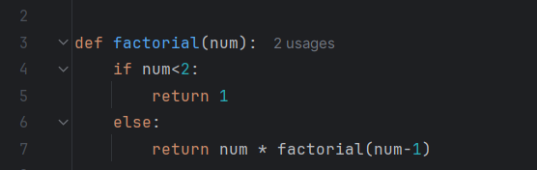

1. Returns the calculated factorial.

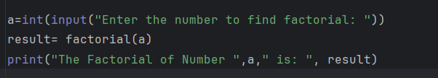

1. Calls the function with a sample number and prints the output.

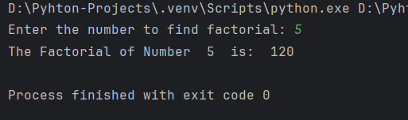

**Task 2: Using the Math Module for Calculations**

**Problem Statement:** Write a Python program that:

1. Asks the user for a number as input.

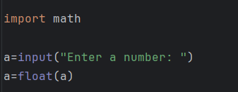

1. Uses the math module to calculate the:

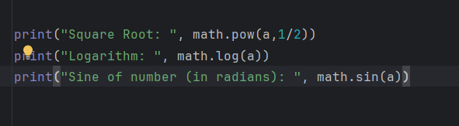

1. Displays the calculated results.

