ASSIGNMENT 2:
Module 3: Control Structures in Python

Task 1: Check if a Number is Even or Odd
Problem Statement: Write a Python program that:
- Takes an integer input from the user.
- Checks whether the number is even or odd using an if-else statement.
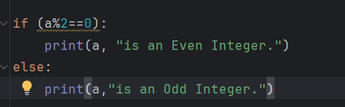
- Displays the result accordingly.
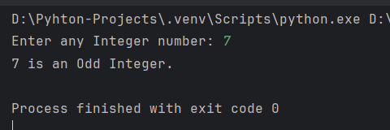
==========================================================================
Task 2: Sum of Integers from 1 to 50 Using a Loop
Problem Statement: Write a Python program that:

- Uses a for loop to iterate over numbers from 1 to 50.
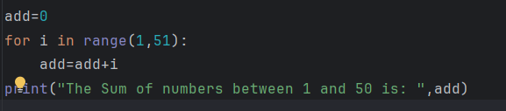

- Calculates the sum of all integers in this range.
Using logic:
add=0
For each iteration of count from 1 to 50:
Then, add=add+count
3. Displays the final sum.
