**Docker Image Pull / Push Dockerhub**

**Create file & build image from container on Linux aws Instance**

**Project Scenario:**

1. Check docker services
2. Create container & file
3. Build image from container
4. Build container form my image

**Practical Work:**

Create aws Linux ec2 instance with docker

Access the instance via Putty

>>> Install and start the docker services:

__| __|_ )

_| ( / Amazon Linux 2 AMI

___|\___|___|

https://aws.amazon.com/amazon-linux-2/

[ec2-user@ip-172-31-45-174 ~]$ **sudo su**

[root@ip-172-31-45-174 ec2-user]# **yum docker update -y**

[root@ip-172-31-45-174 ec2-user]# **yum install docker –y**

[root@ip-172-31-45-174 ec2-user]# **service docker start**

>>> Create container now;

[root@ip-172-31-45-174 ec2-user]# **docker run -it ubuntu /bin/bash**  
Status: Downloaded newer image for ubuntu:latest

>>> create dummy files in this container and list;

oot@d275840c013a: /root@d275840c013a:/# **touch file1 test1 test2 xyz**

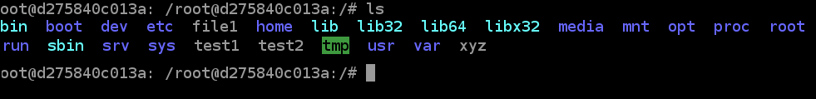

>>> Enter tmp directory and make some files here

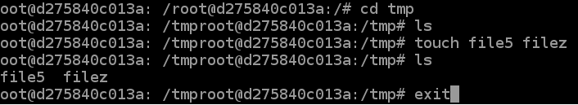

>>>> Exit from container & Create Image from this Container “lucid_lamport”

[root@ip-172-31-45-174 ec2-user]# **docker commit lucid_lamport image1**

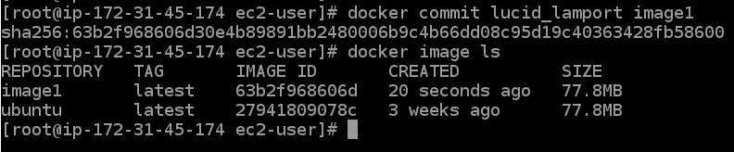

>>> NOW this image “image1” needs to be PUSHED at Docker HUB;

Open dockerhub site to login (or create dockerhub account if not exist):   
<https://hub.docker.com/login>

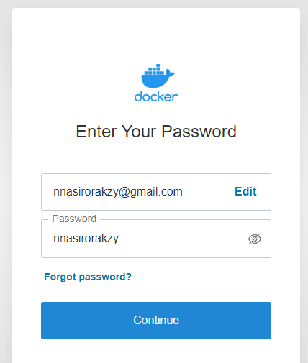

>>>> Now LOGIN in ex2 instance Docker with your account;

[root@ip-172-31-45-174 ec2-user]# **docker login**

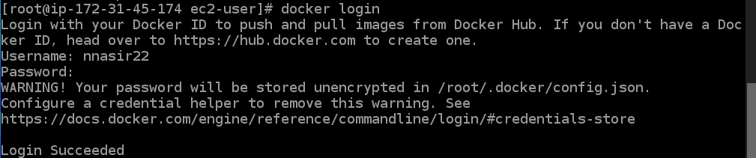

>>>Now TAG & PUSH the image1 on Dockerhub;

[root@ip-172-31-45-174 ec2-user]# **docker tag image1 nnasir22/project1**

[root@ip-172-31-45-174 ec2-user]# **docker push nnasir22/project1**

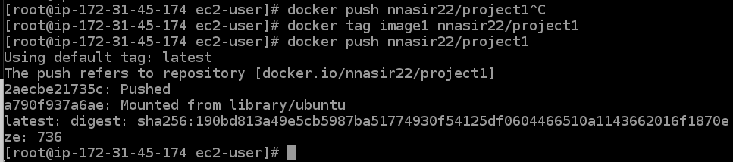

>>> Now go to your Dockerhub Account and see the published image;

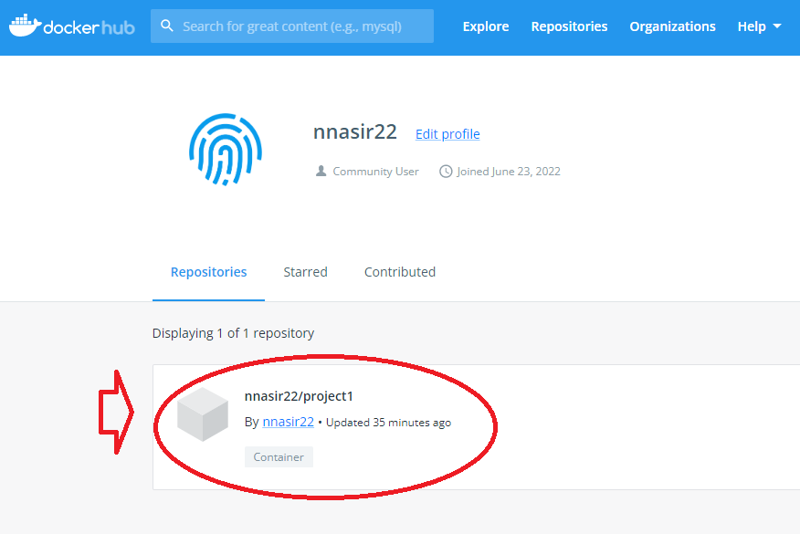

>>> Now PULL this image from anywhere in the world on any docker based OS to create container; Below shots are from Local virtual Box VM based on UBUNTU operating System

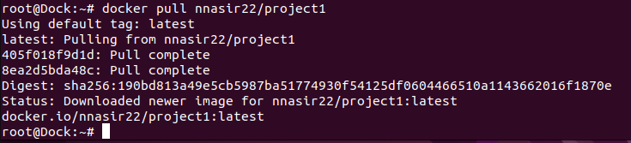

>>> Now Run the Container;



>>> Now within the container you can verify your files that you created in your images with names File1, text1, text2….;

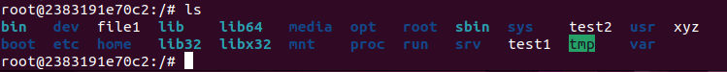

Even in the tmp directory we had created few files like “file5, filez”

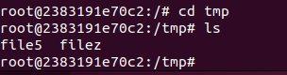

**NOTE:** we could easily pullthe image from dockerhub coz it was publically accessable. We can secure it by doing **make it private** in settings

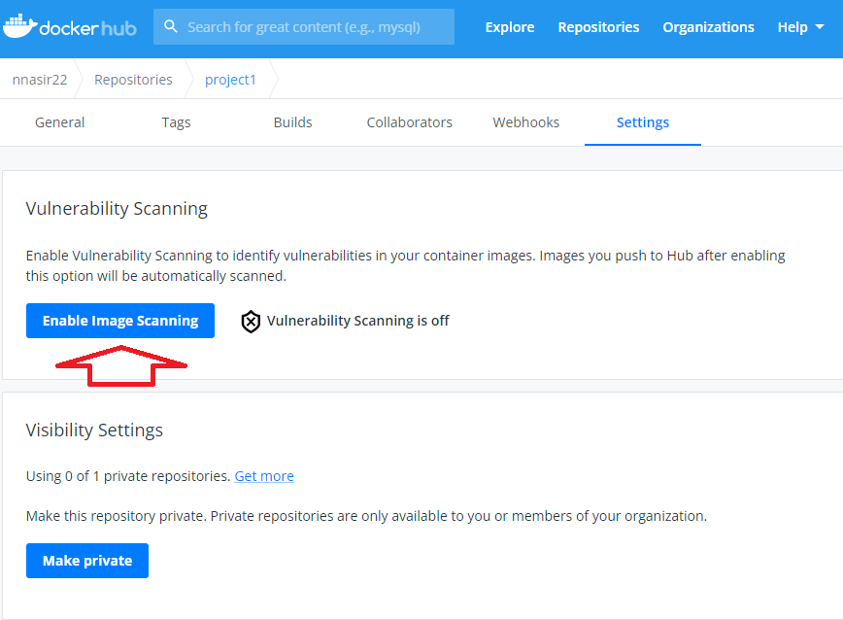

>>>>>>>>>>>>>>>>>>>>>>>>>>>>>>>>>>> Best of Luck<<<<<<<<<<<<<<<<<<<<<<<<<<<<<<<<<<<<<<<