COIT20256 Object-Oriented Development
Assignment 2 Report

Student ID: 12290114
Student Name: Natthapong Rinsakul

Introduction
This program is designed to work with the PatientRecord.txt. It serves as a comprehensive Patient Management System specifically developed to perform Cardiovascular Risk Assessments. The system evaluate a patient’s health status by calculating a risk score based on key medical data, including age, blood pressure, cholesterol levels, and smoking history.

System Scope
- Graphical User Interface (GUI): Developed using JavaFX.
- Data Existence: Support data storage by allowing users to save and load patient records from a text file (.txt).
- Data Management: Support adding new patients (Add), searching patients by phone number (Search), and sorting the list by age (Sort)
- Input Validation: Features a robust validation system that checks for empty fields, incorrect data types, and out-of-range values to prevent system errors.

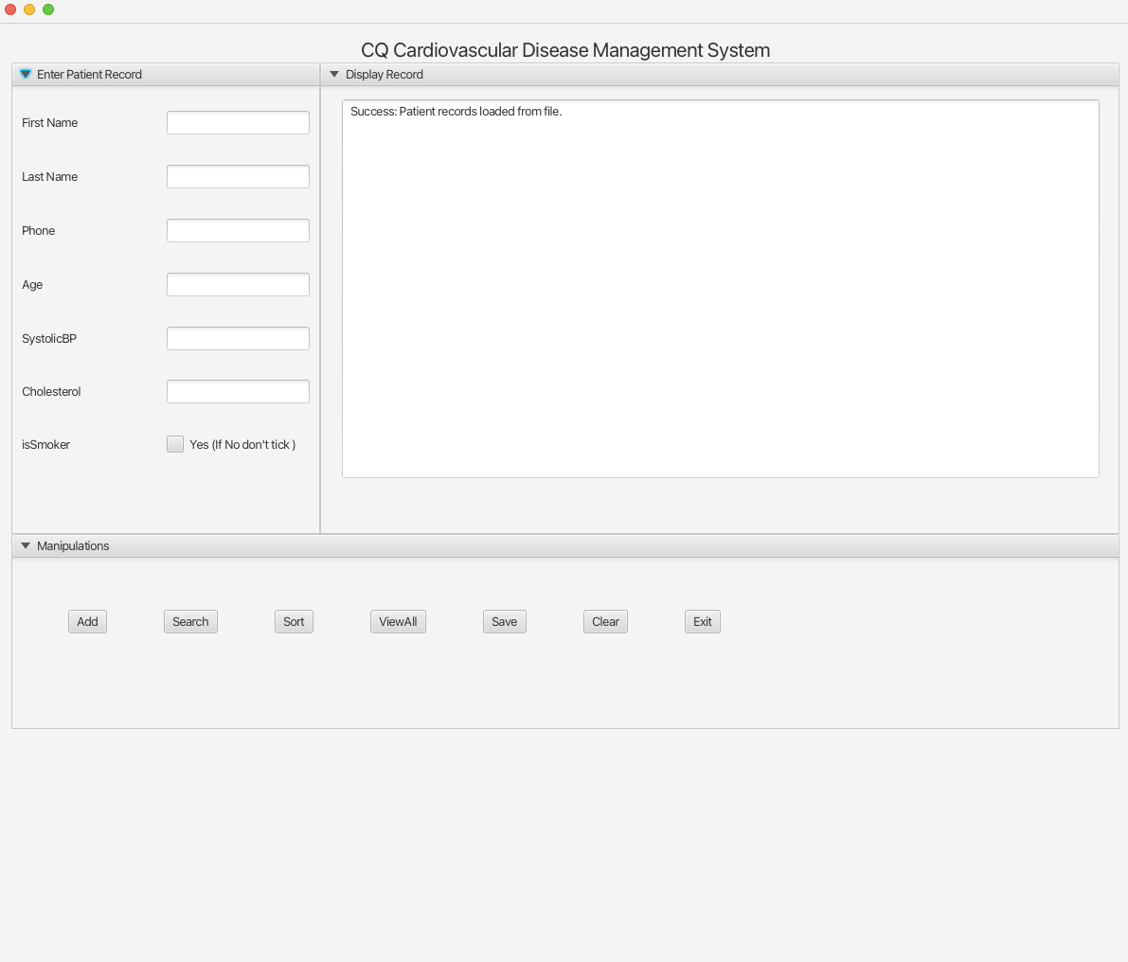
Figure 1: The program showing successful data loading from the text file

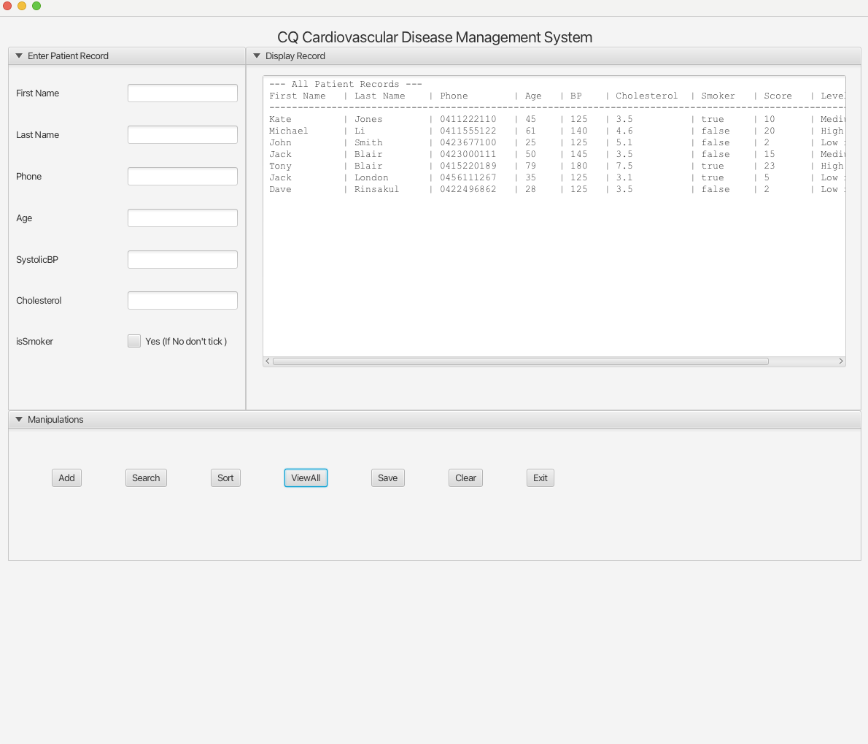
Figure 2: The View All functionality retrieves and displays all patient records stored in the data file in a structured format

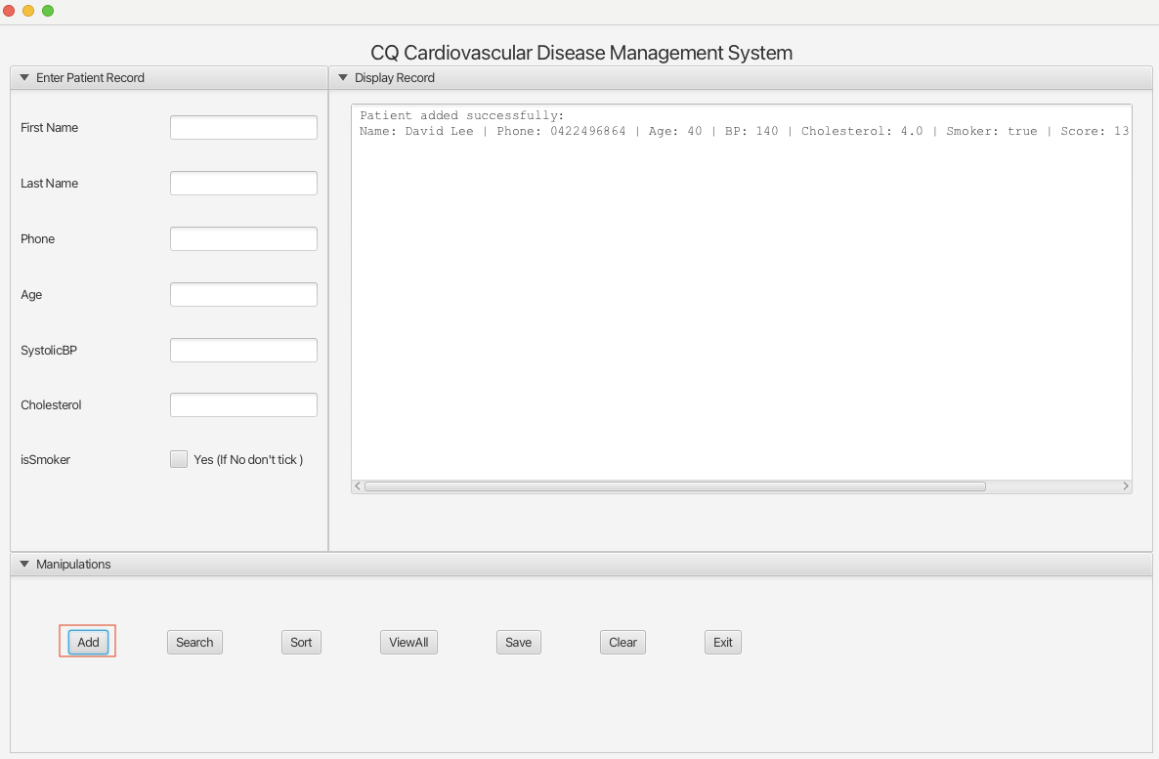
Figure 3: The Add functionality successfully creates a new patient record and displays a confirmation message along with the patient details
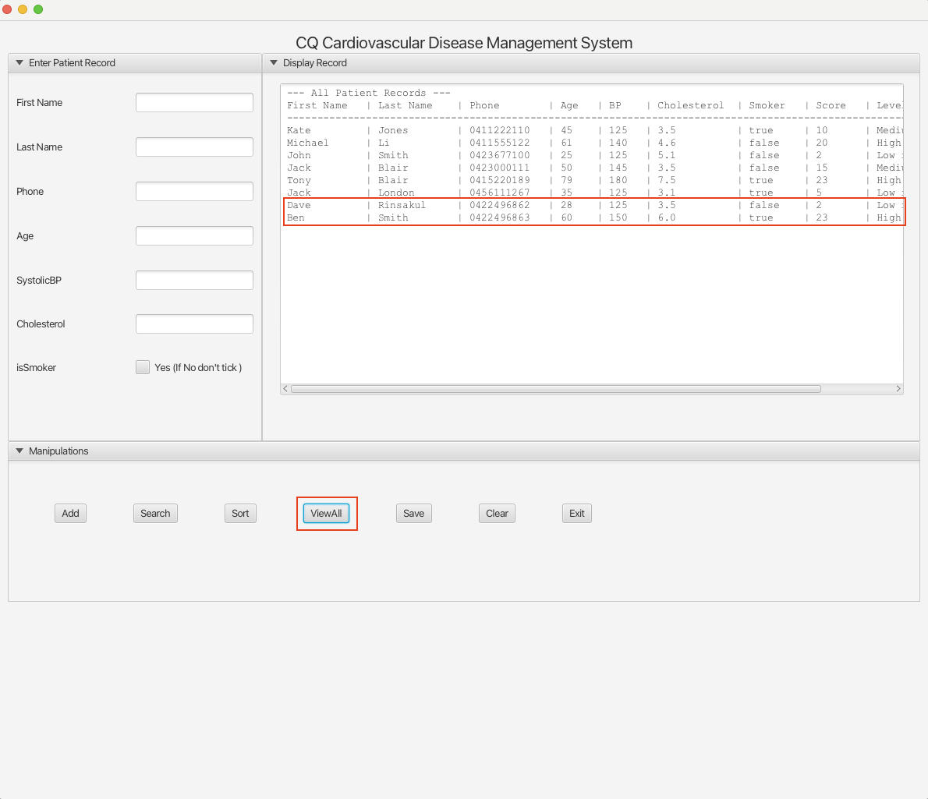
Figure 4: The View All functionality displays the updated list of patient records, confirming that the newly added patients have been successfully

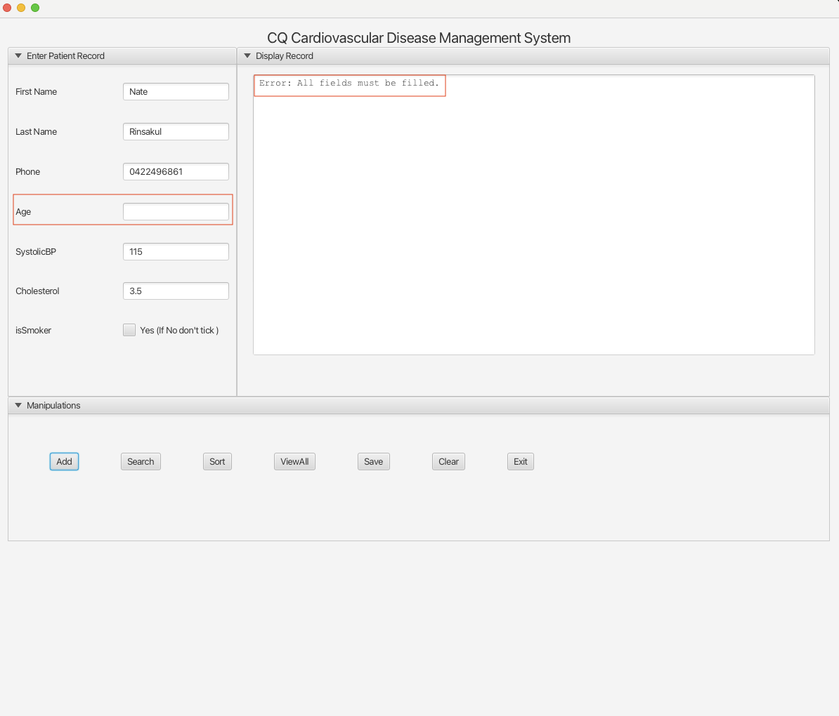
Figure 5: The system's input validation in action; an error message is displayed when mandatory fields are left blank
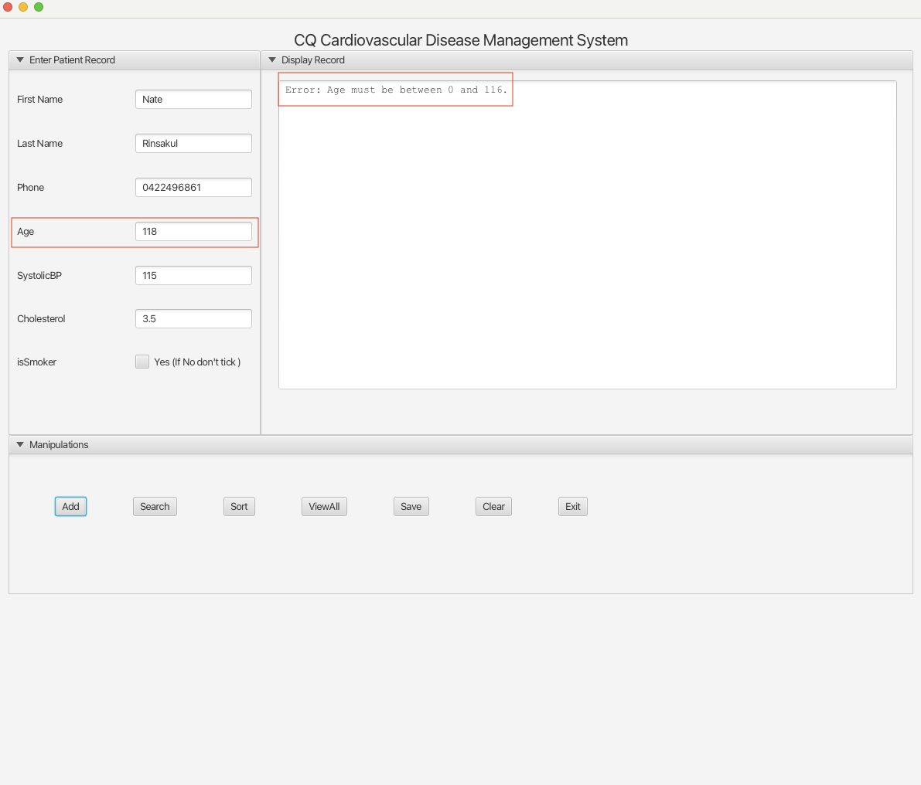
Figure 6: The system enforces an age range constraint. If the entered value is outside the valid range of 0 to 116

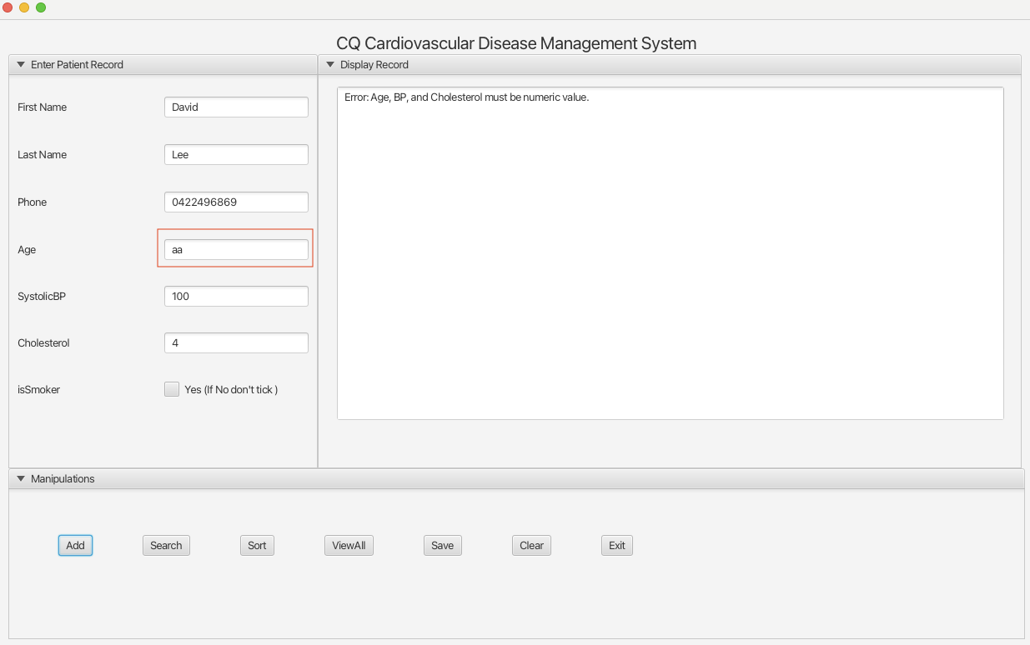
Figure 7: Error message displayed when non-numeric data is entered, ensuring all health metrics are recorded in the correct format

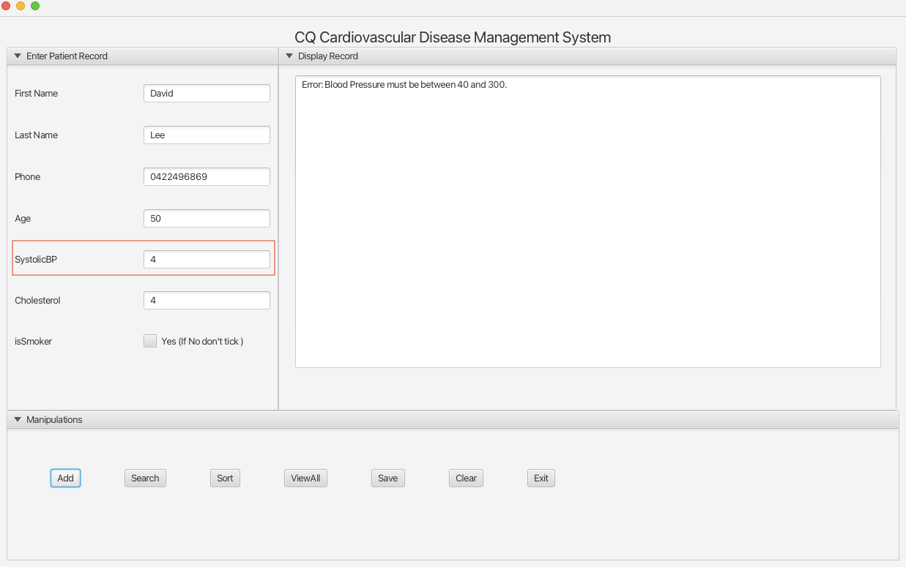
Figure 8: Error message displayed when blood pressure is outside the range between 40 and 300

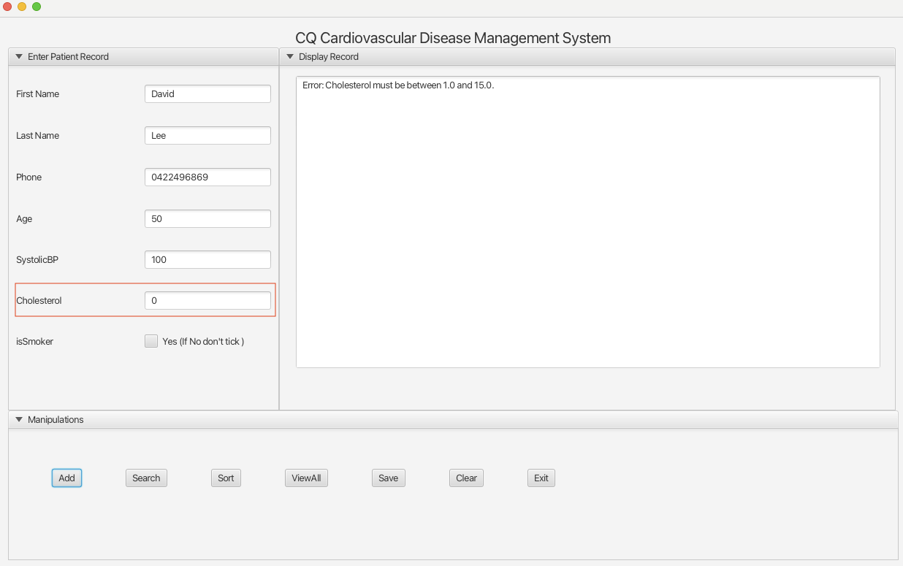
Figure 9: Error message displayed when cholesterol is outside the range between 1.0 and 15.0

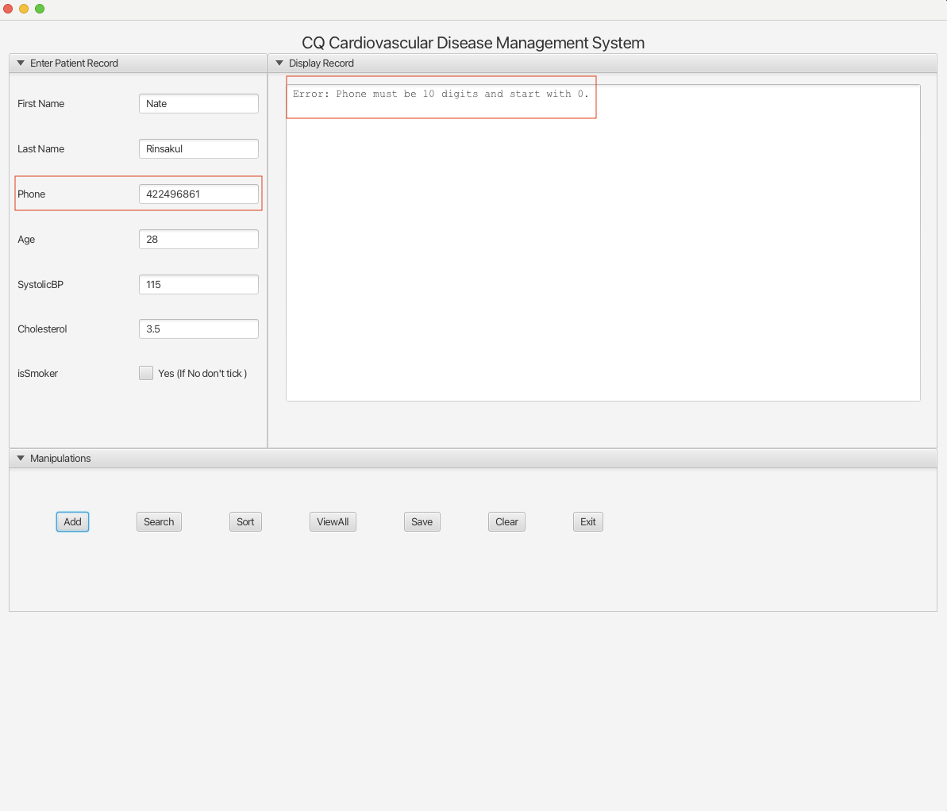
Figure 10: Input validation for the Phone field, showing error handling for incorrect length or improper starting digits

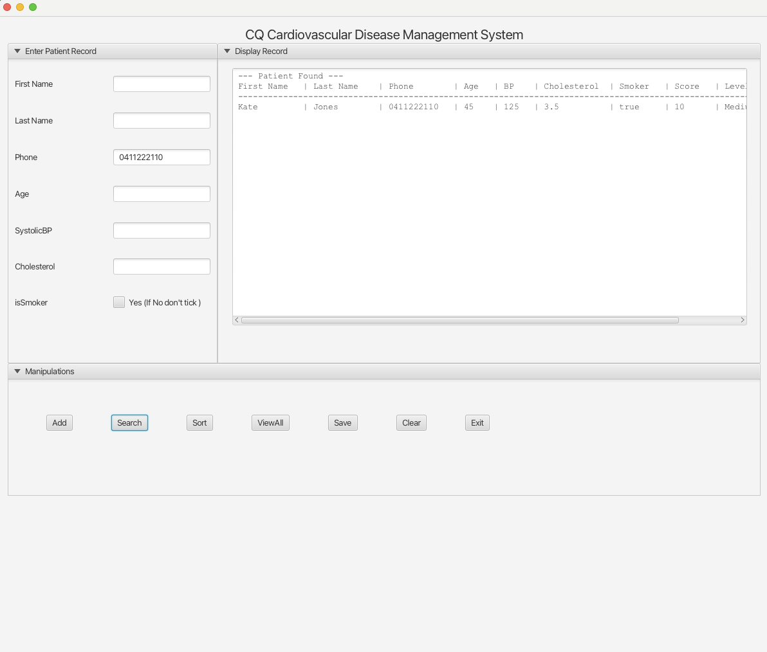
Figure 11: The Search functionality, when a valid phone number is entered, the system retrieves and displays
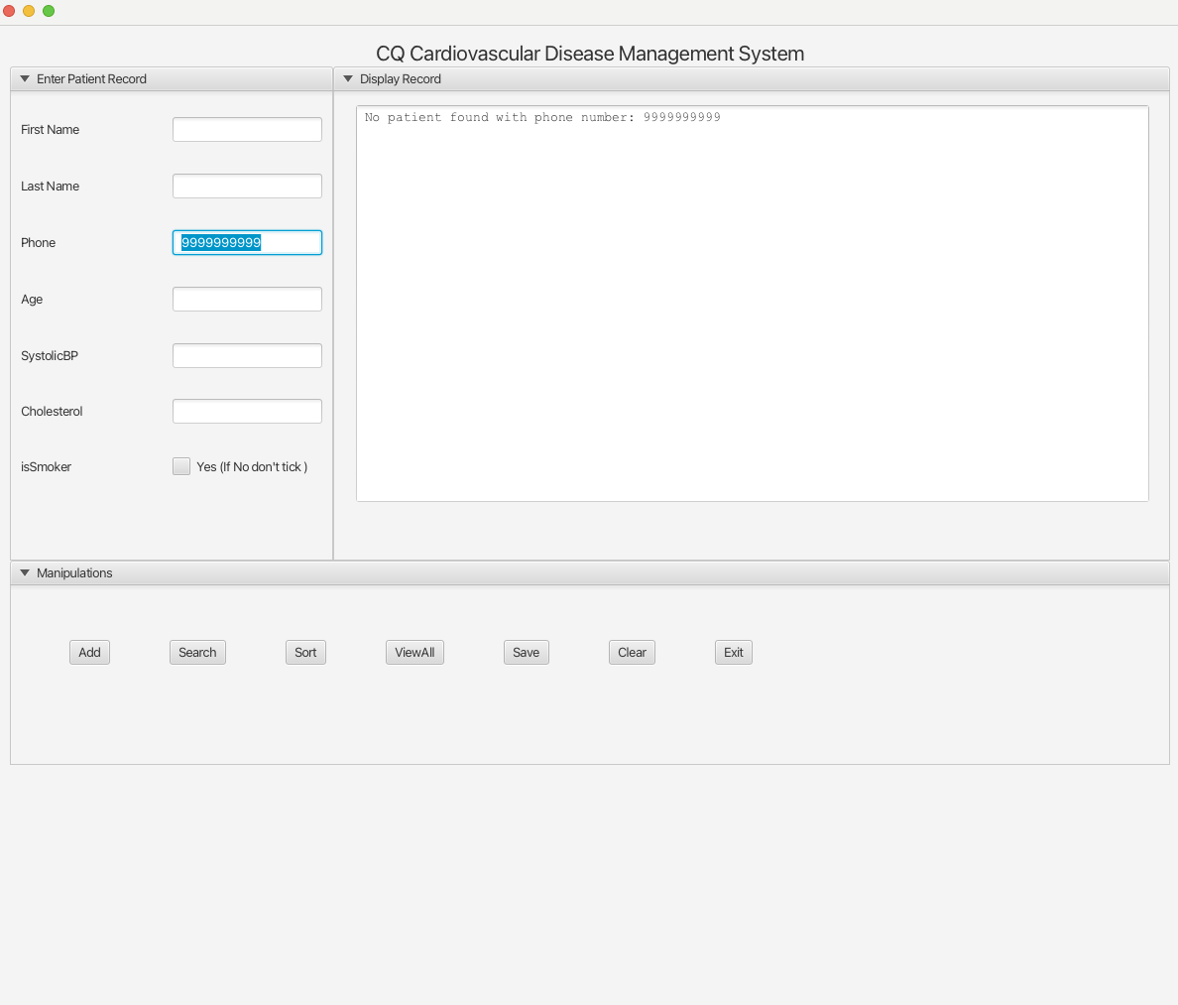
Figure 12: Search result when no patient was found

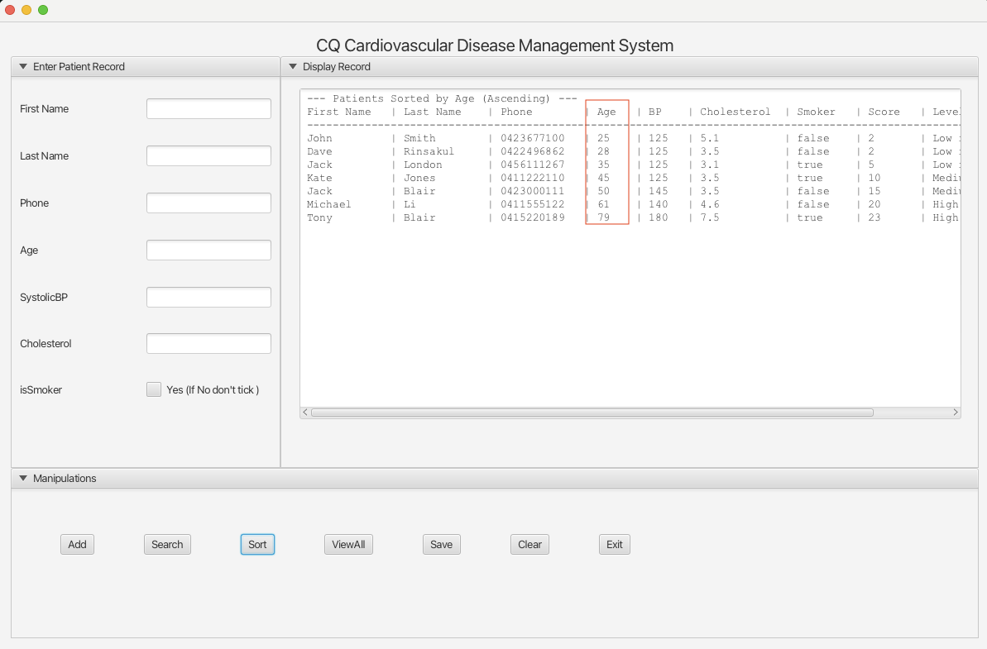
Figure 13: Patient records sorted by Age (Ascending)

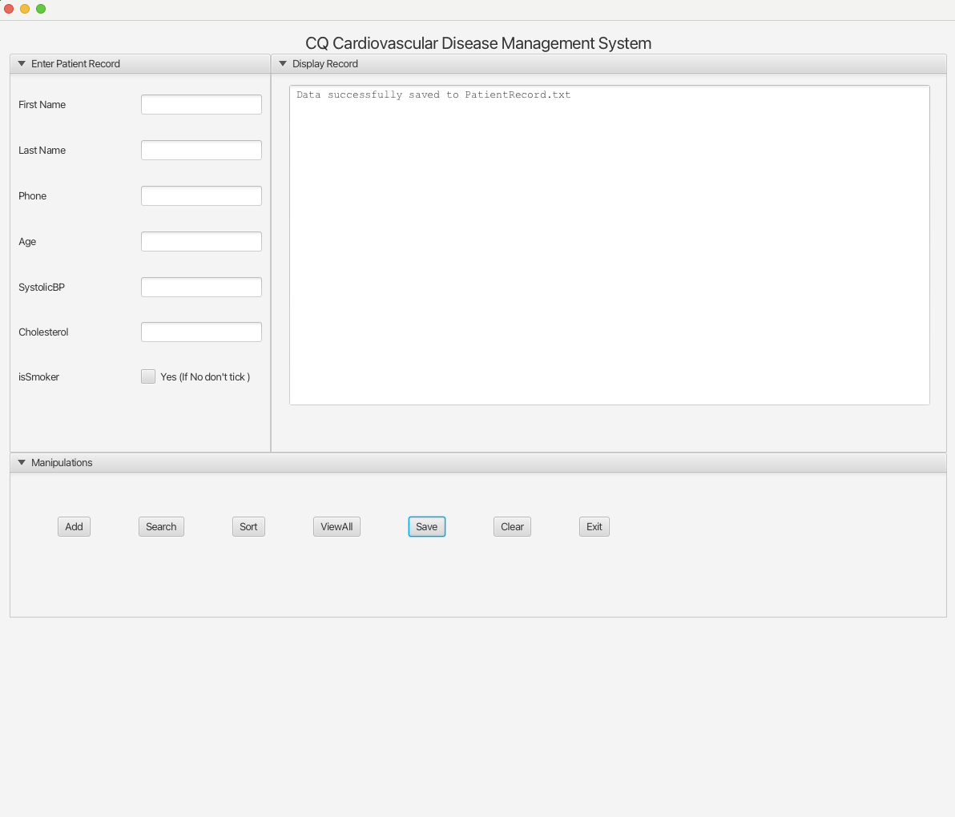
Figure 14: Save new patient details successfully exported to the PatientRecord.txt file

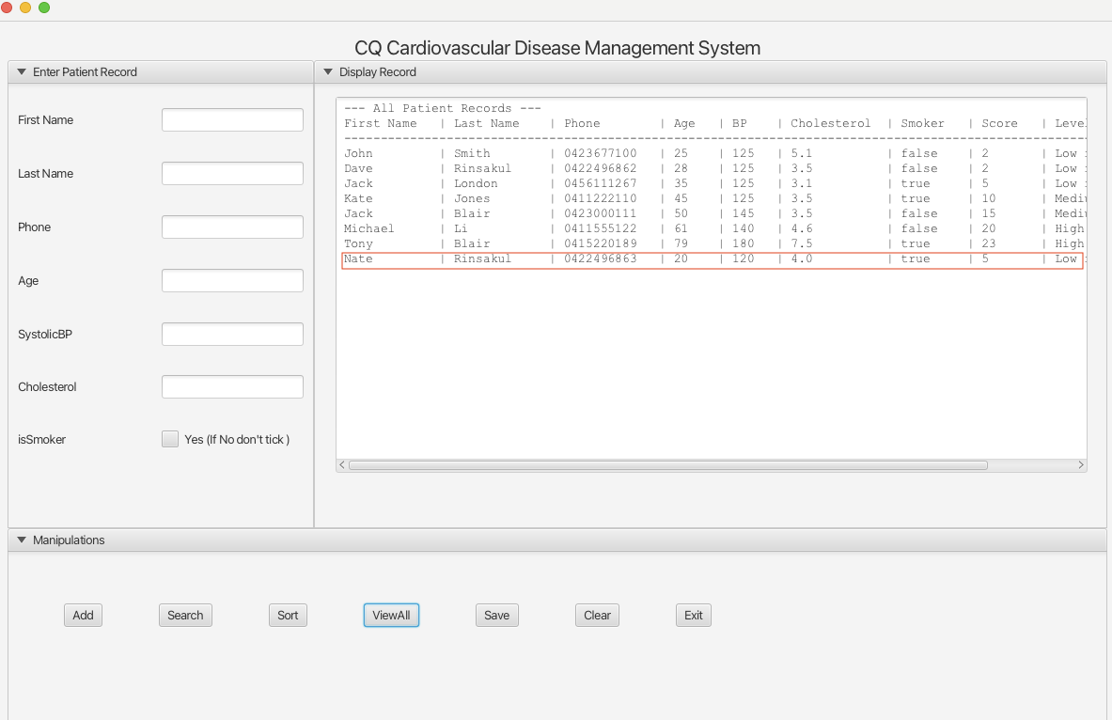
Figure 15: New registered patients remain in the system after an application restart

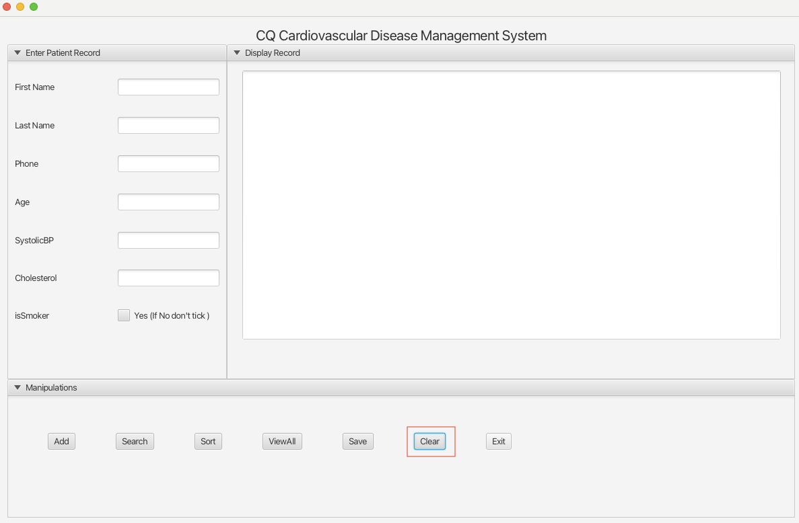
Figure 16: Utilizing the Clear feature to reset all text fields and the display console

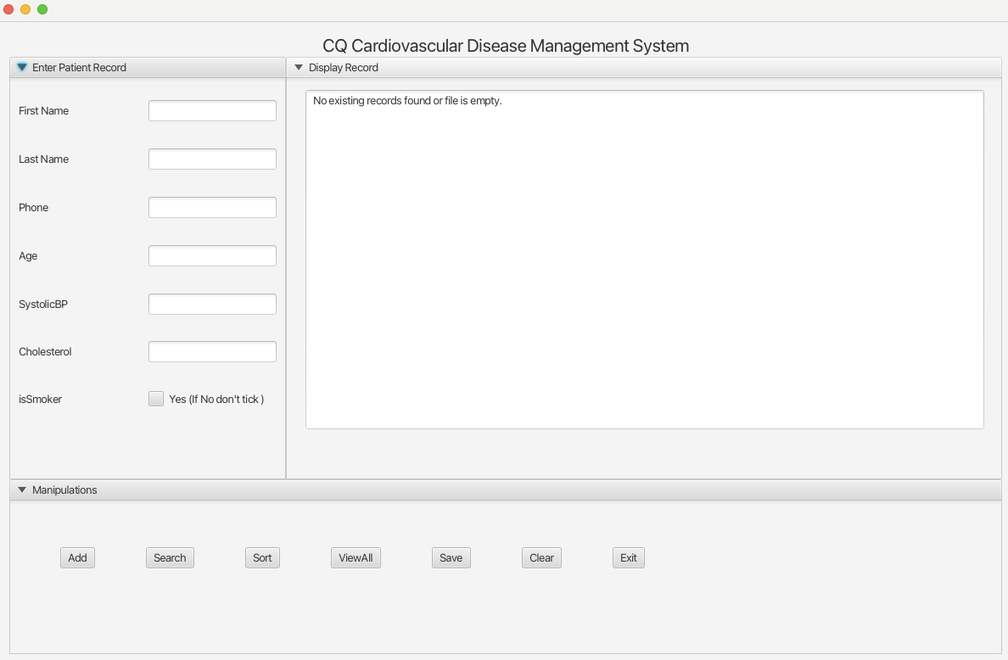
Figure 17: Notification message for an empty data file

