

Software Engineering
(HT1, 2026) COIT20258
Assignment 2: Disaster
Response System (DRS) Prototype

Natthapong Rinsakul
12290114

Unit Coordinator
Meiru Che

Tutor
Hrishikesh Kulkarni

Table of Contents

1. Introduction 1
2. UML Class Diagram 2
3. Test Plan 3
3.1 Test Result Summary 4
3.2 Test Cases 5
4. Reflection 7
4.1 Requirements Specification Review 7
4.2 User Interface Design 8
4.3 Implementation 8

1. Introduction
This report presents the design and implementation of the DRS-Initial prototype developed as part of Assignment 2. The prototype is a JavaFX desktop application built using the Model-View-Controller (MVC) architecture pattern, based on the requirements specification from Assignment 1. The system allows users to report disaster incidents, assess severity levels, assign response teams, update incident status, and monitor active incidents through a dashboard. This report includes a UML class diagram showing the complete design of the system, a test plan with 27 JUnit tests and results, and a reflection on the requirements specification, user interface design, and Implementation process.

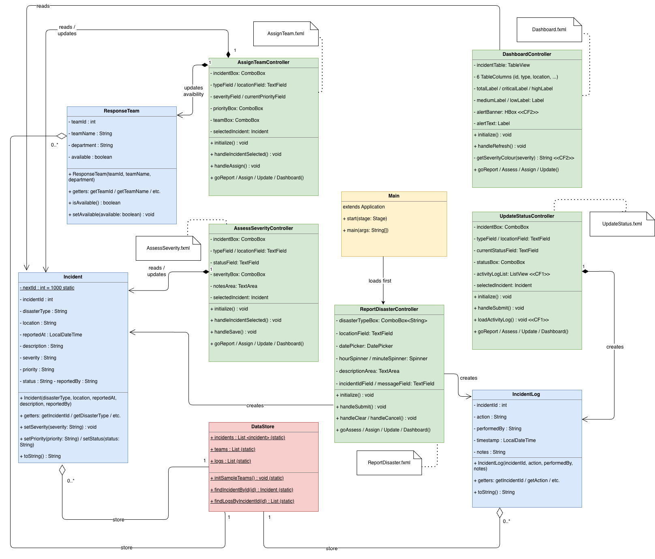
2. UML Class Diagram

Figure 1: UML Class Diagram of the Disaster Response System (DRS)

The UML class diagram shows the complete design of the DRS prototype. The system is structured using the MVC architectural pattern and consists of four layers: the Application Entry (Main), the View layer (five FXML files), the Controller layer (five controller classes), and the Model/Data layer (Incident, ResponseTeam, IncidentLog, and DataStore).
The Model layer contains three domain classes. Incident is the central class that stores all disaster report data, including disaster type, location, severity, priority, and status. ResponseTeam represents a response unit that can be assigned to an incident. IncidentLog records every action performed on an incident with a timestamp and user name, which supports Creative Feature 1. DataStore acts as a shared static storage class that holds lists of all incidents, teams, and logs, and provides helper methods such as findIncidentById() and findLogsByIncidentId().
The diagram shows three types of relationships. Aggregation arrows from DataStore to Incident, ResponseTeam, and IncidentLog indicate that DataStore holds collections of these objects with a one-to-many cardinality (1 to 0..*). The arrows from each Controller to DataStore and the Model classes show that the controllers read and write data through DataStore. The Main class has a dependency to ReportDisasterController, indicating that it loads the ReportDisaster screen first when the application starts.

3. Test Plan
The test plan was developed based on the UML class diagram, use cases, and functional requirements identified in Assignment 1. JUnit 5 was used to implement and execute the tests. A total of 27 tests were created covering four test classes, IncidentTest, ResponseTeamTest, IncidentLogTest, and DataStoreTest.

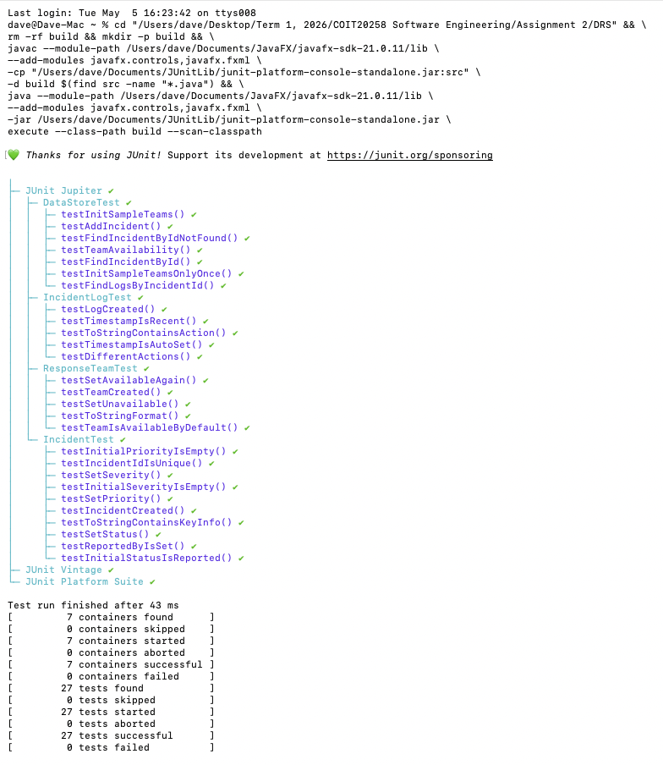
Figure 2: JUnit test via Terminal

3.1 Test Result Summary
Test Class | Total Tests | Passed | Failed
IncidentTest | 10 | 10 | 0
ResponseTeamTest | 5 | 5 | 0
IncidentLogTest | 5 | 5 | 0
DataStoreTest | 7 | 7 | 0
TOTAL | 27 | 27 | 0

3.2 Test Cases
No. | Test Class | What is being tested | Test Input | Expected Result
IncidentTest - Tests for the Incident class (10 tests)
1 | IncidentTest | A new Incident is created with the correct values | disasterType=Fire, location=Melbourne, description=Big fire in the city | Object is not null. getDisasterType()=’Fire’ and getLocation()=’Melbourne’
2 | IncidentTest | A new incident starts with status Reported by default | A new Incident object is created with no status set manually | getStatus() returns Reported
3 | IncidentTest | A new incident has no severity set yet | A new Incident object is created | getSeverity() returns an empty string
4 | IncidentTest | A new incident has no priority set yet | A new Incident object is created | getPriority() returns an empty string
5 | IncidentTest | Each new incident gets a unique ID | Two Incident objects are created one after another | getIncidentId() of the first incident does not equal getIncidentId() of the second
6 | IncidentTest | setSeverity() saves the severity correctly | setSeverity(High) is called on the incident | getSeverity() returns High
7 | IncidentTest | setPriority() saves the priority correctly | setPriority(Immediate) is called on the incident | getPriority() returns Immediate
8 | IncidentTest | setStatus() saves the status correctly | setStatus(Active Response) is called on the incident | getStatus() returns Active Response
9 | IncidentTest | toString() includes the disaster type and location | toString() is called on an incident with type=Fire and location=Melbourne | The returned string contains ‘Fire’ and ‘Melbourne’
10 | IncidentTest | The reportedBy field is saved correctly | reportedBy= Citizen User is passed to the constructor | getReportedBy() returns Citizen User
ResponseTeamTest - Tests for the ResponseTeam class (5 tests)
11 | ResponseTeamTest | A new ResponseTeam is created with the correct values | teamId=1, teamName=Fire Unit A, department=Fire Department | Object is not null. getTeamId()=1 and getTeamName()=Fire Unit A
12 | ResponseTeamTest | A new team is available by default | A new ResponseTeam object is created | isAvailable() returns true
13 | ResponseTeamTest | setAvailable(false) marks the team as unavailable | setAvailable(false) is called on the team | isAvailable() returns false
14 | ResponseTeamTest | A team can be made available again after being set unavailable | setAvailable(false) is called, then setAvailable(true) is called | isAvailable() returns true
15 | ResponseTeamTest | toString() includes the team name and department | toString() is called on the team | The returned string contains ‘Fire Unit A’ and ‘Fire Department’
IncidentLogTest - Tests for the IncidentLog class / Creative Feature 1 (5 tests)
16 | IncidentLogTest | A new IncidentLog is created with the correct values | incidentId=1000, action=Reported, performedBy=Citizen User, notes=Initial report | Object is not null. getAction()=Reported and getPerformedBy()=Citizen User
17 | IncidentLogTest | The timestamp is set automatically when a log is created | A new IncidentLog object is created without setting the timestamp manually | getTimestamp() is not null
18 | IncidentLogTest | The timestamp is very close to the current time | A new IncidentLog object is created | The difference between the log timestamp and LocalDateTime.now() is less than 5 seconds
19 | IncidentLogTest | Different action types can be stored in separate log entries | One log with action= Severity Assessed and one log with action= Team Assigned | getAction() returns the correct string for each log
20 | IncidentLogTest | toString() includes the action and the user name | toString() is called on a log with action=Reported and performedBy=Citizen User | The returned string contains Reported and Citizen User
DataStoreTest — Tests for the DataStore class (7 tests)
21 | DataStoreTest | An incident can be added to DataStore.incidents | A Fire incident is created and added to DataStore.incidents | incidents.size() equals 1 and getDisasterType() equals Fire
22 | DataStoreTest | initSampleTeams() loads exactly 5 teams | initSampleTeams() is called once | DataStore.teams has exactly 5 entries
23 | DataStoreTest | initSampleTeams() does not add duplicate teams if called twice | initSampleTeams() is called twice in a row | DataStore.teams still has exactly 5 entries
24 | DataStoreTest | findIncidentById() returns the correct incident when the ID exists | A Flood incident is added, then findIncidentById() is called with its ID | The returned object is not null and getDisasterType() equals Flood
25 | DataStoreTest | findIncidentById() returns null when the ID does not exist | findIncidentById(99999) is called with an ID that does not exist in DataStore | The returned value is null
26 | DataStoreTest | findLogsByIncidentId() returns only the logs for the given incident | 2 logs added for ID=1000 and 1 log added for ID=2000 | findLogsByIncidentId(1000) returns 2 entries, findLogsByIncidentId(2000) returns 1 entry
27 | DataStoreTest | setAvailable(false) correctly marks a team as unavailable | initSampleTeams() is called, then setAvailable(false) is called on the first team | isAvailable() returns false after the call

4. Reflection
This section reflects on the overall improvement of revising the requirements specification from assignment 1 and developing the DRS prototype, including the observations on the user interface design and implementation.

4.1 Requirements Specification Review
Most of the functional requirements from assignment 1 worked well in practice. For example, FR1 (Disaster Reporting), FR5 (Severity Assessment), FR7 (Response Team Assignment), FR9 (Incident Status Update), and FR10 (Dashboard View) were all implemented as separate screens in the application. The use cases and user stories provided a clear picture of what each screen needed to do. This made it easier to identify the classes and design the controller methods. However, some requirements needed to be revised during implementation. FR8 (Agency Notification) could not be implemented as a real external system as a prototype application. So, it was changed to record a log in the Activity log (creative feature) instead. FR11 (User Authentication) was also not fully implemented. Instead of building a login system, role-based access was represented through separate screens for each user type, such as the Assess screen for officers and the Dashboard for managers. Following these adjustments, the overall requirements specification from assignment 1 provided a strong foundation for building the prototype.

4.2 User Interface Design
The user interface of the DRS prototype follows the same theme as the mockups from assignment 1. All five screens share a consistent layout with a dark navy header, a navigation menu bar, white form cards, and a status bar at the bottom that shows the user role for each screen. A DatePicker and Spinner components were used for date and time input instead of a plain text field to prevent users from entering an incorrect format. Alert popups were used for validation errors and confirmations so that they do not interrupt the main screen layout. When a user selects an incident on the Assess, Assign, or Update screens, the incident details are displayed as read-only fields to prevent accidental changes.
Two creative features were added to this prototype. First, an Activity Log List View on the Update Status screen displays the action history of the selected incident, including the timestamp, action, and user. Second, the Dashboard includes severity colour on the incident table, where Critical is shown in red, High in orange, Medium in yellow, and Low in green. A red alert banner also appears automatically at the top of the Dashboard where there is at least one critical incident that has not yet been resolved.
Some areas could be improved in future development. The application does not have a login screen, so role-based access was handled by separating the functions across different screens instead. In addition, all data is lot when the application is closed because the prototype uses in-memory storage rather than a database.

4.3 Implementation
The DRS prototype was built following the MVC pattern. FXML files define the View layout, Controller classes handle user events and input validation, and Model classes such as Incident, ResponseTeam, and IncidentLog store the data. DataStore was used as a shared in-memory storage class using static Lists, which is simple to implement and good enough for this stage, as it does not need to save data in a database. For Creative Feature 1, every action on an incident is automatically saved as an IncidentLog with a timestamp and the user’s name and displayed as a timeline in the Update Status screen. For Creative Feature 2, the Dashboard applies colour to the severity column and shows a red alert banner when a Critical incident exists and has not yet been resolved.
One problem I faced during implementation was configuring JavaFX with VS Code. The application required –module-path and –add-modules VM arguments to run correctly, which was resolved by setting up the correct JavaFX SDK path in the .vscode/launch.json file. For testing, Junit 5 was used to verify that the Model classes and DataStore behave correctly. A total of 27 tests were written and run using the JUnit Platform Console Standalone JAR via Terminal. All 27 tests passed successfully, which showed that the core classes work as expected before being used in the controllers and screens.

