COIT20258 Software Engineering
Assessment 2: Disaster Response System (DRS)
DRS-Initial Prototype Report
Student Name: Natthapong Rinsakul
Student ID: 12290114
Unit: COIT20258 Software Engineering (HT1, 2026)

1. UML Class Diagram
The UML class diagram below presents the complete object-oriented design of the DRS-Initial prototype. The system is structured using the Model-View-Controller (MVC) architectural pattern and consists of four layers: Application Entry, View, Controller, and Model/Data.
Figure 1.1 shows the class diagram exported from draw.io. The diagram includes all classes with their attributes, methods, data types, access modifiers, and relationships including aggregation and dependency associations.

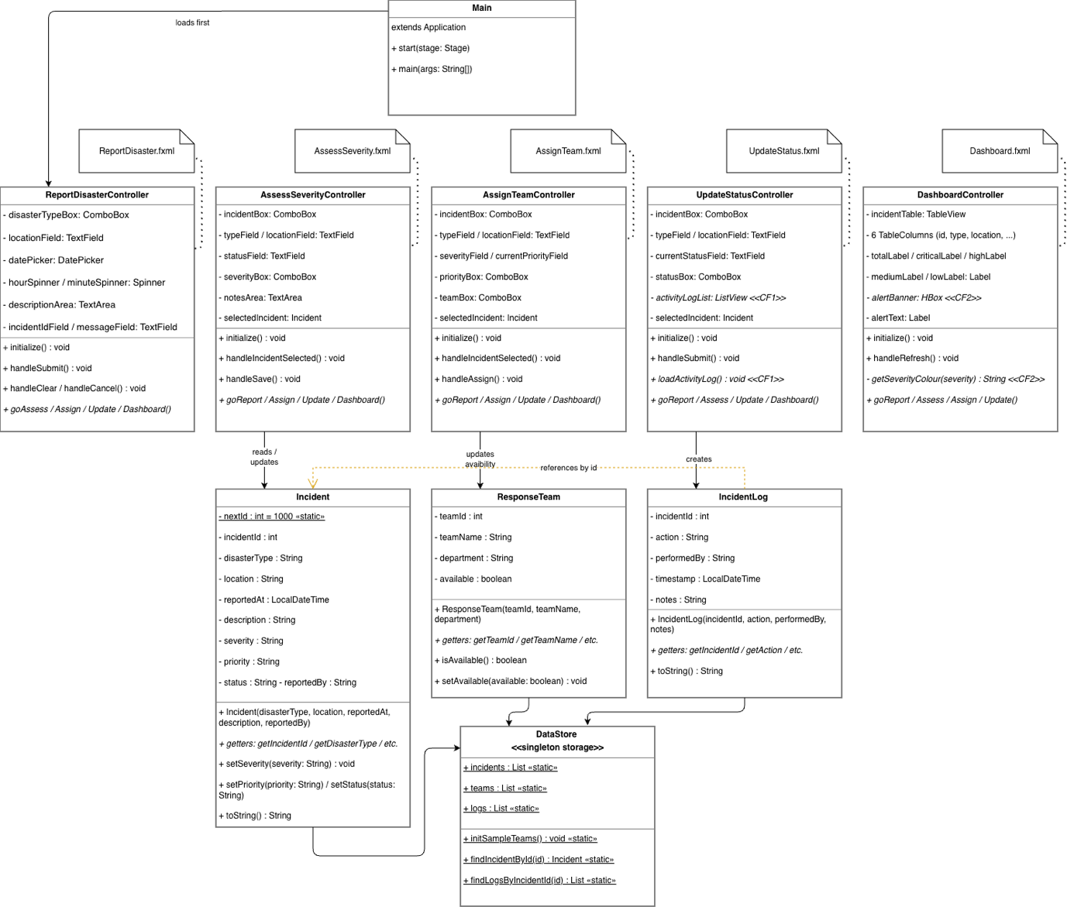Figure 1.1 UML Class Diagram of the Disaster Response System (DRS-Initial)
The diagram contains the following classes:
Model Layer — Incident, ResponseTeam, and IncidentLog. The Incident class is the central domain entity storing all disaster report data. ResponseTeam represents an available response unit. IncidentLog records every action performed on an incident and supports Creative Feature 1 (Activity Log Timeline).
Data Layer — DataStore provides a static in-memory storage shared across all screens, holding lists of incidents, teams, and logs. It also provides utility methods findIncidentById() and findLogsByIncidentId().
Controller Layer — Five controller classes (ReportDisasterController, AssessSeverityController, AssignTeamController, UpdateStatusController, DashboardController) each handle user events for one screen. DashboardController implements Creative Feature 2 (Severity Colour Coding and Alert Banner).
View Layer — Five FXML files define the graphical layout for each screen. Controllers are paired with their corresponding FXML file.

2. Test Plan
The test plan was developed based on the UML class diagrams, use cases, and functional requirements identified in Assessment 1. JUnit 5 was used to implement and execute the tests. A total of 27 test cases were created covering four test classes: IncidentTest (10 tests), ResponseTeamTest (5 tests), IncidentLogTest (5 tests), and DataStoreTest (7 tests).
All tests were compiled and executed using the JUnit Platform Console Standalone runner with JavaFX on the classpath. All 27 tests passed successfully.

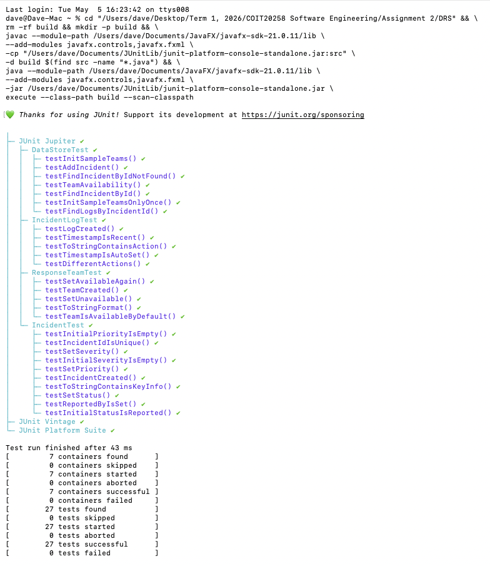

2.1 Test Results Summary
Test Class | Tests | Passed | Failed
IncidentTest | 10 | 10 | 0
ResponseTeamTest | 5 | 5 | 0
IncidentLogTest | 5 | 5 | 0
DataStoreTest | 7 | 7 | 0
TOTAL | 27 | 27 | 0

2.2 Detailed Test Cases
# | Test Class | Test Method | Test Data / Input | Expected Result | Status
1 | IncidentTest | testIncidentCreated | disasterType=Fire, location 123 Main Street, description=... | Object not null, getDisasterType()=Fire, getLocation()= 123 Main Street | PASS
2 | IncidentTest | testInitialStatusIsReported | New Incident object created | getStatus() returns 'Reported' | PASS
3 | IncidentTest | testInitialSeverityIsEmpty | New Incident object created | getSeverity() returns empty string '' | PASS
4 | IncidentTest | testInitialPriorityIsEmpty | New Incident object created | getPriority() returns empty string '' | PASS
5 | IncidentTest | testIncidentIdIsUnique | Two Incident objects created | getIncidentId() of inc1 != getIncidentId() of inc2 | PASS
6 | IncidentTest | testSetSeverity | setSeverity('High') | getSeverity() returns 'High' | PASS
7 | IncidentTest | testSetPriority | setPriority('Immediate') | getPriority() returns 'Immediate' | PASS
8 | IncidentTest | testSetStatus | setStatus('Active Response') | getStatus() returns 'Active Response' | PASS
9 | IncidentTest | testToStringContainsKeyInfo | toString() called on incident | Result contains 'Fire' and '123 Main Street' | PASS
10 | IncidentTest | testReportedByIsSet | reportedBy='Citizen User' | getReportedBy() returns 'Citizen User' | PASS
11 | ResponseTeamTest | testTeamCreated | teamId=1, name=Fire Unit A, dept=Fire Dept | Object not null, getId=1, getName=Fire Unit A | PASS
12 | ResponseTeamTest | testTeamIsAvailableByDefault | New ResponseTeam created | isAvailable() returns true | PASS
13 | ResponseTeamTest | testSetUnavailable | setAvailable(false) | isAvailable() returns false | PASS
14 | ResponseTeamTest | testSetAvailableAgain | setAvailable(false) then setAvailable(true) | isAvailable() returns true | PASS
15 | ResponseTeamTest | testToStringFormat | toString() called on team | Result contains 'Fire Unit A' and 'Fire Department' | PASS
16 | IncidentLogTest | testLogCreated | incidentId=1000, action=Reported, by=Citizen | Object not null, getAction()=Reported | PASS
17 | IncidentLogTest | testTimestampIsAutoSet | New IncidentLog created | getTimestamp() is not null | PASS
18 | IncidentLogTest | testTimestampIsRecent | New IncidentLog created | Timestamp is within 5 seconds of LocalDateTime.now() | PASS
19 | IncidentLogTest | testDifferentActions | action=Severity Assessed / Team Assigned | getAction() returns matching action string | PASS
20 | IncidentLogTest | testToStringContainsAction | toString() called on log | Result contains 'Reported' and 'Citizen User' | PASS
21 | DataStoreTest | testAddIncident | Add Fire incident to DataStore.incidents | incidents.size() == 1, getDisasterType() == 'Fire' | PASS
22 | DataStoreTest | testInitSampleTeams | Call initSampleTeams() once | teams.size() == 5 | PASS
23 | DataStoreTest | testInitSampleTeamsOnlyOnce | Call initSampleTeams() twice | teams.size() still == 5 (no duplicates) | PASS
24 | DataStoreTest | testFindIncidentById | Add incident, call findIncidentById(id) | Returns matching Incident object, type == 'Flood' | PASS
25 | DataStoreTest | testFindIncidentByIdNotFound | Call findIncidentById(99999) | Returns null | PASS
26 | DataStoreTest | testFindLogsByIncidentId | 2 logs for id=1000, 1 log for id=2000 | findLogsByIncidentId(1000).size()==2, (2000).size()==1 | PASS
27 | DataStoreTest | testTeamAvailability | Call setAvailable(false) on first team | isAvailable() returns false after setting | PASS

3. Reflection
This section reflects on the overall experience of revising the requirements specification from Assessment 1 and developing the DRS-Initial prototype, including observations on the user interface design and implementation process.

3.1 Requirements Specification Review

Most of the functional requirements from Assignment 1 worked well in practice. For example, FR1 (Disaster Reporting), FR5 (Severity Assessment), FR7 (Response Team Assignment), FR9 (Incident Status Update), and FR10 (Dashboard View) were all implemented directly as separate screens in the application. The use cases and user stories provided a clear picture of what each screen needed to do, which made it easier to identify the classes and design the controller methods. However, some requirements needed to be revised during implementation. FR8 (Agency Notification) could not be implemented as a real external notification system in a JavaFX desktop prototype, so it was changed to recording a log in the Activity Log instead. FR11 (User Authentication) was also not fully implemented. Instead of building a login system, role-based access was represented conceptually through separate screens for each user type, such as the Assess screen for officers and the Dashboard for managers. Following these adjustments, the overall requirements specification from Assignment 1 provided a strong foundation for building the prototype.

3.2 User Interface Design
[ Write 1-2 paragraphs based on these key points: ]

- The five screens align with the preliminary GUI mockups from Assessment 1 — consistent header (dark navy), menu bar navigation, form card layout with white panels, and status bar
- DatePicker + Spinner components for date/time input avoided parse errors that would occur with raw TextField input
- Alert dialogs (JavaFX Alert) were used for validation errors and confirmations — this provided immediate feedback without cluttering the main screen
- One design improvement opportunity: the Assess screen only shows incidents that exist in DataStore — if no incidents are reported first, the list is empty and confusing; a message like 'No incidents available' would improve usability

3.3 Implementation
[ Write 1-2 paragraphs based on these key points: ]

- The MVC pattern was applied throughout — FXML files define the View, Controller classes handle events and validation, and Model classes (Incident, ResponseTeam, IncidentLog) hold the data
- DataStore with static Lists was chosen as a straightforward in-memory storage approach — simple to implement and sufficient for a prototype that does not require persistence between sessions
- Creative Feature 1 (Activity Log Timeline) — every user action on an incident is automatically recorded in IncidentLog with a timestamp, user, and description; the UpdateStatus screen displays the full history in a ListView
- Creative Feature 2 (Severity Colour Coding + Alert Banner) — the Dashboard applies colour-coded text to the severity column (red=Critical, orange=High, yellow=Medium, green=Low) and displays a prominent red alert banner when any Critical incident exists
- Main challenge encountered: JavaFX module path configuration required --module-path and --add-modules VM arguments; this was resolved by configuring .vscode/launch.json with the correct JavaFX SDK path
- JUnit 5 tests were run via Terminal using the Console Standalone JAR — all 27 tests passed, confirming that the Model classes and DataStore behave correctly

References
CQUniversity 2026, COIT20258 Software Engineering — workshop and lecture materials, Term 1 2026, viewed throughout the semester.
Oracle 2024, JavaFX documentation, viewed 2026, https://openjfx.io
JUnit Team 2024, JUnit 5 user guide, viewed 2026, https://junit.org/junit5/docs/current/user-guide/

