Pretree Documentation

back to main page

Installation 1
Introduction 1
How to use the GUI-Version 1
Configure database connection: 2
Training a Pretree from database: 3
Training a Pretree from file: 3
Training a Pretree from insert data: 4
Prune a Pretree: 5
Save the Pretree to file: 5
Classify a word: 5
Load a Pretree from file: 5
Evaluate your Pretree: 5
How to use the Command Line Version 6
Commands: 6
Options: 6
Examples: 7
How to use Pretree in your own Programm 7
Classes and Methods: 7
Example: 7

Installation
A description how to install a module is available at the main page of the ASV Toolbox project.
The line you have to copy into the toolbox.start file looks like this:
de.uni_leipzig.asv.toolbox.pretree.PretreePanel

Introduction
Pretree classifys words with Pretrees, evaluates your Pretree with a word set and create Pretrees from your data.

How to use the GUI-Version
If you start the Toolbox and choosing the Pretree-Tool you will see a Welcome Panel looking like in figure 1.
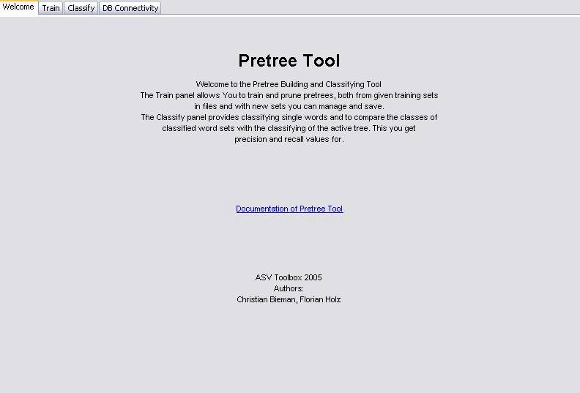
figure 1

Configure database connection:
Choose the “DB Connectivity” Panel. Enter the required in information about your database in the text fields (see figure 2).
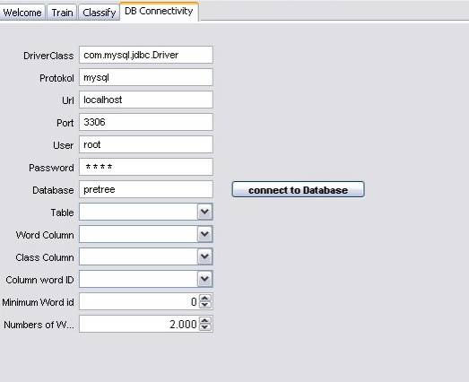
figure 2
Click on "connect to Database". The database information about tables and columns will be loaded. Now choose the table containing the classified words, the columns containing the words, the classes and the ids for the words and choose the id of the first word an the numbers of words which should be used from the drop-down-menus. The panel may look line in figure 3.
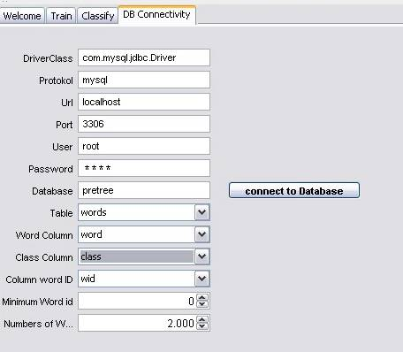
figure 3

Training a Pretree from database:
Be sure that you configure your database settings at “DB Connectivity” Panel before training a Pretree from database. Choose ignore case option and/or reverse if it is needed for the Pretree like in figure 4.
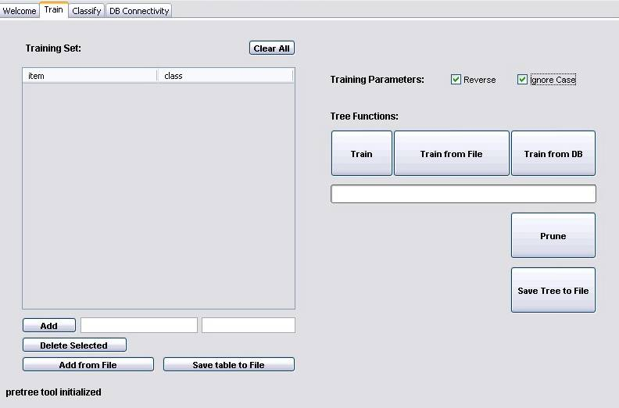
figure 4
Now just click on the "Train from DB"-button. The Pretree is readily trained as soon as the progress bar under the button indicates 100%.

Training a Pretree from file:
Choose ignore case option and/or reverse if it is needed for the Pretree. Click the "Train from file"-button. A new window will open for opening a file. Choose the file with the Pretree data and open it. The progress will shown in the progress bar under the buttons. Be sure that the file has the right format, that means that it contains a number of lines which consists of word and class(in this order) separated by a tab. An example file is shown in figure 5.
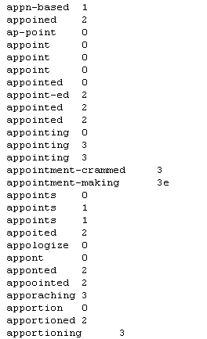
figure 5

Training a Pretree from insert data:
At first you have to insert data. For this enter the word in the left and the class in the right text field under the table of the left side of the panel and click the "Add"-button. You can also load a tab-separated file in the table. Click on the "Add from File"-button and open the file containing the data. The file should have the same format like in figure 5 above . The table may look like in figure 6.
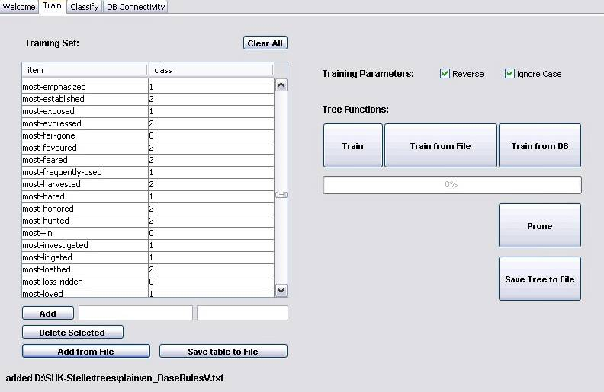
figure 6
For deleting a single line mark the line and click the "Delete Selected"-button. If you want to clear the entire table click the "Clear All"-button.
Clicking the "Save table to File"-button opens a new window. Choose the directory and name for the file and save it. The created file which contains the data of the table may look like in figure 7.
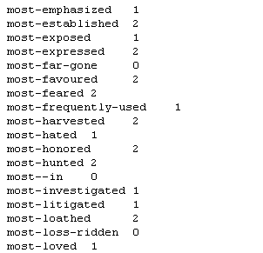
figure 7
Choose ignore case option and/or reverse if it is needed for the Pretree. At least click the "Train"-button. The progress bar under the buttons show the progress.

Prune a Pretree:
Be sure that you have trained already a Pretree. Now click on "Prune".

Save the Pretree to file:
For saving the trained and may be pruned Pretree to file click on "Save Tree to File"-button. Choose the directory and filename in the new window and click on “save”.

Classify a word:
Be sure that you have trained or load a pretree. If a pretree is trained or loaded, it will be shown with his Classes, Nodes, Reverse and Ignore Case information over the "Classify"-button. Enter a Classify Threshold in the text field at the right side and the word to classify in the text field at the left side for example "works". Now click "Classify". The word with his class will be show in the table. It may looks like in figure 8.
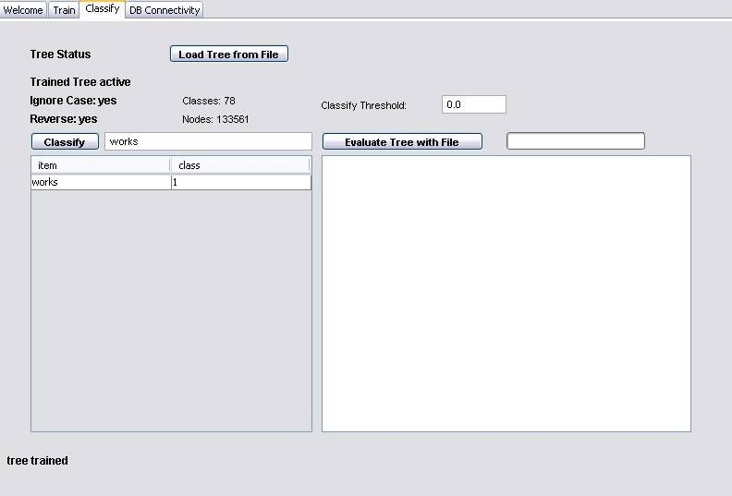
figure 8

Load a Pretree from file:
You can load a Pretree file into the Pretree-Tool. Change to the Classify Panel and click on the "Load Tree from File"-button. In the new window, choose the file and open it. The Pretree is now loaded. Use only Pretree files that were created with the Pretree-Tool.

Evaluate your Pretree:
You can evaluate you loaded Pretree with a Pretree from file. For this click the "Evaluate Tree with File"-button. In the new window choose the file for the evaluation and open it. The Pretree will now be evaluated and the progress is shown right besides the button for evaluation. The results will be shown in textbox under the button. The result will contain all different classified words and the precision and recall values shown in figure 9.
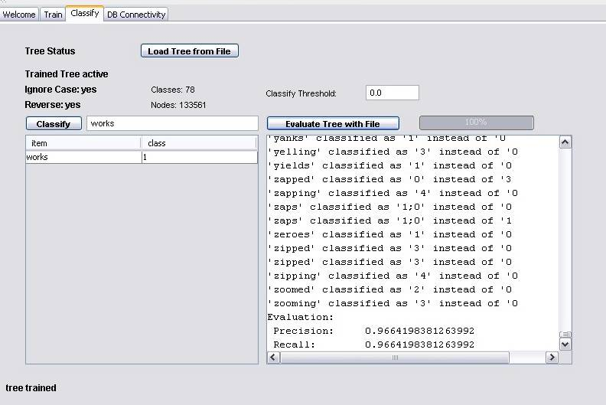
figure 9

How to use the Command Line Version
java -classpath .;./lib/ASV_Pretree.jar -Djava.ext.dirs=.;./lib de.uni_leipzig.toolbox.pretree.PretreeTool [commands][options] [parameters]

Commands:
The following commands are supported:
train, t: trains a pretree from a map file and save it to a tree file
java de.uni_leipzig.toolbox.pretree.PretreeTool t [options] <mapfile> <treefile>
prune, p: prune a pretree given as a tree file and save it to another tree file
java de.uni_leipzig.toolbox.pretree.PretreeTool p [options] <treefile_not_pruned> <treefile_pruned>
trainprune, tp: train and prune a pretree from a map file and save it to a tree file
java de.uni_leipzig.toolbox.pretree.PretreeTool tp [options] <mapfile> <treefile>
classify, c: classifies a word with the tree from a given tree file
java de.uni_leipzig.toolbox.pretree.PretreeTool c [options] <word> <treefile>
convert, cv: converts trees in the given tree files in to the latest format
java de.uni_leipzig.toolbox.pretree.PretreeTool cv [options] <treefile_0> <treefile_1> … <treefile_n>
print, pr: print out the pretrees that are given in the tree files
java de.uni_leipzig.toolbox.pretree.PretreeTool pr [options] <treefile_0> <treefile_1> … <treefile_n>

Options:
[options] could be replaced through following commands
-t=#: sets the threshold for classifying to #, this should be a value between 0 and 1
-f: can be used only with the command classify, c : instead of single word all words from a word will are taken for classification, -f must appear directly before the
absolute path to the word file
the following options are only for commands train and trainprune
-rv: reverse tree
-ic: ignore case
-sc=#: character # as first “number”, default: 33
-ec=#: character # as last “number”, default: 248
-az=#: character # as number separator, default: 2
-ak=#: character # as node separator, default: 3

Examples:
- java -classpath .; ./lib/ASV_Pretree.jar -Djava.ext.dirs=.;./lib de.uni_leipzig.asv.toolbox.pretree.PretreeTool print ./resources/trees/de-nouns.tree
- java -classpath .; ./lib/ASV_Pretree.jar -Djava.ext.dirs=.;./lib de.uni_leipzig.asv.toolbox.pretree.PretreeTool classify -t=0.4 Hochhäuser ./resources/trees/de-nouns.tree
- java -Xmx500M -classpath .; ./lib/ASV_Pretree.jar -Djava.ext.dirs=.;./lib de.uni_leipzig.asv.toolbox.pretree.PretreeTool trainprune ./resources/trees/plain/de-BaseRulesV.txt ./examples/neu-de-verbs.tree (take some time)

How to use Pretree in your own Programm

Classes and Methods:
It is easy to use Pretree for your own program. You only need the one class Pretree which you find in the package de.uni_leipzig.asv.utils.
class or method | description
class Pretree | class which represent a pretree
void load(String filename) | load a pretree from the given file
String classify(String word) | returns the classification of word related to the loaded pretree

Example:
Here are an example of a JAVA class(PretreeTest.java) using the Pretree tool. You can find the class PretreeTest.java in the package de.uni_leipzig.asv.toolbox.tests.
package de.uni_leipzig.asv.toolbox.tests;

import de.uni_leipzig.asv.utils.Pretree;

public class PretreeTest {

public static void main(String[] args) {
//word for classification
String word = "classifies";
//treshold for classification
double treshold = 0.1;
//pretree file
String pretreeFile = "./resources/trees/en-verbs.tree";
//pretree
Pretree pretree = new Pretree();
pretree.load(pretreeFile);
pretree.setThresh(treshold);
System.out.println(word + " is classified as " + pretree.classify(word));

}

}

You can start this test. Below you see the output of the test.
classifies is classified as 3y

back to main page

