DIVISION OF IT CONVERGENCE ENGINEERING (ITCE)
DISTRIBUTED PROCESSING AND NETWORK MANAGEMENT

ASSIGNMENT I

Professor: James Won-Ki Hong
Mentor: Yoonsen Han
Student: Nguyen Ngoc Chau Sang

CONTENTS
I. How can we detect a mobile devices access to our websites? 3
a. Use JavaScript 3
b. Use PHP, JSP, ASP… to detect the User-Agent 3
c. WURFL (the Wireless Universal Resource File) 3
d. Some useful modules 4
II. Modolabs 5
a. Abbreviation 5
b. Summary 5
c. The fragmented mobile value chain 5
d. The architecture of Kurogo Mobile Optimized Middleware 7
e. The benefits of Kurogo Mobile Optimized Middleware 9
III. A few Available adaptation frameworks 11

How can we detect a mobile devices access to our websites?
When building a website, this is what most people want to do. They want to detect if their customer is on a mobile device and then redirect them to the suitable site (desktop version or mobile version). There are several methods to address this requirement:
Use JavaScript
Using some type of browser detection script (example: http://javascript.about.com/library/blbrsdet.htm) to detect if the customer is on a mobile device.
Problems:
There are thousands of mobile devices so it is a nightmare to attempt to detect them all with one JavaScript.
Many devices currently don’t support JavaScript. So if a device doesn’t support JavaScript, can we conclude it is a mobile device? The answer is no because iPhone supports JavaScript.
Use PHP, JSP, ASP… to detect the User-Agent
User-Agent: tools were developed, acting on the user’s behalf so that the user didn’t have to understand the cryptic commands in order to retrieve information. Today, nearly everyone uses a web browser as their user agent. User agent strings identify what a user is using to access a web-page such as: its application type, operating system, software vendor, or software revision.
Most Web browsers use a User-Agent value as follow:

Mozilla/[version] ([system and browser information]) [platform] ([platform details]) [extensions]

Advantage: doesn’t depend on a scripting language. It uses a server-side language (PHP, ASP, JSP, ColdFusion…) to look at the user-agent.
Problems: lots and lots of potential user-agents that used by mobile devices.
WURFL (the Wireless Universal Resource File)
Definition: a big repository of information that will help us to recognize browsers, devices, the ability to support certain features and standards such as image formats, mark-ups, but also the screen size, colors of the screen and so on. It is an open-source project providing libraries for the most common programming languages such as Java, Python, Ruby, Perl, and PHP4.
The benefit of using WURFL is that there are lots of people updating and adding to the config file all the time. So while the file you're using is out-of-date almost before you've finished downloading it, chances are that if you download it once a month or so, you'll have all the mobile browsers your readers habitually use without any problems.
Some useful modules
DeviceAtlas: This Mobile Device Detection module uses dotMobi's DeviceAtlas device detection API to offer mobile device detection in VCL. Capabilities include detection of screen size, Adobe Flash support, supported video codecs and more, which can be used for any operations within Varnish. Popular usage scenarios include redirecting mobile clients to a different URL or serving different content on the same URL based on what the client supports
51 Degrees: It’s provided as a .NET open source class library that detects mobile devices and browsers, enhancing the information available to .NET programmers. Using 51Degrees.mobi Device Data, accurate screen sizes, input methods, plus manufacturer and model information are all available. Mobile handsets can optionally be redirected to content designed for mobile devices. Smart phones, tablets and feature phones are all supported.
Modolabs
Abbreviation
ERP: Enterprise Resource Planning
LMS: Learning Management System
CMS: Content Management System
BPM: Business Process Management
C: Cloud
LOB: Line Of Business
CIO: Chief Information Officer or Information Technology Director
QA: Quality Assurance
Summary
Mobile Optimized Middleware is a new kind of middleware developed to address the fragmented mobile value chain.
Based on the MIT Mobile Framework, it was designed from the ground up specifically for mobile.
The fragmented mobile value chain
This issue creates many challenges, such as: complex integration and maintenance, extensive mobile development costs…
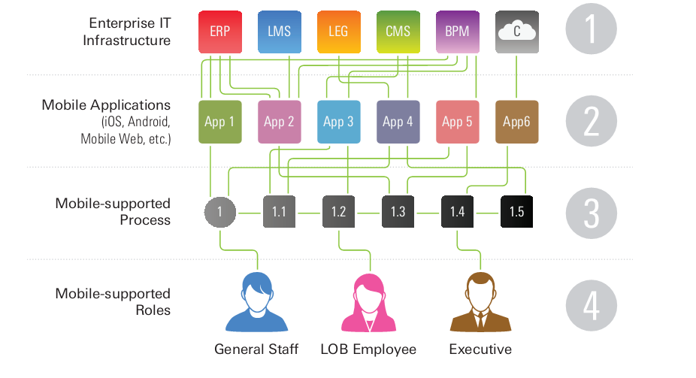
Figure 1. Mobile Value Chain Faces Issues
There are four basic problems:
Complex integration and maintenance: much money, time for creating, and maintaining the connections between mobile apps and data sources.
Extensive development/QA: a lot of time for developing mobile applications because skills spread on multiple platforms and programming languages. Testing is so complex because of the vast number of different mobile form factor and extends deployment time frames.
Fractured process-level support: App users must often visit multiple mobile and even use desktop applications to complete critical tasks while mobile. This is very inconvenient, creates inefficiencies, and limits productivity.
Under-supported roles: Users are not always provided with a targeted, device-appropriate mobile user experience → less engaged employees and customers and lower mobile app adoption rates.
The question is “How to address the jungle of data sources, connectors, apps, processes, and roles?”
The architecture of Kurogo Mobile Optimized Middleware
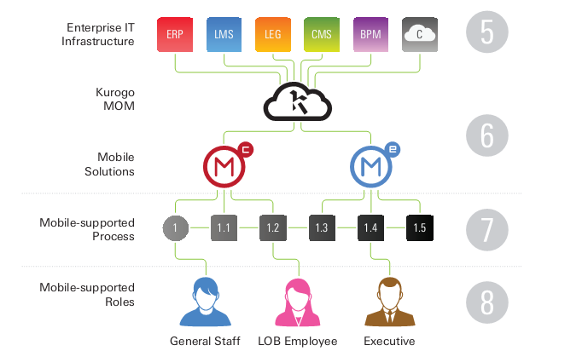
Figure 2. Mobile Optimized Middleware
At the top, MOM simplifies the integration and maintenance for CIOs and enterprise architects by providing a single, open API that plays well with different data sources and data formats. Just one platform and standard programming languages .
The MOM feeds that into pre-configured solutions. These solutions include modules like authentication, directories, news, notifications, calendars, and more.
The mobile solutions pull data from a broad set of data sources and then provide that data to users.
Kurogo Mobile Optimized Middleware detects a user’s device type and optimizes content and data before displaying it → having best user experience and better supported.
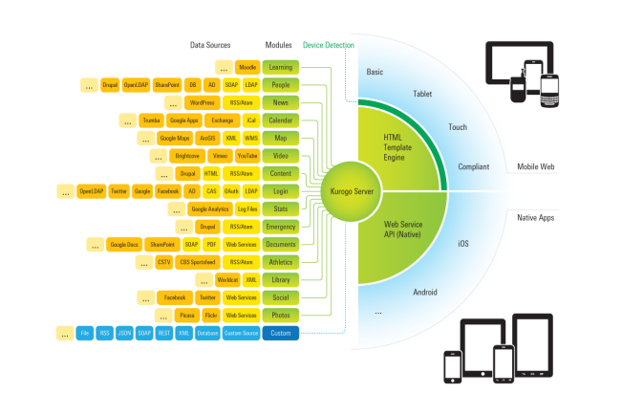
Figure 3. Kurogo Mobile Optimized Middleware Architecture
Kurogo Mobile Optimized Middleware’s functions:
Aggregates and organizes raw data sources.
Delivers them to mobile website and native mobile applications.
Optimizes content and displays it in mobile.
Figure 3 shows clearly the process: data sources integrate with prebuilt module (custom module), then they are pulled into the Kurogo Server. Native and mobile web-based solutions request data and content from Kurogo. Data and content are delivered to these solutions in an optimized way that takes in account the screen size, data input method (including keyboards or touch screens), platform, and device type of the user.
Kurogo Mobile Optimized Middleware also contents an extensive Web-based admin console with minimal coding and short work of site management. Useful functions: Manage overall properties, behavior of each module, authentication, control the site setup, SSL, theme, device detection (see figure below)
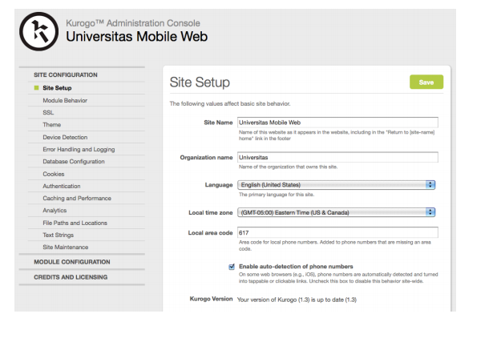
Figure 4. Kurogo Mobile Optimized Middleware Admin Console
The benefits of Kurogo Mobile Optimized Middleware
Open source: 100% direct access to source code.
Faster App and Website Creation: the open, flexible API, pre-built applications, inheritable mobile web templates, flexible data handing, and a useful admin console.
Code Specifically Written for Mobile: KMOM ensure that your mobile websites and apps are optimized for the lower bandwidth, screen sizes and interaction methods of all mobile devices.
Standard Languages and Systems: using familiar languages and standards such as PHP, HTML5, CSS and JavaScript, can be installed on both Linux and Windows servers, will fit into any infrastructure.
Taming the Jungle: integrates quickly, cleanly, and reliably.
Focus on the user: providing the best practice user experience across all platforms and devices.
Customization Options: quickly and easily customized to the functional and user experience needs of an organization.
Clean Break Between Business and Presentation Logic

A few Available adaptation frameworks
A semantics-Based Automatic Web Conten Adaptation Framework for Mobile Devices
This frameworks provides automatically adapted contents to mobile devices RDF Semantics of client device CC/PP configurations and web page tag structures are extracted to determine the proper parameters for the format and layout of web contents. Heuristic transcoding rules in the Jena Inference System are then applied to transform the web contents for each particular device.
Content adaptation framework: bringing the Internet to information appliances.
It is a general framework for customizing Internet content for diverse client devices. First, it analyzes the content to be customized. Then, a variety of transcoders generate multi-resolution, multimodal version of the content. The transcoded version of the multimedia content are represented in a novel multi-modal, multi-resolution representation hierarchy called the InfoPyramid. Finally, a selection module uses an extended rate-distortion framework to pick the best content versions from the InfoPyramid while meeting the client device characteristics and resources.

