DIVISION OF IT CONVERGENCE ENGINEERING (ITCE)
DISTRIBUTED PROCESSING AND NETWORK MANAGEMENT

ASSIGNMENT II

Professor: James Won-Ki Hong
Mentor: Yoonsen Han
Student: Nguyen Ngoc Chau Sang

I. Module in Kurogo 3
a. The role of module 3
b. Input / Output 3
c. Some included module 3

Module in Kurogo

The Kurogo framework is based around modules: building block of Kurogo is modules. Each page request is handled by a module. Each module which is a PHP object gives you the opportunity to choose the data source and processing methods for getting data into your application.

The role of module
Each module provides a distinct set of data and services shown to the user.
Each module is a subclass of the WebModule object. Much of the core logic is located within this class including:
- Initialization of the template system
- Retrieval of configuration and runtime parameters
- Creation of internal URLs
- Authorization
Modules receive user requests, handle them. Modules parse the URL, display one of its page with content. Each module contained pieces of code that connect to external services, process data and display it on the device using standard HTML and CSS.
This figure bellows show how to a module work.
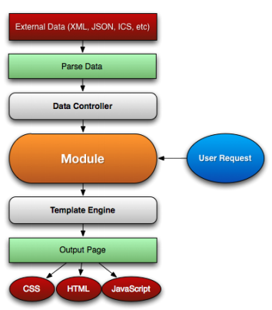
Figure 1. The process of a module
User send their request to a module. Once a request has been made, the loading system determines which module to load and create an instance of it using the factory method. The URL determines which module to load, which page to assign and any parameters that are included. If there is no page indicated, then the page will be set to index.
Next, module using DataController to feed and parse the result. Then the module would pass the data to the Template Engine which outputs the page using appropriate HTML, CSS, JavaScript for the device.
By abstracting the detail of retrieving and parsing data, module can respond to a variety of data sources. Module will use a subclass of DataController. Each DataController has an object that is subclass of DataParser that take resulting data and creates an appropriate PHP structure.
Each module contains the PHP code and template files needed for it use. It also can include CSS and JavaScript files that are specific to that module.
Each module contains a configuration file in SITE_DIR/config/modules/MODULEID.ini. This file contains values common to all modules, as well as module specific values.
- title - The module title. Used in the title bar and other locations
- disabled - Whether or not the module is disabled. A disable module cannot be used by anyone. Use this value for temporarily disabling modules.
- search - Whether or not the module provides search in the federated search feature.
- secure - Whether or not the module requires a secure (https) connection.
Each module has distinct id name.

Some included module
There are a number of modules that are included inside the distribution of Kurogo.
- Home module
  - Provide a unified list of modules available to users.
  - It can be configured to show the list in a variety of styles.
  - Module list and order: There are 2 sections [primary modules] and [secondary modules] that indicate which modules are shown on the home screen.
    - Primary modules can be rearranged and hidden by the user using the Customize modules.
    - Secondary modules appear smaller, but cannot rearranged or removed by the user.
  - Tablet Interface: Kurogo includes a special layout for tablet devices (version 1.0 only support iPad). In this standard layout, there is a navigation strip that appears at the bottom of the screen on all pages. This allows easy navigation to any module. The home screen itself supports showing a reduced set of content on the home screen from a series of modules in panes. Currently the layout of the home screen is fixed with 5 different panes. You can choose which module will show up in which pane. You can easy set which modules will appear in which pane.
- Calendar module
The calendar module provides a mobile interface to a series of events. You can browse events by day, category or list, and then view any details of the event. The built in module supports parsing and viewing events in iCalendar (ICS) format.
- News module
The news module show a list of stories/articles from an RSS freed. If the feed provides full textual content, the article is shown to the user in mobile friendly format. If the feed does not contain full text then the module will redirect the browser to the URL of the article.
- Info module

The info module is, by default, shown to users who visit the site using a desktop browser. The intent it to provide users with information about your site. The default implementation contains no code, and the design included with the reference site is merely an example. You should create your own page that matches the brand and styling of your site. If you would prefer to have users see the home page and not the info module from a desktop browser, you can remove the DEFAULT-COMPLIANT-COMPUTER value in the [urls] section of your site’s site.inifile and ensure the DEFAULT value is set to home.

