DIVISION OF IT CONVERGENCE ENGINEERING (ITCE)
DISTRIBUTED PROCESSING AND NETWORK MANAGEMENT

ASSIGNMENT III

Professor: James Won-Ki Hong
Mentor: Yoonsen Han
Student: Nguyen Ngoc Chau Sang

CONTENT
1. Requirement 4
2. Design Principles when developing a mobile website 4
a. Keeping only necessary thing 4
b. Minimize Distance to Goals 4
c. Make content glanceable and actionable 4
d. Make it available for everyone 4
3. How to make a mobile version of our homepage (http://dpnm.postech.ac.kr/) 4
a. Use mobile site builders 4
b. Using Kurogo 6
c. Comparison between available tools and Kurogo 6
4. What do we need when using Kurogo to make a mobile web for smartphones 7
a. Knowledge about hardware and software of smartphones 7
b. Database (using MySQL) 7
c. Design Principle for smartphones 7
d. Redesign layout 7
e. Tester to test out web 7

Requirement

The rise of the mobile is undeniable. Many even say that the future of the web lies on mobile devices. Gone were the days when people can only access the internet at home or in their office, but now some of them even throw away the heavy PC and adopted the mobile devices for web surfing experience.
Sensing the importance stated above, we want to create a mobile version of our homepage lab for any type of mobile devices.
At the current state, our website do not display well on iPhone, because of the small screen size. But it is okay for iPad.
I used W3C mobileOK Checker to see how mobile-device-friendly our site is. Here is the result:
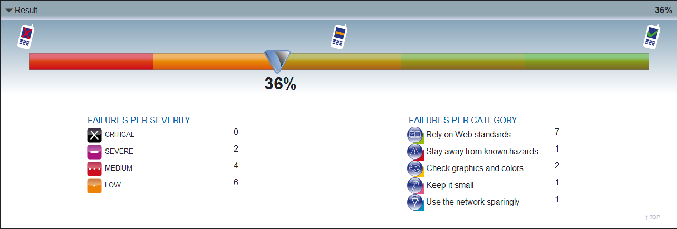
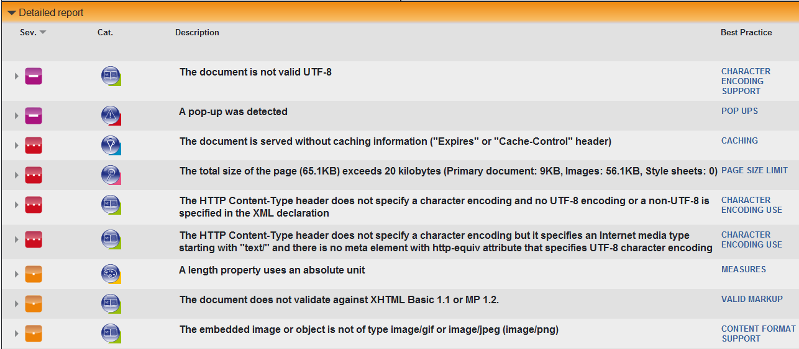
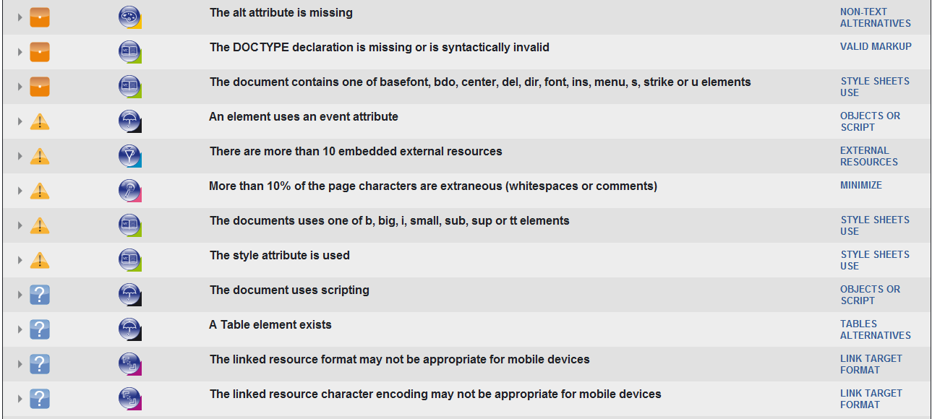

Design Principles when developing a mobile website

Keeping only necessary thing
      - Weed out what is not mobile-appropriate:
        - Long or complex interactions and input: it can be time consuming to browse through or long complex page, so remember to put all of the most important information on the top of page and remove unnecessary things.
        - Heavy network use: heavy images make most mobile phones take forever to load, use plain-text instead of using images for buttons or links.
      - Choose what is mobile-appropriate

Minimize Distance to Goals
      - Easy to find and navigate what user want. If the user takes much time to find out what want, they maybe never come back to your site.
      - A good mobile website design provides back button and links because many phones are no equipped back buttons, try to provide them to escape dead ends.

Make content glanceable and actionable
      - Package, present content in a way that’s quick to understand and action.
      - Arrange your content in a single column layout, minimize the uses of table will make your site be better.

Make it available for everyone
Make sure that your mobile version is well-displayed on many, many user devices regardless of smartphone or stupid phone.

How to make a mobile version of our homepage (http://dpnm.postech.ac.kr/)

Use mobile site builders
Now, we have many websites which help you create websites for mobile interfaces.

- MOBIFY

- MOFUSE
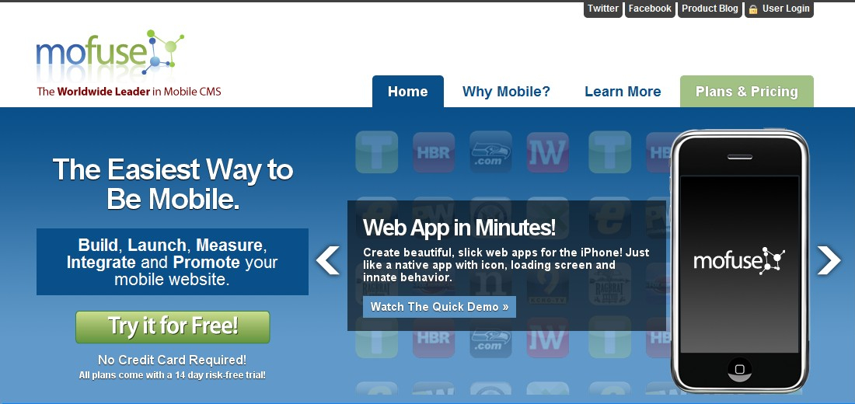
- WIRENODE

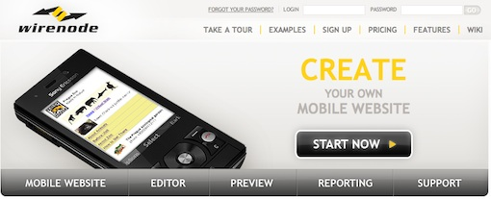
- MOBILEPRESS
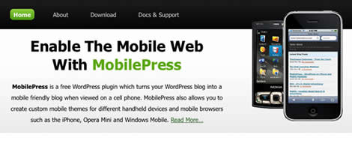
- WP-TAP
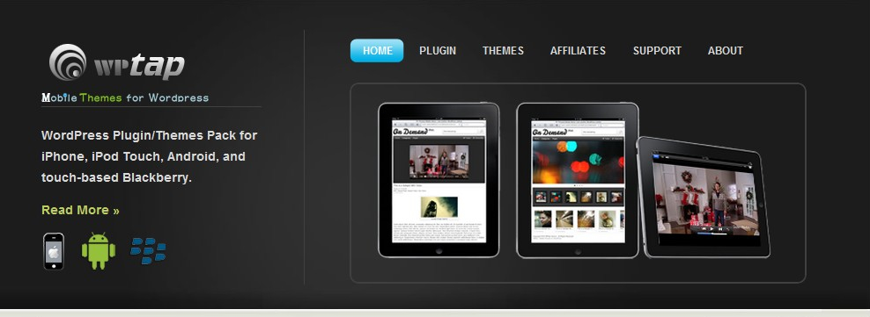
- WP-TOUCH PRO
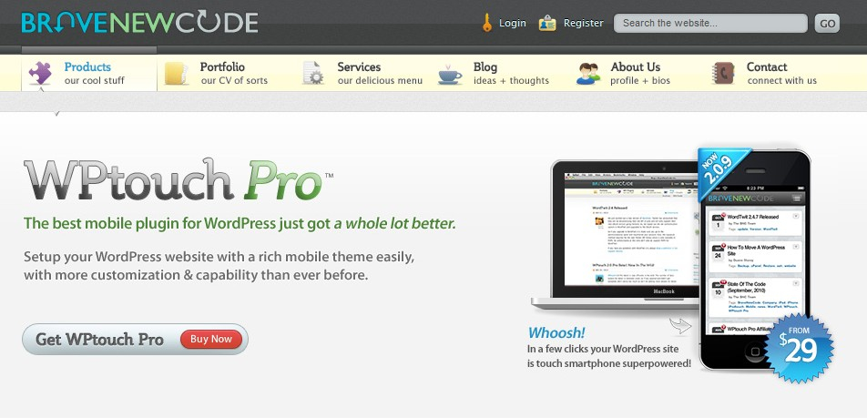

Using Kurogo
      - An integrated solution for native apps and mobile webs.
      - Flexible
      - Open, free

Comparison between available tools and Kurogo
 | Available tools | Kurogo
Difficulty | Easy, made for non-programmer, need just few steps to convert. | Not easy, made for developer, very few documentations, guides and support, not perfect (exists many errors)
Flexibility | Very little template for layout | Very flexible for developer
Fee | High | Free
Time developing | Very short | Need much time
Knowledge | A little knowledge about developing web, do not need care about hardware and software of user devices | Knowledge about PHP, HTML, CSS, hardware and software of user devices

What we need when using Kurogo to make a mobile web for smartphones

Knowledge about hardware and software of smartphones
      - Screen size
      - Operating System
      - Ability of supporting JavaScript
      - Input method
      - ….
These information help us a lot of when design CSS for specific device.

Database (using MySQL)
Because Kurogo uses MySQL as its database.

Design Principle for smartphones

Redesign layout

Using these mentioned principle when redesigning.

Building modules

We need one module for one user request page. With our homepage, maybe we need 9 modules in total. This is:
- Introduction page
- Projects page
- People page
- Publications page
- Seminars page
- Links page
- Board page
- Video
- News page
- Links

Tester to test out web
Many tools like:
- http://iphonetester.com/
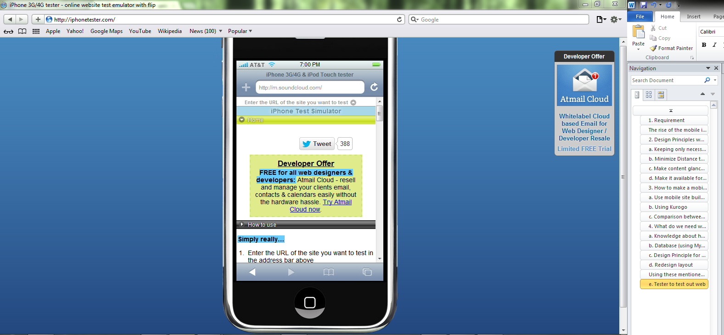
- IPhoney
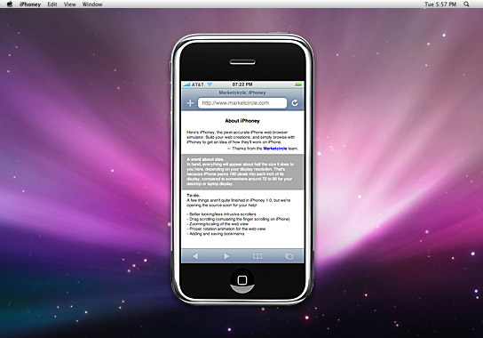
- http://validator.w3.org/mobile/
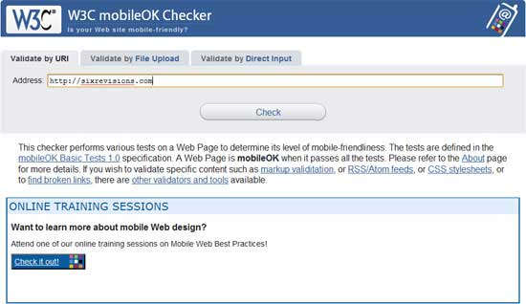
- http://ipadpeek.com/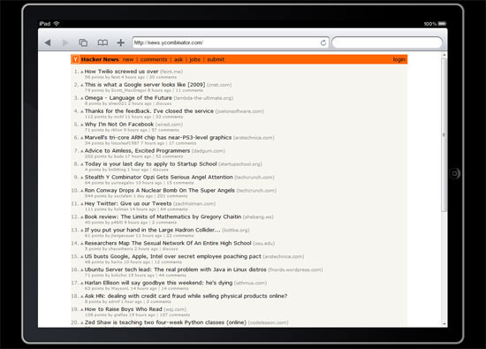
- Adobe Device Central CS5
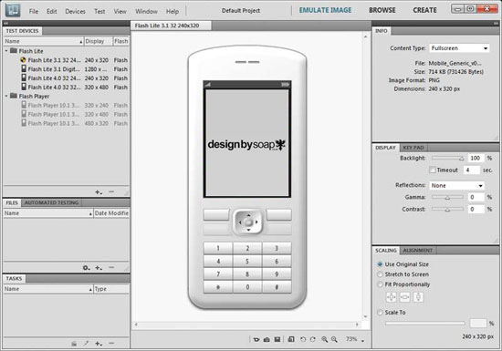
- DotMobi Emulator
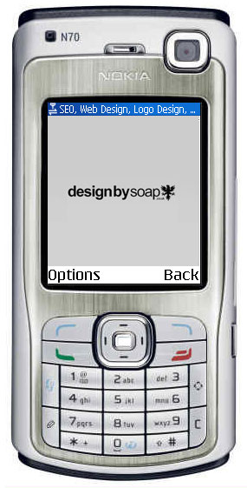
- Opera Mini Simulator
