SQL
SQL Structured Query Language. SQL is used to assess and communicate with a database. SQL is a database language, it is used for database creation, deletion, fetching rows and modifying rows etc. All DBMS like MySQL, Oracle, MS Access, Sybase, Informix, Postgres and SQL Server use SQL as standard database language.
SQL Functions
- SQL is used to execute queries against a database
- SQL is used to add records in a database
- SQL can be used to update and delete records in a database
- SQL can be used to create new databases
- SQL can be used to create new tables in a database
- SQL can be used to create stored procedures in a database
- SQL can be used to retrieve information from the database
- SQL can set permissions on tables, procedures, and views in a database

SQL command
SQL commands are instructions used to communicate with the database. It is used to perform specific tasks, functions, and queries of data.
- SELECT - extracts data from a database
SELECT * FROM Customers;
- UPDATE - updates data in a database
UPDATE table_name
SET column1 = value1, column2 = value2, ...
WHERE condition;
- DELETE - deletes data from a database
DELETE FROM table_name WHERE condition;
- INSERT INTO - inserts new data into a database
INSERT INTO table2
SELECT * FROM table1
WHERE condition;
- CREATE DATABASE - creates a new database
CREATE DATABASE databasename;
- CREATE TABLE - creates a new table
CREATE TABLE table_name (
column1 datatype,
column2 datatype,
column3 datatype,
....
);
- ALTER TABLE - modifies a table
ALTER TABLE table_name
ADD column_name datatype;
- DROP TABLE - deletes a table
DROP TABLE table_name;
- CREATE INDEX - creates an index (search key)
CREATE INDEX index_name
ON table_name (column1, column2, ...);
- DROP INDEX - deletes an index
DROP INDEX index_name ON table_name;
Comparison Operators
= | Equal
> | Greater than
< | Less than
>= | Greater than or equal to
<= | Less than or equal to
<> or != | Not equal to
LIKE | String comparison test

SQL JOIN

As the name shows, JOIN means to combine something. In case of SQL, JOIN means "to combine two or more tables". The SQL JOIN clause takes records from two or more tables in a database and combines it together.
Types of JOIN :
- Inner join- Returns records that have matching values in both tables
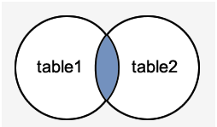
- Left outer join – Return all records from the left table, and the matched records from the right table
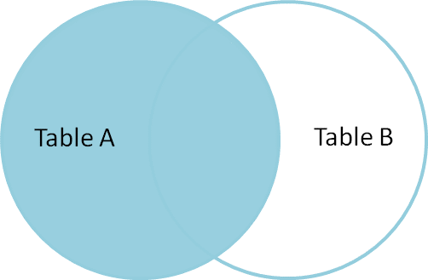
- Right outer join - Return all records from the right table, and the matched records from the left table
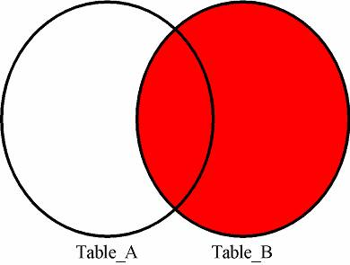
- Full outer join - Return all records when there is a match in either left or right table
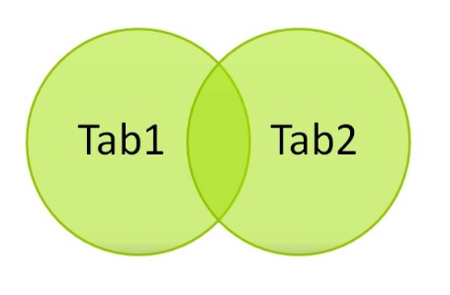
- Cross join- When each row of first table is combined with each row from the second table, it’s also known as Cartesian join.
