GITHUB
Github is a website/platform while git is a tool that helps you to manage your code.
GitHub can be used for:
- Storing, sharing and collaborating on code
- Tracking issues and bugs
- tracking projects
- maintaining a large amount of code
- networking and socialising with other developers

In git terms each hosted project is called a REPOSITORY.
First, you’ll need to sign up for an account on GitHub.com.

Login to Github
In the upper-right corner of any page, click , and then click New repository
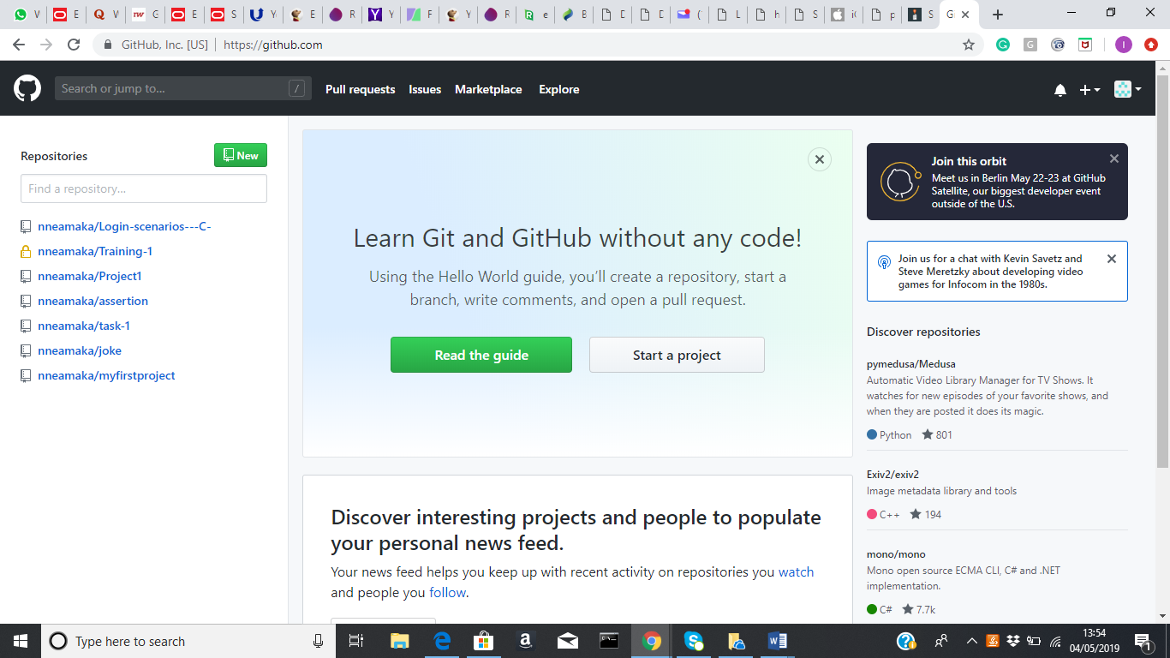

Create a new repository
Enter Repository Name
Select Public – (Public repositories are a great choice for getting started. They're visible to any user on GitHub, so you can benefit from a collaborative community)
Select initialize Repository as Read me
Click on create Repository
FYI - create a separate repository for each and every project.

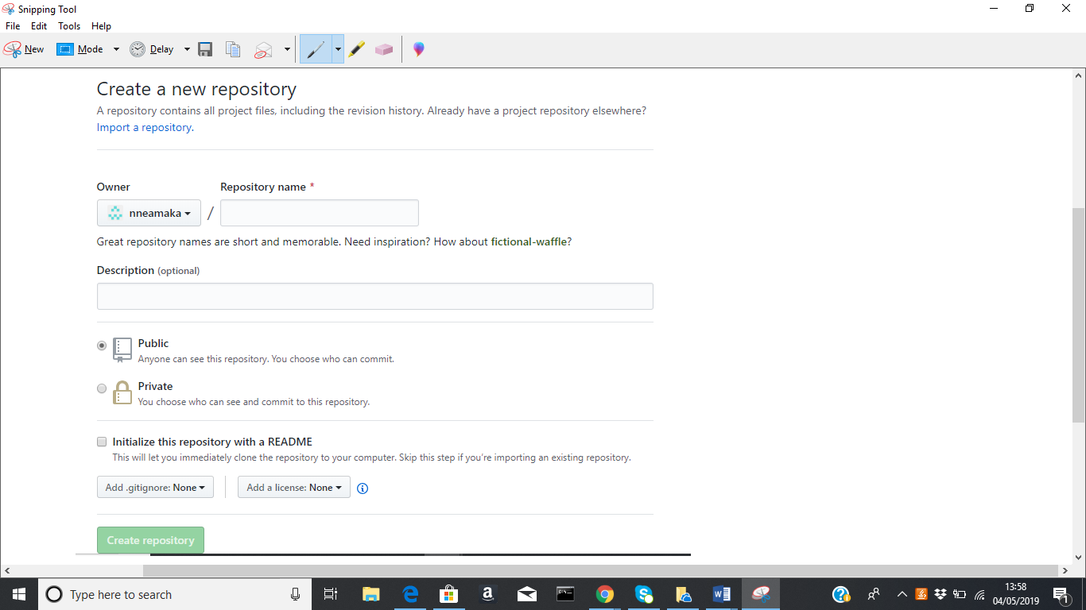
Get started by creating a new file or uploading an existing file. Every repository should include a README, LICENSE, and .gitignore.

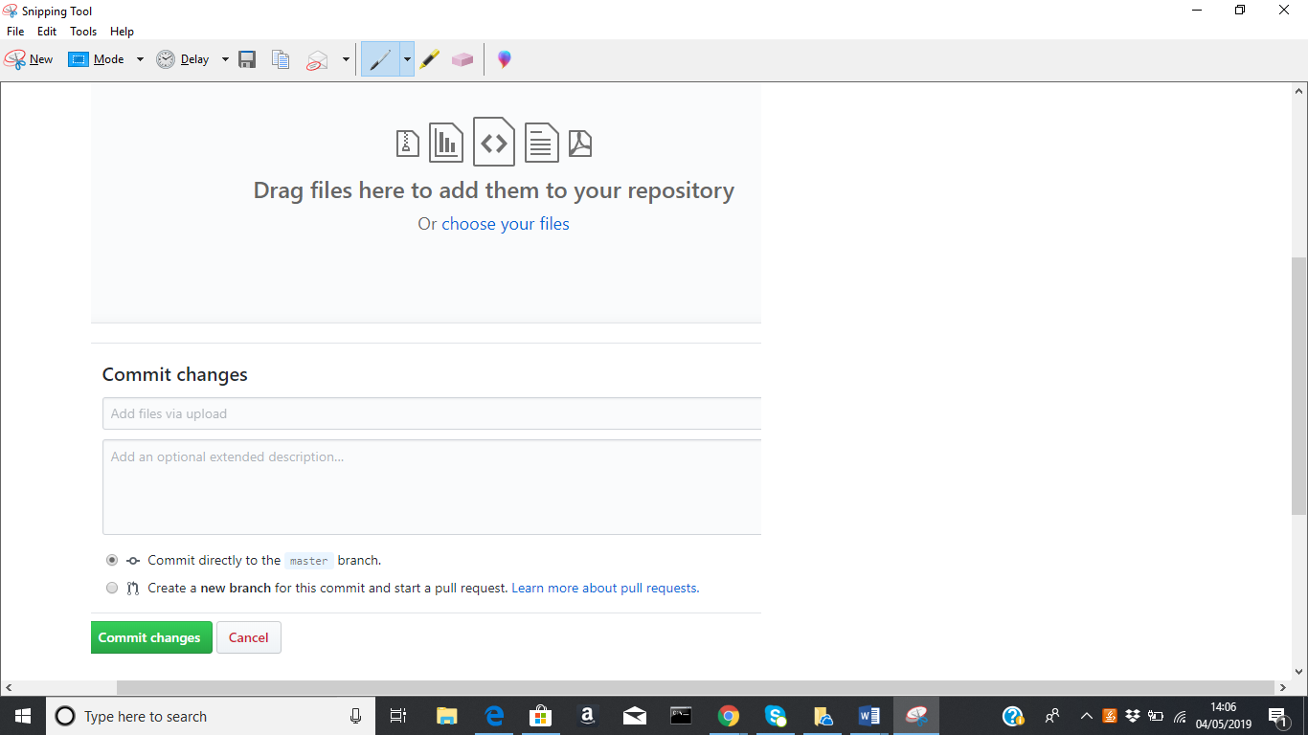
Always Click on Commit changes to save – (A commit is like a snapshot of all the files in your project at a particular point in time).
After uploading project, you can click on file to view 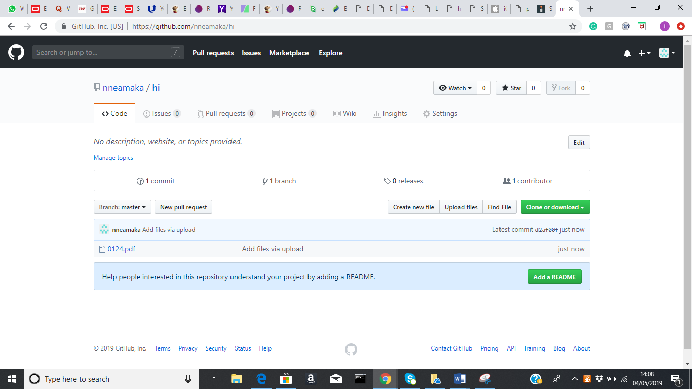

Some Git commands
git push: Push changes to remote repository
git pull: Update local repository to the newest commit
git init: Initialize a local Git repository
git clone ssh://git@github.com/[username]/[repository-name].git: Create a local copy of a remote repository
git commit -m "[commit message]": Commit changes
git rm -r [file-name.txt]: Remove a file (or folder)

