BDA400 - Data Science Tools and Techniques
Assignment 2 - Technical Analysis using R, Preliminary Stage

Student: Nnedi Okafor
GitHub Repository: https://github.com/nnediokafor/TechnicalAnalysis

1. GitHub Account and Repository Setup
I created a GitHub repository called TechnicalAnalysis for the technical analysis project. This is the main repository I will use for the different stages of the project.
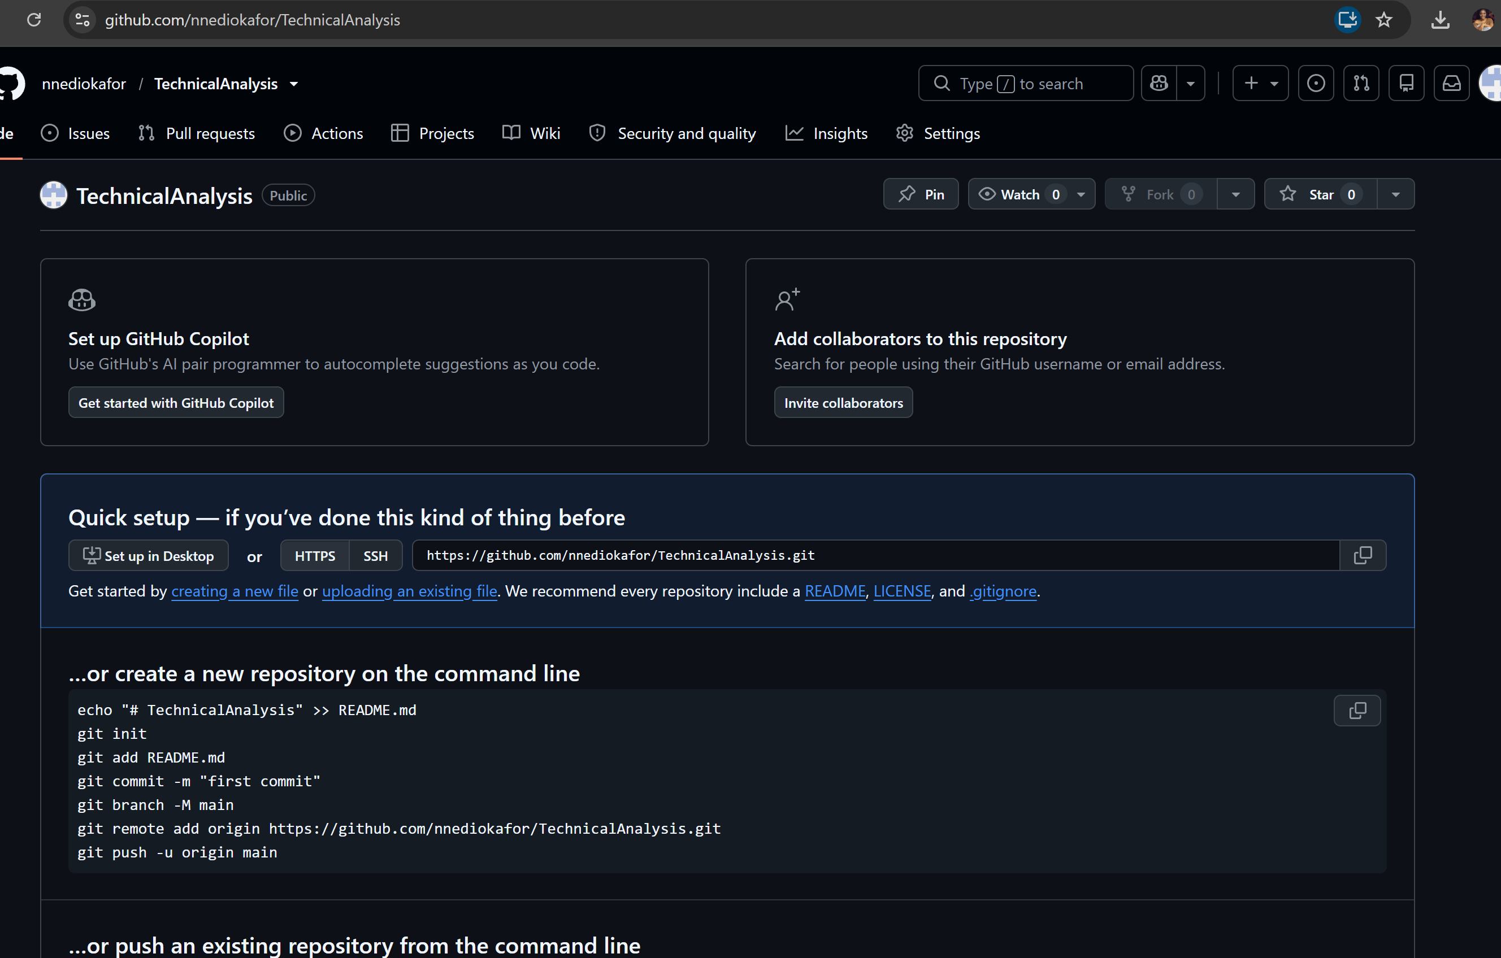
GitHub repository named TechnicalAnalysis
Inside the repository, I created a separate folder called Assignment2 so that the files for this assignment are kept together and easy to find.
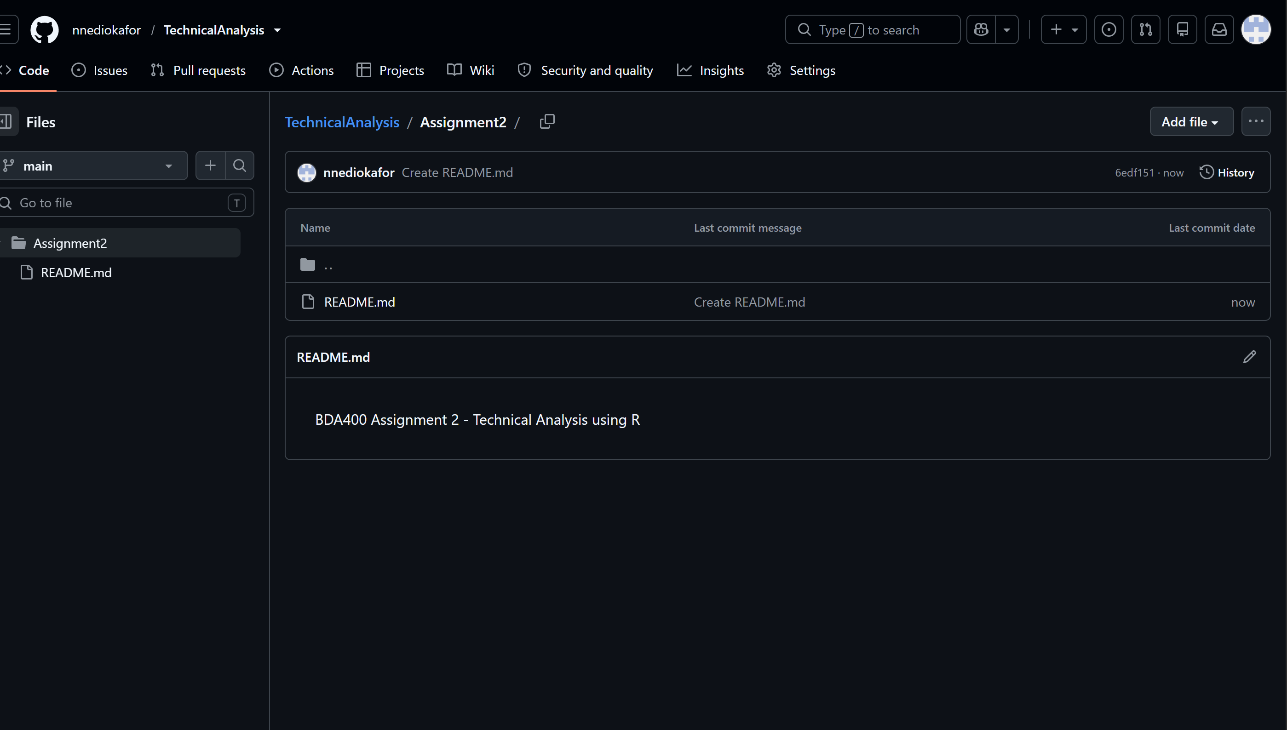
Assignment2 folder created inside the TechnicalAnalysis repository

2. R and RStudio Installation and Setup
I installed both R and RStudio on my computer. R is the programming language used for the analysis, while RStudio gives me a simpler place to write, run and check the R code.
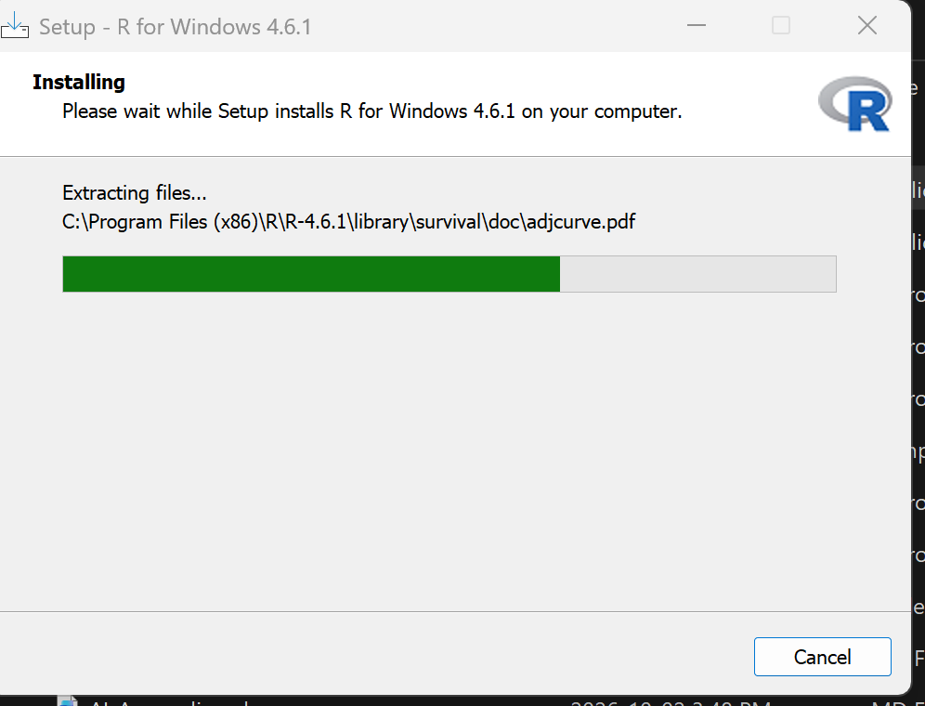
R installation in progress
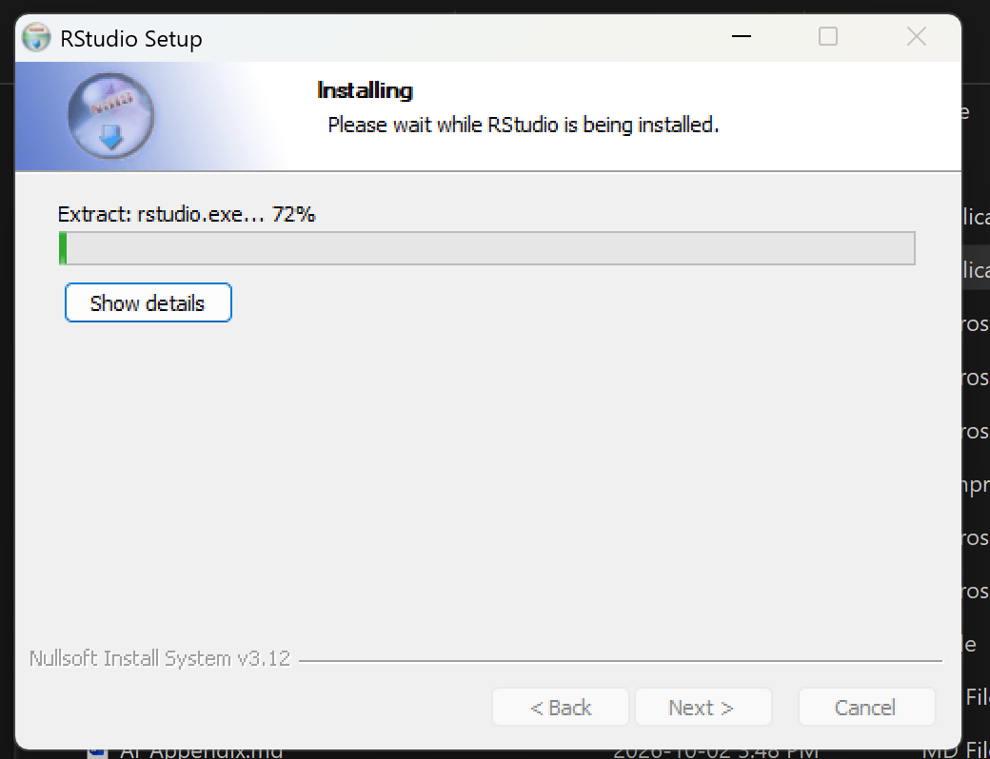
RStudio installation in progress
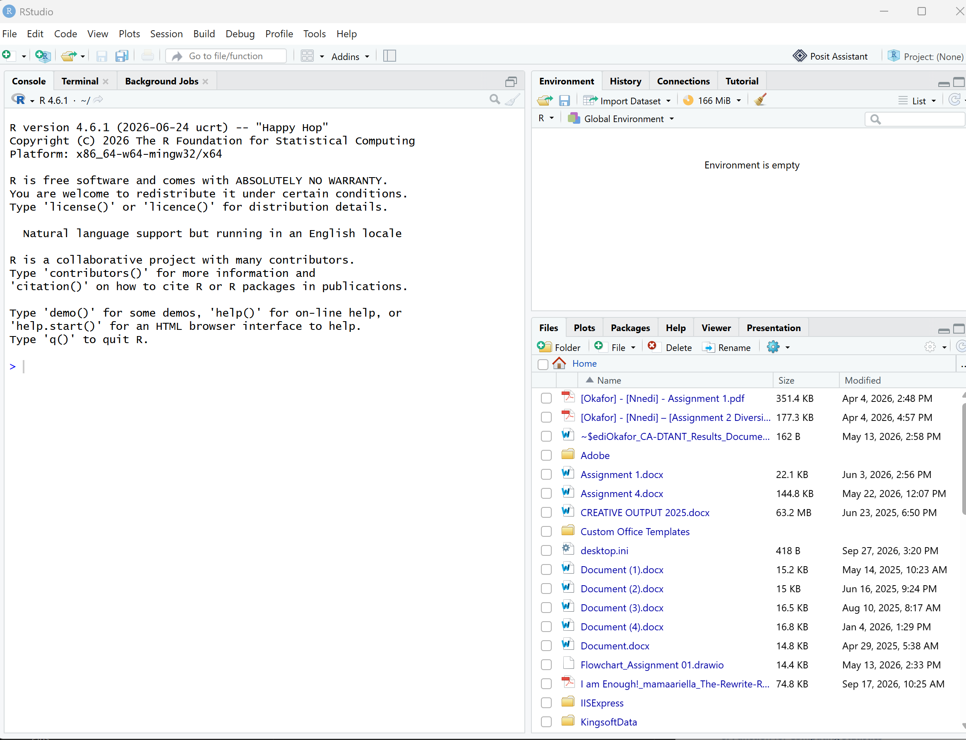
RStudio opened successfully

3. R Packages Installation
For this assignment I installed the quantmod and TTR packages. Quantmod is used to download and work with stock market data, while TTR provides technical analysis functions such as moving averages.
I used these commands in the RStudio Console:
install.packages(c("quantmod", "TTR"))
library(quantmod)
library(TTR)
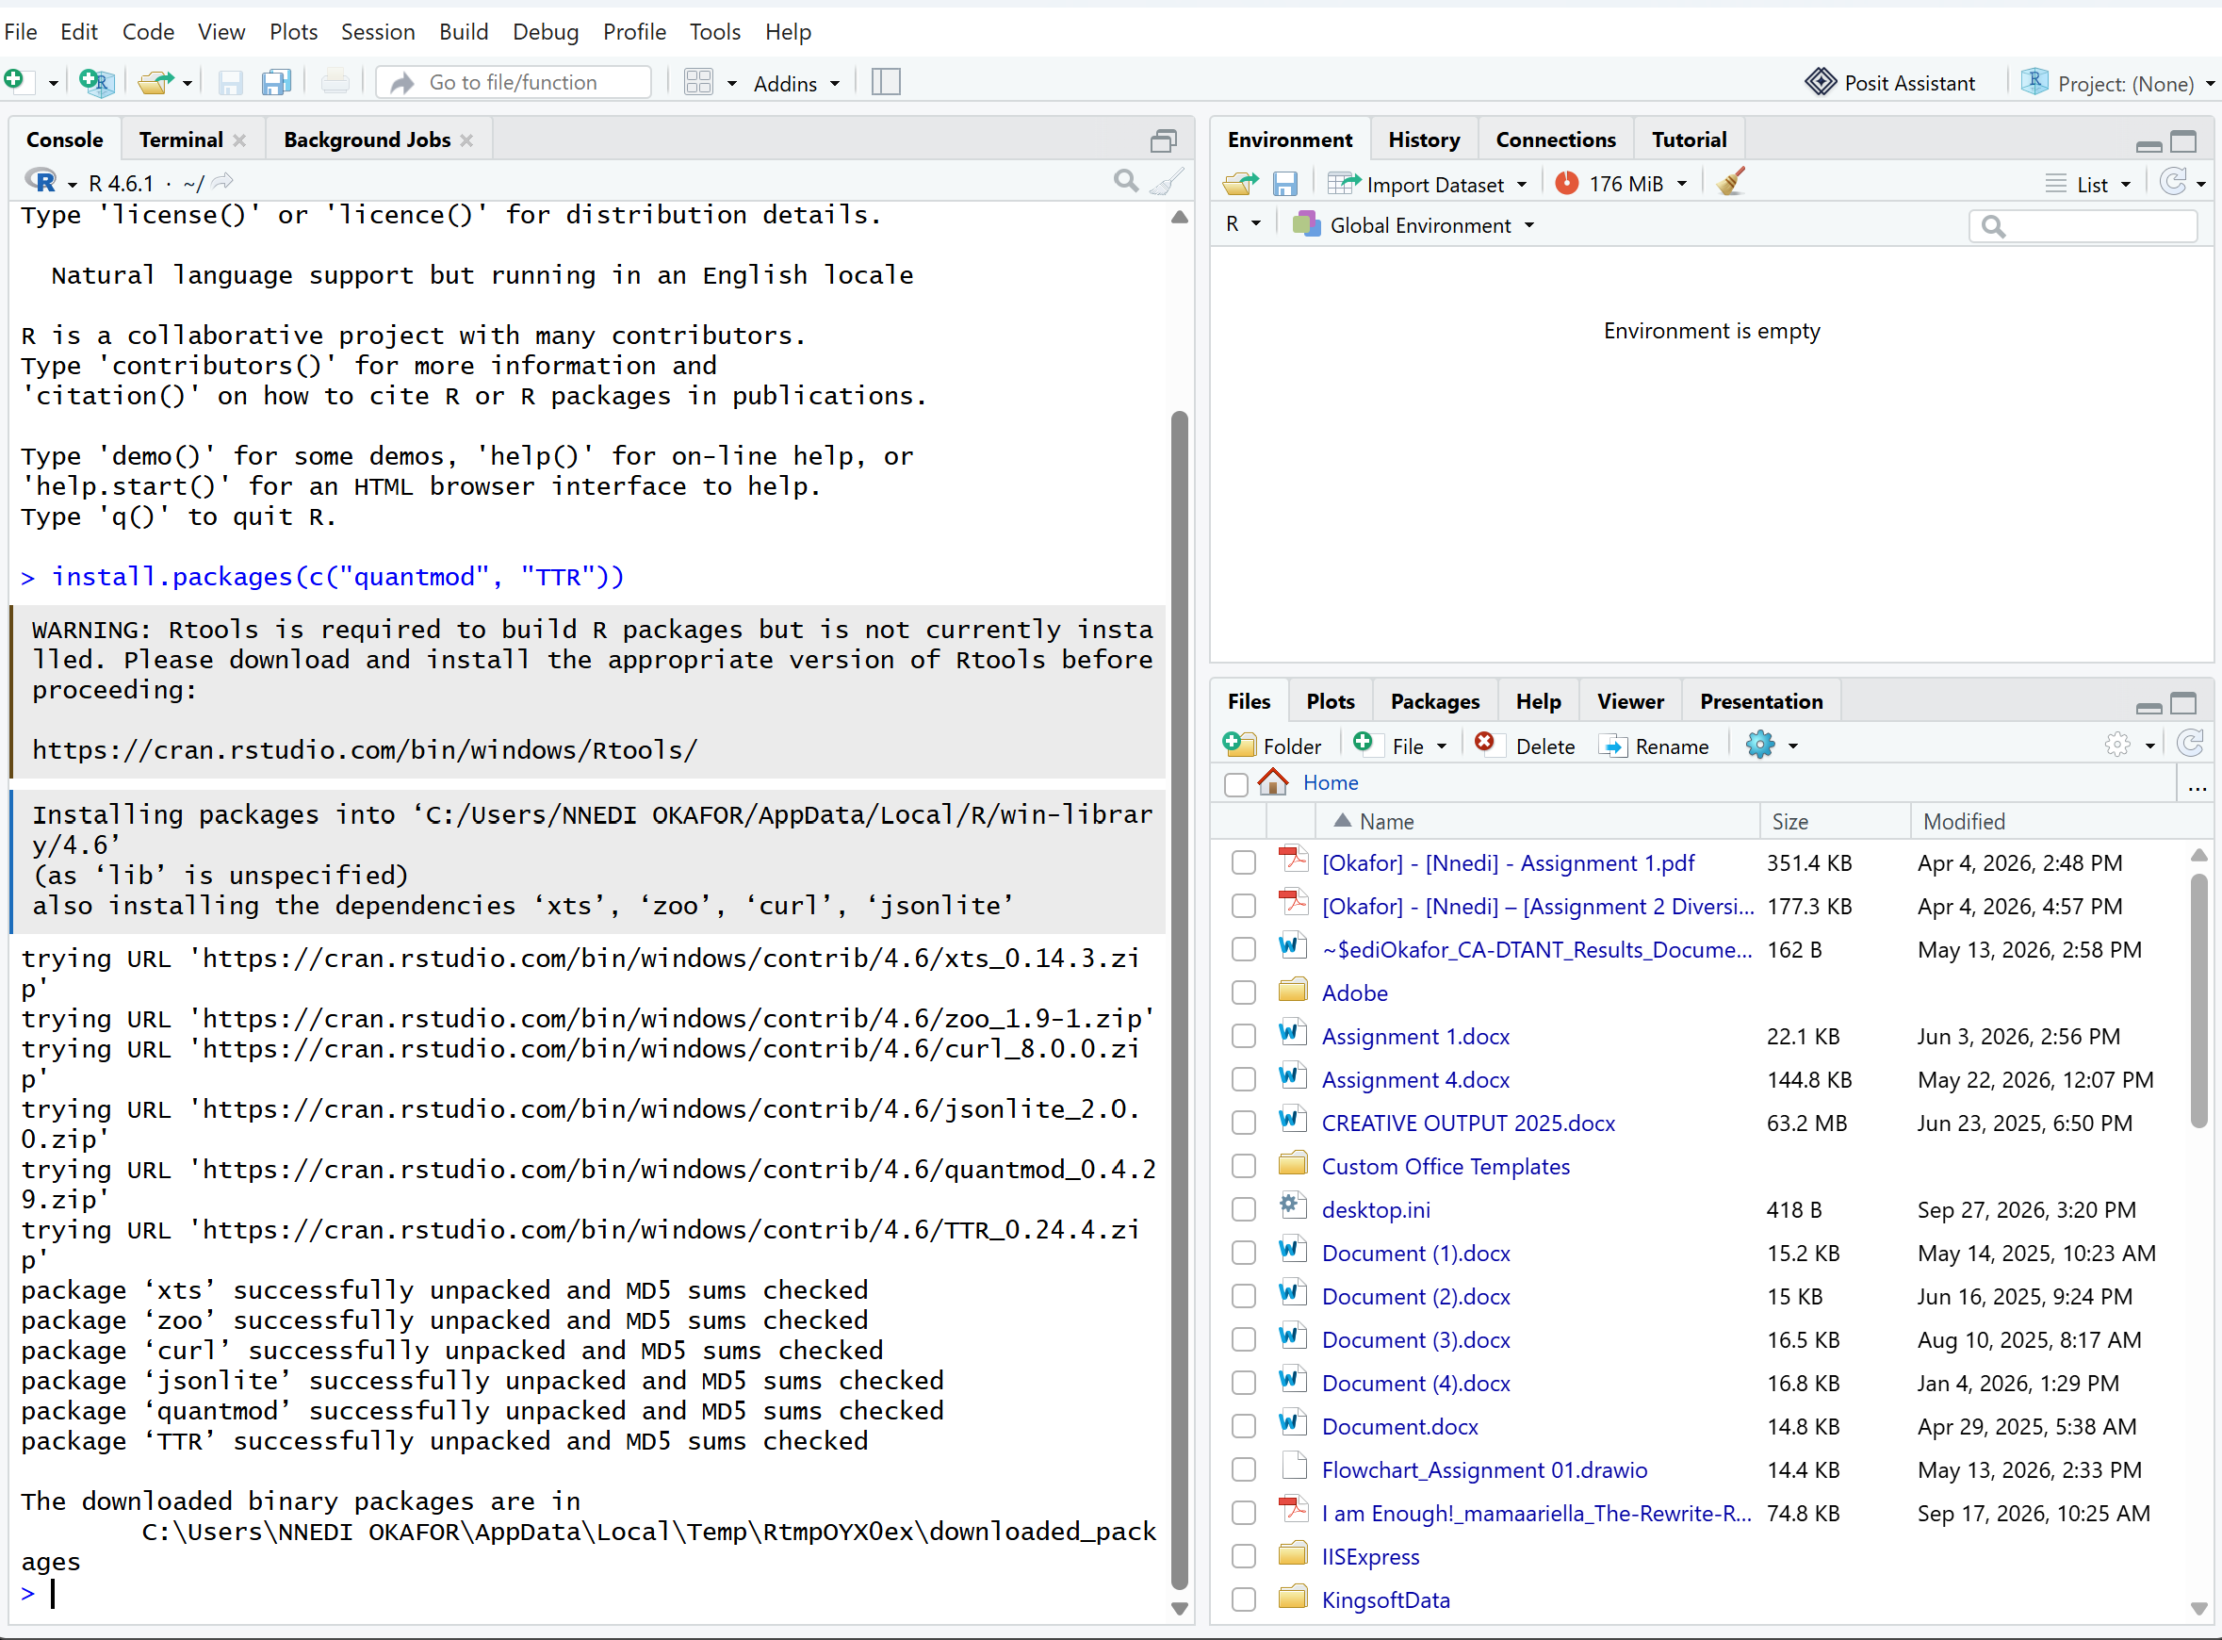
Installing the required R packages
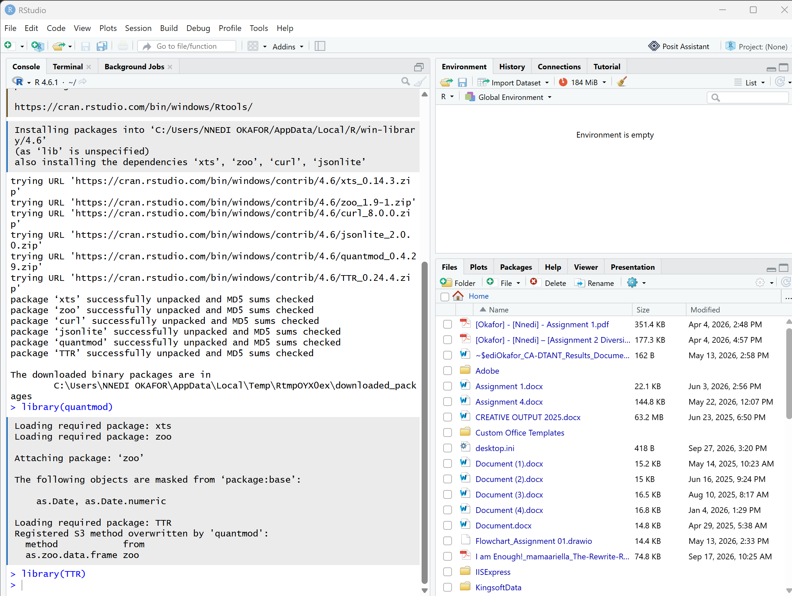
quantmod and TTR loaded in RStudio

4. Project Configuration and Initialization
I created a folder for Assignment 2 on my computer and kept the report, R script and portfolio text file together.
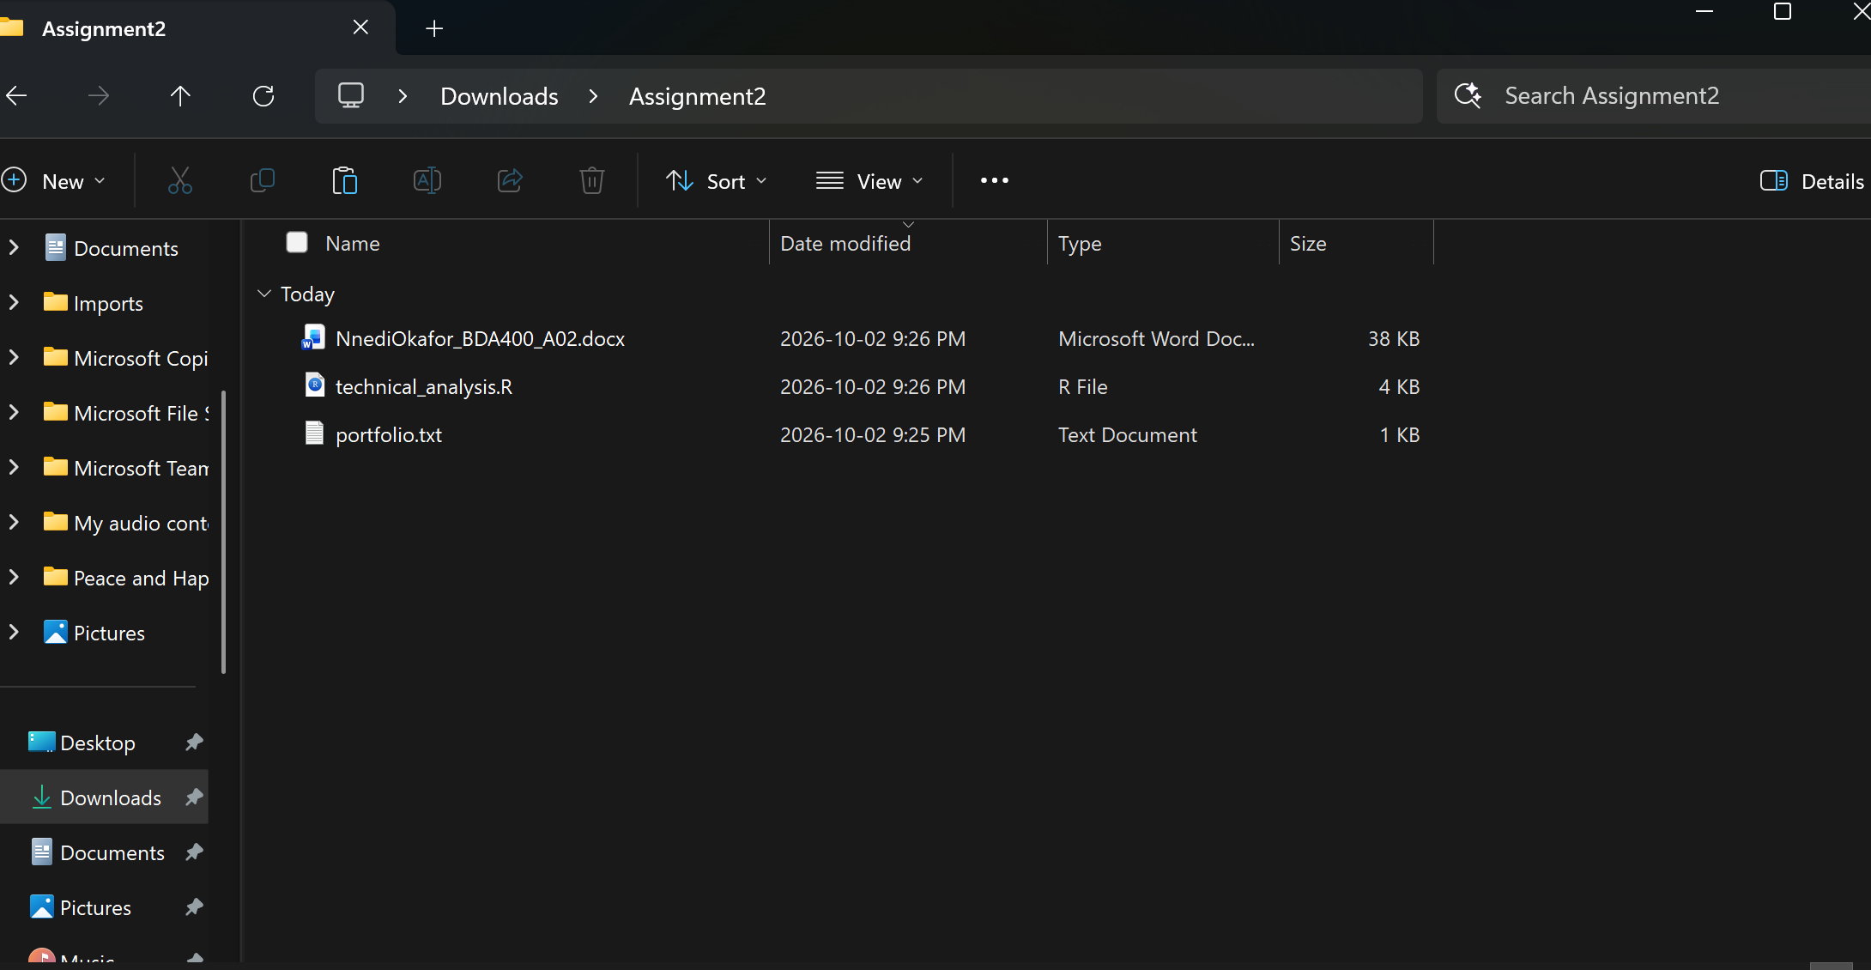
Assignment2 project folder on my computer
I created portfolio.txt with one stock symbol on each line:
AAPL
MSFT
GOOG
These symbols represent the three stocks used in my portfolio for this preliminary stage.

5. Function for Importing Stock Data
I created a function called load_stock_data(). It reads the stock symbols from portfolio.txt and downloads data for each symbol from Yahoo Finance using quantmod. Each stock is stored separately inside a list.
The main part of the function is:
load_stock_data <- function(portfolio_file = "portfolio.txt") {
symbols <- readLines(portfolio_file)
symbols <- trimws(symbols)
symbols <- symbols[symbols != ""]

stock_list <- list()

for (symbol in symbols) {
stock_data <- getSymbols(
Symbols = symbol,
src = "yahoo",
from = Sys.Date() - 180,
to = Sys.Date(),
auto.assign = FALSE
)

stock_list[[symbol]] <- stock_data
}

return(stock_list)
}
The function is set up to load AAPL, MSFT and GOOG from the portfolio file.

6. Function for Computing Statistics
I also created a function called calculate_statistics(). For each stock, it uses the closing prices and calculates the statistics required in the assignment: moving average, mean, mode, median and standard deviation.
calculate_statistics <- function(stock_xts, symbol) {
close_prices <- na.omit(Cl(stock_xts))
moving_average_20 <- SMA(close_prices, n = 20)

stats <- data.frame(
Symbol = symbol,
Mean = mean(close_prices),
Mode = statistical_mode(as.numeric(close_prices)),
Median = median(close_prices),
Standard_Deviation = sd(close_prices),
Latest_20_Day_Moving_Average =
as.numeric(last(na.omit(moving_average_20)))
)

return(stats)
}
The results for all stocks are combined into one statistics table so that they can be viewed together.

7. Data Display and Visualizations
The script displays the beginning and end of the downloaded data for every stock. This makes it easy to confirm that the data was imported and to see the Open, High, Low, Close, Volume and Adjusted values.
for (symbol in names(stock_data)) {
print(head(stock_data[[symbol]]))
print(tail(stock_data[[symbol]]))
}
The script also creates stock charts for every symbol and adds a 20-day simple moving average. I also included a simple closing-price plot for each stock.
for (symbol in names(stock_data)) {
chartSeries(
stock_data[[symbol]],
name = paste(symbol, "- Stock Price"),
theme = chartTheme("white")
)

addSMA(n = 20, on = 1)
}

8. Files Included in Assignment 2
The files prepared for the Assignment2 folder are:
- NnediOkafor_BDA400_A02_FINAL.docx - assignment report
- portfolio.txt - stock symbols used for the portfolio
- technical_analysis.R - R code for downloading data, calculating statistics and creating visualizations
- README.md - identifies the Assignment2 folder in GitHub

9. What the R Script Does
- Checks that quantmod and TTR are available.
- Loads quantmod and TTR.
- Reads the stock symbols from portfolio.txt.
- Downloads approximately 180 days of stock data from Yahoo Finance.
- Stores the stock data separately for each symbol.
- Calculates the 20-day moving average, mean, mode, median and standard deviation.
- Combines the statistics into one table.
- Displays the imported data for each stock.
- Creates stock price charts and closing-price plots.

10. Conclusion
This assignment helped me set up the preliminary stage of the technical analysis project. I created the GitHub repository and Assignment2 folder, installed R and RStudio, installed the required packages, created my portfolio file and prepared the functions for importing stock data, calculating statistics and displaying the results. The files are organized inside the TechnicalAnalysis project so I can continue with the next stages.

