CRM Integration Requirements
Inbound Call — Lead Capture APIs
Note on sample data: All domains, endpoints, client identifiers, secrets, tokens, and record IDs in this document are illustrative mock values for specification purposes only. Production values will be issued during onboarding.
1. Parties
We operate an Integration Platform that routes inbound phone calls and exchanges lead and billing data with a Customer Relationship Management (CRM) system. The two systems communicate over three REST API touchpoints across the lifecycle of a single call.
This document defines the integration requirements to mirror the existing CRM workflow. Changes to the workflow may occur as part of the onboarding process, and will be documented in a technical specification document.
1.1 Parties
Party | Role
Integration Platform | Originates all API calls. Routes inbound calls, requests authentication, looks up the Agent of Record, posts lead data on call arrival, and updates billing status at call end.
CRM | Receives and authenticates the API calls. Stores/serves agent and lead records, triggers the agent screen-pop, and records billing status.

2. Integration Overview
Data flows in one direction — from the Integration Platform to the CRM — across three API interactions tied to the call lifecycle:
# | Touchpoint | Timing | Method | Purpose
1 | Agent of Record Lookup | Pre-call | GET | Determine whether the caller already has an Agent of Record.
2 | Lead Post | At call arrival | POST | Create/find the lead record and trigger the agent screen-pop.
3 | Billing Update | At call end | PATCH | Update the lead record with the final billable status.
2.1 Technologies
System | API / Protocol | Authentication
CRM | REST / JSON over HTTPS | OAuth 2.0 — Client Credentials flow

3. Authentication (OAuth 2.0 — Client Credentials)
Before any data API call, the Integration Platform obtains a bearer access token from the CRM using the OAuth 2.0 Client Credentials grant. The CRM must issue the Integration Platform a set of client credentials (client ID + secret) for this purpose.
3.1 Connection Details (mock values)
Field | Value | Notes
Domain | https://crm-instance-4821.example-crm.com | Base URL of the CRM instance
Client ID | MOCK_CLIENT_ID_a1b2c3d4e5f6 | Issued by the CRM
Client Secret | MOCK_CLIENT_SECRET_9f8e7d6c5b4a3210 | Issued by the CRM — treat as sensitive

3.2 Token Request
- Endpoint: POST <Domain>/oauth/token
- Content-Type: application/x-www-form-urlencoded
Request parameters:
Parameter | Value | Description
grant_type | client_credentials | Specifies the OAuth 2.0 flow
client_id | <Client ID> | The issued client identifier
client_secret | <Client Secret> | The issued client secret

3.3 Successful Response
A successful request returns a JSON object containing the access token and related metadata:
Field | Type | Description
access_token | String | Bearer token for subsequent API calls
instance_url | String | Base URL of the CRM instance
id | String | Identity URL of the authenticated client
token_type | String | Bearer
scope | String | Granted scopes

3.4 Token Lifecycle Requirements
- The access token is valid for 24 hours; the Integration Platform caches it and requests a fresh token only once per 24-hour period.
- On any HTTP 401 Unauthorized response, the Integration Platform requests a fresh token and retries the original request once.
- All subsequent data API calls (GET / POST / PATCH) include the token in the Authorization header as: Bearer <access_token>.
4. API 1 — Pre-Call: Agent of Record Lookup (GET)
Before connecting a call, the Integration Platform queries the CRM by caller ID (ANI) to determine whether that caller already has an Agent of Record. The result influences call routing and billing on the Integration Platform side.
4.1 Request
- URL: <Domain>/api/v1/leads?ani=<ani>
- Method: GET
- Authorization header: Bearer <access_token>
- Query parameter: ani — the 10-digit caller ID (e.g., 5551234567)
4.2 Response Scenarios
HTTP Status | Payload | Meaning
200 OK | {"pcId": "agent-00123"} | Match found — returns the unique ID of the Agent of Record (pcId).
204 No Content | (none) | No match — no Agent of Record exists for the provided ANI.

4.3 Requirement
- The CRM must expose a token-authenticated GET endpoint that accepts an ANI and returns the associated agent's unique identifier when a record exists, or a 204 when none exists.
5. API 2 — Call Arrival: Lead Post (POST)
When a call is answered, the Integration Platform posts the lead/call details to the CRM. The CRM finds or creates the corresponding lead record and triggers the agent screen-pop.
5.1 Request
- URL: <Domain>/api/v1/leads
- Method: POST
- Headers: Authorization: Bearer <access_token> | Content-Type: application/json
The request body uses the shared lead data structure defined in Section 7. Sample payload:
{
"ani": "5551234567",
"state": "TX",
"recordType": "Quote_Shopper",
"pcId": "agent-00123",
"callStart": "2026-01-09T14:00:00Z",
"duration": 301,
"offerId": "offer-7788",
"billable": 1,
"callProgram": "PROG-01",
"requestTag": "req-0001",
"subId": "sub-1001"
}

5.2 Expected CRM Behavior
- Validate the bearer token.
- Find or create the lead record keyed on the inbound data.
- Trigger the agent screen-pop (e.g., via a platform/notification event).
- Return 200 OK on success.
6. API 3 — Call End: Billing Update (PATCH)
At call end, the Integration Platform sends a PATCH to the same lead record to record the final billable status. The same data structure is used as the lead post, with the billable field carrying the result.
6.1 Request
- URL: <Domain>/api/v1/leads
- Method: PATCH
- Headers: Authorization: Bearer <access_token> | Content-Type: application/json
The billable field is an integer: 1 = billable, 0 = non-billable. Sample payload:
{
"ani": "5551234567",
"state": "TX",
"recordType": "Quote_Shopper",
"pcId": "agent-00123",
"callStart": "2026-01-09T14:00:00Z",
"duration": 301,
"offerId": "offer-7788",
"billable": 0,
"callProgram": "PROG-01",
"requestTag": "req-0001",
"subId": "sub-1001"
}

6.2 Expected CRM Behavior
- Locate the lead record previously created by the POST.
- Update the billable field (1 or 0). No other fields are expected to change.
- Return 200 OK on success.
7. Lead Data Structure
The POST (Section 5) and PATCH (Section 6) share the following structure. All fields are required.
Field | Type | Description
ani | String | 10-digit caller ID, no dashes or spaces (e.g., "5551234567").
offerId | String | Identifier of the offer associated with the call.
state | String | 2-letter state code (e.g., "CA").
recordType | String | Record classification (e.g., Quote_Shopper or Customer_Service).
pcId | String | Unique identifier of the agent (Agent of Record) within the CRM.
callStart | String | Call start time in ISO 8601 format (e.g., 2026-01-09T14:00:00Z).
duration | Integer | Call length in seconds.
billable | Integer | Billable status: 1 = billable, 0 = non-billable.
callProgram | String | Lead sub-source / program identifier.
requestTag | String | Unique identifier for the individual call/request.
subId | String | Sub-account / sub-publisher identifier.

8. Process Flow
The diagram below shows the end-to-end exchange between the Integration Platform and the CRM: the daily authentication step followed by the three per-call API touchpoints.
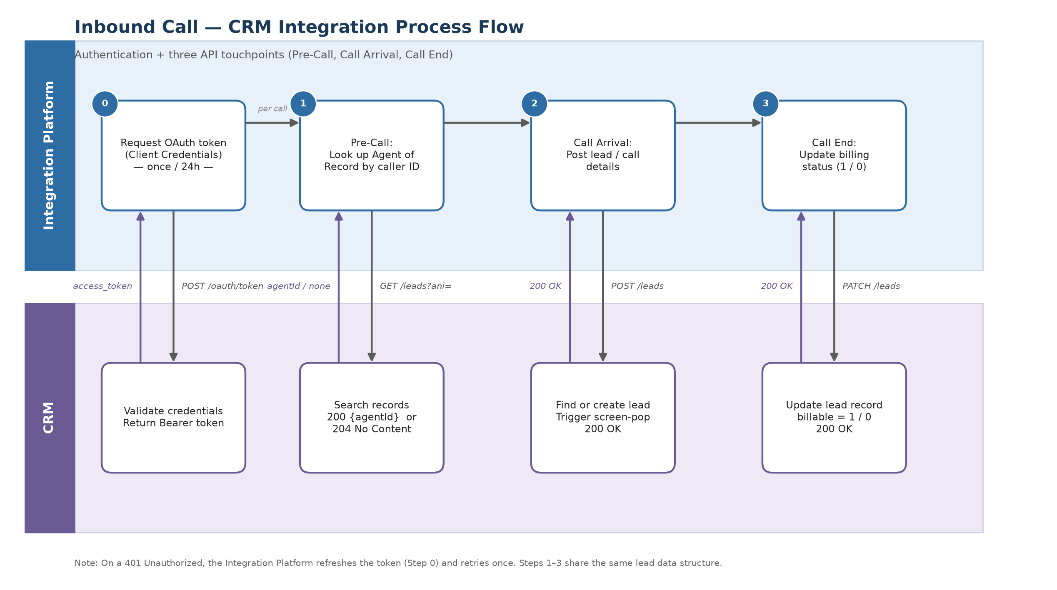
Figure 1 — Inbound call CRM integration: authentication + three API touchpoints.
9. Error Handling
- Authentication errors: If token retrieval fails, the error is logged and a retry mechanism (e.g., exponential backoff) is initiated.
- Data API errors: Validation failures or permission errors returned by the CRM are logged with the corresponding request payload and error message.
- Token refresh: On an HTTP 401 Unauthorized, the Integration Platform refreshes the token (Section 3) and retries the request once.
- Timeouts: If the CRM fails to respond or times out on the pre-call lookup, the Integration Platform proceeds with its default routing path. The CRM should therefore respond to the GET lookup promptly.
10. Security Requirements
- Encryption: All traffic must be transmitted over HTTPS (TLS 1.2 or higher).
- Authentication: OAuth 2.0 Client Credentials flow; client secret stored and transmitted securely; tokens treated as sensitive.
- Secrets handling: Client credentials and tokens are never logged in clear text.
11. Vendor Response & Acceptance Criteria
For each requirement below, the responding CRM vendor should indicate support (Yes / Partial / No) and provide notes on any deviation or alternative approach.
# | Requirement | Supported? | Notes
1 | OAuth 2.0 Client Credentials authentication with 24-hour cached bearer tokens.
2 | Token-authenticated GET lookup of Agent of Record by ANI (200 with agent ID / 204 if none).
3 | Token-authenticated POST that finds/creates a lead and triggers an agent screen-pop.
4 | Token-authenticated PATCH that updates the billable status on the existing lead record.
5 | Accepts the shared lead data structure (Section 7) as JSON.
6 | Returns standard HTTP status codes (200 / 204 / 401) as described.
7 | HTTPS (TLS 1.2+) for all traffic.
8 | Prompt response time on the pre-call GET lookup to avoid routing timeouts.

