Project: | Moffat Bay Lodge – Group 2
Course: | CSD460 – Capstone in Software Development
Description: | Room Reservation & Loft pages and backend functional tests.
Date: | 10/18/2026
Group 2 Test Template
TABLE OF CONTENTS
Test 1: Reservation: Successful Input & Saved to Database 2
Test 2: Reservation: Verify Invalid Input 3
Test 3: Lodges: Display all 6 4
Test 4: Lodges: Selection 5

Test 1 | Reservation: Successful Input & Saved to Database
 | Test Objective: Verify users can successfully submit a reservation, and confirm it is saved in the database. | Developer: Trenten Coffman  Date tested: 10/18/26 | Peer tester: Natasha Foreman  Date tested: 10/18/26
Step | Action | Expected results: | Developer pass/fail | Tester pass/fail
1 | Open the Moffat Bay Lodge website. | Homepage loads successfully without errors. | Pass | 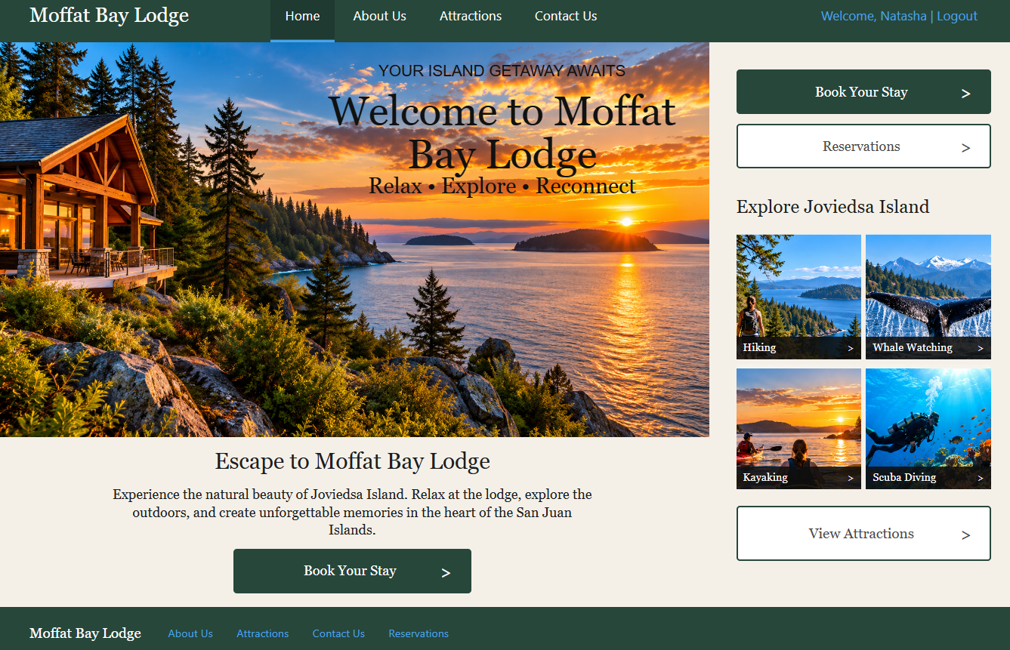
2 | Navigate to Book Your Stay. | Reservation page displays all required fields. | Pass | 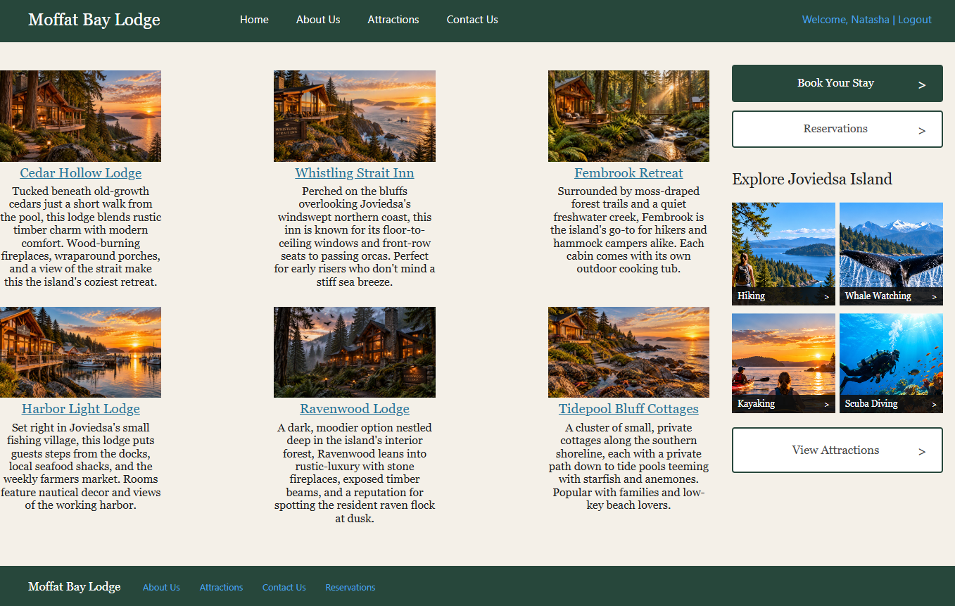
3 | Select a lodge and room type. | Selected lodge and room type are displayed correctly. | Pass | 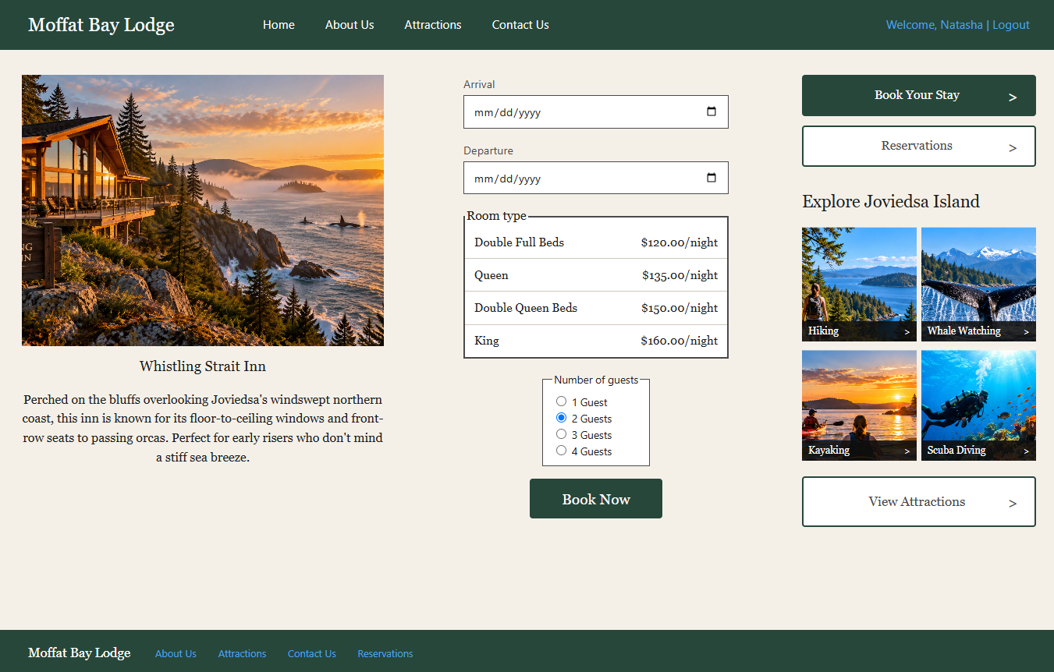
4 | Enter valid Arrival, Departure dates Room Type, and number of guests. | Reservation displays the selected information | Pass | 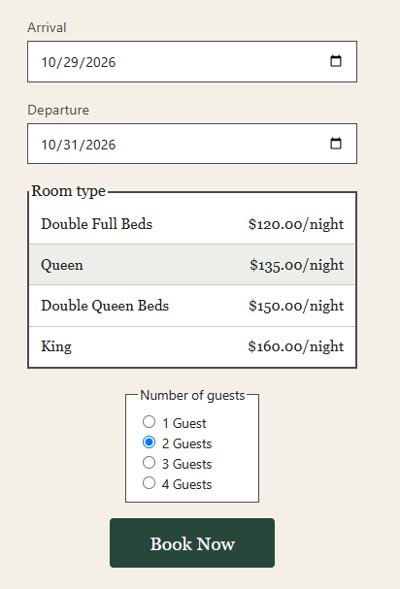
5 | Submit Reservation and display Confirmation. | Reservation is submitted and confirmation is displayed. | Pass | 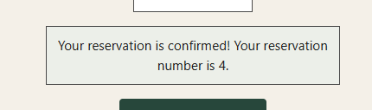
6 | Open MySQL Workbench and verify the reservation was saved. | A new reservation record exists with the correct lodge, room type, dates, and guest count. | Pass | 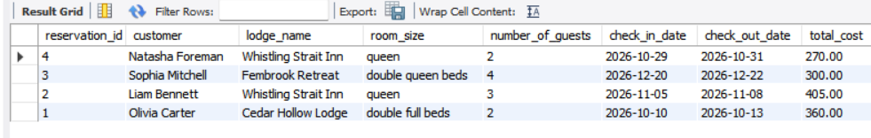
Comments | Reservation was completed and logged successfully.

Test 2 | Reservation: Verify Invalid Input
 | Test Objective: Verify invalid reservation information is rejected, | Developer: Trenten Coffman  Date tested: 10/18/26 | Peer tester: Natasha Foreman  Date tested: 10/18/26
Step | Action | Expected results: | Developer pass/fail | Tester pass/fail
1 | Open the Moffat Bay Lodge website. | Homepage loads successfully without errors. | Pass
2 | Navigate to Book Your Stay. | Reservation page displays all required fields. | Pass
3 | Attempt to submit the form without completing the required fields. | Form prevents submission and indicates which fields are required. | Pass | 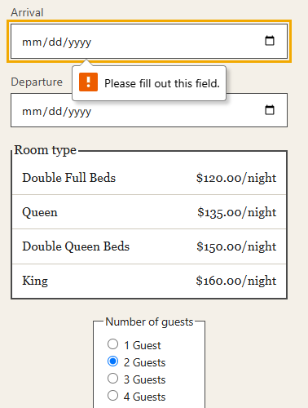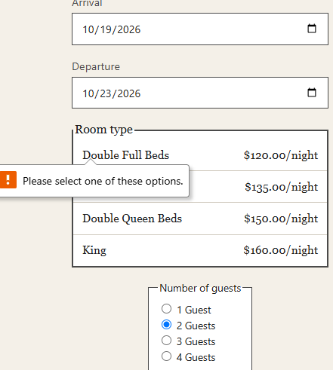
Comments | Validation messages were displayed as expected, and no invalid reservations possible.

Test 3 | Lodges: Displays all 6
 | Test Objective: Verify all six lodges display with the correct names, descriptions, and images. | Developer: Madilyn Carpenter  Date tested: 10/18/26 | Peer tester: Natasha Foreman  Date tested: 10/18/26
Step | Action | Expected results: | Developer pass/fail | Tester pass/fail
1 | Open the Moffat Bay Lodge website. | Homepage loads successfully without errors. | Pass
2 | Navigate to Book Your Stay. | Lodges page loads and displays available lodging options. | Pass
3 | Verify that all six lodges are displayed along with their Images. | All six lodges appear without missing or duplicate entries. | Pass | 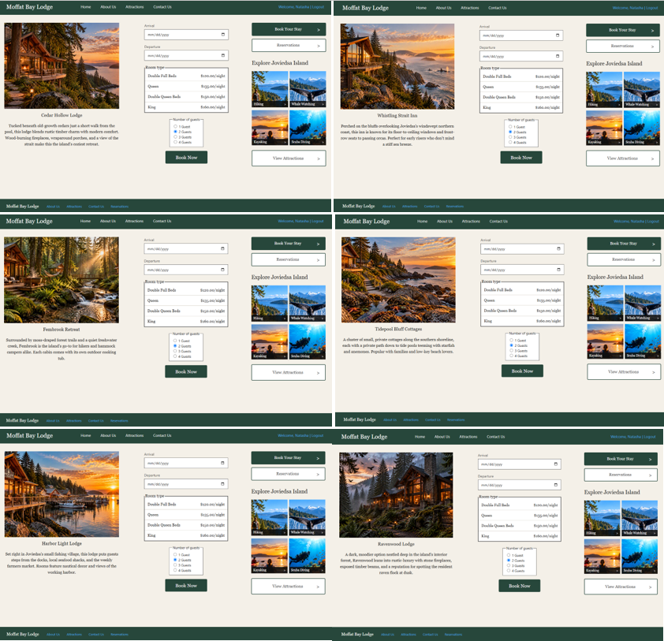
Comments | All six lodges displayed successfully with the correct names, descriptions, and corresponding images.

Test 4 | Lodges: Selection
 | Test Objective: Verify users can select a lodge and navigate to the reservation process. | Developer: Madilyn Carpenter  Date tested: 10/18/26 | Peer tester: Natasha Foreman  Date tested: 10/18/26
Step | Action | Expected results: | Developer pass/fail | Tester pass/fail
1 | Open the Moffat Bay Lodge website. | Homepage loads successfully without errors. | Pass
2 | Navigate to Book Your Stay. | Lodges page displays all six available lodges. | Pass
3 | Select a lodge using its reservation or booking option. | The selected lodge opens the reservation page or begins the booking process. | Pass
4 | Verify the selected lodge on the reservation page. | The reservation page correctly identifies the chosen lodge. | Pass
5 | Return to the Lodges page and select a different lodge. Verify that the new lodge selection is reflected on the reservation page. | The second lodge can be selected successfully and is displayed. | Pass | 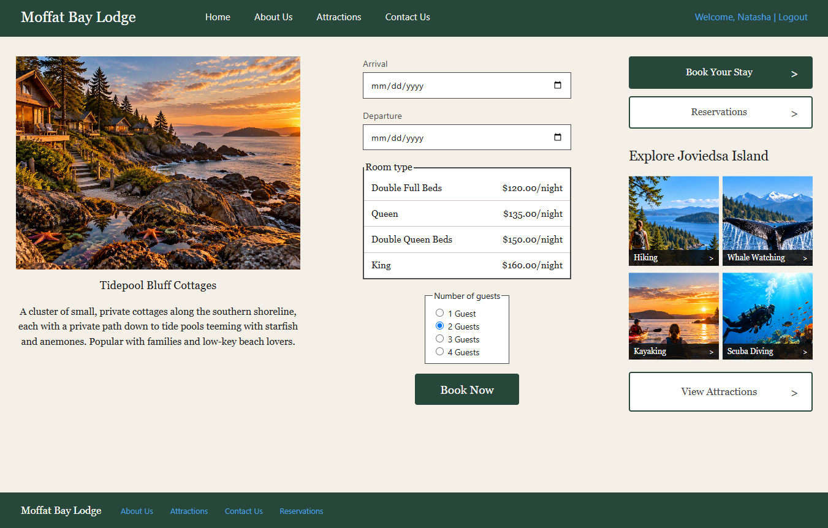
Comments | Each selection was correctly reflected in the reservation form.

