Project: | Moffat Bay Lodge – Group 2
Course: | CSD460 – Capstone in Software Development
Description: | Room reservation summary & About us pages functional tests.
Date: | 10/25/2026
Group 2 Test Template
TABLE OF CONTENTS
Test 1: Reservation-Summary: Valid Input in Booking Form Redirects to Summary 2
Test 2: Reservation-Summary: Choosing Same Dates Doesn’t Redirect to Summary 3
Test 3: About-Us: Loads 4
Test 4: About-Us: Links Directing to About-Us On All Pages Work 5

Test 1 | Reservation-Summary: Valid Input in Booking Form Redirects to Summary
 | Test Objective: Verify users can successfully submit a reservation, and are redirected to summary page. | Developer: Natasha Foreman  Date tested: 10/25/26 | Peer tester: Trenten Coffman  Date tested: 10/25/26
Step | Action | Expected results: | Developer pass/fail | Tester pass/fail
1 | Open the Moffat Bay Lodge website. | Homepage loads successfully without errors. | Pass | 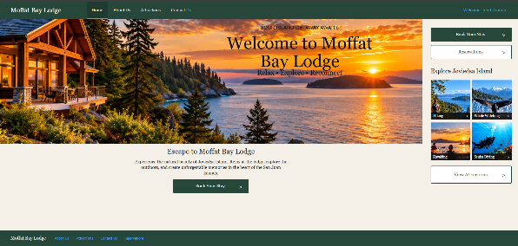
2 | Navigate to Book Your Stay. | Available lodges are displayed. | Pass | 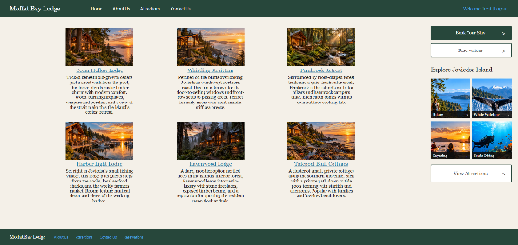
3 | Select a lodge. | Selected lodge reservation page loads. | Pass | 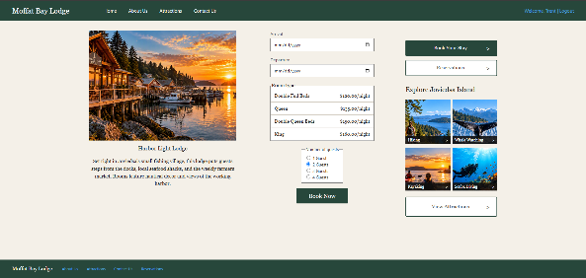
4 | Enter valid Arrival, Departure dates Room Type, and number of guests. | Form fields display inputted information correctly. | Pass | 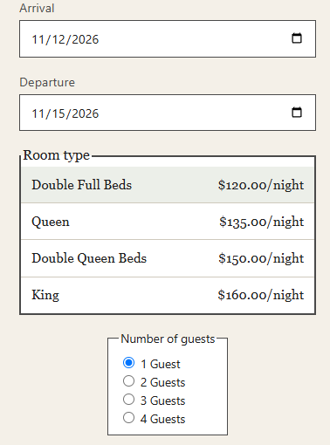
5 | Submit Reservation using Book Now button. | Reservation is submitted and summary page loads with user’s name, filled out form information, and guest’s unique confirmation number. | Pass | 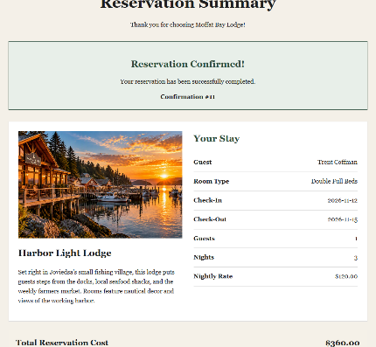
Comments | Reservation summary displays all relevant information.

Test 2 | Reservation-Summary: Choosing Same Dates Doesn’t Redirect to Summary
 | Test Objective: Verify that users can’t double book the same room at the same lodge. | Developer: Natasha Foreman  Date tested: 10/25/26 | Peer tester: Trenten Coffman  Date tested: 10/25/26
Step | Action | Expected results: | Developer pass/fail | Tester pass/fail
1 | Open the Moffat Bay Lodge website. | Homepage loads successfully without errors. | Pass | 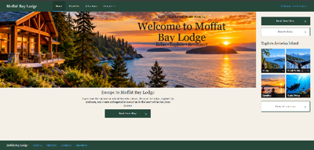
2 | Navigate to Book Your Stay. | Available lodges are displayed. | Pass | 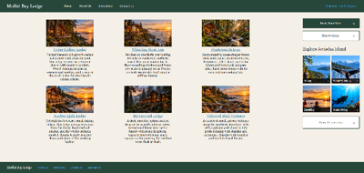
3 | Select a lodge. | Selected lodge reservation page loads. | Pass | 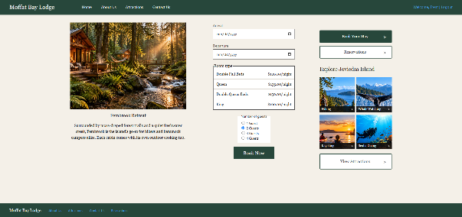
4 | Enter valid Arrival, Departure dates Room Type, and number of guests. | Form fields display inputted information correctly. | Pass | 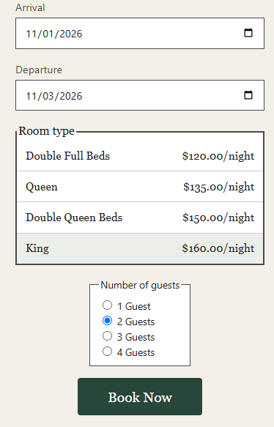
5 | Submit Reservation using Book Now button. | Reservation is submitted and summary page loads with user’s name, filled out form information, and guest’s unique confirmation number. | Pass | 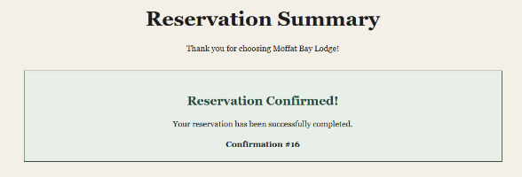
6 | Click view lodges button and repeat steps 3-5 with the same information filled in the reservation form. | Message is displayed under form telling the user that room is already booked for those dates. | Pass | 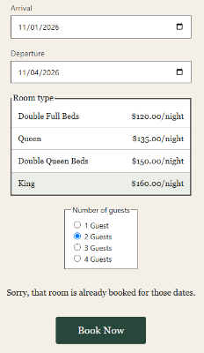
Comments | Double booking the same room is not possible. Attempting to do so does not redirect to summary page.

Test 3 | About-Us: Loads
 | Test Objective: Verify the about-us page loads correctly. | Developer: Madilyn Carpenter  Date tested: 10/25/26 | Peer tester: Trenten Coffman  Date tested: 10/25/26
Step | Action | Expected results: | Developer pass/fail | Tester pass/fail
1 | Open the Moffat Bay Lodge website. | Homepage loads successfully without errors. | Pass | 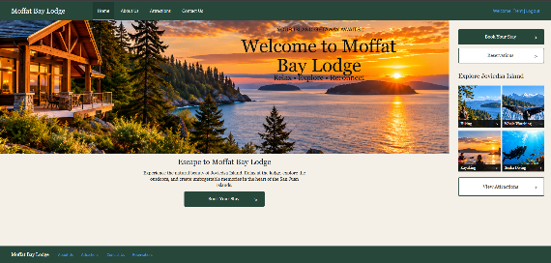
2 | Click the About Us button on upper nav-bar. | About-Us page loads successfully without errors. | Pass | 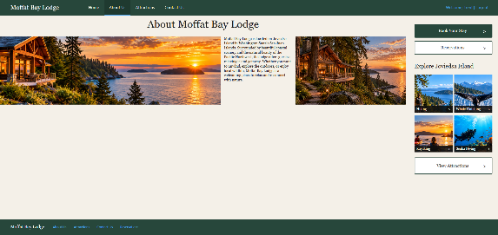
Comments | About-Us page loads with no issues.

Test 4 | About-Us: Links Directing to About-Us On All Pages Work
 | Test Objective: Verify links work directing to about-us on every page. | Developer: Madilyn Carpenter  Date tested: 10/25/26 | Peer tester: Trenten Coffman  Date tested: 10/25/26
Step | Action | Expected results: | Developer pass/fail | Tester pass/fail
1 | Open the Moffat Bay Lodge website. | Homepage loads successfully without errors. | Pass | 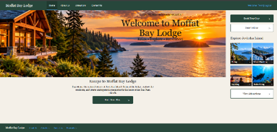
2 | Click the About-Us link in the lower left of homepage. | About-Us page loads successfully without errors. | Pass | 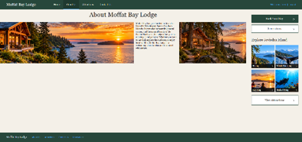
3 | Click the About Us button on upper nav-bar and the link in the lower left of about us page. | About-Us page reloads. | Pass
4 | Click the book your stay button. | Available lodges are displayed. | Pass
5 | Click the About Us button on upper nav-bar and the link in the lower left of lodges page. Click your browser’s go back button after about us page loads each time. | About-Us page loads successfully without errors. | Pass
6 | Select a lodge. Click both about us links again on the reservation page. Click your browser’s go back button after about us page loads each time. | About-Us page loads successfully without errors. | Pass
7 | Fill out reservation form with valid data and submit with book now. | Reservation is successfully submitted and reservation summary page loads. | Pass | 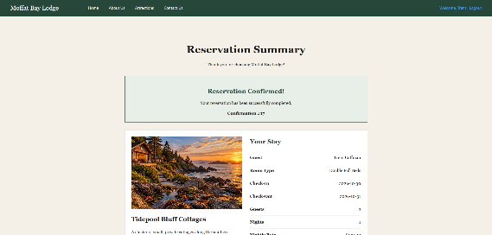
8 | From the summary page click the About Us button on upper nav-bar. | About-Us page loads successfully without errors. | Pass
Comments | All links to About-Us page work correctly.

