Project: | Moffat Bay Lodge – Group 2
Course: | CSD460 – Capstone in Software Development
Description: | Attractions Page Functional Testing
Date: | 11/08/2026
Group 2 Test Template
TABLE OF CONTENTS
Attractions: Page Display & Navigation 2
Attractions: Attraction Selection 3

Test 1 | Attractions: Page Display & Navigation
 | Test Objective: Verify that the Attractions page loads correctly and displays the attractions, images, and navigation links. | Developer: Madilyn Carpenter  Date tested: 11/08/2026 | Peer tester: Natasha Foreman  Date tested: 11/08/2026
Step | Action | Expected results: | Developer pass/fail | Tester pass/fail
1 | Open the Moffat Bay Lodge website. | Homepage loads successfully. | Pass | 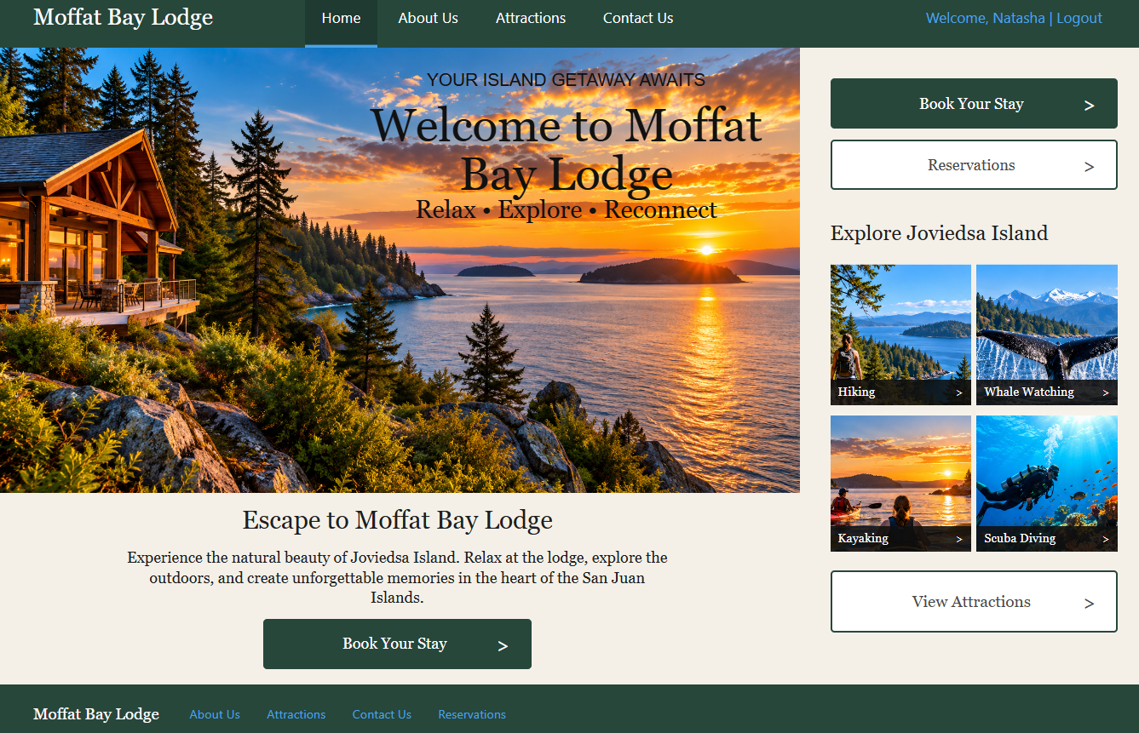
2 | Click Attractions in the navigation menu. | Attractions page opens successfully. | Pass | 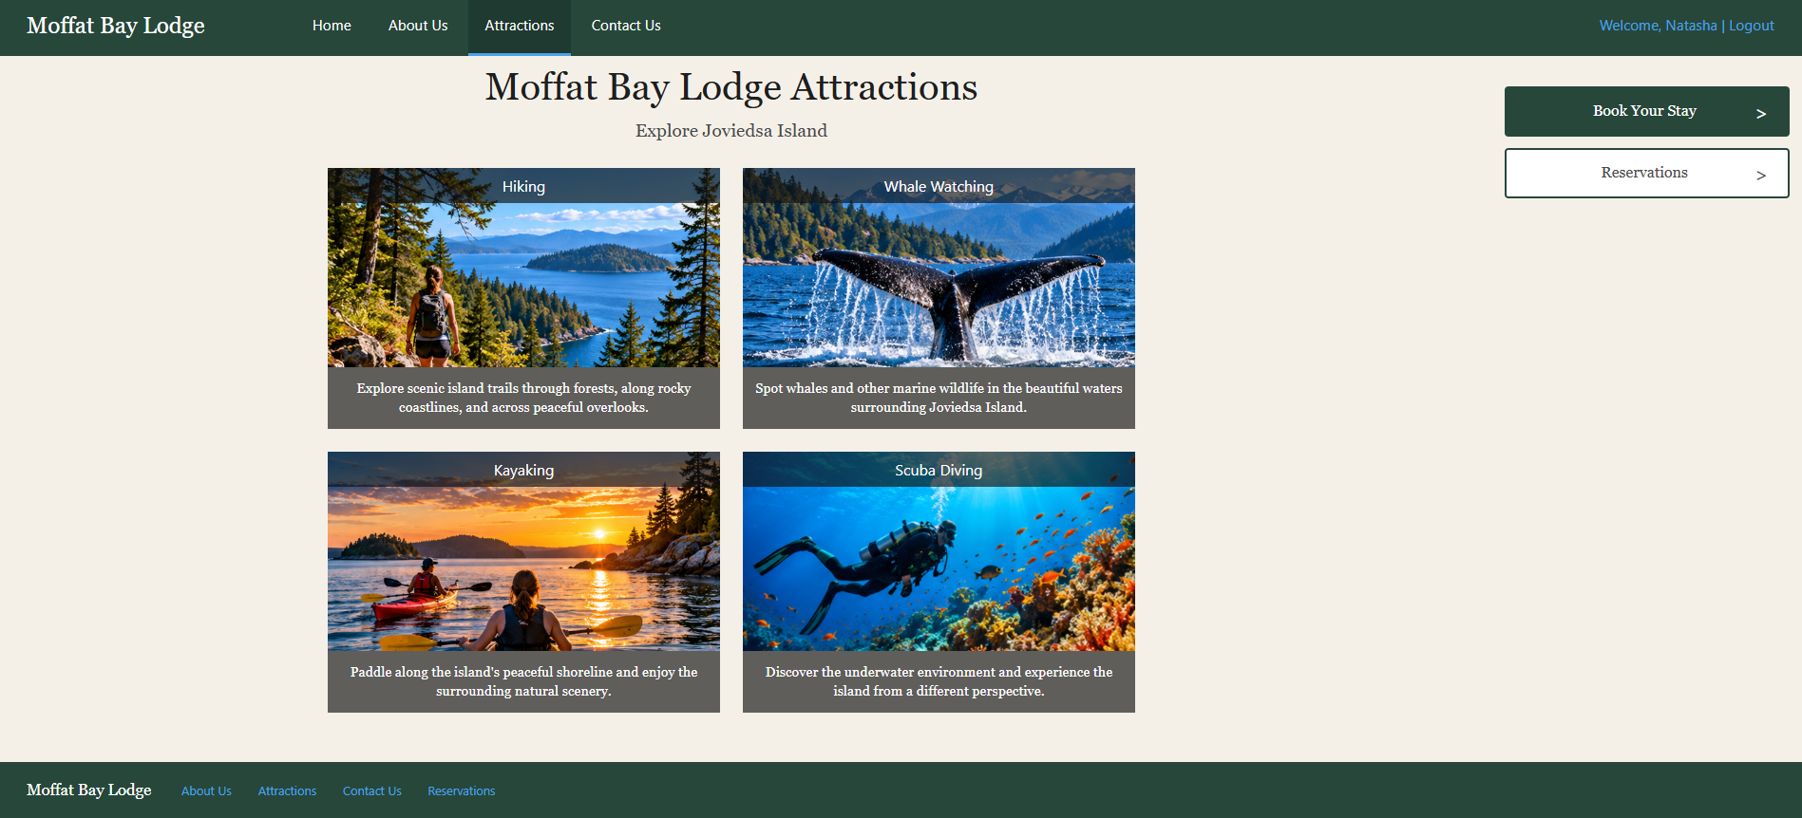
3 | Verify all four attractions are displayed. | Hiking, Whale Watching, Kayaking, and Scuba Diving are visible. | Pass | 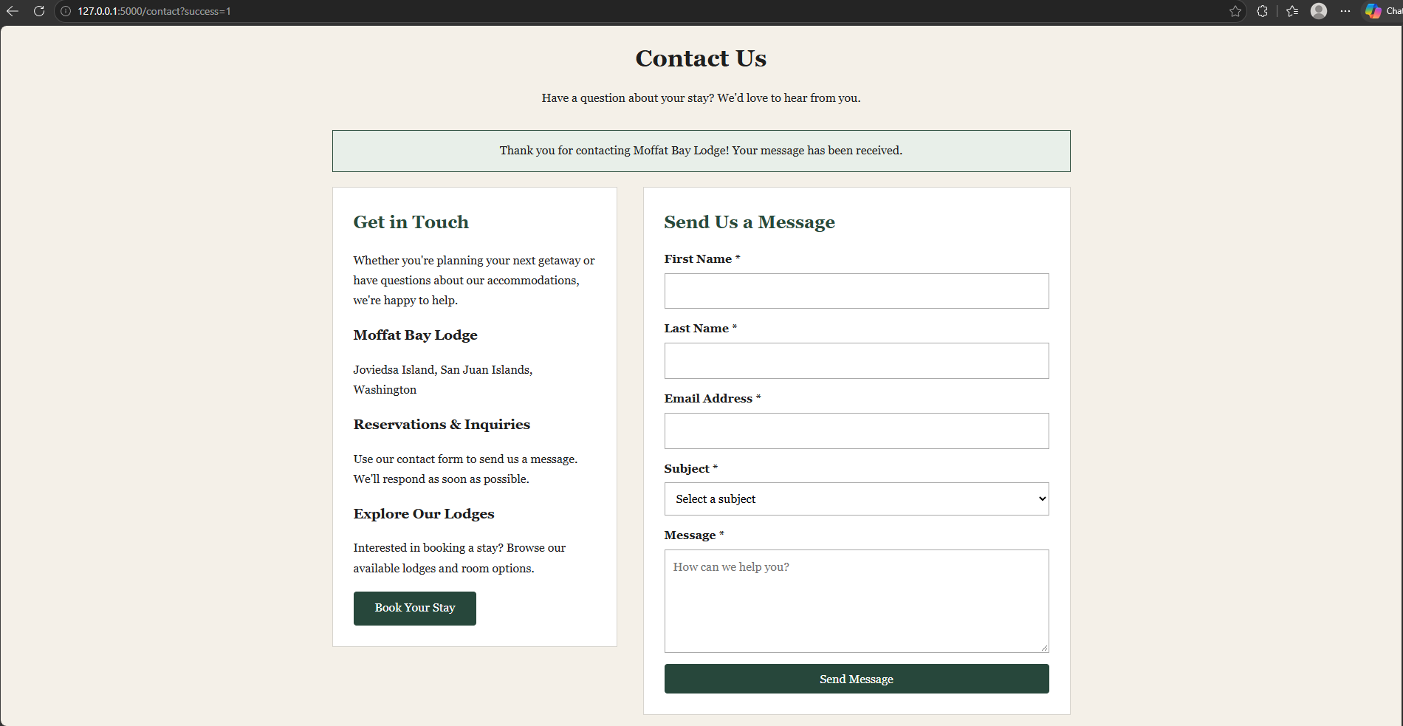
4 | Verify each attraction has an image & description. | All four images load without errors and display descriptions. | Pass | 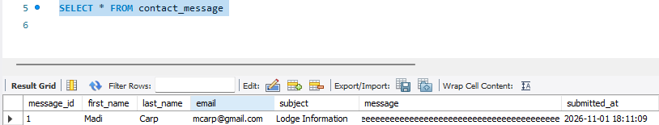
Comments | All four attractions displayed correctly with their images and descriptions. No issues were identified during testing.

Test 2 | Attractions: Navigation
 | Test Objective: Verify that selecting an attraction opens the correct content or destination and that the navigation works as intended. | Developer: Madilyn Carpenter  Date tested: 11/08/2026 | Peer tester: Natasha Foreman  Date tested: 11/08/2026
Step |  | Expected results: | Developer pass/fail | Tester pass/fail
1 | Open the Attractions page. | Attractions page loads successfully. | Pass
2 | Click Home in the navigation menu. | User is directed to the homepage. | Pass
3 | Return to Attractions and click Contact Us. | Contact Us page opens successfully. | Pass | 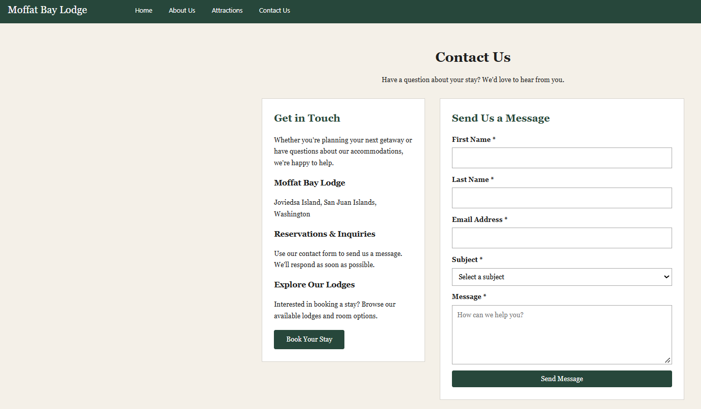
4 | Return to Attractions and click Book Your Stay. | Lodge selection page opens successfully. | Pass | 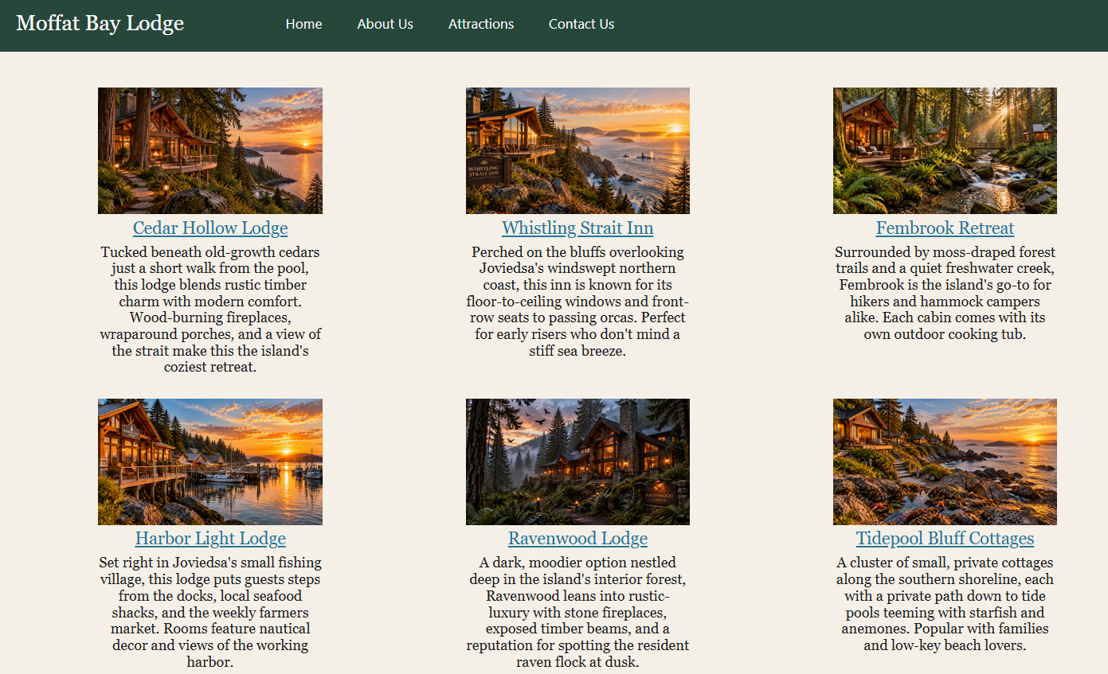
5 | Return to Attractions and click Reservations. | Reservation lookup page opens successfully. | Pass | 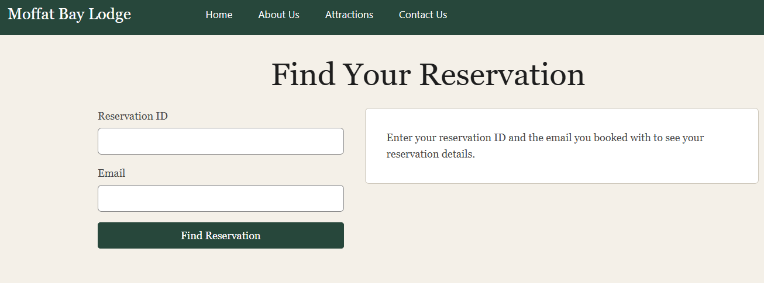
Comments | All navigation links and booking options directed to their intended pages without errors.

