Project: TODO
Course: CSD380
Description: Test Cases for TODO Business Requirements
Date: 1/18/2026
To complete the test case plan, fill out the information for Project, Course, Description and Date in the header below.
.
TABLE OF CONTENTS
Verify application will load from standard URL 2
View List of Todo Items 2
Prevent Empty Todo Submission 3
Edit a todo task item and prevent empty edit submission 3
Delete a todo task item 4

For each test, the developer should: provide a test description, a test objective, the developer name and date tested. For each step, fill out the actions to be taken and describe the expected results, and indicate yes or no for each step depending upon the result. The peer tester should provide their name, date tested, indicate yes or no for each step depending upon the result, and a screenshot (thumbnail) of the result.

Test 1 | Verify application will load from standard URL
 | Test Objective: allow users to visit the website through https://buwebdev.github.io/todo/ | Developer:  Date tested: 1/18/26 | Peer tester: Natasha Foreman  Date tested: 1/18/26
Step | Action | Expected results: | Developer pass/fail | Tester pass/fail  + Screenshot
1 | Open web browser | Browser open | pass | Yes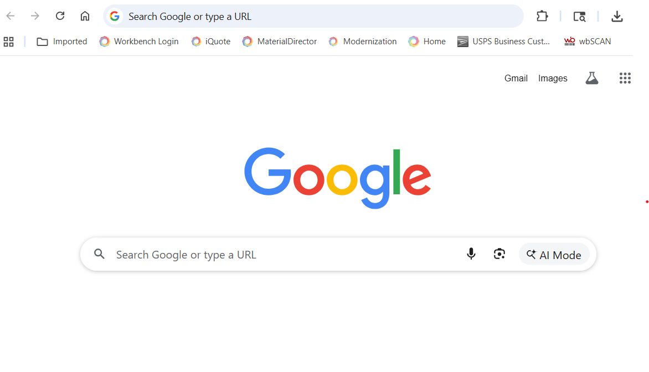
2 | Navigate to link | Link is not broken/URL does not lead to unknown page | pass | Yes  v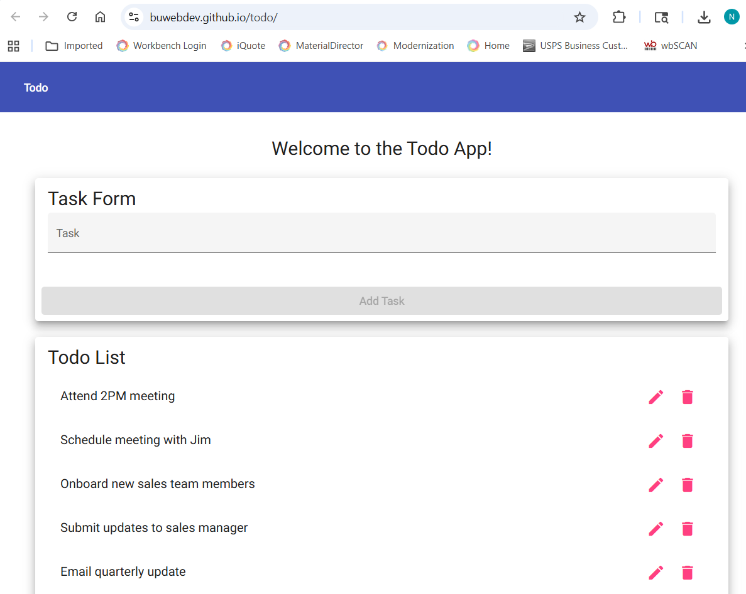
3 | Wait for page load | Page loads without errors | pass | Yes
4 | Refresh | Page loads without errors | pass | Yes
5 | Wait for page load | Page loads without errors | pass | Yes
Comments

Test 2 | View List of Todo Items
 | Test Objective: View a list of todo task items | Developer:  Date tested: 1/18/26 | Peer tester: Natasha Foreman  Date tested: 1/18/26
Step | Action | Expected results: | Developer pass/fail | Tester pass/fail
1 | Navigate to the TODO application | Application loads | pass | Yes
2 | Observe the main task list area | A list area for todo items is displayed, existing tasks are visible to user | pass | Yes  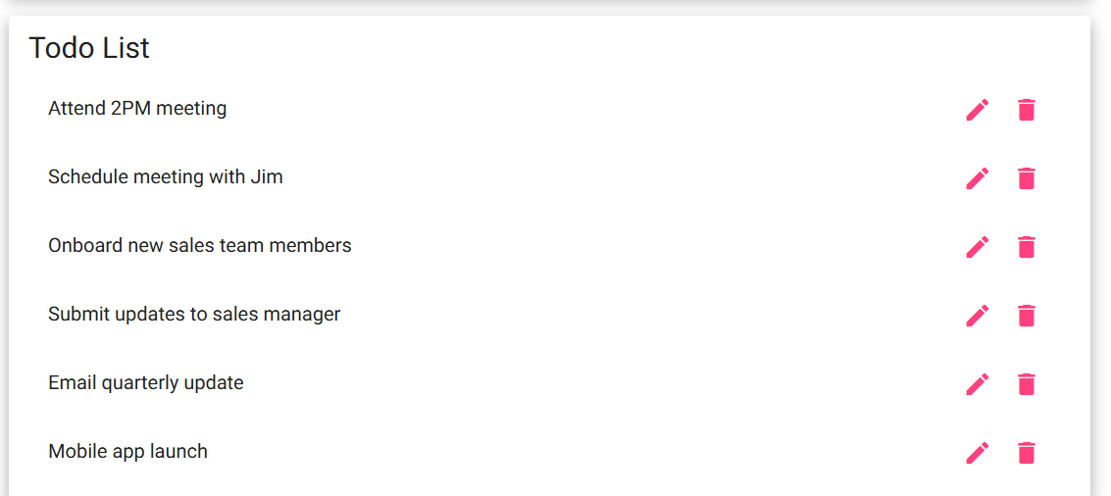
Comments | Comments should be substantive; this means there should be at least 2-3 well-structured sentences with constructive feedback.

Test 3 | Prevent Empty Todo Submission
 | Test Objective: Validate empty task submission | Developer:  Date tested: 1/18/26 | Peer tester: Natasha Foreman  Date tested: 1/18/26
Step | Action | Expected results: | Developer pass/fail | Tester pass/fail
1 | Leave the task input field empty | Empty task field | pass | Yes  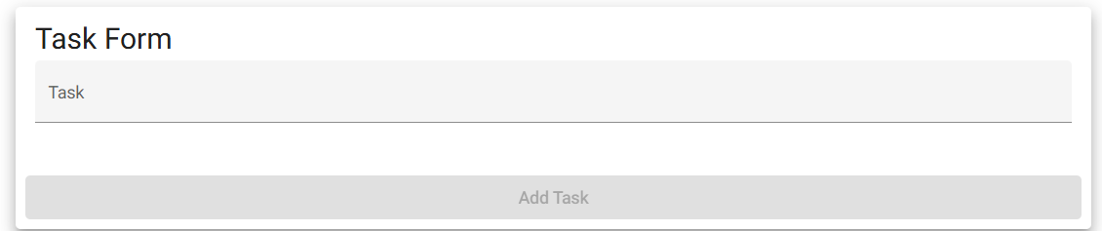
2 | Click the “Add” or submit button | Application displays error/prevents submission | pass | Yes  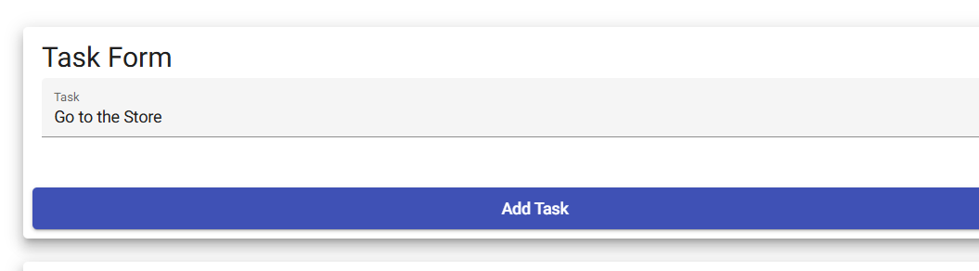
Comments | Comments should be substantive; this means there should be at least 2-3 well-structured sentences with constructive feedback.

Test 4 | Edit a todo task item and prevent empty edit submission
 | Test Objective: | Developer:  Date tested: 1/18/26 | Peer tester: Natasha Foreman  Date tested: 1/18/26
Step | Action | Expected results: | Developer pass/fail | Tester pass/fail
1 | Select an existing todo item |  | pass | Yes  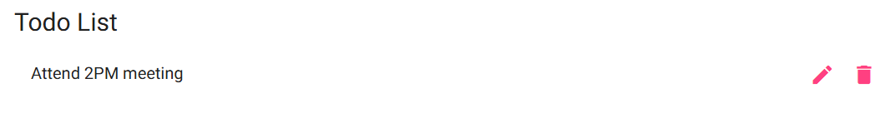
2 | Click edit | Directed to editing | pass | Yes  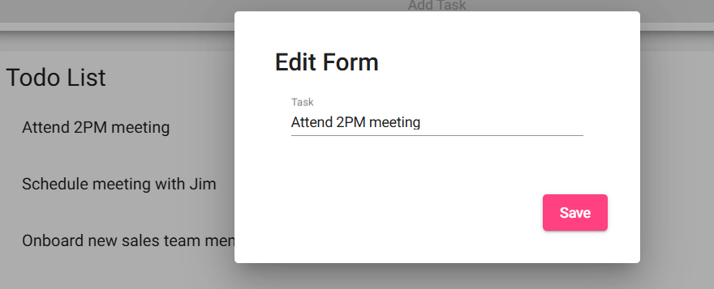
3 | Modify the task text | New text | pass | Yes  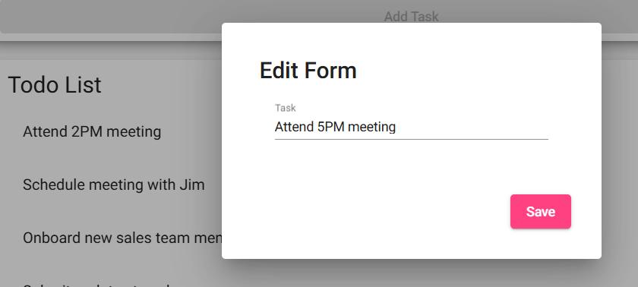
4 | Modify the task text | Changes are saved without errors | pass | Yes
Comments | Comments should be substantive; this means there should be at least 2-3 well-structured sentences with constructive feedback.

Test 5 | Delete a todo task item
 | Test Objective: | Developer:  Date tested: 1/18/26 | Peer tester: Natasha Foreman  Date tested: 1/18/26
Step | Action | Expected results: | Developer pass/fail | Tester pass/fail
1 | Select an existing todo item |  | pass | Yes  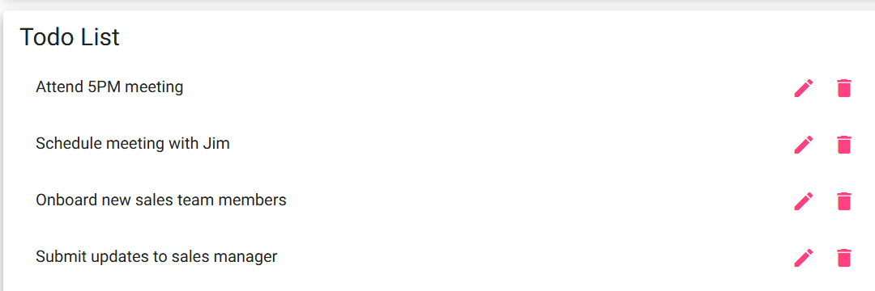
2 | Click the delete option | Todo task is deleted | pass | Yes  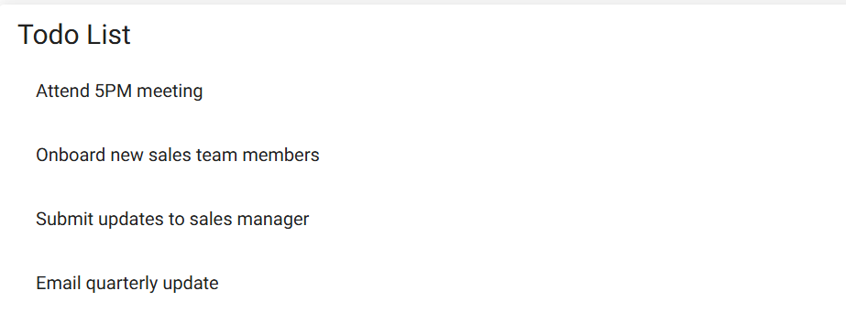
Comments | Comments should be substantive; this means there should be at least 2-3 well-structured sentences with constructive feedback.

