Natasha Foreman
Assignment 5.2

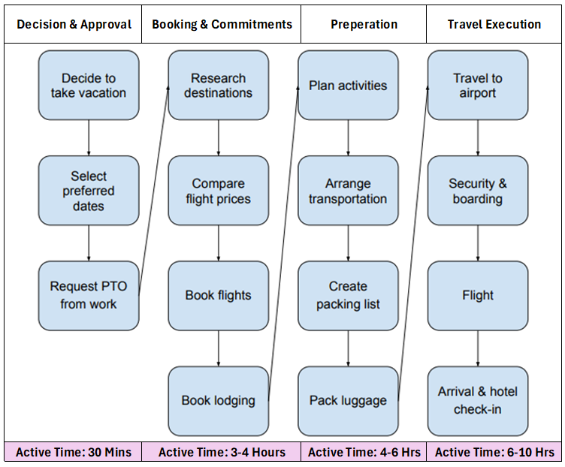
For my Value Stream Map, I analyzed the process of planning and taking a vacation, beginning with the decision to travel and ending with arrival and check-in at the destination. This process spans several weeks and involves multiple phases, including decision and approval, booking and commitments, preparation, and travel execution. Grouping the steps into phases helped make the flow easier to understand and highlighted where delays and inefficiencies occur. Mapping the entire process visually showed that while the actual hands-on work is relatively limited, the overall lead time is extended due to waiting, repeated decision-making, and external constraints such as approvals and pricing availability.

Waste Identified
Several types of waste became clear through the value stream mapping exercise. Waiting was the most significant source of waste, particularly during the time-off approval process and while waiting for travel dates to arrive. Overprocessing was also common, especially when repeatedly checking flight prices and accommodation across multiple platforms. Rework occurred when plans had to be changed due to fluctuating prices or schedule adjustments, leading to rebooking and re-packing. Motion waste showed up in the constant switching between apps, websites, and documents to manage different parts of the trip. Together, these inefficiencies increased stress and extended the overall lead time without adding value to the final outcome.
Process Optimization
Based on the identified waste, several improvements could be made to streamline the vacation planning process. Requesting time off before committing to travel arrangements would reduce the risk of rework and last-minute changes. Using price alerts instead of manually checking flights would minimize overprocessing and save time. Establishing clear budget and destination criteria early in the process would shorten decision-making delays. Creating a standardized packing checklist would reduce overpacking and eliminate unnecessary last-minute adjustments. These optimizations would not eliminate all waiting, but they would reduce variability, improve flow, and make the overall process more predictable and less stressful.

