Natasha Foreman
CSD 420-Module 9.2 Assignment
May 16, 2026
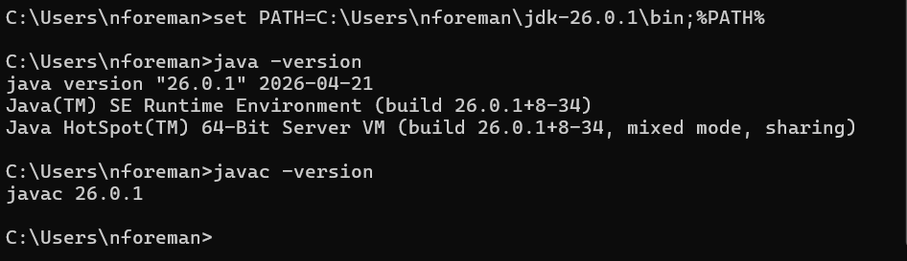

I can’t get MySQL running and cannot get the Password figured out no matter how many times I try to delete the files and reinstall it. Needing to utilize a different computer.

