Natasha Foreman
CSD-430-Module 10.2
8/16/2026
Creating Custom Tags in JSP
JavaServer Pages (JSP) provides developers with several ways to create dynamic web pages using Java. As web applications become larger, however, JSP pages can become difficult to read and maintain when the same logic is repeated throughout multiple pages. One solution to this problem is the use of custom tags. Custom tags allow developers to create their own JSP elements that perform specific tasks and can then be reused throughout an application. Instead of repeatedly placing the same Java or presentation logic into multiple JSP pages, the functionality can be placed inside a custom tag and referenced when it is needed.
According to Oracle's Java EE documentation, a custom tag is a user defined JSP language element. When a JSP containing the custom tag is translated into a servlet, the tag is converted into operations involving a tag handler, which the web container executes when processing the page (Oracle, n.d.). In simpler terms, custom tags allow developers to create JSP elements that behave somewhat like the standard HTML or JSP tags they already use. A developer could create a tag for displaying a formatted message, generating a page heading, displaying user information, or performing another action that is needed repeatedly throughout an application.
One of the biggest advantages of custom tags is code reusability. If the same functionality appears on several JSP pages, developers do not need to copy the same code to every page. Instead, they can create the functionality once and reuse the custom tag. Oracle explains that custom tags can increase developer productivity because they can be reused across applications (Oracle, n.d.). Reusability also improves maintenance. If the functionality needs to change later, the developer can modify the custom tag rather than searching through several JSP pages and making the same change multiple times.
Another advantage is that custom tags can make JSP pages cleaner and easier to understand. Throughout this course, we have used scriptlets to place Java directly inside JSP pages. While this demonstrates how JSP and Java interact, a page containing a large amount of Java can quickly become difficult to follow. Custom tags can move some of this functionality away from the JSP page. Oracle's documentation specifically identifies reducing Java programming within JSP pages as one of the problems custom tags can help solve (Oracle, n.d.). A page containing a descriptive tag such as <travel:record /> can be easier to understand than a page containing many lines of Java code that produce the same result.
Custom tags also support attributes, allowing the same tag to behave differently depending on the information provided by the JSP page. For example, a custom greeting tag could accept a user's name as an attribute. Instead of creating separate tags for every user, the JSP could pass a different name into the same reusable tag. Custom tags can also work with JSP objects, pass variables back to the calling page, and be nested inside other tags (Oracle, n.d.). These features make them flexible enough to handle more than simply displaying static content.
There are also disadvantages to creating custom tags. The first is that they introduce additional development and configuration. For a small application, creating a custom tag may take more time than simply writing the necessary JSP code. Developers must decide how the tag will be implemented, make the tag available to the application, and correctly reference it from JSP pages. If the functionality is only needed once, creating a reusable tag may add unnecessary complexity.
There are different approaches for developing JSP custom tags. One option is a tag file, which contains a reusable fragment of JSP code. Oracle explains that tag files are translated into simple tag handlers by the web container and can be particularly useful for presentation oriented functionality (Oracle, n.d.). Developers can also implement tag handlers using Java. Modern simple tag handlers implement the SimpleTag interface, and SimpleTagSupport provides a convenient base class. The primary method used by a simple tag handler is doTag(), which contains the logic performed when the custom tag is executed (Jakarta EE, n.d.).
Correctly using a custom tag also requires making the tag library available to the web application and declaring it on the JSP page. JSP uses a taglib directive to identify the tag library and assign a prefix that will be used when calling its tags (Oracle, n.d.). For tag files, the tagdir can identify the location under /WEB-INF/tags/. Once properly configured, the JSP page can invoke the custom tag using the assigned prefix and tag name.
In my opinion, custom tags are useful when an application contains JSP functionality that is repeated or complicated enough to distract from the purpose of the page. I would consider using them for elements or operations that appear throughout several JSP pages because the ability to update the functionality in one place could save time and reduce errors. I also like that they can make the JSP itself easier to read.
At the same time, I would avoid creating custom tags simply because the feature is available. If I were developing a small application and a particular piece of logic was only used once, creating an entire custom tag for it could make the project more complicated than necessary. I think the decision should depend on how often the functionality is used and whether separating it actually improves the organization of the application.
Custom tags provide JSP developers with a way to encapsulate reusable functionality and reduce repeated code. They can improve organization, readability, consistency, and maintainability when used appropriately. However, they also require additional development and can make an application harder to follow if too many unnecessary custom tags are created. For me, the greatest value of custom tags is not simply that they reduce the amount of code on a JSP page, but that they provide a structured way to separate reusable functionality from the pages that use it.
References
Jakarta EE. (n.d.). SimpleTag (Jakarta Server Pages API documentation). Jakarta EE.
Oracle. (n.d.). Custom tags in JSP pages. The Java EE Tutorial.
Oracle. (n.d.). Using custom tags. The Java EE Tutorial.

Coding Examples
Example 1 — Simple custom tag handler 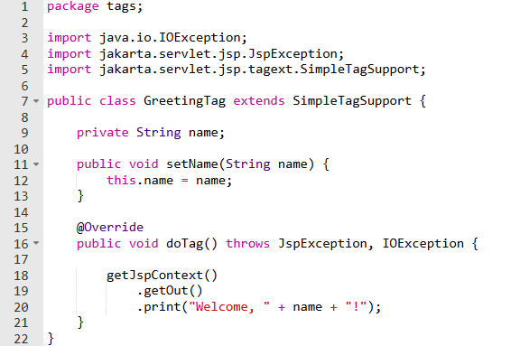

Example 2 — Using a tag file from JSP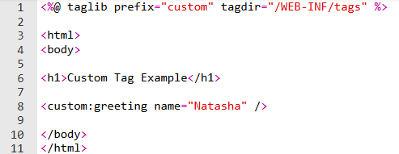
Example 3 — Simple greeting.tag file
