

**CAPSTONE PROJECT REPORT**

**Report 3 – Software Requirement Specification**

# II. Software Requirement Specification thienanhfix

# 1. Overall Description

# 1.1 Product Overview

Nowadays, there are many products that have been born, but inventory management is still very difficult. There are a lot of mistakes that lead to many companies suffering heavy losses and even going bankrupt

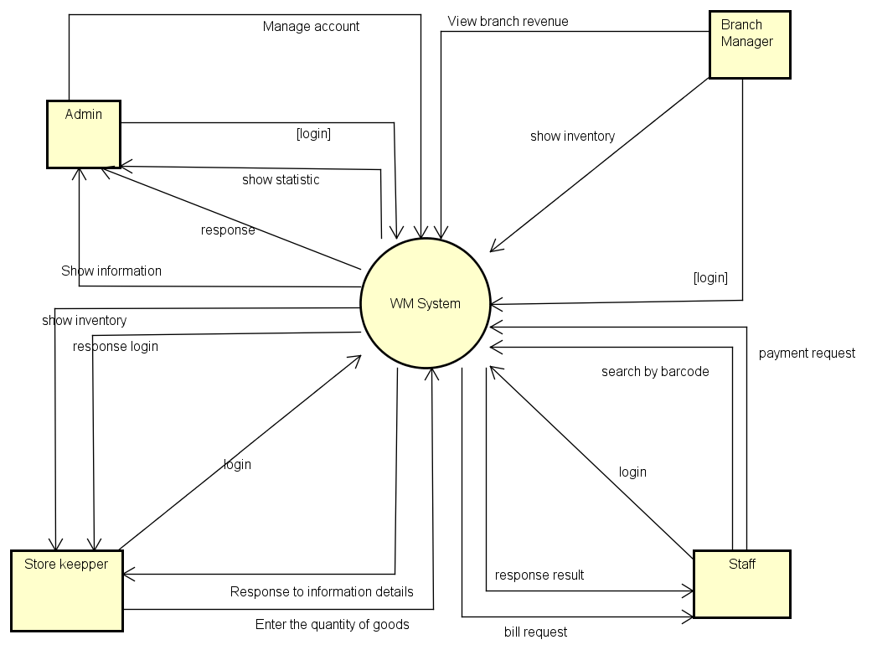

So along with the development of the internet, this project will bring features that people involved in warehouse management really need. It will reduce errors to a minimum and make it possible for companies to manage their branches.

### 1.2 Business Rules

|  |  |
| --- | --- |
| **ID** | **Description** |
| B01 | The email address must be valid |
| B02 | Password must be at least 8 characters in length |
| B03 | Password must be encrypted |
| B04 | When registering or changing a password, a user must enter the new password twice |
| B05 | User must provide their username or email and password when logging into the website |
| B06 | When changing a password, a new password must not be the same as the current password |
| B07 | The quantity of imported goods must not exceed the capacity of the warehouse. |
| B08 | The number of products purchased cannot exceed the number of products in stock. |
| B09 | When an account is registered, the initial role of the account is Staff |
| B10 | Staff must scan the barcode and enter the quantity to issue the invoice |
| B11 | Invoicing can only be done once and cannot be undone |
| B12 | A barcode is automatically generated if left empty |
| B13 | Enter number must be a positive integer |
| B14 | A user must belong to one of the 4 roles: admin, branch manager, storekeeper, staff |
| B15 | When the product in stock is no longer available, other warehouses with that product will be displayed |
| B16 | Each product will have a different barcode |
| B17 | When a product is exported, the stock will automatically update the quantity of that product |
| B18 | An order can include many products but it must contain at least one product |
| B19 | When the product is no longer in stock, app will be notified |
| B20 | In the product invoice, if the product quantity is increased or decreased, the amount will also be updated |
| B21 | Each order will have a different order ID |
| B22 | Product code must be set according to SKU code rule |
| B23 | When the number of products is less than 50, a notification will be displayed to the manager |
| B24 | Only admins can create accounts. |
| B25 | Unit currency must be VND |
| B26 | After paying the bill, it will automatically return to the original homepage |
| B27 | At checkout, if the product quantity is entered as 0, it will be automatically removed from the invoice |
| B28 | Products can only be exchanged before invoice once |
| B29 | Managers can only view information of their own branches |
| B30 | quantity of imported goods must be greater than 0 |

## 2. User Requirements

### 2.1 Overview

#### **a. Use Case Diagram**

##### **Admin**

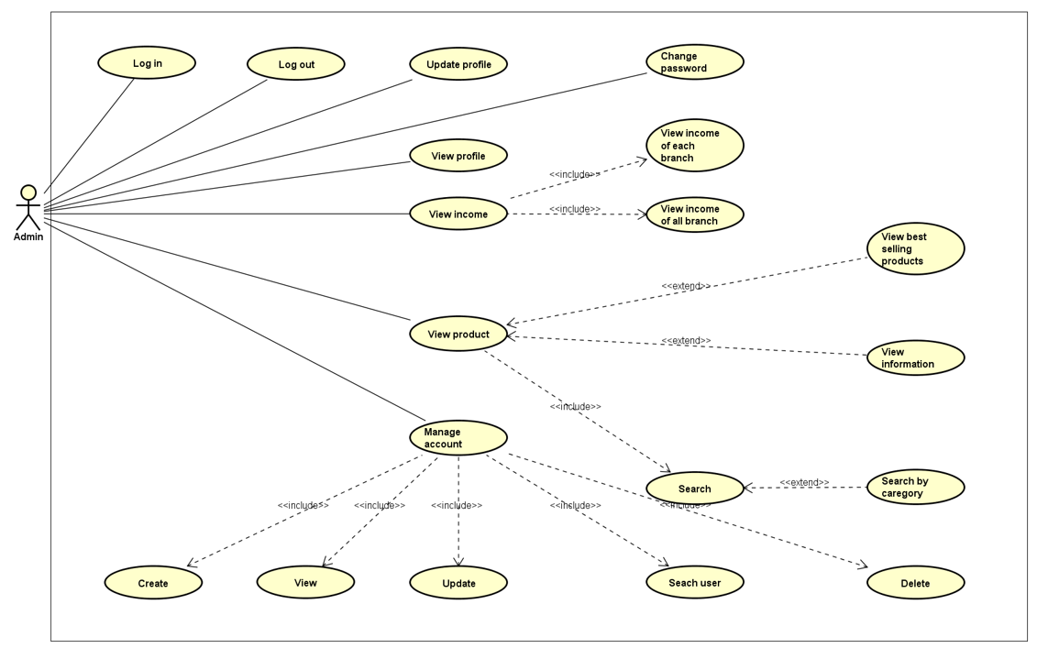

##### **Branch manager**

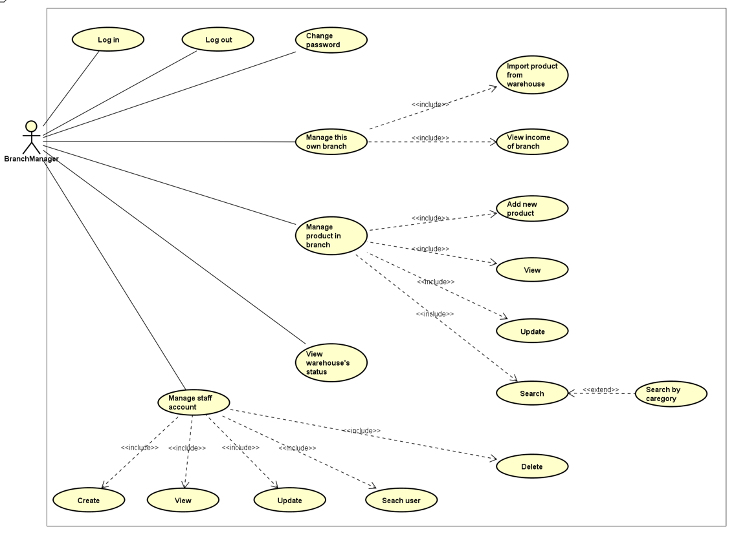

##### **Store Keeper**

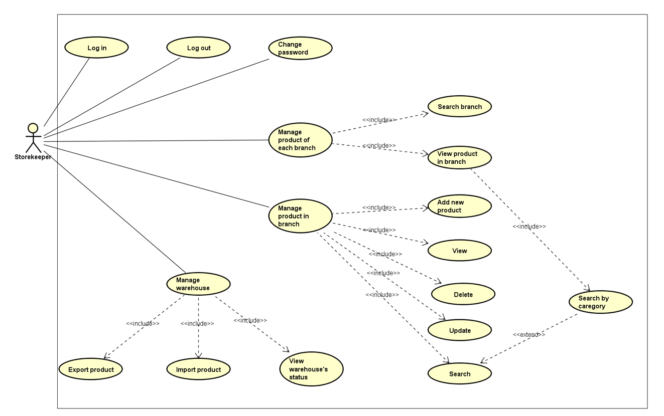

##### **Staff**

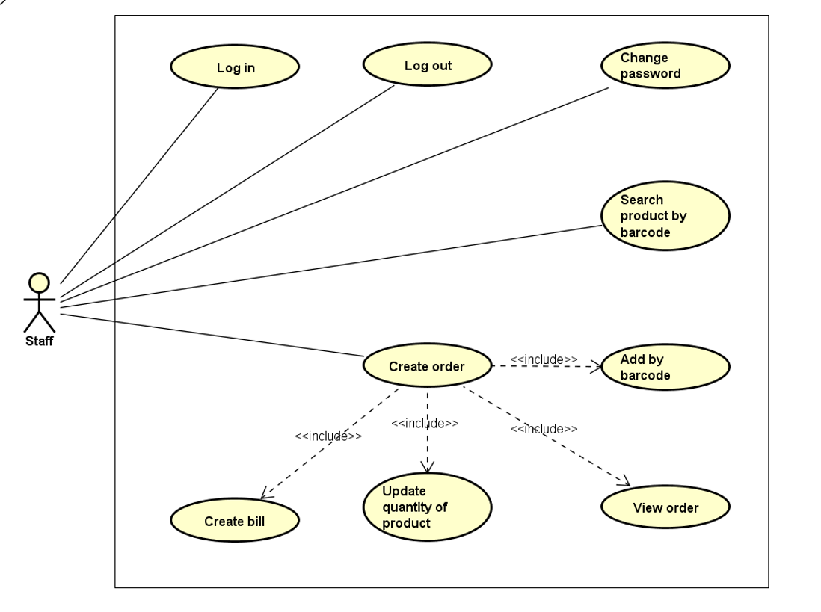

#### **b. System Actors**

|  |  |  |
| --- | --- | --- |
| **#** | **Actors** | **Description** |
| 1 | Admin | People who manage the Warehouse Management System |
| 2 | Branch Manager | Manager of a specific branch |
| 3 | Store Keeper | People who manage products and warehouse |
| 4 | Staff | People who sell products for customers |

#### **c. Use Cases List**

|  |  |  |  |
| --- | --- | --- | --- |
| **ID** | **Use Case** | **Primary Actors** | **Secondary Actor** |
| UC-01 | Log in | Admin | N/A |
| UC-02 | Log out | Admin | N/A |
| UC-03 | Update profile | Admin | N/A |
| UC-04 | View profile | Admin | N/A |
| UC-05 | View income of each branch | Admin | N/A |
| UC-06 | View income of all branch | Admin | N/A |
| UC-07 | View best selling product | Admin | N/A |
| UC-08 | View information of products | Admin | N/A |
| UC-09 | Search product by category | Admin | N/A |
| UC-10 | Create new account | Admin | N/A |
| UC-11 | View account | Admin | N/A |
| UC-12 | Update account | Admin | N/A |
| UC-13 | Search user | Admin | N/A |
| UC-14 | Delete account | Admin | N/A |
| UC-15 | Log in | Branch manager | N/A |
| UC-16 | Log out | Branch manager | N/A |
| UC-17 | Change password | Branch manager | N/A |
| UC-18 | Import product from warehouse | Branch manager | N/A |
| UC-19 | View income of branch | Branch manager | N/A |
| UC-20 | Add new product | Branch manager | N/A |
| UC-21 | View product | Branch manager | N/A |
| UC-22 | Update product | Branch manager | N/A |
| UC-23 | Search product by category | Branch manager | N/A |
| UC-24 | Create staff account | Branch manager | N/A |
| UC-25 | View staff account | Branch manager | N/A |
| UC-26 | Update staff account | Branch manager | N/A |
| UC-27 | Search staff account | Branch manager | N/A |
| UC-28 | Delete staff account | Branch manager | N/A |
| UC-29 | Log in | Store keeper | N/A |
| UC-30 | Log out | Store keeper | N/A |
| UC-31 | Change password | Store keeper | N/A |
| UC-32 | Search branch | Store keeper | N/A |
| UC-33 | View product in branch | Store keeper | N/A |
| UC-34 | Add new product | Store keeper | N/A |
| UC-35 | View product | Store keeper | N/A |
| UC-36 | Delete product | Store keeper | N/A |
| UC-37 | Update product | Store keeper | N/A |
| UC-38 | Search product by category | Store keeper | N/A |
| UC-39 | Import product | Store keeper | N/A |
| UC-40 | Export product | Store keeper | N/A |
| UC-41 | View warehouse’s status | Store keeper | N/A |
| UC-42 | Log in | Staff | N/A |
| UC-43 | Log out | Staff | N/A |
| UC-44 | Change password | Staff | N/A |
| UC-45 | Search product by barcode | Staff | N/A |
| UC-46 | Create bill | Staff | N/A |
| UC-47 | Update quantity of product | Staff | N/A |
| UC-48 | View order | Staff | N/A |
| UC-49 | Add product to order by barcode | Staff | N/A |

### 2.2 Use Case Specification

#### **2.2.1. Admin**

##### **2.2.1.1. Sign up**

|  |  |  |  |
| --- | --- | --- | --- |
| **Use Case ID** | UC - 01 | **Use Case Name** | Log in |
| **Created By** | Lê Minh Thiện Anh | **Created Date** | 27/05/2022 |
| **Primary Actor** | Admin | **Secondary Actor** | N/A |
| **Description** | Log in to the system | | |
| **Pre-conditions** | 1. Admin can access the system 2. Admin already have an account | | |
| **Post-conditions** | Admin is signed into the system | | |
| **Normal Flow** | 1. On the Login Screen of system. 2. System displays “Login” form. 3. Input username and password. 4. Clicks “Login” button. 5. Direct to Home Screen. | | |
| **Alternative Flow** | N/A | | |
| **Exceptions** | The system displays an error message when:   1. Not input all fields in “Login” form. 2. Wrong username/email or password. 3. Cannot connect to the server. | | |
| **Priority** | Medium | | |
| **Frequency of Use** | Medium | | |
| **Business Rules** | B05 | | |
| **Other Information** | N/A | | |
| **Assumptions** | N/A | | |

##### **2.2.1.2. Log out**

|  |  |  |  |
| --- | --- | --- | --- |
| **Use Case ID** | UC - 02 | **Use Case Name** | Log out |
| **Created By** | Lê Minh Thiện Anh | **Created Date** | 27/05/2022 |
| **Primary Actor** | Admin | **Secondary Actor** | N/A |
| **Description** | Log out the system | | |
| **Pre-conditions** | Admin has signed into the admin website. | | |
| **Post-conditions** | Admin is signed out of the system | | |
| **Normal Flow** | 1. On the home page screen of admin. 2. Click on “Log out” on the navigator. 3. The system will redirect Admin to the home page. | | |
| **Alternative Flow** | N/A | | |
| **Exceptions** | N/A | | |
| **Priority** | Medium | | |
| **Frequency of Use** | Medium | | |
| **Business Rules** |  | | |
| **Other Information** | N/A | | |
| **Assumptions** | N/A | | |

##### **2.2.1.3 Update profile**

|  |  |  |  |
| --- | --- | --- | --- |
| **Use Case ID** | UC – 03 | **Use Case Name** | Update profile |
| **Created By** | Lê Minh Thiện Anh | **Created Date** | 27/05/2022 |
| **Primary Actor** | Admin | **Secondary Actor** | N/A |
| **Description** | Update admin’s profile | | |
| **Pre-conditions** | Admin has signed into the admin website. | | |
| **Post-conditions** | Data is updated to the database | | |
| **Normal Flow** | 1. On the home page screen of navigator. 2. Click on “Profile” on the sidebar. 3. The system displays a information of admin 4. Click to “Edit” button 5. System show Edit form 6. Change information of admin 7. Choose “Update” button | | |
| **Alternative Flow** | N/A | | |
| **Exceptions** | The system displays an error message when:   1. Cannot connect to the server. 2. Required information field blank | | |
| **Priority** | Medium | | |
| **Frequency of Use** | Medium | | |
| **Business Rules** | B04,B06 | | |
| **Other Information** | N/A | | |
| **Assumptions** | N/A | | |

##### **2.2.1.4 View admin profile**

|  |  |  |  |
| --- | --- | --- | --- |
| **Use Case ID** | UC – 04 | **Use Case Name** | View profile |
| **Created By** | Lê Minh Thiện Anh | **Created Date** | 27/05/2022 |
| **Primary Actor** | Admin | **Secondary Actor** | N/A |
| **Description** | View information of admin profile | | |
| **Pre-conditions** | Admin has signed into the admin website. | | |
| **Post-conditions** | N/A | | |
| **Normal Flow** | 1. On the home page screen of admin. 2. Click on “Profile” on the navigator. 3. The system displays a information of admin | | |
| **Alternative Flow** | N/A | | |
| **Exceptions** | The system displays an error message when:   1. Cannot connect to the server. | | |
| **Priority** | Low | | |
| **Frequency of Use** | Low | | |
| **Business Rules** |  | | |
| **Other Information** | N/A | | |
| **Assumptions** | N/A | | |

##### **2.2.1.5 View income of each branch**

|  |  |  |  |
| --- | --- | --- | --- |
| **Use Case ID** | UC – 05 | **Use Case Name** | View income of each branch |
| **Created By** | Lê Minh Thiện Anh | **Created Date** | 27/05/2022 |
| **Primary Actor** | Admin | **Secondary Actor** | N/A |
| **Description** | View income of each branch | | |
| **Pre-conditions** | Admin has signed into the admin website. | | |
| **Post-conditions** | N/A | | |
| **Normal Flow** | 1. On the home page screen of admin 2. Click “Branch” in sidebar 3. Choose one branch in list 4. System display income of branch | | |
| **Alternative Flow** | N/A | | |
| **Exceptions** | The system displays an error message when:   1. Cannot connect to the server. 2. Cannot see future date data | | |
| **Priority** | High | | |
| **Frequency of Use** | High | | |
| **Business Rules** |  | | |
| **Other Information** | N/A | | |
| **Assumptions** | N/A | | |

##### **2.2.1.6 View income of all branch**

|  |  |  |  |
| --- | --- | --- | --- |
| **Use Case ID** | UC – 06 | **Use Case Name** | View income of all branch |
| **Created By** | Lê Minh Thiện Anh | **Created Date** | 27/05/2022 |
| **Primary Actor** | Admin | **Secondary Actor** | N/A |
| **Description** | See total income of all branch | | |
| **Pre-conditions** | Admin has signed into the admin website. | | |
| **Post-conditions** | N/A | | |
| **Normal Flow** | 1. On the home page screen of admin 2. Click “Income” in sidebar 3. The system displays all the information of income in day, in month, in year. | | |
| **Alternative Flow** | N/A | | |
| **Exceptions** | The system displays an error message when:   1. Cannot connect to the server. 2. Cannot see future date data | | |
| **Priority** | High | | |
| **Frequency of Use** | High | | |
| **Business Rules** |  | | |
| **Other Information** | N/A | | |
| **Assumptions** | N/A | | |

##### **2.2.1.7 View best selling product**

|  |  |  |  |
| --- | --- | --- | --- |
| **Use Case ID** | UC – 07 | **Use Case Name** | View best selling product |
| **Created By** | Lê Minh Thiện Anh | **Created Date** | 27/05/2022 |
| **Primary Actor** | Admin | **Secondary Actor** | N/A |
| **Description** | View best selling product of warehouse. | | |
| **Pre-conditions** | Admin has signed into the admin website. | | |
| **Post-conditions** | N/A | | |
| **Normal Flow** | 1. On the home page screen of admin, 2. Click “View best selling product” in sidebar 3. The program displays all the information about the best-selling products for management. | | |
| **Alternative Flow** | 1. Go to the Admin Page. 2. Click “View product” in sidebar. 3. Click to “Sort by sales quantity” 4. The program displays products sorted by the number of sold items | | |
| **Exceptions** | The system displays an error message when:   1. Cannot connect to the server. | | |
| **Priority** | High | | |
| **Frequency of Use** | High | | |
| **Business Rules** |  | | |
| **Other Information** | N/A | | |
| **Assumptions** | N/A | | |

##### **2.2.1.8 View information of products**

|  |  |  |  |
| --- | --- | --- | --- |
| **Use Case ID** | UC – 08 | **Use Case Name** | View information of products |
| **Created By** | Lê Minh Thiện Anh | **Created Date** | 27/05/2022 |
| **Primary Actor** | Admin | **Secondary Actor** | N/A |
| **Description** | View information of all products in warehouse | | |
| **Pre-conditions** | Admin has signed into the admin website. | | |
| **Post-conditions** | N/A | | |
| **Normal Flow** | 1. On the home page screen of admin. 2. Click “View product” in sidebar. 3. System display information all current products in warehouse | | |
| **Alternative Flow** | N/A | | |
| **Exceptions** | The system displays an error message when:   1. Cannot connect to the server. | | |
| **Priority** | Medium | | |
| **Frequency of Use** | Medium | | |
| **Business Rules** |  | | |
| **Other Information** | N/A | | |
| **Assumptions** | N/A | | |

##### **2.2.1.9 Search product by category**

|  |  |  |  |
| --- | --- | --- | --- |
| **Use Case ID** | UC – 09 | **Use Case Name** | Search product by category |
| **Created By** | Lê Minh Thiện Anh | **Created Date** | 27/05/2022 |
| **Primary Actor** | Admin | **Secondary Actor** | N/A |
| **Description** | Search products by name or category | | |
| **Pre-conditions** | Admin has signed into the admin website. | | |
| **Post-conditions** | Search results are displayed | | |
| **Normal Flow** | 1. On the home page screen of admin. 2. Click “Search” bar in sidebar. 3. Enter the name or category product want to find 4. Click “Search” button. 5. The system displays the product corresponding to the word on the search bar. | | |
| **Alternative Flow** | N/A | | |
| **Exceptions** | The system displays an error message when:   1. Cannot connect to the server. | | |
| **Priority** | High | | |
| **Frequency of Use** | High | | |
| **Business Rules** |  | | |
| **Other Information** | N/A | | |
| **Assumptions** | N/A | | |

##### **2.2.1.10 Create new account**

|  |  |  |  |
| --- | --- | --- | --- |
| **Use Case ID** | UC – 10 | **Use Case Name** | Create new account |
| **Created By** | Lê Minh Thiện Anh | **Created Date** | 27/05/2022 |
| **Primary Actor** | Admin | **Secondary Actor** | N/A |
| **Description** | Create new account for new user | | |
| **Pre-conditions** | Admin has signed into the admin website. | | |
| **Post-conditions** | When the normal flow completes successfully, the new account will be added to database | | |
| **Normal Flow** | 1. On the home page screen of admin. 2. Click “Create account” in sidebar. 3. Select 1 in 3 roles(Staff, Store Keeper, Branch Manager) 4. Input username/email and password of account 5. Click “Create” button. 6. System will show information of this account and show success massage | | |
| **Alternative Flow** | N/A | | |
| **Exceptions** | The system displays an error message when:   1. Cannot connect to the server. 2. Username and password field blank 3. Username/password exist in database | | |
| **Priority** | High | | |
| **Frequency of Use** | High | | |
| **Business Rules** | B09,B14,B24 | | |
| **Other Information** | N/A | | |
| **Assumptions** | N/A | | |

##### **2.2.1.11 View account**

|  |  |  |  |
| --- | --- | --- | --- |
| **Use Case ID** | UC - 11 | **Use Case Name** | View account |
| **Created By** | Lê Minh Thiện Anh | **Created Date** | 27/05/2022 |
| **Primary Actor** | Admin | **Secondary Actor** | N/A |
| **Description** | View information of an account | | |
| **Pre-conditions** | 1. Admin has signed into the admin website. 2. Choose a user who admin wants to view. | | |
| **Post-conditions** | N/A | | |
| **Normal Flow** | 1. On the home page screen of admin. 2. Choose “View all account” in the sidebar. 3. The system displays a list of all users. 4. Admin chooses what user wants to see. 5. System show all information of that account | | |
| **Alternative Flow** | N/A | | |
| **Exceptions** | The system displays an error message when:   1. Cannot connect to the server. | | |
| **Priority** | Medium | | |
| **Frequency of Use** | Medium | | |
| **Business Rules** |  | | |
| **Other Information** | N/A | | |
| **Assumptions** | N/A | | |

##### **2.2.1.12 Update account**

|  |  |  |  |
| --- | --- | --- | --- |
| **Use Case ID** | UC - 12 | **Use Case Name** | Update account |
| **Created By** | Lê Minh Thiện Anh | **Created Date** | 27/05/2022 |
| **Primary Actor** | Admin | **Secondary Actor** | N/A |
| **Description** | Admin update information of an user | | |
| **Pre-conditions** | 1. Admin has logged into admin website 2. Choose a user admin who wants to update. | | |
| **Post-conditions** | User information what be changed will be updated in the database | | |
| **Normal Flow** | 1. On the home page screen of admin. 2. Choose “View all account” in the sidebar. 3. The system displays a list of all users. 4. Admin chooses what user wants to see. 5. System show all information of that account 6. Choose “Edit” button 7. System show Edit form 8. Input or change information want to change 9. Click “Update” button 10. System show Successful message and redirrect to this account | | |
| **Alternative Flow** | N/A | | |
| **Exceptions** | The system displays an error message when:   1. Cannot connect to the server. 2. Required information field blank 3. New username/password exist in database | | |
| **Priority** | Medium | | |
| **Frequency of Use** | Medium | | |
| **Business Rules** | B05 | | |
| **Other Information** | N/A | | |
| **Assumptions** | N/A | | |

**2.2.1.13 Search user**

|  |  |  |  |
| --- | --- | --- | --- |
| **Use Case ID** | UC - 13 | **Use Case Name** | Search user |
| **Created By** | Nguyen Van Long | **Created Date** | 27/05/2022 |
| **Primary Actor** | Admin | **Secondary Actor** | N/A |
| **Description** | Search user by username and type of user | | |
| **Pre-conditions** | Admin is already logged in the system. | | |
| **Post-conditions** | N/A | | |
| **Normal Flow** | 1. At home page, admin click “Manage user” 2. System display “Manage user” form. 3. At the top of “Manage user” page, click “Search” 4. Input username or part of username and select type of user on drop down list. 5. System shows all users which is satisfy. | | |
| **Alternative Flow** | N/A | | |
| **Exceptions** | The system displays an error message when:   1. Cannot connect to the server. 2. Do not exist user contain keyword with role selected. | | |
| **Priority** | High | | |
| **Frequency of Use** | High | | |
| **Business Rules** |  | | |
| **Other Information** | N/A | | |
| **Assumptions** | N/A | | |

**2.2.1.14 Delete user**

|  |  |  |  |
| --- | --- | --- | --- |
| **Use Case ID** | UC – 14 | **Use Case Name** | Delete user |
| **Created By** | Nguyen Van Long | **Created Date** | 27/05/2022 |
| **Primary Actor** | Admin | **Secondary Actor** | N/A |
| **Description** | Delete account of user. | | |
| **Pre-conditions** | Admin is already logged in the system. | | |
| **Post-conditions** | Account deleted has been removed of the database. | | |
| **Normal Flow** | 1. At home page, admin click “Manage user” 2. System display “Manage user” form. 3. Click “Delete” button in which account wanna delete. 4. Deleted account removed. | | |
| **Alternative Flow** | N/A | | |
| **Exceptions** | The system displays an error message when:   1. Cannot connect to the server. | | |
| **Priority** | Medium | | |
| **Frequency of Use** | Medium | | |
| **Business Rules** |  | | |
| **Other Information** | N/A | | |
| **Assumptions** | N/A | | |

**2.2.2 Branch Manager**

**2.2.2.1 Log in**

|  |  |  |  |
| --- | --- | --- | --- |
| **Use Case ID** | UC - 15 | **Use Case Name** | Log in |
| **Created By** | Nguyen Van Long | **Created Date** | 27/05/2022 |
| **Primary Actor** | Branch Manager | **Secondary Actor** | N/A |
| **Description** | Branch managers log in to the system | | |
| **Pre-conditions** | Branch Manager already has an account | | |
| **Post-conditions** | N/A | | |
| **Normal Flow** | 1. Go to Home Page 2. Click “Log in” 3. System displays “Log in” form 4. Input “Username” and “Password”. 5. Click “Log in” 6. The system checks your input data. If Branch Manager entered true, Branch Manager will be Login successful 7. Redirect to Home Page of Branch Manager. | | |
| **Alternative Flow** | N/A | | |
| **Exceptions** | The system displays an error message when:   1. Username or password is not correct 2. Leave “Username” blank 3. Leave “Password” blank 4. Cannot connect to the server. | | |
| **Priority** | High | | |
| **Frequency of Use** | High | | |
| **Business Rules** | B05 | | |
| **Other Information** | N/A | | |
| **Assumptions** | N/A | | |

**2.2.2.2 Log out**

|  |  |  |  |
| --- | --- | --- | --- |
| **Use Case ID** | UC - 16 | **Use Case Name** | Log out |
| **Created By** | Nguyen Van Long | **Created Date** | 27/05/2022 |
| **Primary Actor** | Branch Manager | **Secondary Actor** | N/A |
| **Description** | Branch Manager log out of the system. | | |
| **Pre-conditions** | Branch Manager is already log in to the system. | | |
| **Post-conditions** | N/A | | |
| **Normal Flow** | 1. On the home page screen, select the menu with the user icon in the upper right corner.  2. Mentor clicks “Đăng xuất”.  3. The system will redirect Mentor to the home page. | | |
| **Alternative Flow** | N/A | | |
| **Exceptions** | N/A | | |
| **Priority** | High | | |
| **Frequency of Use** | High | | |
| **Business Rules** |  | | |
| **Other Information** | N/A | | |
| **Assumptions** | N/A | | |

**2.2.2.3 Change password**

|  |  |  |  |
| --- | --- | --- | --- |
| **Use Case ID** | UC - 17 | **Use Case Name** | Change password |
| **Created By** | Nguyen Van Long | **Created Date** | 27/05/2022 |
| **Primary Actor** | Branch Manager | **Secondary Actor** | N/A |
| **Description** | Branch Manager change password of own account. | | |
| **Pre-conditions** | Branch Manager is already log in to the system. | | |
| **Post-conditions** | When the normal flow completes successfully, the new password will be updated to success and saved into the database. | | |
| **Normal Flow** | 1. On the home page screen, select the menu with the user icon in the upper right conner. 2. Branch Manager clicks “Change password”. 3. The system will redirect Branch Manager to the change password page. 4. Branch Manager input password, new password, and re-password. 5. Click “Update” | | |
| **Alternative Flow** | N/A | | |
| **Exceptions** | The system displays an error message when:   1. Cannot connect to the server. 2. Leave “password” or “new password” or “re-password”. 3. Password is not correct. 4. “New password” and “re-password” is not the same. | | |
| **Priority** | Medium. | | |
| **Frequency of Use** | Medium | | |
| **Business Rules** | B02, B04, B06 | | |
| **Other Information** | N/A | | |
| **Assumptions** | N/A | | |

**2.2.2.4 Import product from warehouse**

|  |  |  |  |
| --- | --- | --- | --- |
| **Use Case ID** | UC - 18 | **Use Case Name** | Import products from warehouse |
| **Created By** | Nguyen Van Long | **Created Date** | 27/05/2022 |
| **Primary Actor** | Branch Manager | **Secondary Actor** | N/A |
| **Description** | Branch Manager import product from warehouse to branch. | | |
| **Pre-conditions** | System has been logged in with Branch Manager role. | | |
| **Post-conditions** | After Branch Manager import products, database will add all products which are imported into “Import products from warehouse” form. | | |
| **Normal Flow** | 1. At home page, click button “Import products from warehouse” 2. System display “Import products from warehouse” form. 3. Choose type of product and Input quantity. 4. Click button “Add”. 5. Display the table of imported products. 6. Check the information of table. 7. If information is not correct, return step 3. 8. Click “Confirm” button. | | |
| **Alternative Flow** | N/A | | |
| **Exceptions** | The system displays an error message when:   1. Cannot connect to the server. 2. Leave without choose type of product or quantity before click add. 3. Input quantity is not a positive integer. | | |
| **Priority** | High | | |
| **Frequency of Use** | High | | |
| **Business Rules** | B07 | | |
| **Other Information** | N/A | | |
| **Assumptions** | N/A | | |

**2.2.2.5 View income of branch**

|  |  |  |  |
| --- | --- | --- | --- |
| **Use Case ID** | UC - 19 | **Use Case Name** | View income of branch |
| **Created By** | Nguyen Van Long | **Created Date** | 27/05/2022 |
| **Primary Actor** | Branch Manager | **Secondary Actor** | N/A |
| **Description** | View detail income of branch by chart. | | |
| **Pre-conditions** | System has been logged in with Branch Manager role. | | |
| **Post-conditions** | N/A | | |
| **Normal Flow** | 1. At home page, click button “Import products from warehouse” 2. Click “view income of branch” 3. System display “View income of branch” form. | | |
| **Alternative Flow** | N/A | | |
| **Exceptions** | The system displays an error message when:   1. Cannot connect to the server. | | |
| **Priority** | Medium | | |
| **Frequency of Use** | Medium | | |
| **Business Rules** | B29 | | |
| **Other Information** | N/A | | |
| **Assumptions** | N/A | | |

2.2.2.6 Add new product

|  |  |  |  |
| --- | --- | --- | --- |
| **Use Case ID** | UC - 20 | **Use Case Name** | Add new product |
| **Created By** | Nguyen Van Long | **Created Date** | 27/05/2022 |
| **Primary Actor** | Branch Manager | **Secondary Actor** | N/A |
| **Description** | Add new type of product to branch. | | |
| **Pre-conditions** | System has been logged in with Branch Manager role. | | |
| **Post-conditions** | New type of product has been added to database. | | |
| **Normal Flow** | 1. At home page click “Add new product”. 2. Redirect to “Add new product” page. 3. Input attribute of product 4. Click “Save” button. 5. System shows all information of new product. 6. Click “Cancel” button, return step 3. 7. Click “Confirm” button. | | |
| **Alternative Flow** | N/A | | |
| **Exceptions** | The system displays an error message when:   1. Cannot connect to the server. 2. Do not fill all attribute | | |
| **Priority** | Medium | | |
| **Frequency of Use** | Medium | | |
| **Business Rules** |  | | |
| **Other Information** | N/A | | |
| **Assumptions** | N/A | | |

**2.2.2.7 View product**

|  |  |  |  |
| --- | --- | --- | --- |
| **Use Case ID** | UC - 21 | **Use Case Name** | View product |
| **Created By** | Nguyen Van Long | **Created Date** | 27/05/2022 |
| **Primary Actor** | Branch Manager | **Secondary Actor** | N/A |
| **Description** | View detail information of product. | | |
| **Pre-conditions** | System has been logged in with Branch Manager role. | | |
| **Post-conditions** | N/A | | |
| **Normal Flow** | 1. At home page, click “Manage product in branch” 2. Redirect to “Manage product in branch” page. 3. Click “View” button on the right of product. 4. Redirect to “View Product” page of this product. | | |
| **Alternative Flow** | N/A | | |
| **Exceptions** | The system displays an error message when:   1. Cannot connect to the server. | | |
| **Priority** | High | | |
| **Frequency of Use** | High | | |
| **Business Rules** | B29 | | |
| **Other Information** | N/A | | |
| **Assumptions** | N/A | | |

**2.2.2.8 Update product**

|  |  |  |  |
| --- | --- | --- | --- |
| **Use Case ID** | UC - 22 | **Use Case Name** | Update product |
| **Created By** | Nguyen Van Long | **Created Date** | 27/05/2022 |
| **Primary Actor** | Branch Manager | **Secondary Actor** | N/A |
| **Description** | Update information of a product. | | |
| **Pre-conditions** | System has been logged in with Branch Manager role. | | |
| **Post-conditions** | Product information has been updated to database. | | |
| **Normal Flow** | 1. At home page, click “Manage product in branch”  2. Redirect to “Manage product in branch” page.  3. Click “Update” button on the right of product.  4. Redirect to “Update product” page.  5. Edit information.  6. Click “Save” button.  7. System shows all information of new product.  8. Click “Cancel” button, return step 5.  9. Click “Confirm” button. | | |
| **Alternative Flow** | N/A | | |
| **Exceptions** | The system displays an error message when:   1. Cannot connect to the server. | | |
| **Priority** | Medium | | |
| **Frequency of Use** | Medium | | |
| **Business Rules** |  | | |
| **Other Information** | N/A | | |
| **Assumptions** | N/A | | |

##### **2.2.2.9 Search product by category**

|  |  |  |  |
| --- | --- | --- | --- |
| **Use Case ID** | UC – 09 | **Use Case Name** | Search product by category |
| **Created By** | Nguyen Van Long | **Created Date** | 27/05/2022 |
| **Primary Actor** | Branch Manager | **Secondary Actor** | N/A |
| **Description** | Search products by name or category | | |
| **Pre-conditions** | Branch Manager has signed into the admin website. | | |
| **Post-conditions** | Search results are displayed | | |
| **Normal Flow** | 1. On the home page screen of admin. 2. Click “Search” bar in sidebar. 3. Enter the name or category product want to find 4. Click “Search” button. 5. The system displays the product corresponding to the word on the search bar. | | |
| **Alternative Flow** | N/A | | |
| **Exceptions** | The system displays an error message when:   1. Cannot connect to the server. | | |
| **Priority** | High | | |
| **Frequency of Use** | High | | |
| **Business Rules** |  | | |
| **Other Information** | N/A | | |
| **Assumptions** | N/A | | |

**2.2.2.10 Create staff account**

|  |  |  |  |
| --- | --- | --- | --- |
| **Use Case ID** | UC - 24 | **Use Case Name** | Create staff account |
| **Created By** | Nguyen Van Long | **Created Date** | 27/05/2022 |
| **Primary Actor** | Branch Manager | **Secondary Actor** | N/A |
| **Description** | Create an account of staff. | | |
| **Pre-conditions** | System has been logged in with Branch Manager role. | | |
| **Post-conditions** | A new account will be created with the role of staff and saved into a database. | | |
| **Normal Flow** | 1. At home page, click “Create staff account”.  2. System displays “Create staff account” form.  3. Input full name, username, email, password, re-password.  4. Clicks “Register” button.  5. System displays a toast success message. | | |
| **Alternative Flow** | N/A | | |
| **Exceptions** | The system displays an error message when:  1. Not input all fields in “Create staff account” form.  2. Username or Email existed.  3. Cannot connect to the server. | | |
| **Priority** | Medium | | |
| **Frequency of Use** | Medium | | |
| **Business Rules** |  | | |
| **Other Information** | N/A | | |
| **Assumptions** | N/A | | |

**2.2.2.11. View staff account**

|  |  |  |  |
| --- | --- | --- | --- |
| **Use Case ID** | UC – 25 | **Use Case Name** | View staff account |
| **Created By** | Lê Hoàng | **Created Date** | 28/05/2022 |
| **Primary Actor** | Branch manager | **Secondary Actor** | N/A |
| **Description** | View account of staffs in the system. | | |
| **Pre-conditions** | Branch manager has signed into the branch manager website. | | |
| **Post-conditions** | N/A | | |
| **Normal Flow** | 1. Go to the Branch Manager page. 2. Click on “Manager staff account” on the sidebar. 3. The system displays a list of selections with create, view, update, search and delete. 4. Branch manager clicks on “View” button, the system displays all the information of staff. | | |
| **Alternative Flow** | N/A | | |
| **Exceptions** | The system displays an error message when:   1. Cannot connect to the server. | | |
| **Priority** | High | | |
| **Frequency of Use** | High | | |
| **Business Rules** |  | | |
| **Other Information** | N/A | | |
| **Assumptions** | N/A | | |

**2.2.2.12. Update staff account**

|  |  |  |  |
| --- | --- | --- | --- |
| **Use Case ID** | UC – 26 | **Use Case Name** | Update staff account |
| **Created By** | Lê Hoàng | **Created Date** | 28/05/2022 |
| **Primary Actor** | Branch manager | **Secondary Actor** | N/A |
| **Description** | Update account of staffs in the system. | | |
| **Pre-conditions** | Branch manager has signed into the branch manager website. | | |
| **Post-conditions** | * The branch manager is logged into the system successfully. * System displays Branch Manager page. | | |
| **Normal Flow** | 1. Go to the Branch Manager page.  2. Click on “Manager staff account” on the sidebar.  3. The system displays a list of selections with create, view, update, search and delete.  4. Branch manager click the “Update” button  5. Branch manager change information of staff if needed  6. Branch manager clicks on “ Save” button to update staff’s information | | |
| **Alternative Flow** | N/A | | |
| **Exceptions** | The system displays an error message when:  1. Cannot connect to the server. | | |
| **Priority** | High | | |
| **Frequency of Use** | High | | |
| **Business Rules** |  | | |
| **Other Information** | N/A | | |
| **Assumptions** | N/A | | |

**2.2.2.13. Search staff account**

|  |  |  |  |
| --- | --- | --- | --- |
| **Use Case ID** | UC – 27 | **Use Case Name** | Search staff account |
| **Created By** | Lê Hoàng | **Created Date** | 28/05/2022 |
| **Primary Actor** | Branch manager | **Secondary Actor** | N/A |
| **Description** | Search account of staffs in the system. | | |
| **Pre-conditions** | Branch manager has signed into the branch manager website. | | |
| **Post-conditions** | * The branch manager is logged into the system successfully. * System displays Branch Manager page. | | |
| **Normal Flow** | 1. Go to the Branch Manager page.  2. Click on “Manager staff account” on the sidebar.  3. The system displays a list of selections with create, view, update, search and delete.  4. Branch manager click the “Search” button  5. Branch manager inserts id of staff in search text box  6. Branch manager clicks on “Submit” button  7. System show username of staff searched | | |
| **Alternative Flow** | N/A | | |
| **Exceptions** | The system displays an error message when:   1. Cannot connect to the server. 2. EXC1: At step 5 of normal flow, branch manager insert wrong id of staff, the system display the error massage “Id does not exist, please insert again!” | | |
| **Priority** | High | | |
| **Frequency of Use** | High | | |
| **Business Rules** |  | | |
| **Other Information** | N/A | | |
| **Assumptions** | N/A | | |

**2.2.2.14. Delete staff account**

|  |  |  |  |
| --- | --- | --- | --- |
| **Use Case ID** | UC – 28 | **Use Case Name** | Delete staff account |
| **Created By** | Lê Hoàng | **Created Date** | 28/05/2022 |
| **Primary Actor** | Branch manager | **Secondary Actor** | N/A |
| **Description** | Delete account of staffs in the system. | | |
| **Pre-conditions** | Branch manager has signed into the branch manager website. | | |
| **Post-conditions** | * The branch manager is logged into the system successfully. * System displays Branch Manager page. | | |
| **Normal Flow** | 1. Go to the Branch Manager page.  2. Click on “Manager staff account” on the sidebar.  3. The system displays a list of selections with create, view, update, search and delete.  4. Branch manager click the “Delete account” button  5. The system show all the staff’s username  6. Branch manager choose the staff they want to delete  7. Branch manager click the “Delete” button  8. System displays confirm dialog box  9. Branch manager clicks “Yes” button  10. System displays notification of deleting successfully | | |
| **Alternative Flow** | N/A | | |
| **Exceptions** | The system displays an error message when:  1. Cannot connect to the server. | | |
| **Priority** | High | | |
| **Frequency of Use** | High | | |
| **Business Rules** |  | | |
| **Other Information** | N/A | | |
| **Assumptions** | N/A | | |

**2.2.3.1. Log in**

|  |  |  |  |
| --- | --- | --- | --- |
| **Use Case ID** | UC – 29 | **Use Case Name** | Log in |
| **Created By** | Lê Hoàng | **Created Date** | 28/05/2022 |
| **Primary Actor** | Storekeeper | **Secondary Actor** | N/A |
| **Description** | Log in to an account using email and password. | | |
| **Pre-conditions** | * Storekeeper can access the website. * Storekeeper has already registered an account * Storekeeper is currently not logged into the website | | |
| **Post-conditions** | * The storekeeper is logged into the website successfully. * The storekeeper is redirected to Home page | | |
| **Normal Flow** | 1. Storekeeper visits website and clicks “Login” 2. The system displays the Login page. 3. Storekeeper enters “Username” and “Password”. 4. Storekeeper clicks "Login" button. 5. The system redirects Storekeeper to the Home page. | | |
| **Alternative Flow** | N/A | | |
| **Exceptions** | EXC1: At step 3 of normal flow, Mentor leaves “Username” blank, then proceeds to step 4.   1. The system displays the error message "You must input username". 2. The mentor is not signed in.   EXC2: At step 3 of normal flow, Mentor leaves “Password” blank, then proceeds to step 4.   1. The system displays the error message “You must input password". 2. The mentor is not signed in.   EXC3: At step 3 of normal flow, Mentor enters invalid Login credentials, then proceeds to step 4.   1. The system displays the error message " Wrong username or password, please try again!” 2. The mentor is not signed in. | | |
| **Priority** | High | | |
| **Frequency of Use** | High | | |
| **Business Rules** | B01, B02, B03, B05, | | |
| **Other Information** | N/A | | |
| **Assumptions** | N/A | | |

**2.2.3.2. Log out**

|  |  |  |  |
| --- | --- | --- | --- |
| **Use Case ID** | UC - 30 | **Use Case Name** | Log out |
| **Created By** | Lê Hoàng | **Created Date** | 28/05/2022 |
| **Primary Actor** | Storekeeper | **Secondary Actor** | N/A |
| **Description** | Sign out the system. | | |
| **Pre-conditions** | 1. Storekeeper accesses to the system. 2. Storekeeper is currently logged in. | | |
| **Post-conditions** | The storekeeper is signed out of the system. | | |
| **Normal Flow** | 1. On the home page screen, storekeeper clicks “Log out”. 2. The system will redirect storekeeper to the original website. | | |
| **Alternative Flow** | N/A | | |
| **Exceptions** | N/A | | |
| **Priority** | High | | |
| **Frequency of Use** | High | | |
| **Business Rules** |  | | |
| **Other Information** | N/A | | |
| **Assumptions** | N/A | | |

**2.2.3.3. Change password**

|  |  |  |  |
| --- | --- | --- | --- |
| **Use Case ID** | UC – 31 | **Use Case Name** | Change password |
| **Created By** | Lê Hoàng | **Created Date** | 28/05/2022 |
| **Primary Actor** | Storekeeper | **Secondary Actor** | N/A |
| **Description** | Storekeeper changes their password. | | |
| **Pre-conditions** | The storekeeper must sign in. | | |
| **Post-conditions** | When the normal flow completes successfully, the new password will be updated successfully and saved into the database. | | |
| **Normal Flow** | 1. On the home page screen. 2. Storekeeper clicks “Settings and Securities” and choose “Securities”. 3. Storekeeper inputs old password, new password and confirm password. 4. Click “Change password” button. | | |
| **Alternative Flow** | N/A | | |
| **Exceptions** | EXC1: At step 3 of normal flow, if storekeeper re-enter password doesn’t match the password   1. The storekeeper has to re-enter the password again. | | |
| **Priority** | High | | |
| **Frequency of Use** | High | | |
| **Business Rules** | B04, B06 | | |
| **Other Information** | N/A | | |
| **Assumptions** | N/A | | |

**2.2.3.4. Search branch**

|  |  |  |  |
| --- | --- | --- | --- |
| **Use Case ID** | UC – 32 | **Use Case Name** | Search branch |
| **Created By** | Lê Hoàng | **Created Date** | 28/05/2022 |
| **Primary Actor** | Storekeeper | **Secondary Actor** | N/A |
| **Description** | Search all the branches in the system. | | |
| **Pre-conditions** | Storekeeper has signed into the storekeeper website. | | |
| **Post-conditions** | * The storekeeper is logged into the system successfully. * System displays Storekeeper page. | | |
| **Normal Flow** | 1. Go to the Storekeeper page.  2. Click on “Manage product of each branch” on the sidebar.  3. The system displays a list of selections with search branch and view product in branch.  4. Storekeeper click the “Search branch” button  5. Storekeeper inserts id of branch in search text box  6. Storekeeper clicks on “Submit” button  7. System show detailed information of branch searched | | |
| **Alternative Flow** | N/A | | |
| **Exceptions** | The system displays an error message when:   1. Cannot connect to the server. 2. EXC1: At step 5 of normal flow, storekeeper insert wrong id of branch, the system display the error massage “Id does not exist, please insert again!” | | |
| **Priority** | High | | |
| **Frequency of Use** | High | | |
| **Business Rules** |  | | |
| **Other Information** | N/A | | |
| **Assumptions** | N/A | | |

**2.2.3.5. View product in branch**

|  |  |  |  |
| --- | --- | --- | --- |
| **Use Case ID** | UC – 33 | **Use Case Name** | View product in branch |
| **Created By** | Lê Hoàng | **Created Date** | 28/05/2022 |
| **Primary Actor** | Storekeeper | **Secondary Actor** | N/A |
| **Description** | View product in the branch | | |
| **Pre-conditions** | Storekeeper has signed into the storekeeper website. | | |
| **Post-conditions** | * The storekeeper is logged into the system successfully. * System displays Storekeeper page. | | |
| **Normal Flow** | 1. Go to the Storekeeper page.  2. Click on “Manage product of each branch” on the sidebar.  3. The system displays a list of selections with search branch and view product in branch.  4. Storekeeper click the “View product” button, the system show all the product available in the branch. | | |
| **Alternative Flow** | N/A | | |
| **Exceptions** | The system displays an error message when:  1. Cannot connect to the server. | | |
| **Priority** | High | | |
| **Frequency of Use** | High | | |
| **Business Rules** |  | | |
| **Other Information** | N/A | | |
| **Assumptions** | N/A | | |

**2.2.3.6. Add new product**

|  |  |  |  |
| --- | --- | --- | --- |
| **Use Case ID** | UC – 34 | **Use Case Name** | Add new product |
| **Created By** | Lê Hoàng | **Created Date** | 28/05/2022 |
| **Primary Actor** | Storekeeper | **Secondary Actor** | N/A |
| **Description** | Add new product to the branch. | | |
| **Pre-conditions** | Storekeeper has signed into the storekeeper website. | | |
| **Post-conditions** | When the normal flow completes successfully, the new product will be added into the database. | | |
| **Normal Flow** | 1. Go to the Storekeeper page. 2. Click on “Manage product in branch” on the sidebar. 3. The system displays a list of selections with add, view, update, search and delete product. 4. Storekeeper click the “Add new product” button 5. Input name of the new product. 6. Click on “Add” button. | | |
| **Alternative Flow** | N/A | | |
| **Exceptions** | The system displays an error message when:   1. Cannot connect to the server. 2. Duplicate product name in the system. | | |
| **Priority** | Medium | | |
| **Frequency of Use** | Medium | | |
| **Business Rules** |  | | |
| **Other Information** | N/A | | |
| **Assumptions** | N/A | | |

**2.2.3.7. View product**

|  |  |  |  |
| --- | --- | --- | --- |
| **Use Case ID** | UC – 35 | **Use Case Name** | View product |
| **Created By** | Lê Hoàng | **Created Date** | 28/05/2022 |
| **Primary Actor** | Storekeeper | **Secondary Actor** | N/A |
| **Description** | View product in the branch. | | |
| **Pre-conditions** | Storekeeper has signed into the storekeeper website. | | |
| **Post-conditions** | * The storekeeper is logged into the system successfully. * System displays Storekeeper page. | | |
| **Normal Flow** | 1. Go to the Storekeeper page.  2. Click on “Manager product in branch” on the sidebar.  3. The system displays a list of selections with add, view, update, search and delete.  4. Storekeeper clicks on “View” button, the system displays all the product in the branch. | | |
| **Alternative Flow** | N/A | | |
| **Exceptions** | The system displays an error message when:   1. Cannot connect to the server. | | |
| **Priority** | High | | |
| **Frequency of Use** | High | | |
| **Business Rules** |  | | |
| **Other Information** | N/A | | |
| **Assumptions** | N/A | | |

**2.2.3.8. Delete product**

|  |  |  |  |
| --- | --- | --- | --- |
| **Use Case ID** | UC – 36 | **Use Case Name** | Delete product |
| **Created By** | Lê Hoàng | **Created Date** | 28/05/2022 |
| **Primary Actor** | Storekeeper | **Secondary Actor** | N/A |
| **Description** | Delete product in the branch. | | |
| **Pre-conditions** | Storekeeper has signed into the storekeeper website. | | |
| **Post-conditions** | * The storekeeper is logged into the system successfully. * System displays Storekeeper page. | | |
| **Normal Flow** | 1. Go to the Storekeeper page.  2. Click on “Manager product in branch” on the sidebar.  3. The system displays a list of selections with add, view, update, search and delete.  4. Storekeeper click the “Delete product” button  5. The system show all the product  6. Storekeeper choose the product they want to delete  7. Storekeeper click the “Delete” button  8. System displays confirm dialog box  9. Storekeeper clicks “Yes” button  10. System displays notification of deleting successfully | | |
| **Alternative Flow** | N/A | | |
| **Exceptions** | The system displays an error message when:   1. Cannot connect to the server. | | |
| **Priority** | High | | |
| **Frequency of Use** | High | | |
| **Business Rules** |  | | |
| **Other Information** | N/A | | |
| **Assumptions** | N/A | | |

**2.2.3.9. Update product**

|  |  |  |  |
| --- | --- | --- | --- |
| **Use Case ID** | UC – 37 | **Use Case Name** | Update product |
| **Created By** | Lê Hoàng | **Created Date** | 28/05/2022 |
| **Primary Actor** | Storekeeper | **Secondary Actor** | N/A |
| **Description** | Update product in the branch. | | |
| **Pre-conditions** | Storekeeper has signed into the storekeeper website. | | |
| **Post-conditions** | * The storekeeper is logged into the system successfully. * System displays Storekeeper page. | | |
| **Normal Flow** | 1. Go to the Storekeeper page.  2. Click on “Manager product in branch” on the sidebar.  3. The system displays a list of selections with add, view, update, search and delete.  4. Storekeeper clicks on “Update” button, the system displays all the product in the branch.  5. Storekeeper change information of product if needed  6. Storekeeper clicks on “Save” button to update product information | | |
| **Alternative Flow** | N/A | | |
| **Exceptions** | The system displays an error message when:  1. Cannot connect to the server. | | |
| **Priority** | High | | |
| **Frequency of Use** | High | | |
| **Business Rules** |  | | |
| **Other Information** | N/A | | |
| **Assumptions** | N/A | | |

##### **2.2.3.10. Search product by category**

|  |  |  |  |
| --- | --- | --- | --- |
| **Use Case ID** | UC - 38 | **Use Case Name** | Search product by category |
| **Created By** | Phan Cao Kỳ | **Created Date** | 29/05/2022 |
| **Primary Actor** | Store keeper | **Secondary Actor** | N/A |
| **Description** | Search product in warehouse by category. | | |
| **Pre-conditions** | Store keeper has signed into the website | | |
| **Post-conditions** | Show list product | | |
| **Normal Flow** | 1. On the home page screen of the storekeeper. 2. Click “product management” button. 3. The system displays all function in sidebar. 4. Click “Search product” in sidebar. 5. The system displays a list of all products. 6. Store keeper input category of product want to search in the “Input Category” box. 7. Click the search icon. 8. The system displays the result. | | |
| **Alternative Flow** | N/A | | |
| **Exceptions** | The system displays an error message when:   1. Not input field in “Input Category” form. 2. Category is not exit. 3. Cannot connect to the server. | | |
| **Priority** | Medium | | |
| **Frequency of Use** | Medium | | |
| **Business Rules** |  | | |
| **Other Information** | N/A | | |
| **Assumptions** | N/A | | |

##### **2.2.3.11. Import product**

|  |  |  |  |
| --- | --- | --- | --- |
| **Use Case ID** | UC - 39 | **Use Case Name** | Import product |
| **Created By** | Phan Cao Kỳ | **Created Date** | 29/05/2022 |
| **Primary Actor** | Store keeper | **Secondary Actor** | N/A |
| **Description** | Import product into the warehouse include add information of the product in the list product. | | |
| **Pre-conditions** | Store keeper has signed into the website. | | |
| **Post-conditions** | Add information of the product in the list product. | | |
| **Normal Flow** | 1. On the home page screen of the storekeeper. 2. Click “Import/Export management” button. 3. Click “Import product” button. 4. Input all fields of this import information. 5. Click “Submit” button. 6. The system return Import/Export management screen. | | |
| **Alternative Flow** | 1. On the home page screen of the storekeeper. 2. Click “Import/Export management” button. 3. Click “Import product” button. 4. Input all fields of this product import information. 5. Click “Next” button. 6. Continue input all fields of next product import information. 7. Click “Submit” button. 8. The system return Import/Export management screen. | | |
| **Exceptions** | The system displays an error message when:  1. Not input all fields of “Import Information” form.   1. Wrong information of product . 2. Cannot connect to the server. | | |
| **Priority** | High | | |
| **Frequency of Use** | High | | |
| **Business Rules** |  | | |
| **Other Information** | N/A | | |
| **Assumptions** | N/A | | |

##### **2.2.3.12. Export product**

|  |  |  |  |
| --- | --- | --- | --- |
| **Use Case ID** | UC - 40 | **Use Case Name** | Export product |
| **Created By** | Phan Cao Kỳ | **Created Date** | 29/05/2022 |
| **Primary Actor** | Store keeper | **Secondary Actor** | N/A |
| **Description** | Export product in warehouse to branch. | | |
| **Pre-conditions** | Store keeper has signed into the website | | |
| **Post-conditions** | Delete product export. | | |
| **Normal Flow** | 1. On the home page screen of the storekeeper.   1. Click “Import/Export management” button. 2. Click “Export product” button. 3. Input all fields of this export information. 4. Click “Submit” button. 5. The system return Import/Export management screen. | | |
| **Alternative Flow** | 1. On the home page screen of the storekeeper. 2. Click “Import/Export management” button. 3. Click “Export product” button. 4. Input all fields of this product export information. 5. Click “Next” button. 6. Continue input all fields of next product export information. 7. Click “Submit” button. 8. The system return Import/Export management screen. | | |
| **Exceptions** | The system displays an error message when:  1. Not input all fields of “Export Information” form.   1. Wrong information of product . 2. Cannot connect to the server. | | |
| **Priority** | High | | |
| **Frequency of Use** | High | | |
| **Business Rules** |  | | |
| **Other Information** | N/A | | |
| **Assumptions** | N/A | | |

##### **2.2.3.13. View warehouse’s status**

|  |  |  |  |
| --- | --- | --- | --- |
| **Use Case ID** | UC - 41 | **Use Case Name** | View warehouse’s status |
| **Created By** | Phan Cao Kỳ | **Created Date** | 29/05/2022 |
| **Primary Actor** | Store keeper | **Secondary Actor** | N/A |
| **Description** | View warehouse location information. | | |
| **Pre-conditions** | Store keeper has signed into the website | | |
| **Post-conditions** | N/A | | |
| **Normal Flow** | 1. On the home page screen of the storekeeper.   1. Click “Location management” button. 2. The system display all status of location. | | |
| **Alternative Flow** | N/A | | |
| **Exceptions** | The system displays an error message when:  1. Cannot connect to the server. | | |
| **Priority** | Low | | |
| **Frequency of Use** | Lo | | |
| **Business Rules** |  | | |
| **Other Information** | N/A | | |
| **Assumptions** | N/A | | |

#### **2.2.4. Staff**

##### **2.2.4.1. Login**

|  |  |  |  |
| --- | --- | --- | --- |
| **Use Case ID** | UC - 42 | **Use Case Name** | Login |
| **Created By** | Phan Cao Kỳ | **Created Date** | 29/05/2022 |
| **Primary Actor** | Staff | **Secondary Actor** | N/A |
| **Description** | Login on app using email and password. | | |
| **Pre-conditions** | Staff can access the app  Staff must already have account | | |
| **Post-conditions** | Staff is signed into the app | | |
| **Normal Flow** | 1. On the welcome screen of app.   1. Staff enter “Email” and “Password”. 2. Staff click “Login” button. 3. The system checks your input data. If Staff entered true, Staff will be Login successful. 4. The system redirects Staff to the Home page. | | |
| **Alternative Flow** | N/A | | |
| **Exceptions** | EXC1: At step 2 of normal flow, Staff leaves “Email” blank, then proceeds to step 3.   1. The system displays the error message "You must enter email". 2. The staff is not signed in.   EXC2: At step 2 of normal flow, Staff leaves “Password” blank, then proceeds to step 3.   1. The system displays the error message “You must enter password". 2. The staff is not signed in.   EXC3: At step 2 of normal flow, Staff enters invalid Login credentials, then proceeds to step 3.   1. The system displays the error message "Wrong email or password, Please enter again!”   The staff is not signed in. | | |
| **Priority** | High | | |
| **Frequency of Use** | High | | |
| **Business Rules** | B1,B2,B3,B5 | | |
| **Other Information** | N/A | | |
| **Assumptions** | N/A | | |

##### **2.2.4.2. Log out**

|  |  |  |  |
| --- | --- | --- | --- |
| **Use Case ID** | UC - 43 | **Use Case Name** | Log out |
| **Created By** | Phan Cao Kỳ | **Created Date** | 29/05/2022 |
| **Primary Actor** | Staff | **Secondary Actor** | N/A |
| **Description** | Log out the system. | | |
| **Pre-conditions** | Staff has signed into the website | | |
| **Post-conditions** | Staff is signed out of the app. | | |
| **Normal Flow** | 1. 1 On the home page screen of Staff. 2. Click on “Log out” on the sidebar. 3. The system will redirect Staff to the home page. | | |
| **Alternative Flow** | N/A | | |
| **Exceptions** | N/A | | |
| **Priority** | Medium | | |
| **Frequency of Use** | Medium | | |
| **Business Rules** |  | | |
| **Other Information** | N/A | | |
| **Assumptions** | N/A | | |

##### **2.2.4.3. Change password**

|  |  |  |  |
| --- | --- | --- | --- |
| **Use Case ID** | UC - 44 | **Use Case Name** | Change password |
| **Created By** | Phan Cao Kỳ | **Created Date** | 29/05/2022 |
| **Primary Actor** | Staff | **Secondary Actor** | N/A |
| **Description** | Staff change password of staff account. | | |
| **Pre-conditions** | Staff has signed into the app. | | |
| **Post-conditions** | The system change password of account . | | |
| **Normal Flow** | 1. On the home page screen of Staff. 2. Click “Change password” on the sidebar. 3. The system display form to change password. 4. Staff enter “Old Password”. 5. Staff enter “New Password” and “Input Password again” 6. Click “Change” button. 7. The system return Change password screen and notice successful. | | |
| **Alternative Flow** | N/A | | |
| **Exceptions** | The system displays an error message when:  1. Cannot connect to the server.  2. Staff enter wrong old password.  3. Staff enter password is not enough characters and don’t follow business rule.  4. Staff enter in field “Input Password again” not the same with field “New Password”. | | |
| **Priority** | Low | | |
| **Frequency of Use** | Low | | |
| **Business Rules** | B2,B3 | | |
| **Other Information** | N/A | | |
| **Assumptions** | N/A | | |

##### **2.2.4.4. Search product by barcode**

|  |  |  |  |
| --- | --- | --- | --- |
| **Use Case ID** | UC - 45 | **Use Case Name** | Search product by barcode |
| **Created By** | Phan Cao Kỳ | **Created Date** | 29/05/2022 |
| **Primary Actor** | Staff | **Secondary Actor** | N/A |
| **Description** | Staff find product in stock. | | |
| **Pre-conditions** | Staff has signed into the app. | | |
| **Post-conditions** | The system display information of product search . | | |
| **Normal Flow** | 1. On the home page screen of Staff. 2. Click “Search Product” button 3. The system display camera. 4. Staff put the camera to the barcode need to search 5. System show the product details (name, position, quantity, price) | | |
| **Alternative Flow** | N/A | | |
| **Exceptions** | The system displays an error message when:  1. Cannot connect to the server.  2. Cannot find the product if the barcode scanned not correct or not existed | | |
| **Priority** | Medium | | |
| **Frequency of Use** | Medium | | |
| **Business Rules** |  | | |
| **Other Information** | N/A | | |
| **Assumptions** | N/A | | |

##### **2.2.4.5. Create Bill**

|  |  |  |  |
| --- | --- | --- | --- |
| **Use Case ID** | UC - 46 | **Use Case Name** | Search product by barcode |
| **Created By** | Phan Cao Kỳ | **Created Date** | 29/05/2022 |
| **Primary Actor** | Staff | **Secondary Actor** | N/A |
| **Description** | Staff create bill for payment | | |
| **Pre-conditions** | Staff has signed into the app. | | |
| **Post-conditions** | The system print order for customer and save order details in database, the income will increase and product’s quantity will decrease | | |
| **Normal Flow** | 1. On the Order screen 2. Staff click “Payment ” button 3. System show a alert to ask Staff “Do you want to create order?” 4. Staff click “Yes” to confirm 5. System save the order to database 6. System change to Print Screen 7. Staff click “Print” button 8. System print the order | | |
| **Alternative Flow** | 1. On the Order screen 2. Staff click “Payment ” button 3. System show a alert to ask Staff “Do you want to create order?” 4. Staff click “No” button 5. System exit dialog and return to Order Screen | | |
| **Exceptions** | The system displays an error message when:  1. Cannot connect to the server. | | |
| **Priority** | High | | |
| **Frequency of Use** | High | | |
| **Business Rules** | B26 | | |
| **Other Information** | N/A | | |
| **Assumptions** | N/A | | |

##### **2.2.4.6. Update quantity of product**

|  |  |  |  |
| --- | --- | --- | --- |
| **Use Case ID** | UC - 47 | **Use Case Name** | Search product by barcode |
| **Created By** | Phan Cao Kỳ | **Created Date** | 29/05/2022 |
| **Primary Actor** | Staff | **Secondary Actor** | N/A |
| **Description** | After add product to order list, staff will change number of product if customer buy more than 1 of the same product | | |
| **Pre-conditions** | Staff has signed into the app. | | |
| **Post-conditions** |  | | |
| **Normal Flow** | 1. On the Order screen 2. Staff click to EditText number of Product 3. Staff change “1” to number of product need to sell 4. System re-count the total of this product and total of the bill | | |
| **Alternative Flow** | N/A | | |
| **Exceptions** | The system displays an error message when:   1. Number of product Staff enter is more than number of product in database 2. Cannot connect to the server. | | |
| **Priority** | Medium | | |
| **Frequency of Use** | Medium | | |
| **Business Rules** | B27,B28,B30 | | |
| **Other Information** | N/A | | |
| **Assumptions** | N/A | | |

##### **2.2.4.7. View order**

|  |  |  |  |
| --- | --- | --- | --- |
| **Use Case ID** | UC - 48 | **Use Case Name** | View order |
| **Created By** | Phan Cao Kỳ | **Created Date** | 29/05/2022 |
| **Primary Actor** | Staff | **Secondary Actor** | N/A |
| **Description** | After finish payment, Staff can view payment history in day if necessary | | |
| **Pre-conditions** | Staff has signed into the app. | | |
| **Post-conditions** |  | | |
| **Normal Flow** | 1. On the Homepage screen 2. Staff click to “View Order” button 3. System will change to View Order Screen 4. System show order history in day | | |
| **Alternative Flow** | N/A | | |
| **Exceptions** | The system displays an error message when:  1. Cannot connect to the server. | | |
| **Priority** | Medium | | |
| **Frequency of Use** | Medium | | |
| **Business Rules** |  | | |
| **Other Information** | N/A | | |
| **Assumptions** | N/A | | |

##### **2.2.4.8. Add product to order by barcode**

|  |  |  |  |
| --- | --- | --- | --- |
| **Use Case ID** | UC – 49 | **Use Case Name** | Add product to order by barcode |
| **Created By** | Phan Cao Kỳ | **Created Date** | 29/05/2022 |
| **Primary Actor** | Staff | **Secondary Actor** | N/A |
| **Description** | Staff will create bill by adding product by barcode to order list | | |
| **Pre-conditions** | Staff has signed into the app. | | |
| **Post-conditions** | Size of Order list will increase 1 after each adding time | | |
| **Normal Flow** | 1. On the Homepage 2. Staff click to “Payment” button 3. System change to camera activity 4. Staff scan barcode of product need to pay 5. System search product’s information (barcode, name, price) in database 6. System add product’s information by barcode which was searched to the Order List and count the total of each product 7. System show Order List in Order Screen | | |
| **Alternative Flow** | 1. On the Homepage 2. Staff click to “Payment” button 3. System change to camera activity 4. Staff scan barcode of product need to pay 5. System search product’s information (barcode, name, price) in database 6. System add product’s information by barcode which was searched to the Order List and count the total of each product 7. System show Order List in Order Screen 8. If Staff need to add more than 1 product to payment, Staff will click to “Scan Again” button 9. System will return step 3 10. If there’s no more product need to be added, Staff will click “Payment” button to pay the order | | |
| **Exceptions** | The system displays an error message when:   1. Cannot connect to the server. 2. Cannot find barcode in database | | |
| **Priority** | Medium | | |
| **Frequency of Use** | Medium | | |
| **Business Rules** | B25,B26 | | |
| **Other Information** | N/A | | |
| **Assumptions** | N/A | | |

## 3. Functional Requirements

### 3.1 System Functional Overview

#### **a. Screen Flow**

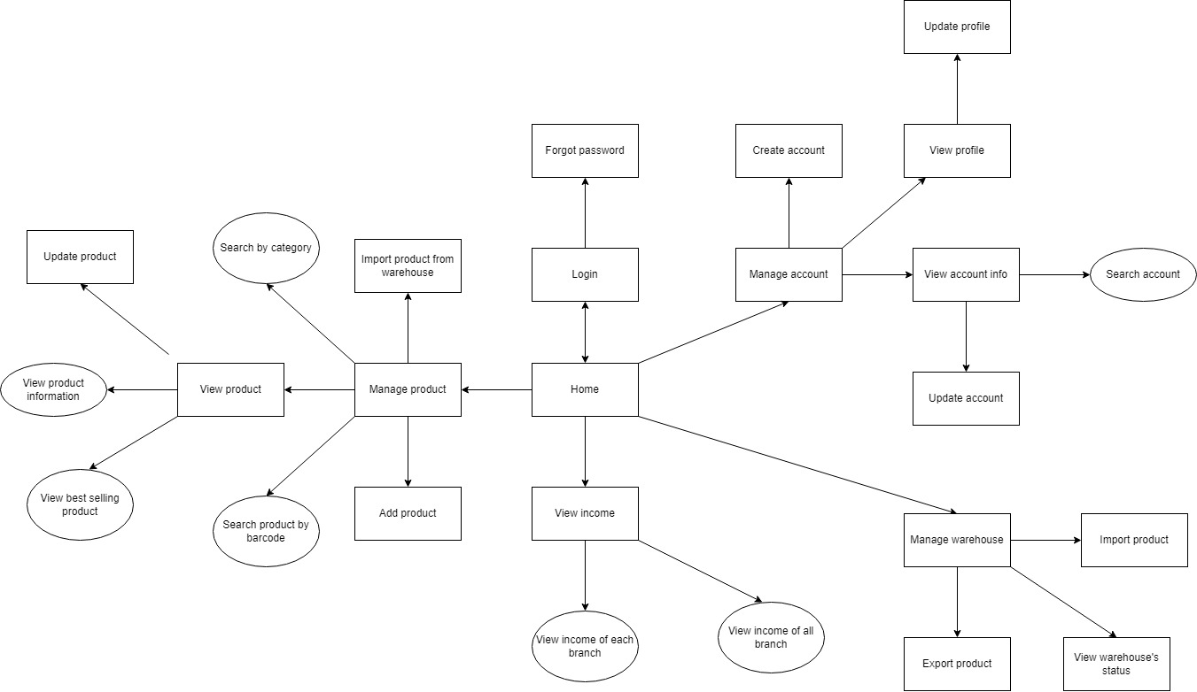

**WEB**

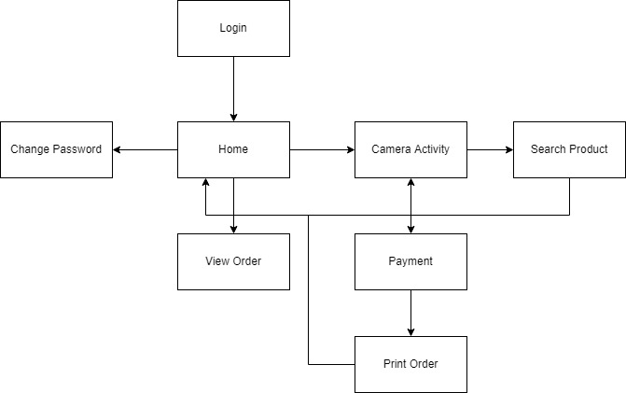

**APP**