**LAB2**  
**Loop structure**

**Ex 1**: Write a program that computes the value of ex by using the formula

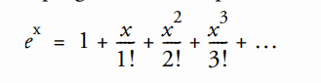

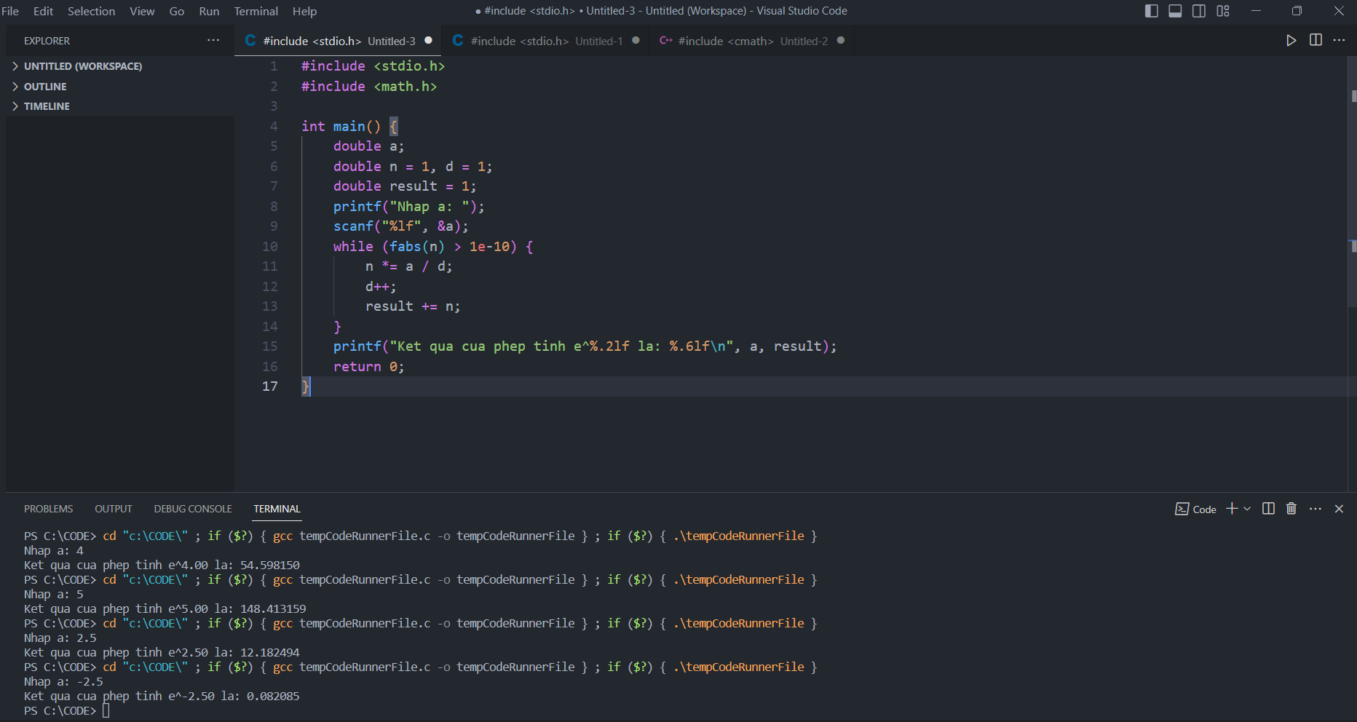

**Ex 2**: write a program to request an integer n from 1 to 9 and print a line of output consisting of ascending digits from 1 to n followed by descending digits from n-1  
to 1.

For example, if n = 5, print the line 123454321

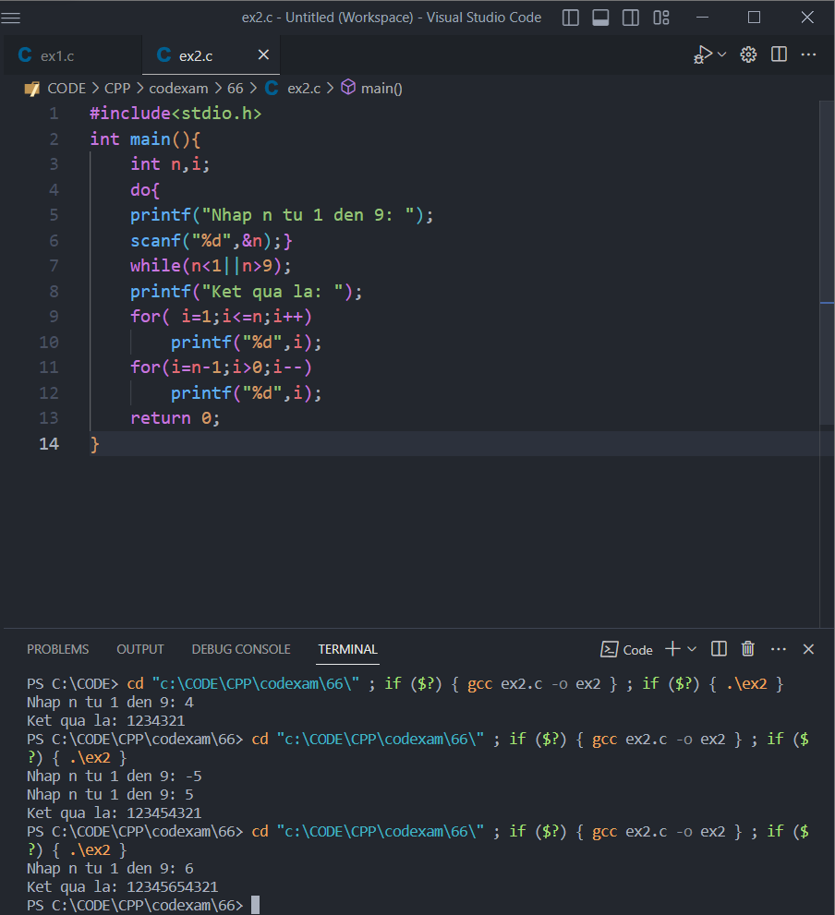

**Ex 3:** Write a program that will help an elementary school student learn multiplication. Use rand() function to produce two positive one-digit integers. It should then type a question such as:EVery  
How much is 6 times 7?The student then types the answer. Your program checks the student's answer. If it is correct, print "Very good!", and then ask another multiplication question.

If the answer is wrong, print "No. Please try again." and then let the student try the same question again repeatedly until the student finally gets it right.

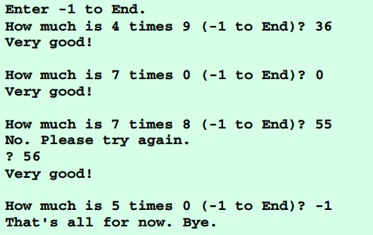

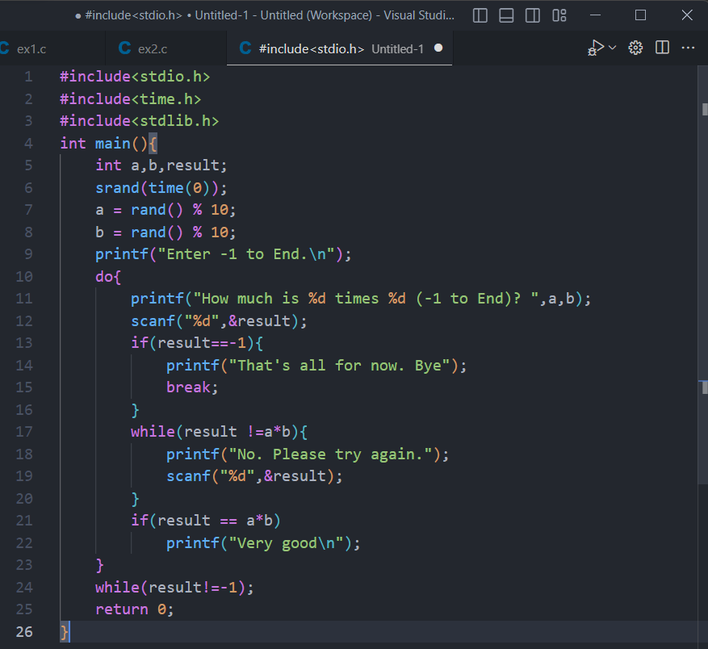

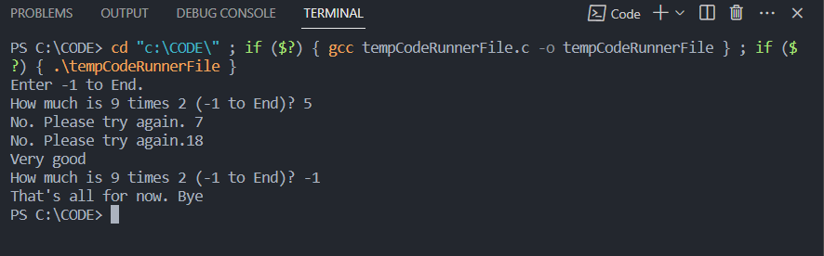

**Ex 4:**

Modify the program of Exercise 5 so the various comments are printed for each correct answer and each incorrect answer as follows:  
Responses to a correct answer:

Very good!Excellent!Nice work!Keep up the good work!Responses to an incorrect answer:  
No. Please try again.Wrong. Try once more.Don't give up!No. Keep trying.Use the random number generator to choose a number from 1 to 4 to select an appropriate response to each answer. Use a switch structure to issue the responses

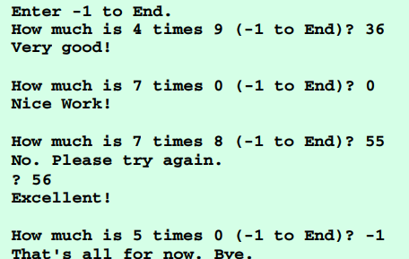

#include<stdio.h>

#include<time.h>

#include<stdlib.h>

int main(){

    int a,b,c,result;

    srand(time(0));

    a = rand() % 10+1;

    b = rand() % 10+1;

    printf("Enter -1 to End.\n");

    do{

         a = rand() % 10+1;

        b = rand() % 10+1;

         c = rand() %4 + 1;

        printf("How much is %d times %d (-1 to End)? ",a,b);

        scanf("%d",&result);

        if(result==-1){

            printf("That's all for now. Bye");

            break;

        }

        while(result !=a*b){

            switch(c){

            case 1: printf("No. Please try again.\n");

                    break;

            case 2: printf("Wrong. Try once more.\n");

            break;

            case 3: printf("Don't give up!\n");

            break;

            case 4: printf("No. Keep trying.\n");

            break;  }

            scanf("%d",&result);

            c = rand() %4 + 1;

            }

        if(result == a*b){

        switch(c){

            case 1: printf("Very good!\n");

                    break;

            case 2: printf("Exellent!\n");

                    break;

            case 3: printf("Nice work!\n");

                    break;

            case 4: printf("Keep up the good work!\n");

                    break;

        }

    }}

    while(result!=-1);

    return 0;

}

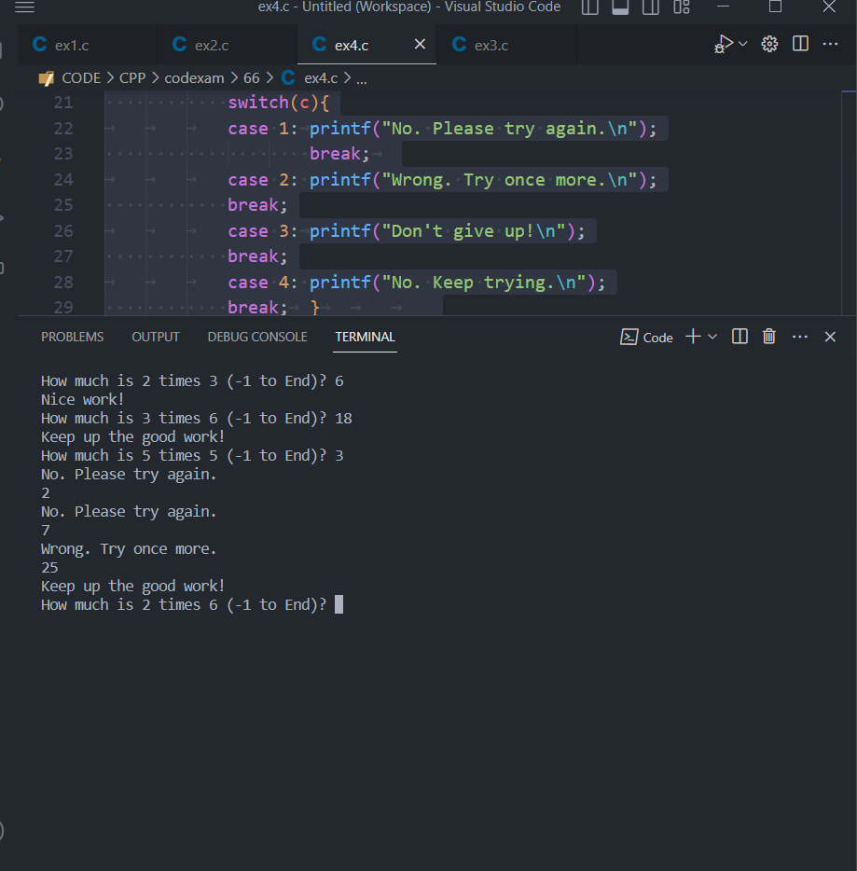

* Good luck - Finish before 8/6/2023?