E-commerce Web Application

Software Development Plan (Small Project)

Version <1.0>

[Note: The following template is provided for use with the Rational Unified Process. Text enclosed in square brackets and displayed in blue italics (style=InfoBlue) is included to provide guidance to the author and should be deleted before publishing the document. A paragraph entered following this style will automatically be set to normal (style=Body Text).]

[To customize automatic fields in Microsoft Word (which display a gray background when selected), select File>Properties and replace the Title, Subject and Company fields with the appropriate information for this document. After closing the dialog, automatic fields may be updated throughout the document by selecting Edit>Select All (or Ctrl-A) and pressing F9, or simply click on the field and press F9. This must be done separately for Headers and Footers. Alt-F9 will toggle between displaying the field names and the field contents. See Word help for more information on working with fields.]

Revision History

|  |  |  |  |
| --- | --- | --- | --- |
| **Date** | **Version** | **Description** | **Author** |
| 06/11/2020 | 1.0 |  | Huỳnh Nhật Nam |
|  |  |  |  |
|  |  |  |  |
|  |  |  |  |

Table of Contents

1. Introduction 4

1.1 Purpose 4

1.2 Scope 4

1.3 Overview 4

2. Project Overview 4

2.1 Project Purpose, Scope, and Objectives 4

2.2 Assumptions and Constraints 4

2.3 Project Deliverables 5

3. Project Organization 5

3.1 Organizational Structure 5

3.2 Roles and Responsibilities 5

4. Management Process 5

4.1 Project Estimates 5

4.2 Project Plan 5

4.2.1 Phase Plan 5

4.2.2 Iteration Objectives 6

4.2.3 Releases 6

4.2.4 Project Schedule 6

4.2.5 Project Resourcing 6

4.3 Project Monitoring and Control 6

4.3.1 Requirements Management 6

4.3.2 Reporting and Measurement 7

4.3.3 Risk Management 7

4.3.4 Configuration Management 7

Software Development Plan (Small Project)

# 

# Introduction

## Purpose

This document presents the activities needed for developing a e-commerce web application.

The following people use the *Software Development Plan*:

* The **project manager** uses it to plan the project schedule and resource needs, and to track progress against the schedule.
* **Project team members** use it to understand what they need to do, when they need to do it,what are their roles and what other activities they are dependent upon.

## Scope

This *Software Development Plan* describes the overall plan to be used by the e-commerce web application project, including deployment of the product. The details of the individual iterations will be described in the Iteration Plans.  
The plans as outlined in this document are based upon the product requirements as defined in the *Vision Document*.

## Overview

This *Software Development Plan* contains the following information:

Project Overview — provides a description of the project's purpose, scope, and objectives.  It also defines the deliverables that the project is expected to deliver.

Project Organization — describes the organizational structure of the project team.

Management process — describes the project’s management, plan and schedule.

# Project Overview

## Project Purpose, Scope, and Objectives

This project will implement a e-commerce web application for small shops. They can advertise and selling their product online to increase their reputation and profit. Customers can buy products to sastify their needs effectively and conveniently through an interface on internet without wasting their time to go to the shop.

## Assumptions and Constraints

- Staff: team with 5 members

- Final product must be releases before final review (around 27/12)

## Project Deliverables

- Project plan

- Vision document

- Use case document

- Use case model

- Design document (class diagrams, software architecture,…)

- Test plan

- Prototype

- Test cases

- Releases

# Project Organization

## Organizational Structure

[Describe the organizational structure of the project team, including management and other review authorities.]

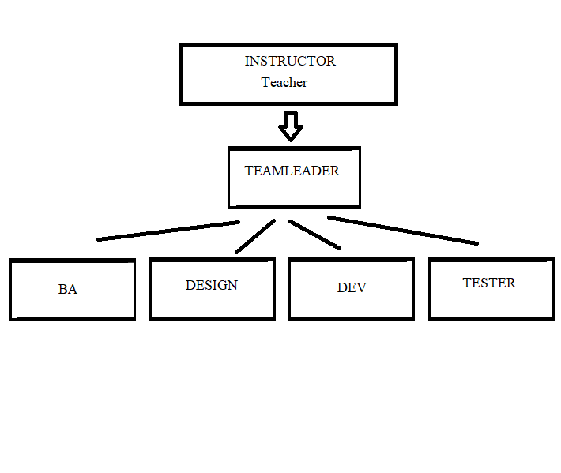

## Roles and Responsibilities

**- All team members are implementers**

|  |  |
| --- | --- |
| **Person** | **Role** |
| **Huỳnh Nhật Nam, Team leader** | - Write project plan (including assign tasks)  - Monitor and report status (weekly report)  - Coordinate meetings  - Contact point for the project |
| **Nguyễn Phúc Thịnh, Business Analyst** | - Document requirements (interview customers, etc.)  - Communicate with team members about the requirements  - Coordinate to review requirements |
| **Phạm Vũ Duy, Designer** | - Design the system (components, classes, databases, etc.)  - Design user interface  - Create Software Architecture Document |
| **Hồ Nguyễn Huy Hoàng, Implementer** | - Write source code  - Perform unit test  - Review source code |
| **Mai Đăng Khánh, Tester** | - Write test plan and test cases  - Perform system test |

# Management Process

## Project Estimates

- Time:

+ 2 Months, 10 Weeks

+ 19/10 – 27/12

- Effort: 10PM

- Cost: 0

- Staff: 5 People

## Project Plan

### Phase Plan

**\* Notes: Project Assignments corresponding to phases may be updated due to their deadlines and our progress**

|  |  |  |  |  |
| --- | --- | --- | --- | --- |
| **Phase** | **Number of Iterations** | **Project Assignments** | **Start** | **End** |
| Inception | 1 | PA1 | 19/10/2020 | 1/11/2020 |
| Elaboration | 2 | PA2, PA3 | 2/11/2020 | 29/11/2020 |
| Construction | 2 | PA4, PA5, PA6 | 30/11/2020 | 27/12/2020 |

### Iteration Objectives

|  |  |  |  |
| --- | --- | --- | --- |
| **Phase** | **Interations No.** | **Project Assignments** | **Objective to be accomplished** |
| Inception | 1 | PA1 | - Vision document  - Project plan |
| Elaboration | 1 | PA2 | - Revised project plan  - Detailed vision document  - Defines use-case model and use-case specification |
| 2 | PA3 | - Submits use-case specification 2nd time.  - Defines sofware architecture (writes SAD) and class diagrams  - UI prototype |
| Construction | 1 | PA4 | - Revised software architecture document  - Implementation (front-end + back-end) |
| 2 | PA5 | - Testing (test plan, test cases, automated testing) |
| PA6 | - Presentation (PP Slides)  - Final submission |

### Releases

- Time: 7/12/2020 – 22/12/2020

+ Demo: Due date: 8/12/2020

+ Alpha: Due date: 13/12/2020

+ Beta: Due date: 20/12/2020

### Project Schedule

**\* Notes: Weekly reports will be submitted at the end of each iteration or based on deadline**

|  |  |  |  |  |
| --- | --- | --- | --- | --- |
| **Phases** | **Interation No.** | **Tasks and Artifacts** | **Start Date** | **End Date** |
| Inception | 1 | - Vision document  - Project plan | 19/10/2020 | 10/11/2020 |
| Elaboration | 1 | - Revised project plan  - Detailed vision document  - Use-case model, use-case specification | 2/11/2020 | 15/11/2020 |
| 2 | - 2nd submission use-case document  - Defines software architecture  - Class diagrams  - UI prototype | 16/11/2020 | 29/11/2020 |
| Construction | 1 | - Revised SAD  - Implementation (Source code)  - Test-plan | 30/11/2020 | 13/12/2020 |
| - Releases (See 4.2.3 for better details) | 8/12/2020 | 20/12/2020 |
| 2 | - Testing  - Prepares presentation slides (PP) | 14/12/2020 | 20/12/2020  (Can be extended to 27/12/2020 corresponding to final submission deadline) |
| - Final Submission  - Presentation | 21/12/2020 | 27/12/2020 |

### Project Resourcing

- Staff: 5 people

+ 1 Project manager

+ 1 Business Analyst

+ 1 Designer

+ 1 Tester

+ 3 or more implementers (All members are implementers) : HTML/CSS/Javascripts skills

- Training: self-training, studying in class.

## Project Monitoring and Control

The requirements for this system are captured in the Vision document. Requested changes to requirements are captured in Change Requests, and are approved as part of the Configuration Management process.

### Reporting and Measurement

Updated cost and schedule estimates, and metrics summary reports, will be generated at the end of each iteration.

The Minimal Set of Metrics, as described in the RUP [Guidelines: Metrics](..\..\..\process\modguide\md_metri.htm), will be gathered on a weekly basis. These include:

Earned value for completed tasks. This is used to re-estimate the schedule and budget for the remainder of the project, and/or to identify need for scope changes.

Total defects open and closed – shown as a trend graph. This is used to help estimate the effort remaining to correct defects.

Acceptance test cases passing – shown as a trend graph. This is used to demonstrate progress to stakeholders.

In addition, overall costs will be monitored against the project budget.

### Risk Management

Risks will be identified in Inception Phase using the steps identified in the RUP for Small Projects activity “Identify and Assess Risks”. Project risk is evaluated at least once per iteration and documented in this table. The risks of the greatest magnitude are listed first in the table.

|  |  |  |
| --- | --- | --- |
| **Risk Ranking (High, Medium, Low)** | **Risk Description and Impact** | **Mitigation Strategy and/or Contingency Plan** |
|  |  |  |

### Configuration Management

Appropriate tools will be selected which provide a database of Change Requests and a controlled versioned repository of project artifacts.

All source code, test scripts, and data files are included in baselines. Documentation related to the source code is also included in the baseline, such as design documentation. All customer deliverable artifacts are included in the final baseline of the iteration, including executables.