Technical Specifications Document
National Land Survey, Title & Tokenization Platform
System Architecture & Implementation Guide

Project: | National Land Survey, Title & Tokenization Platform - Ghana
Document Type: | Technical Specifications
Version: | 1.0
Date: | November 2025
Prepared by: | System Architect
Target Audience: | Development Team, DevOps, Project Managers
Status: | Final for Implementation
Classification: | Internal - Confidential

Table of Contents
1. Executive Summary
2. Document Purpose and Scope
3. System Architecture Overview
- 3.1 High-Level Architecture
- 3.2 Architectural Principles
- 3.3 Architecture Diagrams
4. Technology Stack
- 4.1 Technology Selection Criteria
- 4.2 Ghana-Specific Considerations
- 4.3 Detailed Technology Stack
5. Component Design
- 5.1 Frontend Components
- 5.2 Backend Services
- 5.3 Blockchain Layer
- 5.4 Data Layer
- 5.5 Integration Layer
6. Database Design
- 6.1 Relational Database Schema
- 6.2 Document Database Structure
- 6.3 Blockchain Data Model
7. Security Architecture
- 7.1 Security Layers
- 7.2 Authentication & Authorization
- 7.3 Data Encryption
- 7.4 Network Security
8. Deployment Architecture
- 8.1 Cloud Infrastructure
- 8.2 Multi-Region Strategy
- 8.3 CI/CD Pipeline
9. Integration Specifications
- 9.1 External System Integrations
- 9.2 API Specifications
- 9.3 Payment Gateway Integration
10. Offline Capabilities
- 10.1 Offline Architecture
- 10.2 Synchronization Strategy
11. User Interface Design
- 11.1 Wireframes
- 11.2 Design System
12. Project Plan
- 12.1 Project Timeline
- 12.2 Resource Plan
- 12.3 Budget Estimation
13. Team Structure
14. Risk Management
15. Appendices

1. Executive Summary
This Technical Specifications Document provides comprehensive technical architecture and implementation guidance for the National Land Survey, Title & Tokenization Platform for Ghana. The system is designed as a modern, cloud-native, microservices-based platform that leverages blockchain technology for immutable land title records, GIS capabilities for spatial data management, and multi-channel payment integration including Mobile Money.

Key Technical Highlights:
- Microservices architecture built on containerized infrastructure (Kubernetes)
- Permissioned blockchain (Hyperledger Fabric) for land tokenization
- PostgreSQL with PostGIS extension for geospatial data management
- Multi-region deployment across Accra, Kumasi, and Tamale
- Offline-first mobile applications for field operations
- Integration with 7+ external systems (GELIS, OASL, GRA, Banks, Mobile Money)
- Enterprise-grade security with HSM, biometric authentication, and end-to-end encryption
- Scalable to support 10M+ parcels and 50K concurrent users

Target Implementation Timeline:
12 months from project kickoff to national rollout, with pilot deployment after 9 months.

2. Document Purpose and Scope

2.1 Document Purpose
This document serves as the authoritative technical specification for the development, deployment, and maintenance of the National Land ERP platform. It is intended for:
- Development teams to understand architecture and implementation details
- DevOps engineers for infrastructure setup and deployment
- Project managers for resource planning and timeline management
- Security teams for security architecture review
- External vendors for integration specifications

2.2 Document Scope
This document covers:
- Complete system architecture with layered design
- Technology stack with justifications for Ghana context
- Detailed component specifications for all modules
- Database schemas and data models
- Security architecture and compliance measures
- Deployment strategy for multi-region setup
- Integration specifications for external systems
- Team structure and resource requirements
- Project timeline with Gantt chart
- Risk management and mitigation strategies
- Cost estimation and budget breakdown

3. System Architecture Overview

3.1 High-Level Architecture
The National Land ERP platform is designed using a modern, cloud-native microservices architecture with clear separation of concerns across multiple layers. The architecture supports high availability, scalability, and maintainability while addressing Ghana-specific requirements such as offline operations and mobile money integration.

Architecture Layers:
Layer | Components
Presentation Layer | Web portals (React), mobile apps (React Native), admin console
API Gateway Layer | Kong API Gateway for routing, authentication, rate limiting, and logging
Application Services Layer | Microservices for Identity, Survey, GIS, Blockchain, Title, Payment, Document management
Data & Integration Layer | PostgreSQL/PostGIS, MongoDB, Blockchain (Hyperledger Fabric), Object Storage (MinIO/S3)
Infrastructure Layer | Kubernetes on AWS/Azure, Load Balancers, CDN, Monitoring (ELK Stack, Prometheus)
Security Layer | HSM, WAF, Biometric services, Certificate management, Encryption services

3.2 Architectural Principles
- Microservices Architecture: Services are loosely coupled, independently deployable, and communicate via REST APIs
- API-First Design: All functionality exposed through well-documented APIs for internal and external consumption
- Cloud-Native: Containerized deployment with orchestration, auto-scaling, and self-healing capabilities
- Offline-First: Mobile applications designed to work offline with automatic synchronization
- Security by Design: Security considerations embedded at every layer with defense-in-depth strategy
- Data Sovereignty: Data stored within Ghana with compliance to local data protection regulations
- Scalability: Horizontal scaling capability to support millions of parcels and concurrent users
- High Availability: 99.95% uptime target with multi-region deployment and automatic failover

3.3 Architecture Diagrams

3.3.1 System Architecture Diagram
The following diagram illustrates the complete system architecture with all layers and components:

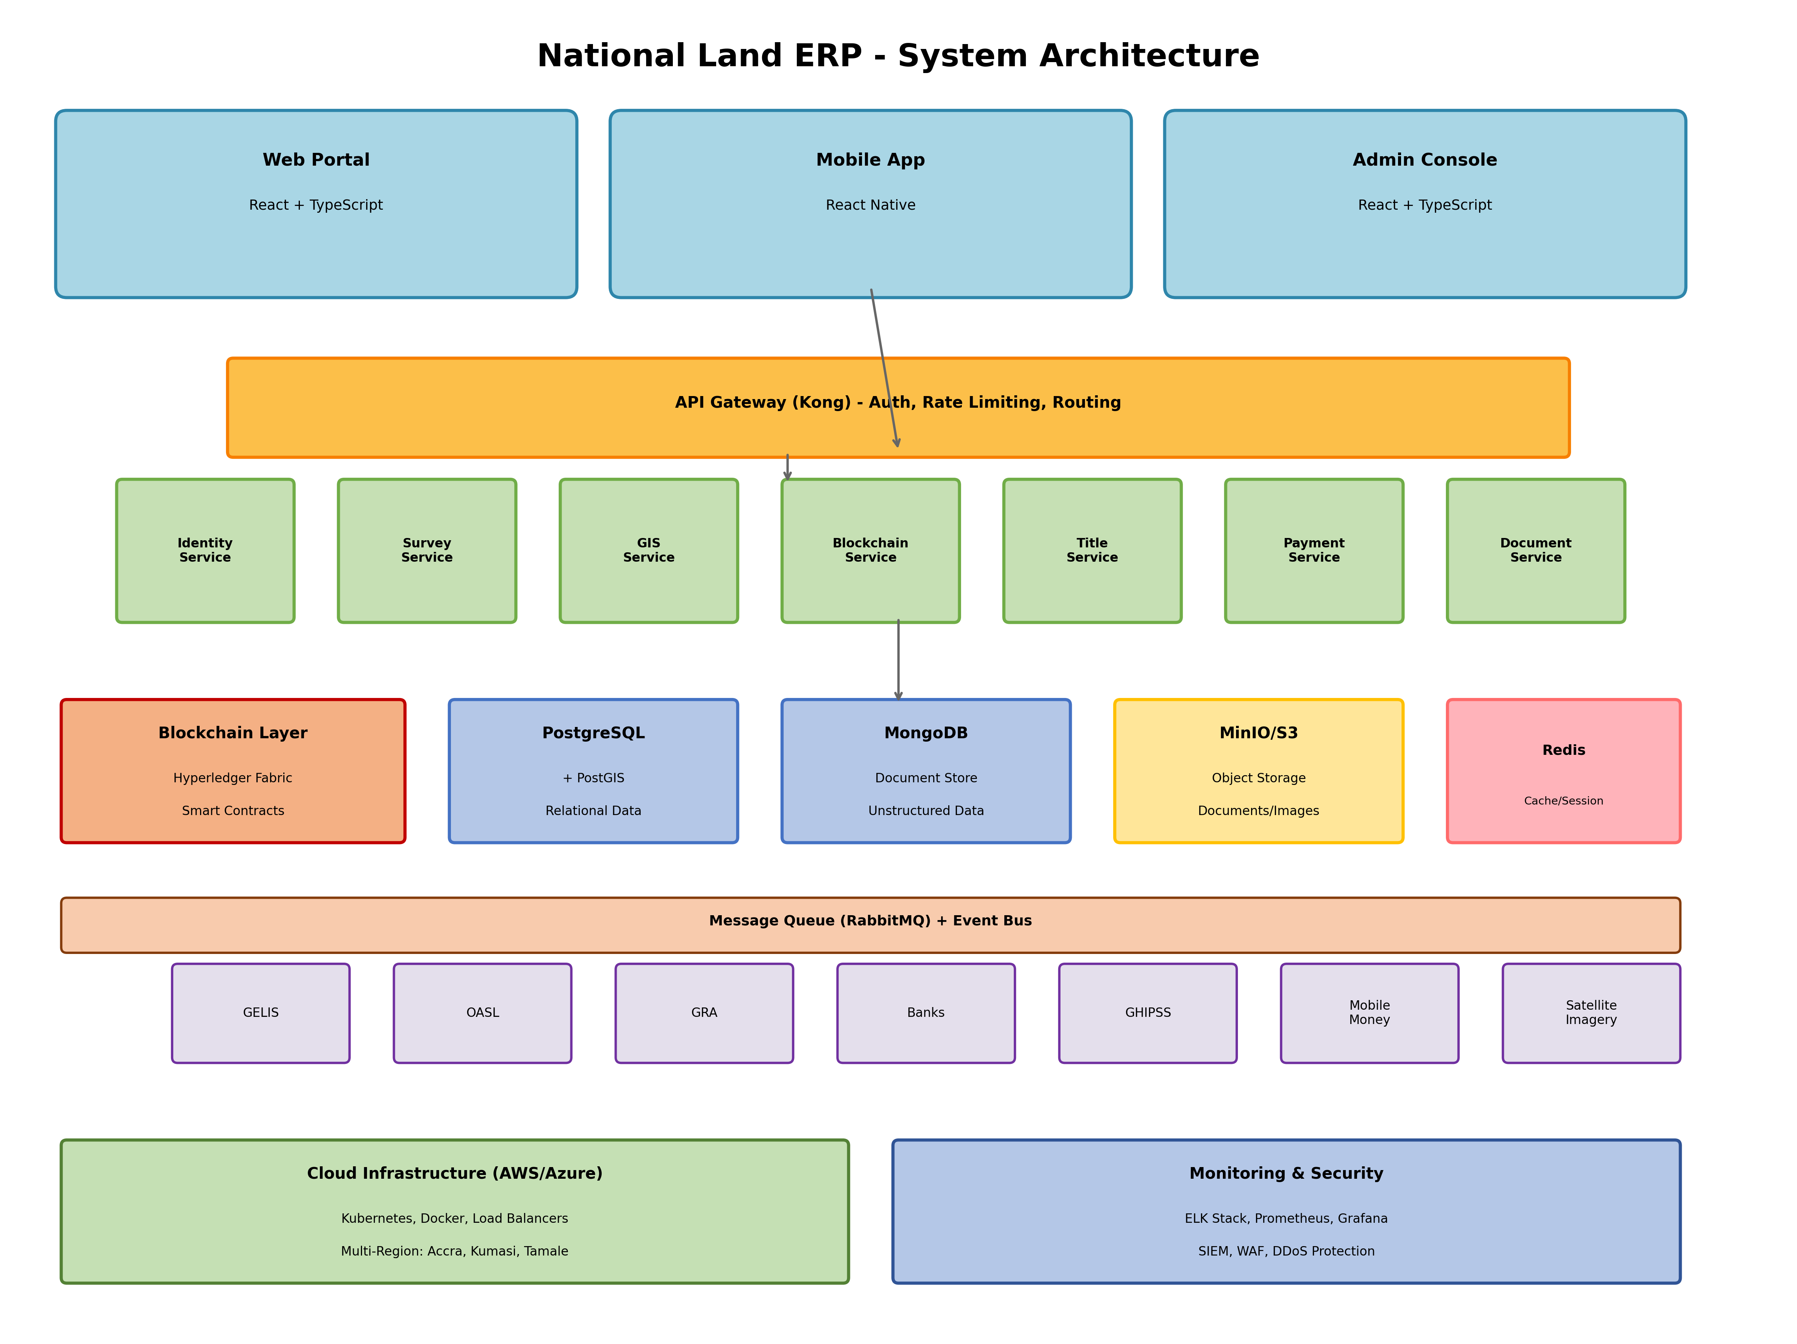

Figure 1: Complete system architecture showing presentation layer, API gateway, microservices, data stores, and infrastructure components.

3.3.2 Blockchain Architecture
The blockchain layer provides immutable, auditable records for land tokenization:

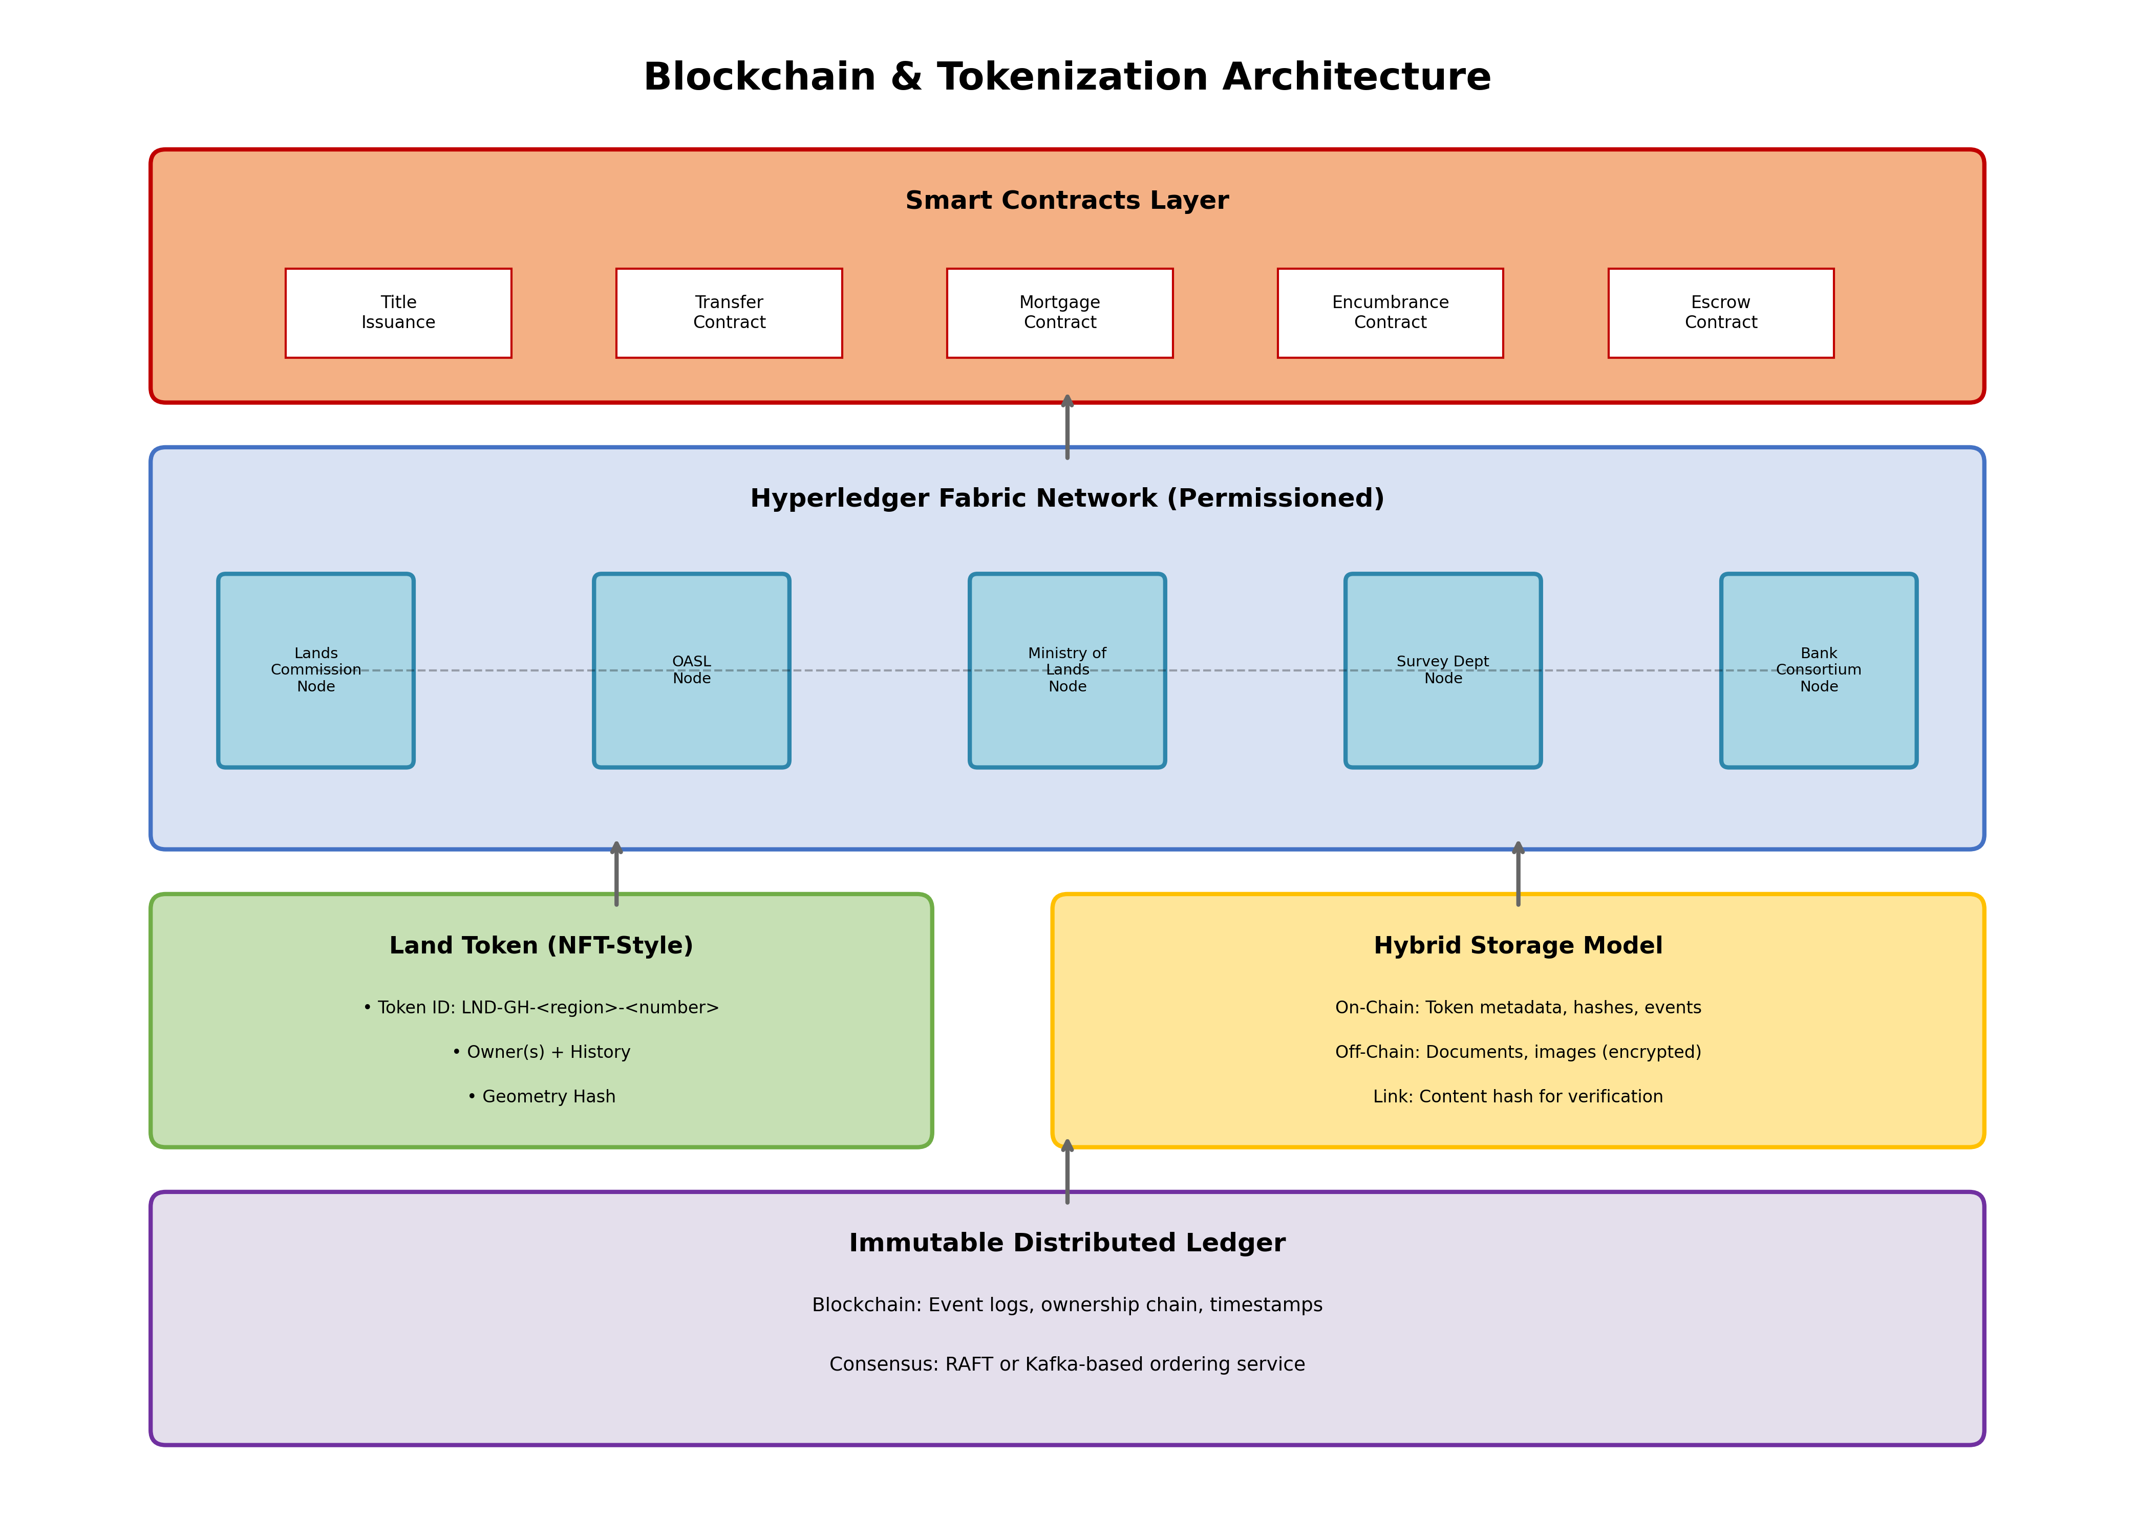

Figure 2: Blockchain architecture using Hyperledger Fabric with consortium nodes, smart contracts, and hybrid storage model.

3.3.3 Data Flow Diagram
Title registration data flow from survey submission to certificate issuance:

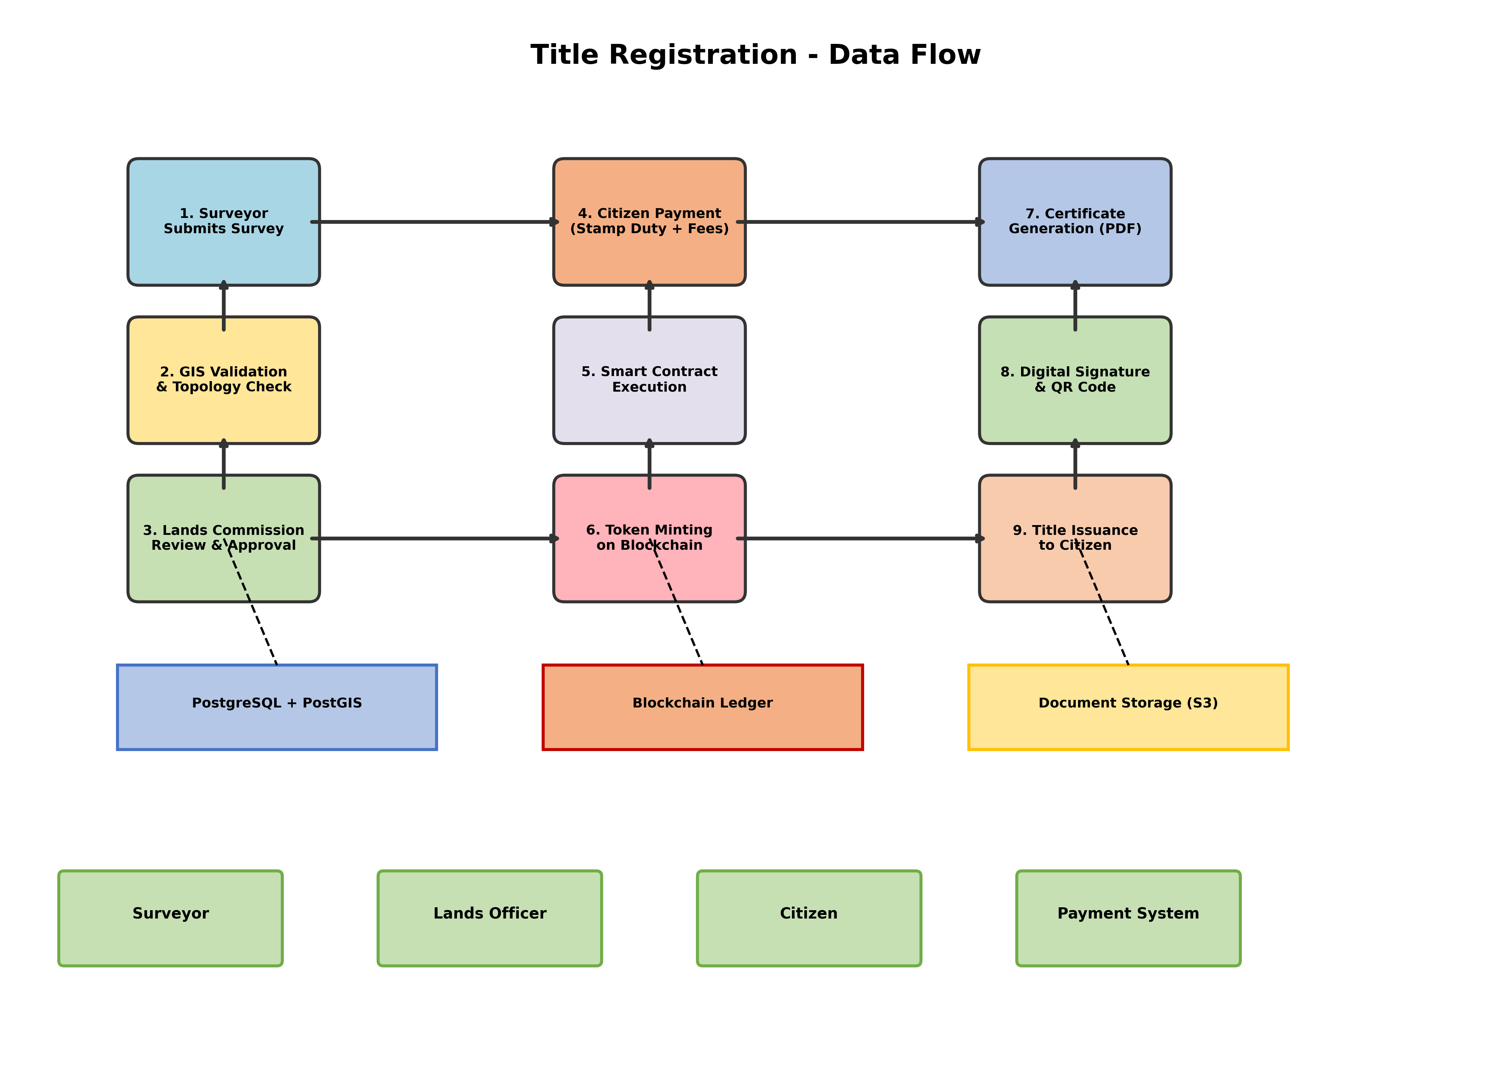

Figure 3: End-to-end data flow for title registration showing all processing steps, data stores, and actor interactions.

3.3.4 Deployment Architecture
Multi-region deployment architecture across Ghana:

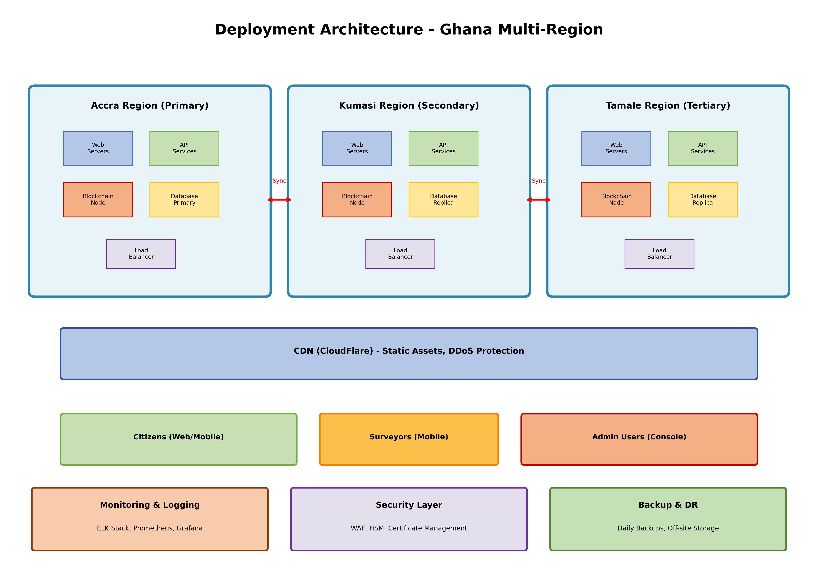

Figure 4: Multi-region deployment across Accra (primary), Kumasi (secondary), and Tamale (tertiary) with replication, load balancing, and failover capabilities.

4. Technology Stack

4.1 Technology Selection Criteria
Technologies were selected based on the following criteria:
- Maturity and production-readiness
- Community support and ecosystem
- Scalability and performance
- Security features and track record
- Cost-effectiveness (preference for open-source)
- Availability of local expertise in Ghana
- Cloud provider compatibility
- Integration capabilities

4.2 Ghana-Specific Considerations
The technology stack has been carefully selected to address Ghana-specific requirements and constraints:

Consideration | Technical Solution
Limited Internet Connectivity in Rural Areas | Offline-first mobile apps with CouchDB/PouchDB sync; local caching; store-and-forward architecture
Mobile Money Dominance (80%+ penetration) | Direct integration with MTN Mobile Money, Vodafone Cash, AirtelTigo Money APIs; fallback to USSD
Local Language Support | Multilingual UI (English, Twi, Ewe, Hausa) with i18n framework; RTL support where needed
Power Reliability Issues | Battery-optimized mobile apps; efficient data sync; minimal background processing
Data Sovereignty Requirements | Primary data centers in Ghana (Accra); backup in-country; compliance with Ghana Data Protection Act
Mobile-First Population | React Native for cross-platform mobile; responsive web design; mobile-optimized bandwidth usage
Cost Sensitivity | Open-source stack where possible; efficient cloud resource usage; multi-tenancy; cost optimization
Local Developer Availability | Popular technologies (React, Node.js, Python) with strong African developer community

4.3 Detailed Technology Stack

Frontend Technologies

Component | Selected Technology | Justification | Alternatives
Web Application | React 18+ with TypeScript | Component-based, large ecosystem, TypeScript for type safety | Vue.js, Angular
Mobile Application | React Native | Cross-platform (iOS/Android), code reuse with web, offline support with AsyncStorage | Flutter, Native
State Management | Redux Toolkit | Predictable state management, dev tools, RTK Query for API integration | Zustand, MobX
UI Component Library | Material-UI (MUI) + Tailwind CSS | Professional components, customizable, accessibility built-in | Ant Design, Chakra UI
Mapping/GIS Frontend | OpenLayers / Mapbox GL JS | Feature-rich mapping, GeoJSON support, WMS/WFS integration | Leaflet, Google Maps
Form Validation | React Hook Form + Yup | Performant, easy validation, good DX | Formik

Backend Technologies

Component | Selected Technology | Justification | Alternatives
API Framework | Node.js with NestJS | TypeScript-based, modular architecture, built-in dependency injection, excellent for microservices | Express.js, Fastify, Python FastAPI
Alternative Backend | Python with FastAPI | Excellent for GIS processing, async support, automatic API docs | Django, Flask
API Gateway | Kong | Open-source, plugins ecosystem, rate limiting, authentication, logging | AWS API Gateway, Apigee
Authentication | Keycloak | Open-source IAM, SSO, OAuth2/OIDC, SAML, user federation | Auth0, Okta, AWS Cognito
Message Queue | RabbitMQ | Reliable message broker, multiple protocols, clustering support | Apache Kafka, Redis Streams
Caching Layer | Redis | In-memory cache, session storage, pub/sub, Lua scripting | Memcached
Search Engine | Elasticsearch | Full-text search, geospatial queries, analytics, scalable | Apache Solr

Blockchain & Smart Contracts

Component | Selected Technology | Justification | Alternatives
Blockchain Platform | Hyperledger Fabric 2.5+ | Permissioned blockchain, consortium model, privacy features, chaincode in Go | Quorum, Corda, Multichain
Smart Contracts | Go (Chaincode) | Native Fabric support, performance, strong typing | JavaScript, Java
Blockchain Explorer | Hyperledger Explorer | Web UI for blockchain monitoring, transaction history | Custom dashboard
Wallet/Key Management | Fabric CA + HSM Integration | Certificate authority, hardware security module for key storage | Software-based

Database Technologies

Component | Selected Technology | Justification | Alternatives
Relational Database | PostgreSQL 15+ with PostGIS | PostGIS for geospatial data, ACID compliance, JSON support, mature | MySQL, SQL Server
Document Database | MongoDB | Flexible schema, horizontal scaling, aggregation framework | CouchDB, DynamoDB
Time-Series Database | TimescaleDB (PostgreSQL extension) | Time-series optimization, SQL interface, automatic partitioning | InfluxDB
Object Storage | MinIO (S3-compatible) | Self-hosted S3, encryption, versioning, erasure coding | AWS S3, Azure Blob
Offline Sync | CouchDB + PouchDB | Built-in replication, conflict resolution, offline-first | Realm, WatermelonDB

GIS & Mapping

Component | Selected Technology | Justification | Alternatives
GIS Server | GeoServer | OGC standards (WMS, WFS, WCS), styling, reprojection | MapServer, QGIS Server
Spatial Processing | GDAL/OGR | Raster/vector processing, format conversion, coordinate transformation | PostGIS functions
Satellite Imagery | Google Earth Engine / Sentinel Hub | High-resolution imagery, time-series, cloud processing | Planet Labs, Maxar
Coordinate Systems | PROJ | Coordinate transformation library, Ghana specific projections | Built-in PostGIS

Payment Integration

Component | Selected Technology | Justification | Alternatives
Mobile Money | Direct API Integration | MTN MoMo API, Vodafone Cash API, AirtelTigo API, USSD fallback | Aggregator (Flutterwave)
Card Processing | Stripe / Paystack | Visa/Mastercard processing, PCI compliance, webhooks | Direct bank integration
GHIPSS Integration | GhIPSS e-Zwich / GIP | National payment switch, instant settlement | Bank-specific
Payment Reconciliation | Custom Service | Automated matching, exception handling, reporting | Manual

Security & Compliance

Component | Selected Technology | Justification | Alternatives
HSM (Hardware Security Module) | Thales Luna / AWS CloudHSM | FIPS 140-2 Level 3, key generation, certificate management | Software-based
Biometric SDK | Neurotechnology MegaMatcher / Innovatrics | Fingerprint, face recognition, AFIS integration, template matching | BioID, Aware
Secret Management | HashiCorp Vault | Secrets storage, dynamic secrets, encryption as a service | AWS Secrets Manager
SSL/TLS Certificates | Let's Encrypt / DigiCert | Automated cert management, renewal | Manual
WAF (Web Application Firewall) | AWS WAF / CloudFlare | OWASP Top 10 protection, DDoS mitigation, bot management | ModSecurity

DevOps & Infrastructure

Component | Selected Technology | Justification | Alternatives
Cloud Provider | AWS / Azure (Hybrid) | Global infrastructure, Ghana region availability, managed services | GCP, On-premise
Container Runtime | Docker | Industry standard, image building, registry integration | Podman
Container Orchestration | Kubernetes (EKS/AKS) | Auto-scaling, self-healing, rolling updates, service mesh | Docker Swarm, Nomad
Service Mesh | Istio | Traffic management, security, observability | Linkerd, Consul
CI/CD | GitLab CI/CD / GitHub Actions | Integrated pipelines, artifact registry, testing automation | Jenkins, CircleCI
Infrastructure as Code | Terraform | Multi-cloud, state management, modules | AWS CloudFormation, Ansible
Configuration Management | Ansible | Agentless, YAML-based, idempotent | Puppet, Chef
Load Balancer | NGINX / AWS ALB | Layer 7 load balancing, SSL termination, caching | HAProxy

Monitoring & Logging

Component | Selected Technology | Justification | Alternatives
Log Aggregation | ELK Stack (Elasticsearch, Logstash, Kibana) | Centralized logging, search, visualization, alerting | Splunk, Datadog
Metrics & Monitoring | Prometheus + Grafana | Time-series metrics, alerting, beautiful dashboards | Datadog, New Relic
APM (Application Performance Monitoring) | Jaeger / OpenTelemetry | Distributed tracing, performance profiling | New Relic, Dynatrace
Error Tracking | Sentry | Real-time error tracking, release tracking, user impact | Rollbar, Bugsnag
Uptime Monitoring | Pingdom / UptimeRobot | External monitoring, alerting, status page | Custom
SIEM (Security Information and Event Management) | Wazuh / Elastic SIEM | Security monitoring, threat detection, compliance | Splunk, QRadar

Development Tools

Component | Selected Technology | Justification | Alternatives
Version Control | Git + GitHub/GitLab | Distributed VCS, code review, CI/CD integration | Bitbucket
API Documentation | Swagger/OpenAPI + Postman | Interactive docs, API testing, code generation | API Blueprint
Code Quality | SonarQube | Static code analysis, security scanning, technical debt | CodeClimate
Testing Framework | Jest (JavaScript) + Pytest (Python) | Unit testing, mocking, coverage | Mocha, unittest
E2E Testing | Cypress / Playwright | Browser automation, visual testing, CI integration | Selenium
Load Testing | k6 / Apache JMeter | Performance testing, stress testing, scalability validation | Gatling

5. Component Design
The system is composed of multiple microservices, each responsible for a specific business capability. Services communicate via REST APIs through the API Gateway and asynchronously via message queues.

5.1 Microservices Overview

Identity Service
Description: User management, authentication, authorization, role-based access control, biometric integration
Technology Stack: Keycloak, PostgreSQL
Key APIs:
- User Registration
- Login/Logout
- Role Management
- Biometric Verification
- Session Management

Survey Service
Description: Survey job management, surveyor accreditation, coordinate validation, report generation
Technology Stack: NestJS, PostgreSQL, S3
Key APIs:
- Create Survey
- Upload Survey Data
- Validate Coordinates
- Generate Survey Report
- Surveyor Verification

GIS Service
Description: Geospatial data processing, coordinate transformation, topology validation, map generation
Technology Stack: Python FastAPI, PostGIS, GeoServer
Key APIs:
- Spatial Query
- Coordinate Transformation
- Topology Validation
- Map Tile Generation
- Overlay Analysis

Blockchain Service
Description: Token minting, smart contract execution, blockchain queries, event listening
Technology Stack: Node.js, Hyperledger Fabric SDK
Key APIs:
- Mint Token
- Transfer Ownership
- Register Encumbrance
- Query Blockchain
- Execute Smart Contract

Title Service
Description: Title issuance workflow, certificate generation, title lifecycle management
Technology Stack: NestJS, PostgreSQL, MongoDB
Key APIs:
- Create Title Application
- Review Application
- Generate Certificate
- Issue Title
- Duplicate Title

Payment Service
Description: Multi-channel payments, stamp duty calculation, reconciliation, receipt generation
Technology Stack: NestJS, PostgreSQL, Redis
Key APIs:
- Calculate Fees
- Process Payment
- Generate Receipt
- Reconcile Payments
- Refund Processing

Document Service
Description: Document storage, versioning, OCR, metadata extraction, secure sharing
Technology Stack: NestJS, MongoDB, MinIO
Key APIs:
- Upload Document
- Version Management
- OCR Processing
- Document Search
- Secure Download

Notification Service
Description: Multi-channel notifications (SMS, Email, Push), template management
Technology Stack: NestJS, Redis, RabbitMQ
Key APIs:
- Send SMS
- Send Email
- Push Notification
- Template Management
- Notification Logs

Integration Service
Description: External system integration orchestration, API proxying, data transformation
Technology Stack: NestJS, RabbitMQ
Key APIs:
- GELIS Integration
- OASL Integration
- GRA Integration
- Bank Integration
- Mobile Money Integration

Analytics Service
Description: Reporting, dashboards, business intelligence, data export
Technology Stack: Python, Elasticsearch, PostgreSQL
Key APIs:
- Generate Reports
- Dashboard Data
- Export Data
- Analytics Queries
- KPI Calculation

Search Service
Description: Full-text search, land record search, advanced queries
Technology Stack: Elasticsearch
Key APIs:
- Search Parcels
- Search Owners
- Advanced Search
- Faceted Search
- Autocomplete

6. Database Design

6.1 Relational Database Schema (PostgreSQL + PostGIS)
The relational database stores structured data for users, surveys, titles, payments, and transactions. PostGIS extension provides geospatial capabilities.

Core Tables:

- USERS
- id (UUID, PK)
- username (VARCHAR)
- email (VARCHAR)
- phone (VARCHAR)
- role_id (UUID, FK)
- biometric_template (BYTEA)
- created_at (TIMESTAMP)
- updated_at (TIMESTAMP)

- ROLES
- id (UUID, PK)
- name (VARCHAR)
- permissions (JSONB)
- created_at (TIMESTAMP)

- SURVEYORS
- id (UUID, PK)
- user_id (UUID, FK)
- license_number (VARCHAR)
- accreditation_status (ENUM)
- accreditation_date (DATE)
- documents (JSONB)

- PARCELS
- id (UUID, PK)
- parcel_id (VARCHAR, UNIQUE)
- geometry (GEOMETRY, PostGIS)
- centroid (GEOMETRY, PostGIS)
- area (NUMERIC)
- land_type (ENUM)
- region (VARCHAR)
- district (VARCHAR)
- created_at (TIMESTAMP)
- updated_at (TIMESTAMP)

- SURVEYS
- id (UUID, PK)
- survey_id (VARCHAR, UNIQUE)
- parcel_id (UUID, FK)
- surveyor_id (UUID, FK)
- coordinates (GEOMETRY, PostGIS)
- survey_date (DATE)
- instrument_type (VARCHAR)
- accuracy_score (NUMERIC)
- status (ENUM)
- metadata (JSONB)
- created_at (TIMESTAMP)

- TITLES
- id (UUID, PK)
- title_id (VARCHAR, UNIQUE)
- parcel_id (UUID, FK)
- owner_id (UUID, FK)
- title_type (ENUM)
- issuance_date (DATE)
- status (ENUM)
- blockchain_token_id (VARCHAR)
- certificate_url (VARCHAR)
- created_at (TIMESTAMP)
- updated_at (TIMESTAMP)

- ENCUMBRANCES
- id (UUID, PK)
- title_id (UUID, FK)
- encumbrance_type (ENUM)
- encumbrance_holder (VARCHAR)
- amount (NUMERIC)
- start_date (DATE)
- end_date (DATE)
- status (ENUM)
- blockchain_event_hash (VARCHAR)
- created_at (TIMESTAMP)

- PAYMENTS
- id (UUID, PK)
- transaction_id (VARCHAR, UNIQUE)
- user_id (UUID, FK)
- application_id (UUID, FK)
- payment_method (ENUM)
- amount (NUMERIC)
- currency (VARCHAR)
- status (ENUM)
- payment_gateway_ref (VARCHAR)
- receipt_url (VARCHAR)
- blockchain_hash (VARCHAR)
- created_at (TIMESTAMP)

- APPLICATIONS
- id (UUID, PK)
- application_id (VARCHAR, UNIQUE)
- applicant_id (UUID, FK)
- application_type (ENUM)
- parcel_id (UUID, FK)
- status (ENUM)
- submitted_at (TIMESTAMP)
- reviewed_by (UUID, FK)
- approved_at (TIMESTAMP)
- workflow_state (JSONB)

- AUDIT_LOGS
- id (UUID, PK)
- entity_type (VARCHAR)
- entity_id (UUID)
- action (VARCHAR)
- user_id (UUID, FK)
- ip_address (INET)
- user_agent (VARCHAR)
- changes (JSONB)
- timestamp (TIMESTAMP)

6.2 Document Database (MongoDB)
MongoDB stores unstructured and semi-structured data including survey reports, application forms, and document metadata.

Collections:
- survey_reports: Detailed survey reports with embedded images, attachments, and metadata
- application_forms: Title application forms with dynamic fields based on application type
- document_metadata: Document metadata, versions, access logs, and blockchain hashes
- notification_templates: SMS, email, and push notification templates with placeholders
- system_configurations: System-wide and regional configuration settings
- integration_logs: External API call logs, responses, and error details

6.3 Blockchain Data Model
Hyperledger Fabric stores land tokens as digital assets with ownership and encumbrance events.

Token Structure (Chaincode State):
{
"tokenId": "LND-GH-GR-00001",
"parcelId": "UUID",
"tokenType": "LAND_TITLE",
"geometry": {
"type": "Polygon",
"coordinates": [...]
},
"geometryHash": "SHA256 hash",
"owner": "UUID",
"coOwners": ["UUID"],
"ownershipHistory": [
{
"owner": "UUID",
"transferDate": "ISO8601",
"transferType": "SALE|INHERITANCE|GIFT",
"blockNumber": 12345,
"transactionHash": "0x..."
}
],
"encumbrances": [
{
"type": "MORTGAGE|LIEN|EASEMENT",
"holder": "UUID",
"amount": 100000,
"registrationDate": "ISO8601",
"expiryDate": "ISO8601",
"status": "ACTIVE|DISCHARGED"
}
],
"titleType": "FREEHOLD|LEASEHOLD|STOOL_LAND",
"issuanceDate": "ISO8601",
"issuingAuthority": "Lands Commission",
"certificateHash": "SHA256 hash",
"status": "ACTIVE|SUSPENDED|CANCELLED",
"metadata": {
"region": "Greater Accra",
"district": "Accra Metropolitan",
"area": 500.5,
"landUse": "RESIDENTIAL"
},
"createdAt": "ISO8601",
"updatedAt": "ISO8601"
}

7. Security Architecture
Security is implemented using a defense-in-depth strategy with multiple layers of protection. The system complies with Ghana Data Protection Act, ISO 27001, and OWASP Top 10 guidelines.

7.1 Security Layers

Network Security
- VPC isolation with private subnets for databases and blockchain nodes
- Security groups and NACLs for ingress/egress filtering
- DDoS protection via CloudFlare / AWS Shield
- WAF (Web Application Firewall) with OWASP rule sets
- IDS/IPS for intrusion detection and prevention

Application Security
- API Gateway with rate limiting (100 req/min per user)
- OAuth 2.0 / OpenID Connect for authentication
- JWT tokens with short expiry (15 minutes) and refresh tokens
- Role-Based Access Control (RBAC) with fine-grained permissions
- Input validation and sanitization at API layer
- CORS configuration for allowed origins
- CSRF protection with tokens

Data Security
- TLS 1.3 for all data in transit
- AES-256 encryption for data at rest
- Database encryption (PostgreSQL pgcrypto, MongoDB encryption)
- Field-level encryption for sensitive PII
- Blockchain data immutability for audit trail
- Secure key storage in HSM (FIPS 140-2 Level 3)
- Regular database backups with encryption

Identity & Access Management
- Biometric authentication (fingerprint, face recognition)
- Multi-factor authentication (MFA) for admin users
- Device binding for surveyors
- Session management with timeout (30 minutes idle)
- Password policy (12+ chars, complexity, rotation)
- Privileged access management (PAM) for system admins
- Audit logging of all authentication events

Compliance & Privacy
- PII data redaction in public APIs
- Data minimization principles
- Consent management for data processing
- Right to access, rectification, and erasure (GDPR-style)
- Data retention policies
- Privacy impact assessments
- Regular compliance audits

7.2 Authentication Flow
- 1. User enters credentials (username/password) or presents biometric
- 2. Frontend sends authentication request to API Gateway
- 3. API Gateway routes to Identity Service (Keycloak)
- 4. Identity Service validates credentials against PostgreSQL
- 5. If biometric, Biometric SDK matches template
- 6. On success, Keycloak generates JWT access token (15 min) and refresh token (7 days)
- 7. Tokens returned to frontend and stored in secure storage (HttpOnly cookies for web, SecureStore for mobile)
- 8. Subsequent API calls include JWT in Authorization header
- 9. API Gateway validates JWT signature and expiry
- 10. If expired, frontend uses refresh token to obtain new access token
- 11. All authentication events logged to audit_logs table

7.3 Data Encryption Strategy
Data Type | Encryption Method | Key Management
Data in Transit | TLS 1.3 with ECDHE cipher suites | Certificate management via Let's Encrypt / DigiCert
Database (at rest) | AES-256 encryption, transparent data encryption (TDE) | Master keys in HSM, automatic key rotation
Object Storage | Server-side encryption (SSE-S3/SSE-KMS) | KMS-managed keys with access policies
Biometric Templates | One-way hashing (cannot be reversed to original biometric) | Template stored in encrypted DB field
Blockchain Private Data | Off-chain encrypted storage, hash on-chain | Per-organization keys in HSM

8. Deployment Architecture

8.1 Cloud Infrastructure
The platform is deployed on AWS (primary) with Azure as backup option. Infrastructure spans three regions in Ghana: Accra (primary), Kumasi (secondary), and Tamale (tertiary) for high availability and disaster recovery.

Deployment Architecture Diagram:

Figure 5: Multi-region deployment architecture showing primary, secondary, and tertiary data centers with replication and failover.

8.2 Infrastructure Components
Component | Implementation Details
Kubernetes Cluster | EKS (Elastic Kubernetes Service) with 3 node groups: frontend (2-10 nodes), backend (3-15 nodes), blockchain (5 fixed nodes)
Load Balancers | Application Load Balancer (ALB) for HTTP/HTTPS traffic, Network Load Balancer (NLB) for TCP/blockchain
Auto Scaling | Horizontal Pod Autoscaler (HPA) based on CPU/memory, Cluster Autoscaler for node scaling
Database Instances | RDS PostgreSQL (Multi-AZ), DocumentDB (MongoDB-compatible, 3 replicas), RDS Aurora for read replicas
Object Storage | S3 with versioning, lifecycle policies, cross-region replication
CDN | CloudFront for static assets, edge caching, DDoS protection
DNS | Route 53 with health checks, geolocation routing, failover
VPN | Site-to-site VPN for Lands Commission offices, Client VPN for remote access
Backup | Automated daily snapshots, cross-region backup, 30-day retention

8.3 CI/CD Pipeline
Continuous Integration and Continuous Deployment pipeline ensures rapid, reliable software delivery:

- Code Commit: Developer commits code to Git repository (GitHub/GitLab) (Git push triggers webhook)
- Build: Compile code, run linters (ESLint, Pylint), static code analysis (SonarQube) (Docker image build)
- Unit Tests: Run unit tests (Jest, Pytest), generate coverage report (>80% required) (Fail fast on test failures)
- Security Scan: Container vulnerability scan (Trivy), dependency check (Snyk), secrets scan (Block deployment on critical vulnerabilities)
- Integration Tests: API integration tests, database tests, blockchain tests (Test environment deployment)
- Deploy to Staging: Deploy to staging Kubernetes cluster, run smoke tests (Automated rollback on failure)
- E2E Tests: End-to-end tests (Cypress), load tests (k6), security tests (OWASP ZAP) (Staging environment)
- Manual Approval: Product Owner / Tech Lead approval for production deployment (Approval gate)
- Deploy to Production: Blue-green deployment to production, canary release (10% → 50% → 100%) (Health checks and monitoring)
- Post-Deployment: Smoke tests, monitoring alerts, rollback if issues detected (Automatic rollback on failure)

9. Integration Specifications

9.1 External System Integrations

GELIS (Ghana Enterprise Land Information System)
Protocol: RESTful API
Purpose: Import existing land records, sync parcel data, query cadastral information
Authentication: OAuth 2.0, TLS 1.3
Data Format: JSON over HTTPS

OASL (Office of Administrator of Stool Lands)
Protocol: RESTful API
Purpose: Retrieve stool land ownership data, validate customary land rights
Authentication: API Key + OAuth
Data Format: JSON over HTTPS

GRA (Ghana Revenue Authority)
Protocol: SOAP / RESTful API
Purpose: Submit stamp duty assessments, receive payment confirmations, tax clearance checks
Authentication: Mutual TLS
Data Format: XML/JSON over HTTPS

Banks (Commercial Banks)
Protocol: RESTful API
Purpose: Mortgage registration, payment verification, account validation
Authentication: OAuth 2.0 + signed requests
Data Format: JSON over HTTPS

GHIPSS (Ghana Interbank Payment Systems)
Protocol: GhIPSS e-Zwich API
Purpose: Payment processing, instant settlement, transaction status
Authentication: Certificate-based auth
Data Format: ISO 8583 / JSON

Mobile Money (MTN, Vodafone, AirtelTigo)
Protocol: Direct API Integration
Purpose: Payment collection, disbursement, transaction status, USSD fallback
Authentication: API Key + HMAC
Data Format: JSON over HTTPS

Satellite Imagery Providers
Protocol: RESTful API (Earth Engine / Sentinel Hub)
Purpose: Download high-resolution imagery, time-series data, change detection
Authentication: API Key
Data Format: GeoTIFF / COG via HTTPS

National ID Authority
Protocol: RESTful API
Purpose: KYC verification, identity validation, biometric matching (future)
Authentication: Mutual TLS
Data Format: JSON over HTTPS

9.2 API Design Standards
All internal and external APIs follow these design standards:
- RESTful design principles with resource-based URLs
- JSON request/response format (application/json)
- HTTP status codes: 200 (OK), 201 (Created), 400 (Bad Request), 401 (Unauthorized), 403 (Forbidden), 404 (Not Found), 500 (Internal Server Error)
- Versioning via URL path (e.g., /api/v1/parcels)
- Pagination for list endpoints (limit, offset, cursor-based)
- Filtering, sorting, and searching via query parameters
- Hypermedia links (HATEOAS) for resource discovery
- Rate limiting headers (X-RateLimit-Limit, X-RateLimit-Remaining)
- Consistent error response format with error codes and messages
- OpenAPI 3.0 specification for all APIs
- Request/response logging for audit and debugging
- Idempotency keys for write operations

10. Offline Capabilities
Offline capabilities are critical for field operations in areas with limited or intermittent internet connectivity. The mobile application is designed with an offline-first architecture.

10.1 Offline Architecture
- Local Data Storage: SQLite database on mobile device for user data, survey drafts, cached land records (Encrypted with device keychain)
- Offline Survey Capture: Full survey form completion with GPS coordinates, photos, attachments (Stores up to 100 surveys locally)
- Offline Authentication: Biometric authentication works offline using stored template (Falls back to PIN code)
- Offline Payments: Smartcard-based payments with stored value, later reconciliation (Lands Commission smartcard)
- Offline Map Access: Pre-cached map tiles for surveyor's region (up to 500MB) (Update monthly)
- Background Sync: Automatic synchronization when connectivity detected (Retry with exponential backoff)
- Conflict Resolution: Server-wins strategy for conflicts, manual resolution for critical data (Conflict notification to user)

10.2 Synchronization Flow
- 1. Mobile app detects internet connectivity (WiFi or cellular)
- 2. Checks for pending local changes (surveys, photos, payments)
- 3. Sends authentication request with refresh token
- 4. On success, initiates sync session with server
- 5. Uploads pending surveys with digital signatures
- 6. Server validates data, checks for conflicts
- 7. If conflict detected, applies conflict resolution strategy
- 8. Server processes uploads, stores in database, triggers blockchain events
- 9. Server responds with sync confirmation and server-side changes
- 10. Mobile app downloads server changes (new title approvals, notifications)
- 11. Updates local database with server data
- 12. Marks synced items as complete, removes from pending queue
- 13. Displays sync summary notification to user

11. User Interface Design

11.1 Wireframes

11.1.1 Citizen Portal Dashboard
The citizen portal provides a user-friendly interface for landowners to apply for titles, track applications, make payments, and download certificates.

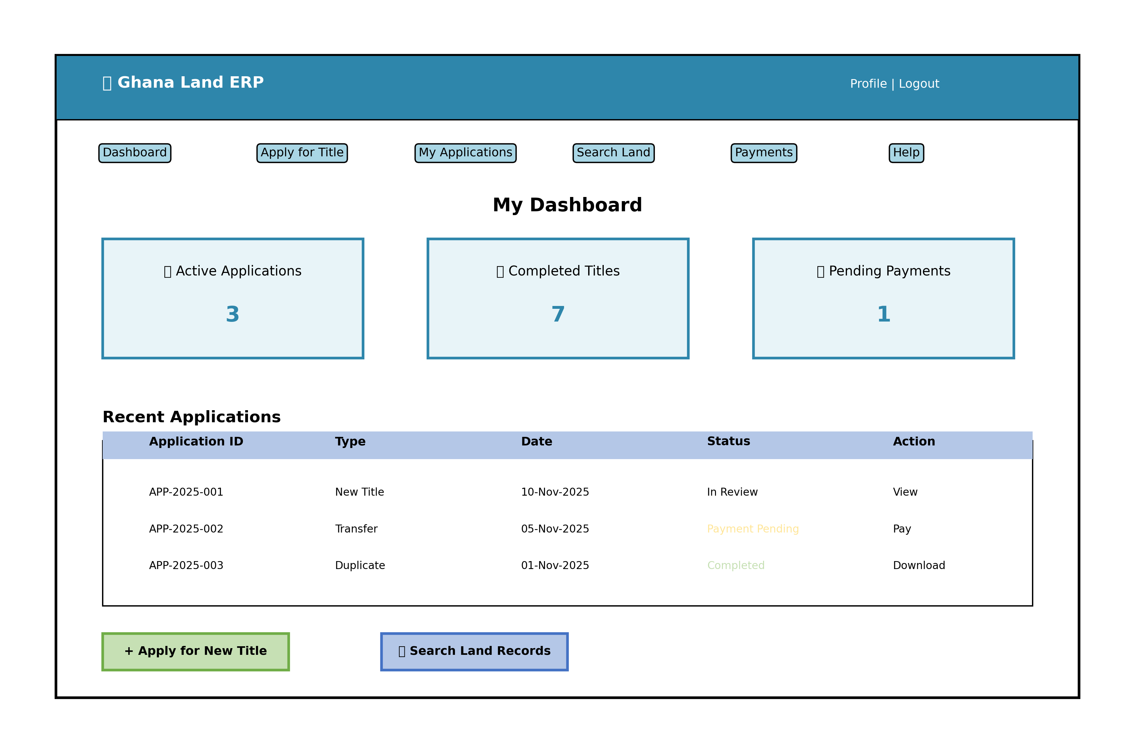

Figure 6: Citizen portal dashboard wireframe showing navigation, active applications, and quick action buttons.

11.1.2 Surveyor Mobile Application
The surveyor mobile app is optimized for field use with offline capabilities, GPS integration, and biometric capture.

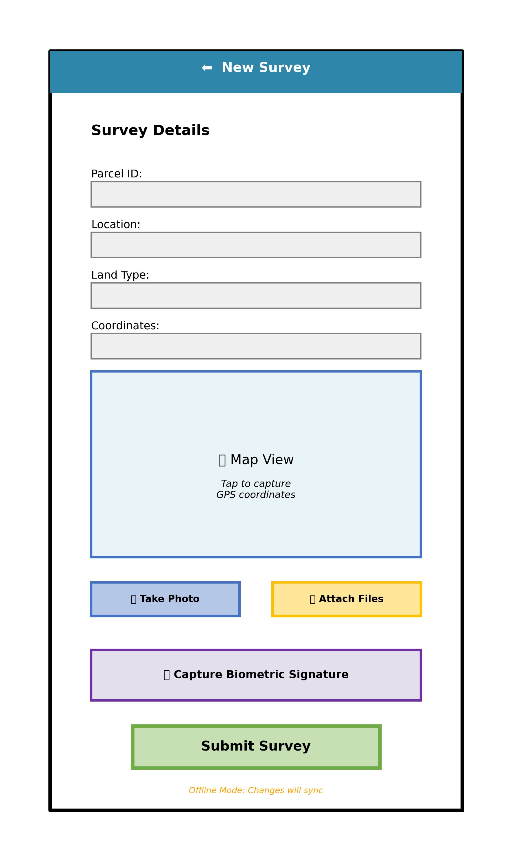

Figure 7: Surveyor mobile app wireframe showing survey data entry form, map integration, and offline mode indicator.

11.2 Design System
A comprehensive design system ensures consistency across all applications:
- Color Palette: Primary: Ghana flag colors (Green #006B3F, Yellow #FCD116, Red #CE1126), Secondary: Blue #2E86AB for UI elements, Neutral: Grays for text and backgrounds
- Typography: Primary: Inter (web), System fonts (mobile), Headings: Bold 24-32px, Body: Regular 16px, Small: 14px
- Spacing: 8px base unit, Margin/padding multiples: 8px, 16px, 24px, 32px, 48px
- Components: Material-UI components for web, React Native Paper for mobile, Custom components for land-specific features
- Icons: Material Icons for standard UI, Custom icons for land/survey features
- Responsive Breakpoints: Mobile: 320-767px, Tablet: 768-1023px, Desktop: 1024+px
- Accessibility: WCAG 2.1 AA compliance, Color contrast ratio 4.5:1, Keyboard navigation, Screen reader support
- Localization: English (default), Twi, Ewe, Hausa with i18next library, RTL support for future Arabic

12. Project Plan

12.1 Project Timeline
The project is planned for a 12-month implementation cycle from kickoff to national rollout. The timeline is divided into phases with clear deliverables and milestones.

Gantt Chart:
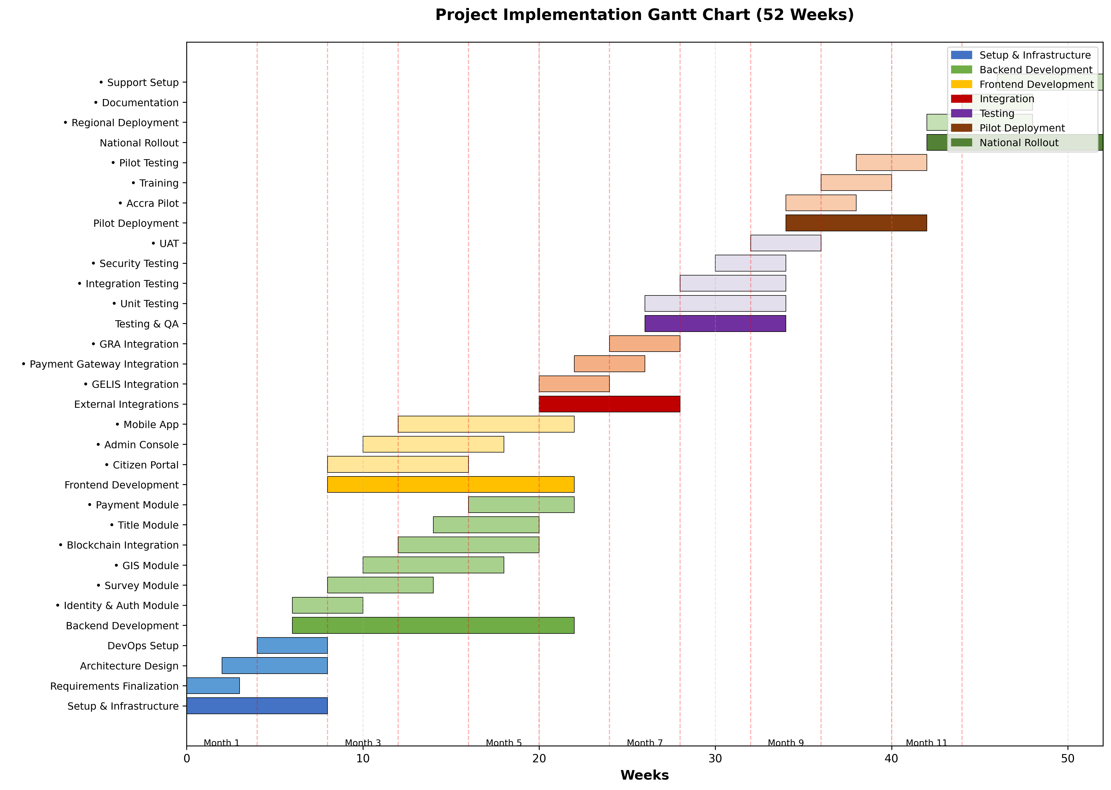

Figure 8: Project Gantt chart showing all phases, tasks, and dependencies over 52 weeks.

12.2 Phase Breakdown

Phase 1: Setup & Infrastructure (Weeks 1-8)
- Requirements finalization and stakeholder sign-off
- Architecture design and technology stack confirmation
- Development environment setup (Git, CI/CD, IDE)
- Cloud infrastructure provisioning (AWS accounts, VPC, Kubernetes)
- DevOps pipeline setup (GitLab CI/CD, Docker registry)
- Security infrastructure (HSM, Keycloak, Vault)
- Blockchain network setup (Hyperledger Fabric nodes)

Phase 2: Core Development (Weeks 6-22)
- Backend microservices development (Identity, Survey, GIS, Blockchain, Title, Payment, Document)
- Database schema creation and migration scripts
- Smart contract development and testing
- Frontend development (Citizen Portal, Admin Console)
- Mobile app development (surveyor app)
- API development and documentation
- Unit testing and code coverage (>80%)

Phase 3: Integration (Weeks 20-28)
- GELIS integration and data migration
- Payment gateway integration (Mobile Money, cards, GHIPSS)
- GRA integration for stamp duty
- Bank API integration for mortgages
- OASL integration for stool lands
- Satellite imagery provider integration
- Integration testing and end-to-end testing

Phase 4: Testing & QA (Weeks 26-34)
- System integration testing
- Security testing and penetration testing
- Performance and load testing (50K concurrent users)
- User acceptance testing (UAT) with Lands Commission
- Accessibility testing (WCAG 2.1 AA)
- Bug fixing and refinement
- Test reports and sign-off

Phase 5: Pilot Deployment (Weeks 34-42)
- Pilot deployment to Accra and Ashanti regions
- Training for Lands Commission staff (100 users)
- Training for surveyors (50 users)
- Pilot testing with 5,000 parcels
- Issue tracking and resolution
- Performance monitoring and optimization
- Pilot evaluation and lessons learned

Phase 6: National Rollout (Weeks 42-52)
- Regional deployment to all 16 regions
- Mass training program (Train-the-Trainer)
- Data migration from legacy systems
- Go-live preparation and communication
- National launch event
- Post-launch support and monitoring
- Hypercare period (24/7 support for first month)

12.3 Milestones
Milestone | Target Week | Deliverable
M1: Project Kickoff | Week 1 | Project charter, team onboarding
M2: Infrastructure Ready | Week 8 | Dev, Staging, Prod environments operational
M3: Backend Services Complete | Week 16 | All microservices deployed to staging
M4: Frontend Complete | Week 20 | Web and mobile apps ready for testing
M5: Integrations Complete | Week 28 | All external integrations functional
M6: Testing Complete | Week 34 | Test reports, UAT sign-off
M7: Pilot Launch | Week 36 | Pilot go-live in Accra/Ashanti
M8: Pilot Evaluation | Week 42 | Pilot report, lessons learned
M9: National Launch | Week 48 | Production go-live, all regions
M10: Project Closeout | Week 52 | Final documentation, handover to operations

12.4 Budget Estimation
The following budget estimate covers a 12-month implementation period and the first year of operations:

Category | Item | Quantity/Period | Cost (USD)
Personnel | Development Team (35 FTE) | 12 months | $1,400,000
Personnel | Project Management | 12 months | $180,000
Infrastructure | Cloud Infrastructure (AWS) | 12 months | $360,000
Infrastructure | Blockchain Network Setup & Operations | 12 months | $120,000
Software Licenses | Development Tools & IDEs | 12 months | $50,000
Software Licenses | Monitoring & Security Tools | 12 months | $80,000
Software Licenses | Biometric SDK Licenses | 12 months | $100,000
Hardware | Field Devices (Tablets, Biometric readers) | 500 units | $250,000
Hardware | Smartcards & Card Readers | 10,000 cards | $75,000
External Services | Satellite Imagery Subscription | 12 months | $60,000
External Services | Payment Gateway Fees | 12 months | $40,000
External Services | Security Audit & Penetration Testing | One-time | $50,000
Training | Staff Training & Change Management | 1,000 users | $150,000
Contingency | Risk Buffer (15%) | - | $444,750

Total Estimated Budget: $3,359,750

Note: This budget is an estimate and may vary based on actual team composition, cloud usage, and external service costs. Annual operational costs (Year 2+) estimated at $800,000.

13. Team Structure
The project requires a cross-functional team of approximately 35-40 Full-Time Equivalents (FTEs) with expertise in various technologies and domains.

Team Structure Diagram:
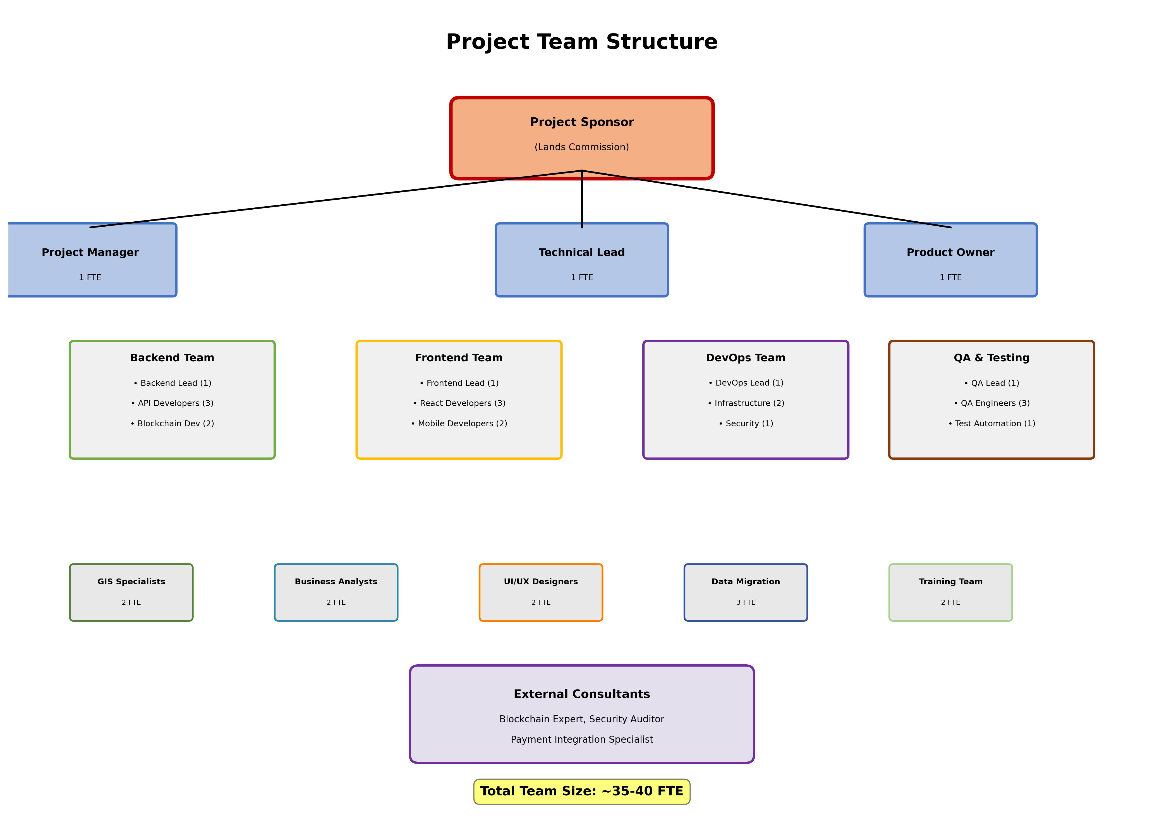

Figure 9: Project team organizational structure showing all roles and reporting lines.

13.1 Detailed Team Breakdown

Leadership & Management
Role | FTE | Responsibilities
Project Sponsor (Lands Commission) | 0.5 FTE | Overall project oversight, stakeholder management, budget approval
Project Manager | 1 FTE | Project planning, resource management, risk management, status reporting
Technical Lead / Architect | 1 FTE | Technical vision, architecture decisions, code reviews, mentorship
Product Owner | 1 FTE | Requirements prioritization, backlog management, UAT coordination

Backend Development Team
Role | FTE | Responsibilities
Backend Team Lead | 1 FTE | Backend architecture, code reviews, team coordination
Senior Backend Developers | 3 FTE | Microservices development, API design, database design
Blockchain Developers | 2 FTE | Smart contract development, Hyperledger Fabric, chaincode
Integration Developers | 2 FTE | External system integration, API connectors, ETL

Frontend Development Team
Role | FTE | Responsibilities
Frontend Team Lead | 1 FTE | Frontend architecture, UI/UX coordination, code reviews
Senior React Developers | 3 FTE | Web application development, state management, responsive design
React Native Developers | 2 FTE | Mobile app development, offline sync, biometric integration
UI/UX Designers | 2 FTE | Wireframes, mockups, user research, usability testing

DevOps & Infrastructure Team
Role | FTE | Responsibilities
DevOps Lead | 1 FTE | Infrastructure architecture, CI/CD design, security
DevOps Engineers | 2 FTE | Kubernetes management, monitoring, deployment automation
Security Engineer | 1 FTE | Security architecture, penetration testing, compliance

QA & Testing Team
Role | FTE | Responsibilities
QA Lead | 1 FTE | Test strategy, test plan, QA process, UAT coordination
QA Engineers | 3 FTE | Manual testing, automated testing, bug tracking
Test Automation Engineer | 1 FTE | Test automation framework, CI/CD integration

Specialized Roles
Role | FTE | Responsibilities
GIS Specialists | 2 FTE | GIS architecture, PostGIS, spatial analysis, map tile generation
Business Analysts | 2 FTE | Requirements analysis, process mapping, user stories
Data Migration Specialists | 3 FTE | Legacy data analysis, ETL development, data cleansing
Training Coordinators | 2 FTE | Training material development, train-the-trainer, user support

External Consultants
Role | FTE | Responsibilities
Blockchain Consultant | 0.25 FTE | Hyperledger Fabric expertise, smart contract best practices
Security Auditor | 0.1 FTE | Third-party security assessment, penetration testing
Payment Integration Specialist | 0.25 FTE | Mobile Money integration, GHIPSS, PCI compliance

13.2 Skill Requirements
Team members should possess the following skills and certifications:
- Programming: JavaScript/TypeScript, Python, Go, SQL
- Frameworks: React, React Native, Node.js, NestJS, FastAPI
- Blockchain: Hyperledger Fabric, smart contracts, distributed systems
- Databases: PostgreSQL, PostGIS, MongoDB, Redis
- Cloud: AWS (preferred) or Azure, Kubernetes, Docker, Terraform
- DevOps: CI/CD (GitLab/GitHub Actions), monitoring (ELK, Prometheus), security
- GIS: PostGIS, GeoServer, OpenLayers, QGIS, GDAL
- Security: OAuth 2.0, HSM, encryption, penetration testing
- Certifications: AWS Certified Solutions Architect, CKA (Kubernetes), CISSP (Security)
- Soft Skills: Communication, collaboration, problem-solving, agile methodologies

14. Risk Management
The following risks have been identified, assessed, and mitigation strategies defined:

Risk | Impact | Probability | Mitigation Strategy | Owner
Integration complexity with legacy GELIS system | High | High | Early integration testing, API mocking, fallback manual processes | Tech Lead
Blockchain scalability under load | Medium | Medium | Performance testing, sharding, hybrid on-chain/off-chain | Blockchain Lead
User adoption resistance | High | Medium | Change management, training, pilot success stories, incentives | Project Manager
Data quality in legacy records | High | High | Data cleansing phase, OCR + human QC, gradual migration | Data Migration Lead
Mobile Money API instability | Medium | Medium | Retry mechanisms, circuit breakers, fallback USSD | Integration Lead
Security vulnerabilities | Critical | Low | Quarterly pentests, code reviews, bug bounty, HSM | Security Engineer
Insufficient biometric hardware | Medium | Low | Early procurement, vendor backup, PIN fallback | Project Manager
Cloud cost overruns | Medium | Medium | Cost monitoring, budget alerts, resource optimization, reserved instances | DevOps Lead
Team attrition / skill shortage | High | Medium | Competitive compensation, knowledge sharing, documentation, backup resources | HR / PM
Regulatory/legal delays | Medium | Medium | Early legal engagement, parallel legal review, pilot under existing framework | Project Sponsor
Internet connectivity issues in rural areas | Medium | High | Offline-first architecture, local caching, satellite internet backup | Tech Lead
Payment reconciliation discrepancies | High | Medium | Automated reconciliation, exception handling, daily monitoring, audit trails | Payment Lead
Satellite imagery licensing costs | Low | Low | Open-source imagery (Sentinel), negotiate volume discounts | GIS Lead
Smart contract bugs | High | Low | Formal verification, extensive testing, audit, upgrade mechanism | Blockchain Lead
Scope creep | Medium | High | Clear requirements, change control board, prioritization, MVP focus | Project Manager

15. Appendices

15.1 Glossary
- API: Application Programming Interface
- AFIS: Automated Fingerprint Identification System
- CRS: Coordinate Reference System
- DMS: Document Management System
- ETL: Extract, Transform, Load
- GELIS: Ghana Enterprise Land Information System
- GIS: Geographic Information System
- GHIPSS: Ghana Interbank Payment and Settlement Systems
- GRA: Ghana Revenue Authority
- HSM: Hardware Security Module
- JWT: JSON Web Token
- KYC: Know Your Customer
- NFT: Non-Fungible Token
- OASL: Office of Administrator of Stool Lands
- OCR: Optical Character Recognition
- RBAC: Role-Based Access Control
- SIEM: Security Information and Event Management
- TLS: Transport Layer Security
- UAT: User Acceptance Testing
- WAF: Web Application Firewall
- WMS: Web Map Service
- WFS: Web Feature Service

15.2 References
- Requirements Specification Document v1.0
- Functional Requirements Document - Lands Commission
- National Land ERP - Key Features Document
- Hyperledger Fabric Documentation (https://hyperledger-fabric.readthedocs.io/)
- PostgreSQL / PostGIS Documentation
- Ghana Data Protection Act, 2012 (Act 843)
- ISO/IEC 27001:2013 - Information Security Management
- OWASP Top 10 Web Application Security Risks
- AWS Well-Architected Framework
- Kubernetes Documentation

15.3 Document Approval
Role | Name | Signature | Date
Executive Director, Lands Commission
Project Sponsor
Technical Lead / Architect
Project Manager
Chief Information Officer

--- End of Technical Specifications Document ---

