|  |  |  |  |  |
| --- | --- | --- | --- | --- |
| Inventory Management | | | | |
|  |  | | |  |
|  | | | | |
|  | | Project Plan |  | |

TABLE OF CONTENTS

**1. Introduction**

2. Tech Stack

3. Screenshots of the project

# Introduction

JavaScript inventory list is a business app for automated record-keeping and maintenance of the corporate computer equipment. The app allows to keep records of the users and devices as well as to create various reports.

# Tech stack

The Project is created using

* HTML5
* CSS3
* Javascript (with ES6)
* jQuery
* Bootstrap 4
* Node
* AJAX
* JSON
* REST API calls.

# Project details

## Inventories dashboard

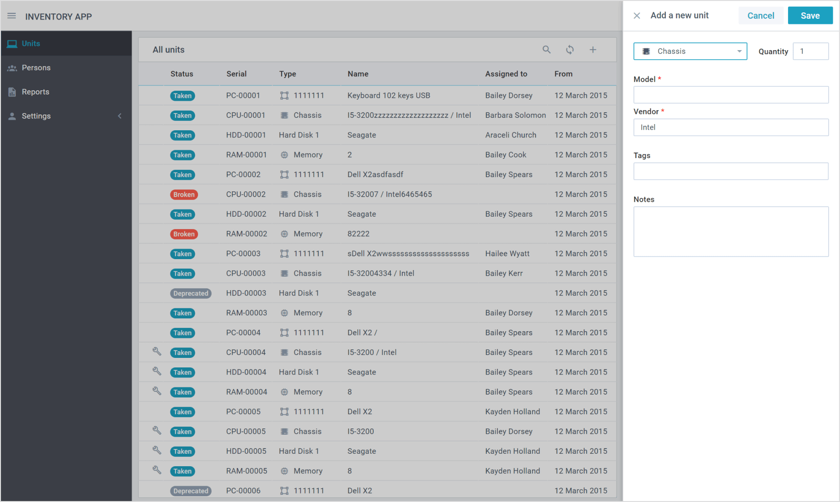

This screen shows the list of all devices present in the database/json and their status. The search bar allows to find needed records fast or to filter the data. The user can create new records and get the report of the equipment used.

## User management module

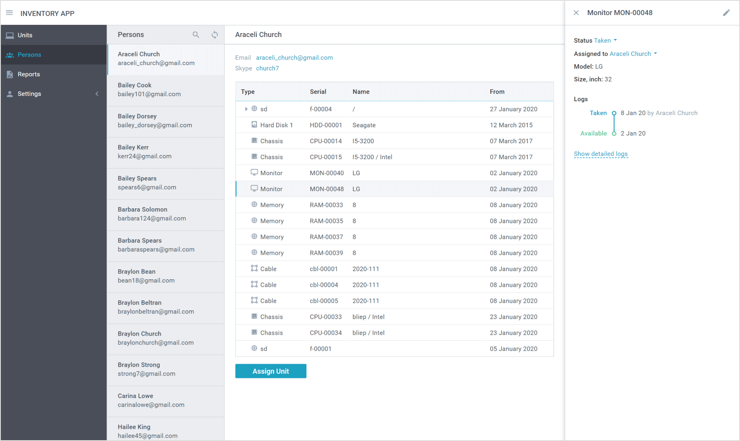

It allows to keep record of the equipment on hand, its maintenance and usage history.

## Report module

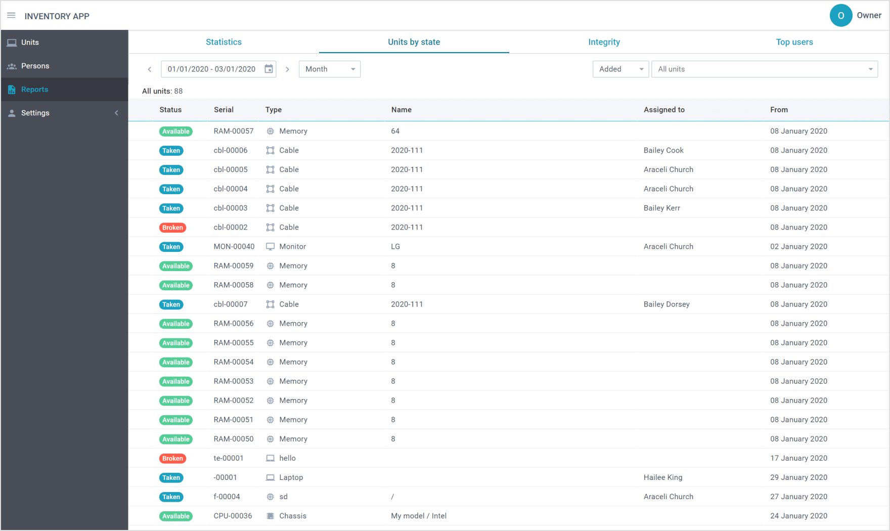

It allows to get statistics on the availability of all types of equipment. Shows the logistics information.

## Application settings

