# 

# Department of Software Engineering

**CS 250: Data Structures and Algorithms**

**Class: BESE-7AB**

**Lab 12: Graph Traversals**

**CLO1: Understand the fundamentals of data structures and algorithms.**

**Date: December 29th, 2017**

**Time: 9:00 am -12:00pm, 2:00pm – 5:00pm**

# Instructor: Dr. Muhammad Shahzad

# 

**Lab 12: Graph Traversals: Breadth First Traversal (BFS)**

**Introduction**

This lab is based on the graph traversals.

**Objectives**

The objective of this lab is to implement Breadth First Traversal algrothm for traversing nodes in a graph.

**Tools/Software Requirement**

Visual Studio C++

**Description**

Breadth First Traveral (or Search) for a graph is similar to Breadth First Traversal of a tree. The only catch here is, unlike trees, graphs may contain cycles, so we may come to the same node again. To avoid processing a node more than once, we use a boolean visited array. For simplicity, it is assumed that all vertices are reachable from the starting vertex. For example, in the following graph, we start traversal from vertex 2. When we come to vertex 0, we look for all adjacent vertices of it. 2 is also an adjacent vertex of 0. If we don’t mark visited vertices, then 2 will be processed again and it will become a non-terminating process. A Breadth First Traversal of the following graph is 2, 0, 3, 1.

[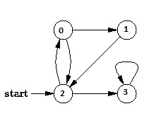](https://www.geeksforgeeks.org/wp-content/uploads/BFS.jpg)

**Task**

Implement BFS traversal algorithm studied in class for a graph with 8 vertices.

As an initial input we have the graph (G) with 8 nodes shown below with and a starting vertex 2.

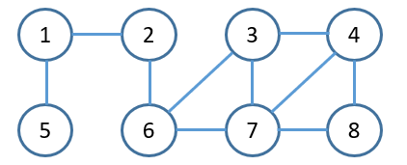

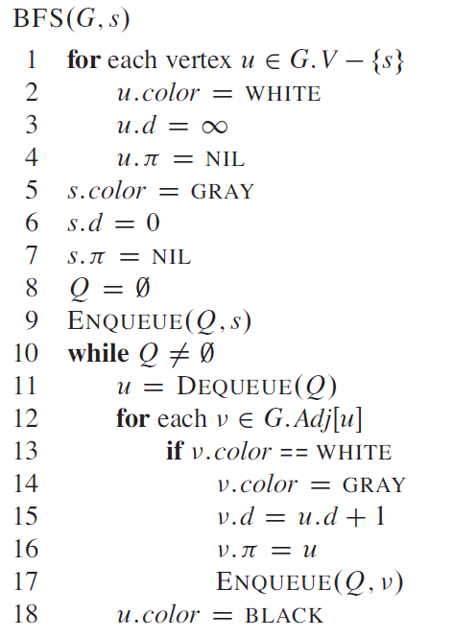Pseudo code is given below:

**Deliverables**

Students are required to upload the lab on LMS before deadline.

Your code should utput the correct BFS sequence for any arbitrary starting vertex.

**Note:** Use proper indentation and comments. Lack of comments and indentation will result in deduction of marks. You will submit your workingcodes in **word document** (do **NOT** take screenshot of code, just copy your code and paste it). The name of word document should follow this format. i.e. **YOUR_NAME_Lab#**