# 

# Department of Software Engineering

**CS 250: Data Structures and Algorithms**

**Class: BESE-7AB**

**Lab 9: Sorting Algorithms & Their Asympototic Complexity (continued)**

**CLO4: Investigate and evaluate various algorithms based on accuracy, time complexity, and memory requirements.**

**Date: November 24th, 2017**

**Time: 9:00 am -12:00pm, 2:00pm – 5:00pm**

# Instructor: Dr. Muhammad Shahzad

**Lab 9: Quick Sort**

**Introduction**

In this lab, you will implement quick sort.

**Objectives**

Objective of this lab is to implement Quick sort.

**Tools/Software Requirement**

Visual Studio C++

**Description**

You will implement the pseudo code given in the book "Introduction to Algorithms" by Cormen.

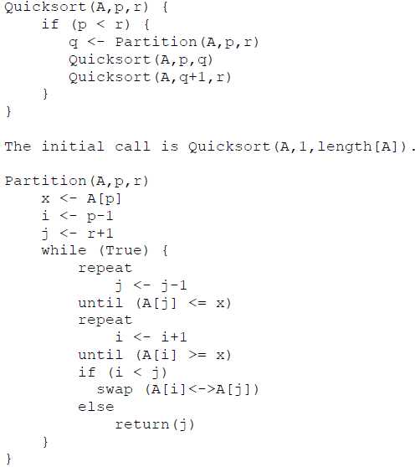

**Lab Tasks**

1. You will run the algorithm on data that we used in the last lab to verify the result.

2. Compare how many partitions happened in each case.

3. Choose a different pivot value and see if number of partitions decreases. The new pivot value can be chosen as the median of the first, middle and last elements of the array.

**Deliverables**

Students are required to upload the lab on LMS before deadline.

# Note: Use proper indentation and comments. Lack of comments and indentation will result in deduction of marks. You will submit your working codes in word document (do NOT take screenshot of code, just copy your code and paste it). The name of word document should follow this format. i.e. YOUR_NAME_L